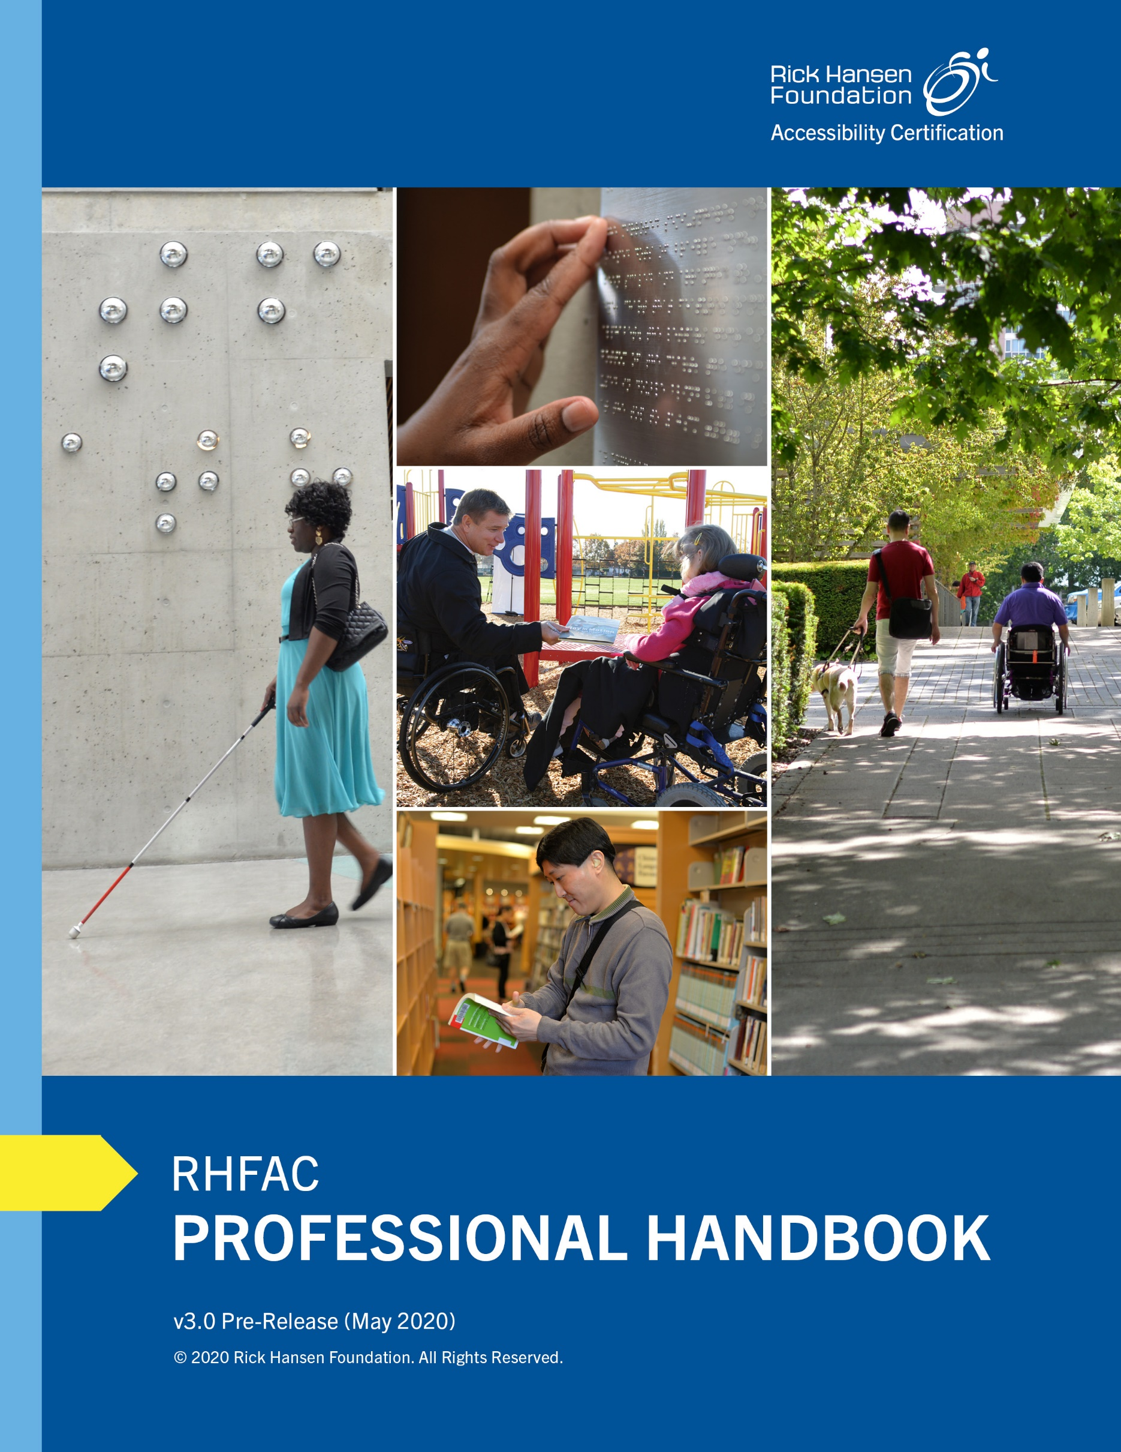

This document was developed to guide the reader through the specific application of the Rick Hansen Foundation Accessibility Certification™ (RHFAC) Program. This is not intended to be a design manual. Guidance on how to rate a specific Site is not included in this document.
For more information about the RHFAC Program and RHFAC Training, please contact us at access@rickhansen.com or visit www.rickhansen.com/rhfac.

COPYRIGHT
©2020 by The Rick Hansen Foundation. All rights reserved.

Disclaimer
None of the parties involved in the funding or creation of the Rick Hansen Foundation Accessibility Certification™ (“RHFAC”) Program, including the Rick Hansen Foundation, its affiliates, members, employees or contractors, assume any liability or responsibility to the user of this handbook or any third parties for the accuracy, completeness, or use of or reliance on any information contained in the RHFAC Program, or for any costs, expenses, injuries, losses, or damages (including, without limitation, equitable relief) arising from the use of any materials for the RHFAC Program.
New construction, Site alterations, repairs, and demolitions in all jurisdictions are or may be subject to federal, provincial, municipal, and local statutes, codes, ordinances, decrees, rules, regulations, bylaws, policies, requirements, standards, and guidelines in their governing jurisdiction (“Building Laws”). These Building Laws may include building codes, standards, or requirements that are specific to accessibility by persons with disabilities. These Building Laws vary from jurisdiction to jurisdiction and may change over time. The user is advised that the ratings, certification levels, recommendations, and build specifications used or included in the RHFAC Program are functional recommendations, not represented or guaranteed to meet, comply with, or be consistent with the requirements of any Building Laws at any time in force or effect in any jurisdiction. It is the sole responsibility of the party undertaking any construction to consult with knowledgeable consultants (including code consultants) and applicable authorities having jurisdiction in the governing jurisdictions, to confirm that the recommendations and specifications of the RHFAC Program intended to be used comply with Building Laws so that any build, renovation, and demolition undertaken is in compliance with the Building Laws. The user acknowledges that it is aware that it may be required to amend or adapt the recommendations and specifications of the RHFAC Program to ensure compliance with Building Laws.
As a condition of use, the user hereby waives the user’s right of any and all claims, demands, and causes of action against the Rick Hansen Foundation, its affiliates, members, employees, or contractors (the “RHF Personnel”), and further releases the RHF Personnel of any and all claims, demands, and causes of action, for any costs, expenses, injuries, losses, or damages (including, without limitation, equitable relief) that the user may now or hereafter have against the RHF Personnel by reason of or arising out of the use of, or reliance on, any materials for the RHFAC Program.

Permissions
Canadian Standards Association
With the permission of Canadian Standards Association (CSA), material is reproduced from CSA standard, B651-18 - Accessible design for the built environment, which is copyrighted by CSA, 178 Rexdale Blvd., Toronto, ON, M9W 1R3. This material is not the complete and official position of CSA on the referenced subject, which is represented solely by the standard in its entirety. While use of the material has been authorized, CSA is not responsible for the manner in which the data is presented, nor for any interpretations thereof. No further reproduction is permitted. For more information or to purchase standards from CSA, please visit http://shop.csa.ca/ or call 1-800-463-6727.

Trademark
Rick Hansen Foundation Accessibility Certification™ is a registered trademark of the Rick Hansen Foundation.

Acknowledgements
The Rick Hansen Foundation gratefully acknowledges the support of the RHFAC Advisory Committee and the following individuals who have contributed to the development and update of this document.
The Rick Hansen Foundation
Brad McCannell, Vice President, Access and Inclusion
Jenny Blome, Manager, Accessibility Services
Kevin Ng, Content Lead, Accessibility Certification
Hans Egger, RHFAC Accessibility Certification Specialist
The RHFAC Technical Subcommittee
Tom Ainscough, Architect
Tim Archer, President, Advanced Listening
Darlene Boyes, Recreation Coordinator – Accessibility, City of Calgary
Aiden Callison, Architect, HCMA Architecture + Design
Douglas Copley, RHFAC Professional
Murray Gallant, Chief Architect, Department of National Defence
Lui Greco, Manager, Regulatory Affairs, The CNIB Foundation
Kristen Habermehl, Vice President, Habermehl Contracting Ltd & RHFAC Training Instructor
Gary Malkowski, former Vice President, Community Development and Outreach Department, Canadian Hearing Society (former)
Lonnie McInnis, former HVMP Barrier Free Design Coordinator, March of Dimes Ontario
Cambria McLeod, Senior Staff Engineer, Codes and Standards, Kohler Company
Martin Mikkelson, Architect, Architecture & Engineering Resources, Public Services & Procurement Canada
Brent North, Vice President, Stantec
Darcy Poitras, RHFAC Professional, New Wave Accessible Design Consulting
Samantha Proulx, Principal, ABE Factors Inc. & RHFAC Training Instructor
Patricia Short, Principal, PeopleFirst Accessibility Solutions & RHFAC Training Instructor
Chris Sutton, CEO, Wavefront Media, former National Executive Director, Canadian Hard of Hearing Association
Ron Wickman, Architect, Ron Wickman Architect
Patrick White, Consultant, Level Playing Field Inc.
Darren Young, Senior Project Manager, Halifax Regional Municipality
Table of Contents
1.0 Introduction 9
2.0 Understanding Certification Levels and Requirements 10
2.1 Certification Levels 10
2.2 Certification Requirements 10
2.2.1 Mandatory Certification Requirement (MCR) 11
2.2.2 Mandatory Gold Certification Requirement (MGCR) 12
3.0 The Rating Survey 17
3.1 Rating Basics 17
3.1.1 How to Assign Points to a Feature 18
3.1.2 Rating Survey Categories 20
3.1.3 Rating Summary 20
3.2 Rating Criteria by Category 21
1. Vehicular Access 24
1.1. Parking 24
1.2. General Vehicular Access 31
2. Exterior Approach and Entrance 34
2.1. Exterior Pathways to Facilities on Site 34
2.2. Exterior Ramps 42
2.3. Exterior Stairs 46
2.4. Building Entrances 52
3. Interior Circulation 62
3.1. Interior Doors and Doorways (not including Washrooms) 63
3.2. Path of Travel 72
3.3. Corridors and Hallways 74
3.4. Interior Ramps 78
3.5. Elevators 83
3.6. Interior Stairs 91
3.7. Escalators and Moving Walkways 97
3.8. Platform Lifts 99
4. Interior Services and Environment 102
4.1. Lobby and Reception Areas 102
4.2. Reception Desks, Service Counters, and Self-Service Transaction Kiosks 105
4.3. Waiting Areas, General Seating, Meeting Rooms, and Lounges 109
4.4. Kitchens 112
4.5. Acoustic Considerations 116
4.6. Illumination and Building Systems 118
5. Sanitary Facilities 122
5.1. Washrooms 122
5.2. Showers 135
6. Wayfinding and Signage 139
6.1. General Wayfinding and Signage 140
6.2. Room Identification Signage 146
6.3. Directory Boards and Interactive Information Kiosks 148
7. Emergency Systems 151
7.1. Emergency Exits and Areas of Refuge 151
7.2. Fire Alarm Systems and Equipment 155
7.3. Evacuation Instructions 157
8. Additional Use of Space 159
8.1. Workstations 159
8.2. Public Assembly Areas 162
8.3. Exhibit Spaces 166
8.4. Lodging and Temporary Accommodation 169
8.5. Outdoor Recreation Areas 174
8.6. Cafeterias, Restaurants and Bars 176
8.7. Retail Outlets 180
8.8. Playgrounds 183
8.9. Fitness Centre 185
8.10. Pools 188
8.11. Change Rooms 192
8.12. Mail Service 194
8.13. Shared Laundry Rooms 196
8.14. Storage Facilities and Lockers 198
8.15. Garbage Rooms 200
8.16. Viewpoints 201
8.17. Visitor Centre and Kiosk 205
8.18. Picnic Areas 208
9. Residential Units 211
9.1. Unit Security and Entry Systems 212
9.2. Unit Entrance and Entrance to Outdoor Spaces 214
9.3. Unit Interior Doors 218
9.4. Unit Kitchen 220
9.5. Unit Hallways 225
9.6. Unit Interior Stairs 227
9.7. Unit Bedrooms and Closets 231
9.8. Unit Toilet Rooms 233
9.9. Unit Showers and Bathtubs 237
9.10. Unit Laundry 240
9.11. Unit General Requirements 241
10. Trails and Pathways 243
10.1. Trail and Pathway Features 243
10.2. Trail and Pathway Ramps 248
10.3. Trail and Pathway Stairs 252
10.4. Trail and Pathway Wayfinding and Signage 256
4.0 Appendices 260
Appendix A. Fundamental Specifications 261
A.1 Space and Clearance 261
A.2 Reach Ranges 268
A.3 Counters, Work Surfaces, and Sinks 270
A.4 Signage 271
A.5 Colour Contrast 272
Appendix B. Guidelines on Writing the Scope of Rating 273
Appendix C. Guidelines on Writing a Rating Summary 276
Appendix D. Technical Language Glossary 279
Appendix E. References 287

Introduction
The RHFAC Professional Handbook (“Handbook”) is an essential resource for RHFAC Professionals. It is meant to assist in navigating the Rick Hansen Accessibility Certification™ (RHFAC) Rating Survey (“Rating Survey”).
The Handbook provides detailed guidance on important components of the Rating Survey. It is not intended to be a design manual. The Handbook includes:
- Certification Levels and Requirements. This section covers the certification basics, which includes an overview of the different certification levels and mandatory certification requirements. A comprehensive guide is provided to help RHFAC Professionals determine if a Site has met the mandatory certification requirements.
- The Rating Survey. This section is organized in two parts. The first part covers the rating survey basics and explains the scoring rationale, while the second part provides detailed rating criteria on a feature-by-feature basis for the 10 Rating Categories.
- Appendices. A list of additional important resources that RHFAC Professionals should use when completing a rating. It includes fundamental dimensions, guidelines on what should be included in the scope of rating, how to write a rating summary, and key technical terminologies and definitions.
In addition to this Handbook, other related RHFAC resources are as follows:
- RHFAC Student Guide. This is provided to students as a textbook for the “RHFAC Training Course”.
- Guide to RHF Accessibility Certification. This document is intended for program participants, such as Site owners or building managers, who are interested in obtaining a rating for a Site.
- Guide to RHFAC Professional Designation. This document explains the specific process and requirements for becoming an RHFAC Professional.
- Accessibility Professional Network (APN). A membership network for those interested in accessibility in the built environment that provides a variety of resources, including job boards, webinars, research papers, and discussion forum for members.

Understanding Certification Levels and Requirements

Certification Levels
RHFAC offers two levels of certification: RHF Accessibility Certified Gold and RHF Accessibility Certified. The certification level for a project is determined by:
- Achieving the minimum rating score, which is the total earned score divided by the total available score, expressed as a percentage; and
- Meeting the Mandatory Certification Requirements (MCR) and Mandatory Gold Certification Requirements (MGCR).
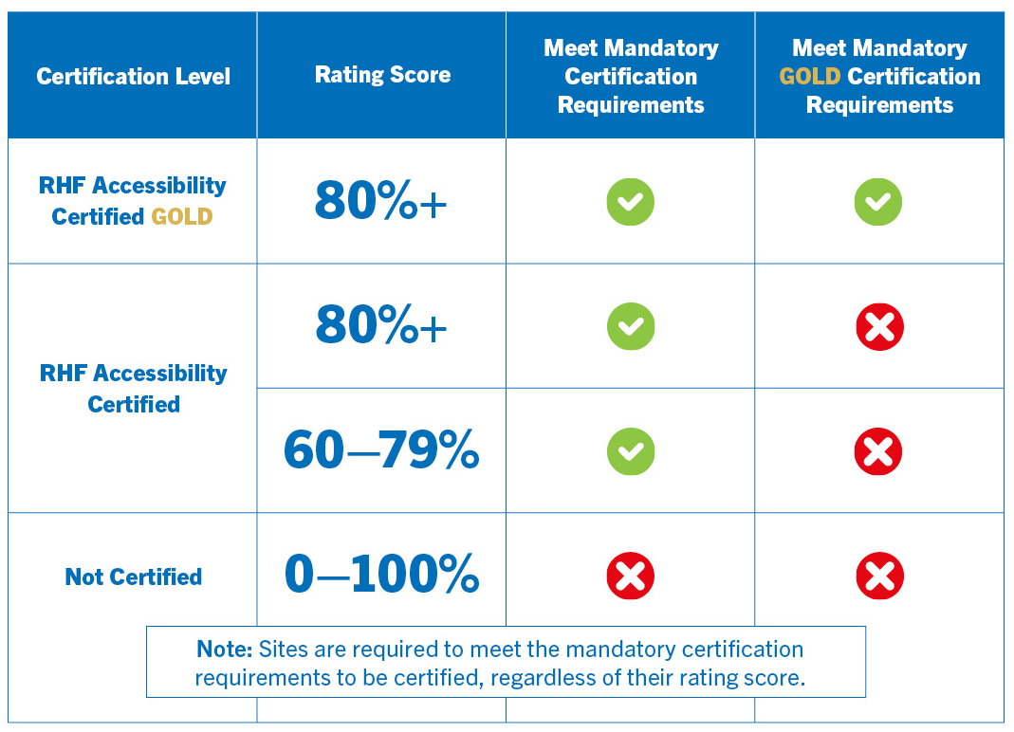

Certification Requirements
In order to be certified, a Site must meet the mandatory certification requirements. RHFAC Professionals are required to confirm that a Site has met the mandatory certification requirements before submitting a rating. If a Site does not meet the mandatory certification requirements, RHFAC Professionals should identify why this is not the case in the Scope of Rating.
Appendix B: Guidelines on Writing the Scope of Rating provides further guidance on ensuring an effective and accurate scope of rating is developed.
This section provides detailed guidance for RHFAC Professionals to determine whether a Site has met the Mandatory Certification Requirements and the Mandatory Gold Certification Requirements.

Mandatory Certification Requirement (MCR)
The Mandatory Certification Requirement (MCR) applies to all Sites.
IMPORTANT: If a Site does not meet the MCR, it is NOT eligible for a certification, regardless of its rating score; Sites achieving a rating score of 60%+ will not be certified in those instances.
To be RHF Accessibility Certified, a Site must have:
- An accessible public entrance; and
Examples | MCR met?
At least one public entrance that is accessible for people using wheeled mobility devices. | Yes
All entrances have step or high threshold and are not accessible for people using wheeled mobility devices. | No

- Access to all key functional spaces
Examples | MCR met?
A two-storey office building with elevator and access to office workstations, meeting rooms, and staff kitchen. | Yes
A two-storey office building with no elevator or access to the second floor. Office workstations are on the ground floor, but all meeting rooms and the staff kitchen are located on the second floor. | No
A two-storey office building with no elevator or access to the second floor. Most of the office workstation, the main meeting room, and staff kitchen are located on the ground floor, which is accessible. | Yes

Mandatory Gold Certification Requirement (MGCR)
The Mandatory Gold Certification Requirement (MGCR) applies when Sites have achieved a rating score of 80%+.
IMPORTANT: If a Site achieves a rating score of 80%+ but does not meet the MGCR, the Site is NOT eligible for an RHF Accessibility Certified Gold. Sites may however be certified RHF Accessibility Certified if it meets the MCR.
Some of the requirements identified below may not apply to all Sites, depending on the Site’s design and expected use.
It is also important to note that the features identified below do not have be perfect to meet the MGCR. The deficiencies of these features will be reflected through a lower score in the rating survey. The intent of the MGCR is to ensure that these features are at least provided and taken into consideration. When determining if a Site has met the MGCR, RHFAC Professionals should use their own judgement, depending on the Site’s expected use.
To be RHF Accessibility Certified Gold, a Site must have:
- Designated accessible parking space(s), if parking is provided for Site users
Examples | MGCR met?
Designated accessible parking spaces are provided when parking is available for Site users. | Yes
Parking is available for Site users but no designated accessible parking spaces are available. | No
No parking is provided for Site users. | N/A

- Access to public transit, if the Site is located in an area serviced by transit
Examples | MGCR met?
Public transit stop is an option to access the Site. It is provided close to the Site. | Yes
Site users are required to travel along unsafe and/or lengthy routes from the public transit stop to reach building entrance. | No
Site is located in a remote location and is not serviced by public transit | N/A

- Accessible path(s) of travel leading to building or trail entrance and throughout the building or trail
Examples | MGCR met?
Accessible paths of travel are provided to all accessible entrances to the building only. | Yes
Large open spaces along route to building entrance with no wayfinding cues available for people who are blind or with low vision to identify building entrance. | No

- An accessible primary entrance for public and staff (if separate)
Examples | MGCR met?
Staff and public use different entrances but both have primary accessible entrances. | Yes
Staff and public use different entrances. Only the primary public entrance is accessible. Staff entrance, if separate, is not accessible. | No
Entrance door is secured and require two-way communication in order to be granted access inside the building. No communication system is provided for a Site user who is deaf or hard of hearing. | No

- Access to all floors expected to be used by elevator or lift usable by everyone
Examples | MGCR met?
Five-storey building equipped with elevator or lift with access to all floors. Elevator is easy to use. | Yes
Two-storey building with accessible building entrances provided on both floors but no elevator is provided. | Yes
A two-storey office building with no elevator or access to the second floor. Most of the office workstations, main meeting room, and staff kitchen are located on the ground floor, which is accessible. | No
Access to only part of the dining areas at cafeteria, therefore not allowing choice of seating. | No

- At least one universal washroom
Examples | MGCR met?
At least one universal washroom is provided in the building. | Yes
Three-storey building with multi-occupancy accessible washrooms are provided on all floors but only one universal washroom is available. | Yes
Multi-occupancy accessible washrooms are provided but no universal washrooms. | No

- Emergency systems with visual and audible fire alarms in both public and private areas
Examples | MGCR met?
Both visual and audible fire alarms are provided in both public and private areas. | Yes
Either audible or visual fire alarm is missing in both or either public or private areas. | No
Both visual and audible fire alarms are provided in public areas only. | No

- Wayfinding strategies in place to navigate throughout the Site
Examples | MGCR met?
Consistent wayfinding cues and signage are provided in a large building complex. | Yes
There are large open areas with no wayfinding cues for people who are blind or with low vision. Site has high ceilings and no sound damping acoustic considerations in place for people who are blind to navigate through areas. | No
Small building with simple layout. Any Site users can navigate through the Site with no need for wayfinding cues and signage. | N/A

- Safety warning features, such as tactile attention indicators at the top of stairs, and cane-detectable features, if there are overhead or protruding hazards along the path of travel
Examples | MGCR met?
All staircases have tactile indicators at the top and any overhead or protruding hazards are cane-detectable. | Yes
No cane-detectable protection at overhead or protruding hazards and/or no tactile attention indictors at the top of stairs. | No
No stairs or overhead or protruding hazards along the path of travel. | N/A

- Tactile markings for permanent room identification signs
Examples | MGCR met?
Key rooms and facilities (e.g., washrooms) are clearly marked with tactile signs that provide both raised characters/symbols and Braille. | Yes
Braille and raised characters/symbols are not used on any room identification signage. | No
Small building with simple layout and where no signage is required, such as a small office space with only two rooms. | N/A

- Assistive listening and communication enhancement technologies, when applicable to the Site
Examples | MGCR met?
Office building with assistive listening and communication enhancement technologies provided at some but not all meeting rooms. | Yes
A large theatre with no assistive listening and communication enhancement technologies available for spectators. | No
A multi-unit residential rental building with residential units, shared laundry room, and garbage rooms. No rooms where communication is expected. | N/A

- Accessibility provision(s) for the key functional facilities of the Site
Examples | MGCR met?
Accessible seating spaces are provided but are not dispersed throughout the theatre. | Yes
Pool with only one pool lift provided to access pool. | Yes
People using wheeled mobility devices are not able to access the stage in a theatre due to stair access only. | No
Community centre/fitness centre with no accessible roll-in-shower. | No

Multi-unit residential buildings must have, in addition to requirements identified above:
- Access to all floors by elevator or lift usable by everyone for residents and visitors
Examples | MGCR met?
Five-storey multi-unit residential building with accessible suites on the ground floor only. Elevator provides access to all other floors. | Yes
Five-storey multi-unit residential building with accessible or adaptable suites, all common building amenities are on the accessible floor. There is stair access only to the other floors and no elevator. | No

- Accessible or adaptable residential unit(s) for each type of unit (e.g., bachelor, 1 bedroom, etc.) available
Examples | MGCR met?
Multi-residential building provides at least one accessible or adaptable residential unit for each type of unit that are available. | Yes
Accessible or adaptable residential units are only available for bachelor size units in a multi-unit residential building that also provides 1-bedroom units. | No

The Rating Survey
This section provides detailed guidelines for applying the Rating Survey to a Site and helps RHFAC Professionals determine a rating score on a feature-by-feature basis.

Rating Basics
The rating criteria provide RHFAC Professionals with a list of specific characteristics to look for when assigning points to a feature.
IMPORTANT: It is not expected that all criteria will apply to every situation — there is no one-to-one correlation between the earned points and the list of requirements. It is not a checklist! RHFAC Professionals are responsible for applying their own judgement, based on the unique characteristics of the Site, together with the criteria outlined in this Handbook and relevant Universal Design standards. The ultimate goal is to determine the level of meaningful access based on the nature of the Site and who is using it.
Rating criteria are grouped as follows:
Points | Criteria
Minimum Points | - Indicators or characteristics of a basic level of accessibility for a feature.  - For a feature to earn points, some, but not all, must be present.
Maximum Points | - Indicators or characteristics of a high level of accessibility or meaningful access for a feature.  - For a feature to earn maximum points, some, but not all, need to be present. This depends on the nature of the Site and/or the design of an element.
Minimum/Maximum Points | - Indicators or characteristics of accessibility that have an equivalent impact.
Innovation Points | - Bonus points awarded for innovative features that enhance meaningful access. Some ideas for innovation are provided throughout the Handbook, however RHFAC Professionals are encouraged to identify new ones.  - The maximum number of innovation points possible per Category is identified in the Table at the beginning of each Category.  - Each individual innovation feature can be awarded 1 to 2 points but a maximum of 5 points is allowed if the innovative feature significantly improves meaningful access to the built environment.

How to Assign Points to a Feature
The example provided below illustrates how to use the Handbook criteria to assign points to a feature in two different scenarios.
Community Centre A
Typical Site Users: All ages, including a senior centre with a variety of programming
The parking lot accommodates up to 100 vehicles, including four (4) designated accessible parking spaces. During busy times, however, the demand for accessible parking spaces at Community Centre A often exceeds the number of designated accessible spaces available. Eight (8) designated limited mobility spaces are provided close to the building entrance.
Community Centre B
Typical Site Users: Young professionals and families, including a daycare
The parking lot also has 100 parking spaces in total, including four (4) designated accessible parking spaces. While accessible parking spaces are sometimes in short supply at Community Centre B, people requiring accessible parking spaces are able to find appropriate parking most of the time.
Based on the two scenarios above, how would you rate each Site on the feature below, taking into consideration the rating criteria provided?
Feature 1.1.1 Number of designated accessible spaces
Minimum Points:
- Provides total number of designated accessible parking spaces following current CSA B651 standards
Note: Local or provincial regulations and other best practices should be reviewed depending on Site location.
Maximum Points:
- Provides additional number of designated accessible parking at specific entrances to meet the needs of all users of the Site (e.g., medical facilities, community centres, trails or pathways used by seniors, and adaptable sports programs will need more accessible parking than CSA B651 standards)
- In multi-unit residential building, provides guest parking with accessible spaces designated for people with disabilities
- If electric vehicles charging stations are provided in parking, ensures they are available at designated accessible parking spaces as well

Ideas for Innovation:
- Clearly signed courtesy or limited mobility parking for seniors, parents with young children, or for deliveries are provided close the building entrance
- Short-term parking spaces (10–15 minutes) near an entrance to prevent double-parking and to reduce congestion
Recommended Score and Rationale
Community Centre A | Community Centre B
Score:  - 3 out of 5 points | Score:  - 5 out of 5 points
Rationale:  - The number of spaces provided is in accordance with CSA standards (a parking lot with 100 spaces requires 2-4 designated accessible parking spaces).  - This is often insufficient to meet the needs of the users. During busy times, there are not enough designated parking spaces to meet the demand.  - The parking lot meets minimum requirements only. | Rationale:  - The number of spaces provided is in accordance with CSA standards, meeting the needs of users most of the time  - The parking lot meets the needs of its users (provides meaningful access) most of the time.
Innovation:  - 1 point for provision of designated limited mobility spaces | Innovation:  - None
Key Points
While these two scenarios help RHFAC Professionals understand how to assign points to a feature, it also illustrates the important concept of meaningful access: given the same feature, what constitutes meaningful access at one Site (Centre B) only represents minimum requirements at another (Centre A). When rating a Site, RHFAC Professionals must always focus on whether the Site provides meaningful access to people who are using the Site. Remember, we are not the code police. You are identifying the overall level of accessibility for the expected user group.
Another important point to note is that Centre A was able to receive an innovation point because it provided designated limited mobility spaces close to the building entrance. Those spaces are suitable for people with limited stamina, heart or respiratory problems, or those with other mobility aids such as canes or crutches.

Rating Survey Categories
The remaining subsections correspond to the specific categories of the Rating Survey itself (1.0 Vehicular Access, 2.0 Exterior Approach and Entrance, etc.), including the elements and features. They are meant as a supplement to the Rating Survey to provide scope, context, and criteria and to guide RHFAC Professionals as they assign points to a Site and determine a rating. Each category subsection includes the following information:
- A summary table that lists each of the elements pertaining to the category, along with the corresponding maximum available scores.
- An overall description of the category as well as its related elements. This is intended to provide context and to help define the scope for a rating.
- A breakdown of the element by features, indicating the rating criteria for scoring, maximum possible points available, and ideas for innovation. This provides guidance to RHFAC Professionals in determining an appropriate score. Photos are also provided for some features as examples only. They are intended to show possible application and design and are specific to the features identified in the captions.
- Appendix A: Fundamental Specifications provides a single source of information with important dimensions and core access features and requirements.

Rating Summary
After completing the Rating Survey, RHFAC Professionals are required to provide a Rating Summary identifying the key areas of success and improvement of the Site, based on the Scorecard.
The Rating Summary is an essential part of the rating as RHFAC Professionals are able to let clients know what they are currently doing well and which areas can be improved in regards to their Site. This is also the part of the rating that identifies potential next steps to guide improvements to the accessibility of a Site.
Refer to Appendix C: Guidelines on Writing a Rating Summary for more details.

Rating Criteria by Category
The following subsection provides more details about the Categories, Elements and Features of the Rating Survey and follows the same numbering format.

1. Vehicular Access 24
1.1. Parking 24
1.2. General Vehicular Access 31
2. Exterior Approach and Entrance 34
2.1. Exterior Pathways to Facilities on Site 34
2.2. Exterior Ramps 42
2.3. Exterior Stairs 46
2.4. Building Entrances 52
3. Interior Circulation 62
3.1. Interior Doors and Doorways (not including Washrooms) 63
3.2. Path of Travel 72
3.3. Corridors and Hallways 74
3.4. Interior Ramps 78
3.5. Elevators 83
3.6. Interior Stairs 91
3.7. Escalators and Moving Walkways 97
3.8. Platform Lifts 99
4. Interior Services and Environment 102
4.1. Lobby and Reception Areas 102
4.2. Reception Desks, Service Counters, and Self-Service Transaction Kiosks 105
4.3. Waiting Areas, General Seating, Meeting Rooms, and Lounges 109
4.4. Kitchens 112
4.5. Acoustic Considerations 116
4.6. Illumination and Building Systems 118
5. Sanitary Facilities 122
5.1. Washrooms 122
5.2. Showers 135
6. Wayfinding and Signage 139
6.1. General Wayfinding and Signage 140
6.2. Room Identification Signage 146
6.3. Directory Boards and Interactive Information Kiosks 148
7. Emergency Systems 151
7.1. Emergency Exits and Areas of Refuge 151
7.2. Fire Alarm Systems and Equipment 155
7.3. Evacuation Instructions 157
8. Additional Use of Space 159
8.1. Workstations 159
8.2. Public Assembly Areas 162
8.3. Exhibit Spaces 166
8.4. Lodging and Temporary Accommodation 169
8.5. Outdoor Recreation Areas 174
8.6. Cafeterias, Restaurants and Bars 176
8.7. Retail Outlets 180
8.8. Playgrounds 183
8.9. Fitness Centre 185
8.10. Pools 188
8.11. Change Rooms 192
8.12. Mail Service 194
8.13. Shared Laundry Rooms 196
8.14. Storage Facilities and Lockers 198
8.15. Garbage Rooms 200
8.16. Viewpoints 201
8.17. Visitor Centre and Kiosk 205
8.18. Picnic Areas 208
9. Residential Units 211
9.1. Unit Security and Entry Systems 212
9.2. Unit Entrance and Entrance to Outdoor Spaces 214
9.3. Unit Interior Doors 218
9.4. Unit Kitchen 220
9.5. Unit Hallways 225
9.6. Unit Interior Stairs 227
9.7. Unit Bedrooms and Closets 231
9.8. Unit Toilet Rooms 233
9.9. Unit Showers and Bathtubs 237
9.10. Unit Laundry 240
9.11. Unit General Requirements 241
10. Trails and Pathways 243
10.1. Trail and Pathway Features 243
10.2. Trail and Pathway Ramps 248
10.3. Trail and Pathway Stairs 252
10.4. Trail and Pathway Wayfinding and Signage 256

- Vehicular Access
The table below displays the Site elements used to measure accessibility for this category, the corresponding maximum score available for each, and the category total.
Site Element | Maximum Score
1.1 Parking | 45
1.2 General Vehicular Access | 20
Innovation | 7
Total Maximum Score | 72
Description
People may get to a Site by driving, taking a taxi or public transit, walking, or cycling. Vehicular access refers to main access points serving people who arrive at a Site by either motor vehicle or transit — in particular, parking, passenger drop-off and pick-up zones, and transit stops. These access points need to be safe and convenient for all of the Site’s intended users.
Sites providing adequate parking, passenger zones, and nearby transit stops make locations more usable, safe, and attractive for people of all abilities. In some cases, it makes the difference as to whether people can participate in sporting and cultural events, or enjoy shopping, restaurants, and other activities.
  - Parking
(Maximum Score: 45 Points)
In general, parking should be accessible, easy to use, and support the needs of all intended users of a Site.
Here are some general guidelines to follow when reviewing the accessibility of parking lots:
- If on-site parking, (including parking lots and garages) is provided, people with disabilities require direct access to designated accessible parking spaces. The number, location, size, and characteristics of designated accessible spaces depend on the size and intended use of the Site, together with the expected demand for the accessible parking.
- Priority must always be given to designated accessible spaces for people with disabilities. Courtesy or limited mobility parking spaces may be provided to accommodate people who require easy access to a Site, such as parents with strollers or people who are unable to walk long distances due to a medical condition or temporary injury.
- If a Site relies on off-site parking over which they have no control, such as street parking or parking in municipal or private lots, then “Parking” should be excluded from the scope of rating. However, these Sites should provide adequate passenger drop-off and transit stops to allow those travelling by motor vehicle with safe and direct access to a Site.
    - Number of designated accessible parking (Maximum Points: 5)
Minimum Points:
- Provides total number of designated accessible parking spaces following current CSA B651 standards
Note: Local or provincial regulations and other best practices should be reviewed depending on Site location.
Maximum Points:
- Provides additional number of designated accessible parking at specific entrances to meet the needs of all users of the Site (e.g., medical facilities, community centres and trails or pathways used by seniors and adaptable sports programs will need more accessible parking than CSA B651 standards)
- In multi-unit residential buildings, provides guest parking with accessible spaces designated for people with disabilities
- If electric vehicles charging stations are provided in parking, ensures they are available at designated accessible parking spaces as well
Ideas for Innovation:
- Clearly signed courtesy or limited mobility parking for seniors, parents with young children, or for deliveries are provided close the building entrance
- Short-term parking spaces (10–15 minutes) near an entrance to prevent double-parking and to reduce congestion
    - Location of designated accessible spaces (Maximum Points: 3)
Minimum/Maximum Points:
- Ensures designated accessible spaces are located on a level surface to allow for safe exit from vehicle and/or transfer to mobility device
- Ensures designated accessible parking spaces are in close proximity to the building or trail entrance(s)
- Where there are multiple entrances to a building or trail, disperse designated accessible spaces among accessible entrances
Ideas for Innovation:
- A shuttle service equipped with a wheelchair lift. This can help people get to an event venue or attraction when parking is a long distance away

    - Dimensions of designated accessible spaces (Maximum Points: 5)
Minimum/Maximum Points:
- Provides overall dimensions for parking space and access aisle following current CSA B651 standards
Note: Marked parking spaces ensure that other vehicles do not park too close to each other and potentially obstruct transfer and entry/exit for people using mobility devices into their vehicle.
- Provides a clearly marked access aisle adjacent to the parking spaces and running the full length of the space
Note: Two spaces can share one aisle. Ideally, access aisles are available on both sides of the parking space to provide choice.
- Has established maintenance policies (e.g., snow clearing, storage) in place to ensure that designated accessible spaces are kept clear and dimension of space is not reduced
Ideas for Innovation:
- Designated accessible spaces that are clearly signed and exceed CSA B651 standards minimum width for parking space and access aisle
    - Surface is stable, firm, and slip resistant (Maximum Points: 5)
Minimum/Maximum Points:
- Has a stable and firm surface that resists movement and allows for safe exit from vehicle and/or transfer to mobility device
- Has appropriate type of surface material for designated use and location (interior, exterior, climate/weather conditions):
- Uses suitable types of exterior surface materials, including asphalt, concrete, and pavement
- Avoids using grass or loose materials, such as sand, gravel, woodchips, or rough/irregular materials such as cobble stones
- Ensures an even surface with minimal irregularities to reduce potential for water accumulation, which can create a slippery surface
- Ensures there are minimal gaps, joints, or breaks in the surface, which present tripping hazards
Note: Any gaps should run perpendicular to the direction of movement.
- Ensures all surfaces are non-glare and have non-slip textured finishes for both dry and wet conditions

    - Clear signage (Maximum Points: 3)
Includes directional and identification signage for designated accessible parking spaces
Minimum Points:
- Ensures designated accessible parking spaces are clearly marked both on the pavement and on a vertically mounted sign
Note: Designated accessible parking spaces reserved for specific tenant or staff should be clearly marked with a sign that label them as reserved.
- Ensures signs are visible while vehicles are parked in spaces
- Uses the International Symbol of Access to identify designated accessible parking spaces
- Ensures signs are mounted out of the path of travel and are cane detectable to prevent people who are blind or have low vision from walking into signs
Maximum Points:
- Provides clear directional signage indicating route to designated accessible, courtesy, and limited mobility spaces, and to ticket machines, as appropriate
- Provides adequate setback for nature and landscaping to ensure overgrowth does not obscure signage
Ideas for Innovation:
- In large parking facilities, colour and prominent signage with location identifiers (such as letters or symbols) can be used to help people remember parking locations
- Parking apps that can help guide people to available accessible parking spaces. This helps to save time and to reduce confusion and stress
    - Safe pedestrian pathways within parking lot (Maximum Points: 5)
Only includes pathways within the inner boundaries of the parking lot; pathways from designated accessible parking space(s) to exterior pathways outside of parking lot
Minimum Points:
- Ensures access aisles connect directly to accessible pedestrian pathways
- In a parking garage, ensures access aisles connect directly to the accessible pedestrian route leading to the closest accessible entrance to the building
- Ensures pathways are in a convenient location close to an accessible entrance
- Ensures route is accessible and easy to understand
- Provides sufficient clear width, free from obstructions, for people using wheelchairs or scooters, and for people with companions or service dogs
- Ensures there are no obstacles along pathways, both on ground and overhead
Note: If there are obstacles along pathways, they should be cane detectable and high contrast with surroundings.
Maximum Points:
- Ensures the route runs in front of and not behind parking spaces; access does not require passing behind vehicles or across roadway
- Does not require users to cross vehicular traffic
- Ensures the route is on the most convenient level for access to building, if multi-storey or underground car park
- Provides directional signage leading to building entrance(s), where applicable
- Provides vehicle stops to ensure that vehicles do not park and overhang into pedestrian route
- Provides convex mirrors at strategic locations to increase visual access for people who are deaf or hard of hearing, where applicable
Note: This helps people who are deaf or hard of hearing to detect oncoming traffic.
- Has established maintenance policies (e.g., snow clearing, storage) in place to ensure that pathways are kept clear
    - Curb ramps (if level change en route to exterior pathway) (Maximum Points: 4)
Only applies if there is a level change between the parking space and the pedestrian pathway
Minimum Points:
- Provides curb ramp that connects accessible parking space to pedestrian pathway
- Ensures curb ramp does not project into designated accessible parking space, access aisle, or vehicle traffic lane to accommodate wheelchair transfers and vehicle ramps or lifts
- Ensures curb ramp has level landing at top
- Ensures curb ramp has suitable returned curb or side flares; or provides a dropped sidewalk or blended transition as alternative to curb ramps
Maximum Points:
- Provides dedicated curb ramp with safe access to pedestrian pathway from each designated accessible parking space
- Incorporates appropriate tactile attention indicator (TAI) with truncated domes to alert users that they are entering vehicular traffic
- Ensures gutter provides flush transition from pathway to minimize tripping hazards
Ideas for Innovation:
- A tactile directional indicator (TDI) with elongated bars that connects to the tactile attention indicator (TAI) to indicate the direction of travel

    - Pedestrian crossings (Maximum Points: 3)
Only includes pedestrian crossings within the inner boundaries of the parking lot
Minimum Points:
- Ensures crosswalks are clearly marked on pavement in high contrast colour
- Ensures crosswalks are located where they are clearly visible, safe, and convenient for all users
Maximum Points:
- Ensures curb ramps align with the crosswalks
- Ensures crosswalks have additional alerts (e.g., flashing lights, audible signal, or embedded LED lighting), where applicable
    - Height clearance (if sheltered or parkade) (Maximum Points: 4)
Minimum Points:
- Provides vertical clearance to accommodate accessible vans at parking spaces and along the vehicle route to and from these spaces
- If clearance is not adequate to accommodate van converted for wheelchair access (higher than standard van), provides suitable parking alternative and sufficient warning in advance of entry and directions to appropriate location
- Ensures there are no projecting elements, such as signs and lighting
Maximum Points:
- Fully accommodates a van that is converted for wheelchair access (higher than standard van)
- Ensures signs at garage entrances indicate vertical height clearances
    - Well-illuminated (if site expected to be lit) (Maximum Points: 3)
N/A if no power to site or policy for outdoor day use only (e.g., remote outdoor park)
Minimum/Maximum Points:
- Provides adequate lighting for use throughout the parking lot, especially in parkade where lighting may be dim
- Ensures there is no sudden contrast between brightly lit areas or bright sunlight and dimly lit or shaded areas
- Provides even light distribution at ground level and minimizes lights presenting a source of glare or creating pools of light and areas of shadow
- Ensures parking can be used safely after dark
- Has fixtures mounted below eye level used in addition to standard lighting to provide better definition of ground surfaces, where required
    - Shelter for designated accessible spaces (Maximum Points: 2)
Minimum/Maximum Points:
- Provides protection from the weather
    - Payment systems are convenient and accessible (if paid parking) (Maximum Points: 3)
Includes ticket dispensers, paying machines, and other payment systems (online, mobile app, etc.)
Minimum Points:
- Ensures dispensers/machines are located at a safe and accessible location on a level ground surface (e.g., no step)
- Ensures dispensers/machines are close to designated accessible parking spaces
- Provides clear floor space for forward or side approach in front of dispensers/machines
- Ensures controls are within accessible reach ranges and can be operated with one hand and not require tight pinching, grasping, or twisting of the wrist
- Ensures dispensers/machines are not obstructed by other parked vehicles
- Ensures dispensers/machines are easy to use and understand
- Ensures the visual display on dispensers/machines is easy to see and read
Maximum Points:
- Ensures dispensers/machines are available at different heights
- Ensures dispensers/machines contrast visually with surrounding surface
- Offers variety of payment options, such as credit cards, smart cards, and cash
- Provides accessible two-way communication intercom if communication with operator is expected
Note: It is important to ensure that users who are deaf or hard of hearing are able to use system (e.g., providing a number they can text to reach operator).
- Provides clear instructions on use
- Provides online and/or mobile application parking payment system
Ideas for Innovation:
- Parking ticket dispensers and payment machines are sheltered for outdoor parking
- Parking ticket dispensers and payment machines with communication systems that include video relay services

  - General Vehicular Access
(Maximum Score: 20 Points)
General vehicular access includes passenger drop-off and pick-up zones and nearby public transit.
Passenger drop-off and pick-up zones allow people to immediately access a Site. They are generally required at medical care facilities, long-term care facilities, airports, and hotels. They are useful at outdoor recreation facilities, especially if picnics and other activities are planned. They may be provided in addition to designated accessible parking spaces and are very helpful where designated accessible parking spaces are not close to a building, or where weather conditions are often poor.
Those who are unable to drive often rely on public transit to get around. While transit is often beyond the control of a building owner, it still impacts a Site’s level of accessibility. In fact, when selecting a location for a building, proximity of public transportation is often one of the criteria.
Here are some general guidelines to follow when reviewing the accessibility of these areas:
- As with designated accessible parking spaces, passenger drop-off and pick-up zones should be accessible, easy to use, and able to support the needs of all intended users. They should not impede vehicular or passenger traffic. The size and number of drop-off areas depends on the size and intended use of the building.
- As with any passenger drop-off or pick-up zones, the ideal transit stop should be close to the building. Provision of a level, stable, and firm surface, adequate lighting for security, a shelter, and a seating area are all important features. There should be safe access to the pedestrian pathway, and the pedestrian pathway should be safe and accessible.
Refer to the latest version of CSA B651, for additional details on passenger drop-off and pick-up zones.
    - Passenger drop-off and pick-up zones (if required for expected usage) (Maximum Points: 10)
N/A only if clear case that passenger drop-off is not expected or possible (e.g., busy urban street)
Minimum Points:
- Ensures passenger drop-off and pick-up zones are located close to building and accessible main entrance(s)
- Ensures the surface is level, stable, firm and slip resistant to support safe loading/unloading
- Ensures the access aisle is clearly marked, level with vehicle drop-off space, and wide enough for expected usage
- Ensures access aisle provides safe and direct access to pedestrian pathway
- Provides clear, easy-to-locate signage identifying passenger drop-off and pick-up zones
- Provides a curb ramp if level changes from access aisle to pedestrian pathway
- Provides tactile attention indicator (TAI) to ensure people who are blind or have low vision are aware that they have entered a vehicular route, if passenger drop-off and pick-up zone is flushed with vehicle space
- Offers height clearance to accommodate van converted for wheelchair access; no projecting elements such as signs and lighting
- Ensures area is well-illuminated, with even light distribution at ground level
- Ensures there are no obstacles presenting tripping hazards (e.g., manhole covers, grilles)
- Provides space for wheelchair users to manoeuvre and for lift or ramp
Maximum Points:
- Provides shelter for protection from the weather
- Provides seating
Ideas for Innovation:
- Installing bollards to further define a passenger drop-off and pick-up zone
- Shelters that complement surroundings aesthetically, yet stand out, can alert motorists and cyclists to use caution in the area and make it safer for passengers
- A scheduling application used in a healthcare office that can advise the driver when a patient is finished with an appointment and is ready for pick-up at a passenger drop-off and pick-up zone. This reduces wait times and congestion
- Dimensions of access aisle and overhead clearance (if applicable) exceed the minimum requirements of CSA B651
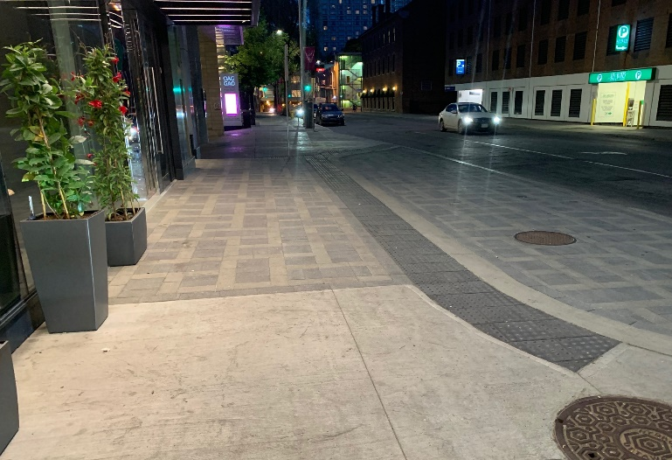
Figure 1: Tactile attention indicators (TAI) installed at the edge of the passenger drop-off and pick-up zone when it is flushed with the vehicle space

    - Public transit (if area is serviced) (Maximum Points: 10)
N/A only if transit is not serviced in region
Minimum Points:
- Provides safe access from transit stop to pedestrian pathway, including clearly marked traffic crossing, if crossing is required
- Ensures transit stop is located near the Site
- Ensures the surface is level, firm, stable, and slip resistant
- Ensures there are no obstacles along pedestrian pathway
- Provides curb ramps where the level changes along the pedestrian pathway
- Provides tactile walking surface indicators (TWSIs) and/or visual and wayfinding cues for people who are blind or with low vision (e.g., sidewalks with grass borders, street furnishings) from transit stop to building entrance(s)
- Provides clear signage (e.g., transit route maps and schedules that are easily interpreted by all users)
- Ensures the transit stop is well-illuminated, with even light distribution at ground level for security
- Provides seating
- Provides shelter for weather protection
Maximum Points:
- Ensures available shelter accommodates all users; shelters have adequate clearance to enter, wait, and exit for users of mobility devices or strollers; provides clear sightlines to allow passengers to see an approaching bus, and for the bus driver to see waiting passengers
- Offers real-time signage indicating arrival time of next vehicle
- Ensures transit stop is located close to the accessible main entrance(s)
Ideas for Innovation
- A climate-controlled area for a transit stop that provides heating and cooling in extreme conditions (e.g., heated shelters at high ridership stops in cold climates). Temperature regulation can affect the health and well-being of people with disabilities and seniors

- Exterior Approach and Entrance
The table below displays the Site elements used to measure accessibility for this category, the corresponding maximum score available for each, and the category total.
Site Element | Maximum Score
2.1 Exterior Pathways to Facilities on Site | 48
2.2 Exterior Ramps | 35
2.3 Exterior Stairs | 41
2.4 Building Entrances | 70
Innovation | 19
Total Maximum Score | 213
Description
The exterior approach and entrance refer to both the entrance itself and all the external pathways and pedestrian routes connecting Site arrival points — including any pathways, ramps, or stairs found along the route with the Site. The exterior approach and entrance should provide a continuous path of travel without any obstacles to ensure the security and safety of its users. Where possible, all routes to a Site should be inclusive, convenient, and accessible for everyone, without labelling or segregating people with disabilities. If access to a Site is restricted, it could be viewed as a human rights issue.
Where there are changes in level, access routes should be easy to understand and navigate with a choice of a ramp and stairs. Some people with mobility disabilities find it easier to use steps, while people using wheelchairs, other wheeled mobility devices, pushing strollers or with luggage, most often prefer a ramp.
Exterior lighting is important for security and safety and helps to ensure people can read signs and directions. Good lighting is critical at site approaches and entrances, and along access routes, including parking areas, pathways, ramps and stairs.
For newly developed sites, designers should consider from the outset how best to minimize level changes along principal access routes, such as between the site entrance and building entrance, and to locate features accordingly. All entrances in a new Site should be universally designed.
  - Exterior Pathways to Facilities on Site
(Maximum Score: 48 Points)
Exterior pathways should be level or gently sloped and provide enough width to accommodate the expected number of people, including people using power wheelchairs and scooters. If pathways are narrow, then passing areas should be provided frequently. Pathways should be safe for all users, free of obstacles, well illuminated, easy to find, and well-integrated with any stairs or ramps along the route. They should include any necessary crosswalk markings and curb ramps, if required. If the route is long, it is important to provide seating for people to rest.
Important: In outdoor parks, this element applies to exterior pathways that connect parking areas with facilities, amenities, and trail entrances. To rate the designated accessible trail itself, please refer to Category 10: Trails and Pathways.
    - Clear width (Maximum Points: 5)
Minimum Points:
- Provides sufficient clear width, free from obstructions, for people using wheelchairs or scooters, and for people with companions or service dogs
- Allows one or two-way flow of people, depending on the nature of the Site and expected number of people
Maximum Points:
- Allows at least two people using wheelchairs or people with strollers to walk alongside or easily pass one another
- Ensures minimal sharp outside corners on pathway to allow easy turn by people using wheeled mobility devices
- Has established maintenance policies (e.g., snow clearing, storage) in place to ensure that pathways are kept clear and provide suitable clear width
    - Surface is firm, stable, and slip resistant (Maximum Points: 5)
Minimum/Maximum Points:
- Has a stable and firm surface that resists movement
- Has appropriate type of surface material (climate/weather conditions):
- Uses suitable types of exterior surface materials, including asphalt, concrete, stone, timber, brick/paving
- Avoids using loose materials, such as sand, gravel, or woodchips, or rough/irregular materials, such as cobble stones
- Ensures an even surface with minimal irregularities to reduce potential for water accumulation, which can create a slippery surface
- Ensures there are minimal gaps, joints, or breaks in the surface, which present tripping hazards
Note: Any gaps should run perpendicular to the direction of movement.
- Ensures all surfaces are non-glare and have non-slip textured finishes for both wet and dry conditions

    - Clear signage (if required for expected usage) (Maximum Points: 3)
N/A only if Sites are in clear view and obvious from site arrival points, or if purpose of Site dictates privacy
Minimum/Maximum Points:
- Provides clear, logical, and understandable directional signage indicating route to main accessible entrance and parking
- Uses large font suitable to viewing distances and colour contrasted with background
- Provides directional signage with international symbol to identify accessible pathways, if not all pathways to the Site are accessible
- Provides directional signage with distance indicator, if appropriate for the Site
    - Path is level or low-gradient slope (when not accommodated by a ramp) (Maximum Points: 3)
Minimum Points:
- Ensures minimal running slope of less than 5% (1:20)
Note: If running slope is more than 5% (1:20), a ramp is required.
- Ensures handrails are installed if sloped pathways have a running slope over 5% but no accessible ramp is present
Note: This can be due to the topography of the Site.
- Ensures cross slope is 2% (1:50) maximum
- Ensures gradient is constant and consistent
Note: Variations in slope, such as grade breaks within runs, can disrupt wheelchair travel.
Maximum Points:
- Has a level surface
    - Passing/rest areas with clear space (Maximum Points: 3)
N/A only if pathway is short or entire length is level
Minimum/Maximum Points:
- Provides level passing areas at reasonable intervals if pathway is not wide enough and at decision points
- Provides level rest areas at appropriate intervals along a pathway when a grade exists; the steeper the terrain, the greater the frequency of the level rest areas
Note: For people using walking aids, rest areas are critical.
- Provides level rest area with clear space for people using mobility devices before and after an incline

    - Curb ramps (if level change en route to entrance) (Maximum Points: 4)
Only applies to pathways connecting Site arrival points to entrance. Does not include pathways within inner boundaries of parking.
N/A Only if there is no sidewalk or equivalent with level change
Minimum Points:
- Ensures curb ramp has level landings at top
- Ensures curb ramp aligns with the direction of travel and the curb ramp on the opposite side of the pathway
- Ensures curb ramp has suitable returned curb or side flares; or provides a dropped sidewalk or blended transition as alternative to curb ramps
Maximum Points:
- Incorporates appropriate tactile attention indicators (TAI) with truncated domes to alert users that they are entering vehicular traffic
- Ensures gutter provides a flush transition from pathway to minimize tripping hazard
Ideas for Innovation:
- A tactile directional indicator (TDI) with elongated bars that connects to the tactile attention indicator (TAI) to indicate the direction of travel
    - Edge protection (Maximum Points: 4)
Only applies if there is a drop-off at edge of pathway, and/or pedestrian pathways are flushed with vehicular traffic. Does not apply to standard sidewalk curbs
Minimum/Maximum Points:
- Provides suitable edge protection, such as curb, barriers or guardrails, on either side of a path to prevent falls where a change in level exists
- Ensures edge protection is cane detectable for people who are blind or have low vision
- Uses guardrails or barriers that visually contrast with surrounding surfaces and allow people using wheelchairs and children to see through railings, where there is a significant change in level
- Provides suitable protection if the pedestrian pathway is flushed with a vehicular route or if it is a shared-use route (e.g., shared with other users such as cyclists)
Note: Tactile attention indicators at edges of pedestrian pathways alert people who are blind and with low vision that they are entering a vehicular route when pedestrian and vehicular routes are flushed.
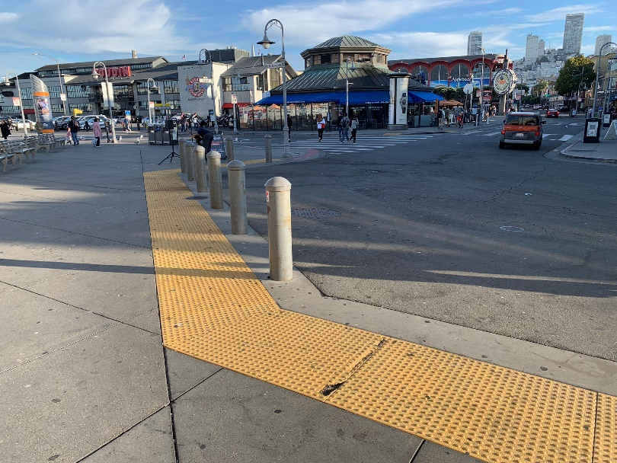
Figure 2: Use of tactile attention indicators where pedestrian pathways are flushed with vehicular routes
    - No obstacles on path and overhead, or obstacles are cane detectable and high contrast (Maximum Points: 5)
Minimum/Maximum Points:
- Provides suitable overhead clearance across the entire width and length of the pathway, meaning it is free of any signs or obstacles (e.g., tree branches)
Note: A cane-detectable feature is required where overhead objects present a hazard to prevent collision hazards for people who are blind or have low vision.
- Ensures obstacles or protruding objects in the path of travel are cane-detectable
Note: Portable signs, such as sandwich boards, are not permitted on the path of travel.
- Ensures the base of trees is protected by a tree grate or cane-detectable tree guard, where trees are in the path of travel
- Ensures any fixed items along the route, such as manholes, utility poles, and furniture (e.g., bollards, seating, disposal bins, bicycle racks, drinking fountains), are located off the path of travel, if possible
- Ensures any fixed items located on the path of travel are cane-detectable and clearly indicated using a contrasting colour
- Has established maintenance policies (e.g., leaves and litter) in place to ensure that pathways are kept clear

    - Convenient and understandable pathway to facilities (Maximum Points: 5)
Minimum Points:
- Ensures easy-to-identify paths to entrance that are convenient and direct
- Has clearly defined pathways edges with a change in texture or tonal contrast to help people who are blind or have low vision
Note: Where area beside the pathway is flush with the path, a change in surface treatment, such as grass or a ground flora verge, at the edge along its entire length will prevent people from straying off the path.
Maximum Points:
- Ensures path is as straight and predictable as possible, as people who are blind or with low vision rely on straight paths and consistency for wayfinding
- Incorporates colour and textural contrasted markings or tactile direction indicators to guide people who are blind or with low vision to building, if pathways include large open areas
Ideas for Innovation:
- Primary pathway(s) to entrance offers protection from the weather
- Landscaping adjacent to the pathway support Crime Prevention Through Environmental Design (CPTED), which is a multi-disciplinary approach to deterring crime. Landscaping does not include any potential hiding spots or danger zones via thick bushes, hedges, or foliage that could expose vulnerable people to attack.
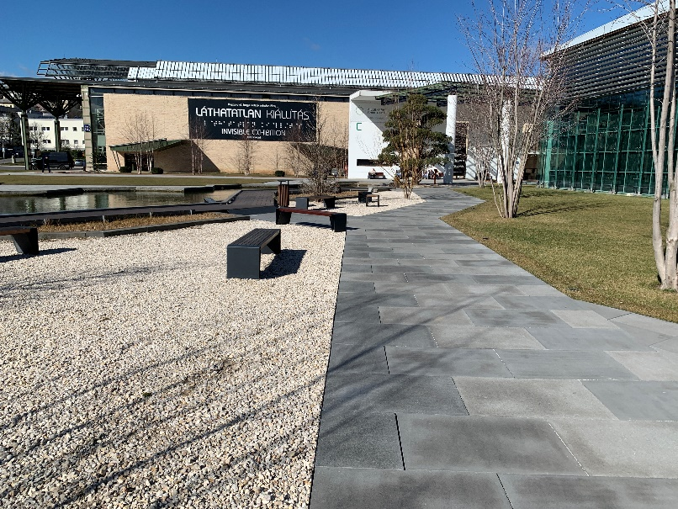
Figure 3: Clearly defined edges of pathway

    - Clearly marked pedestrian crossings (Maximum Points: 3)
N/A only if the path of travel does not cross traffic
Minimum Points:
- Ensures crosswalks are clearly marked on the pavement in high contrast colour
- Ensures crosswalks are located where they are clearly visible, safe, and convenient for all users
Maximum Points:
- Provides logical and understandable directional signage at crossings
- Uses appropriate crosswalk markings to indicate uncontrolled crossing
- Ensure curb ramps lead people directly into the crosswalk
- Ensures crosswalks have additional alerts (e.g., flashing lights, audible signal, or embedded LED lighting) , where applicable
- Ensures raised crossing is in place
- Provides a variety of clear wayfinding cues
- Limits the use of islands along the pedestrian crossing network or installs tactile attention indicators to ensure people who are blind or with low vision are aware that they are about to re-enter vehicular traffic
Ideas for Innovation:
- Accessible pedestrian signals that provides auditory, visual, and tactile information indicating when it is safe to cross
- Bollards with a cut top section to indicate the direction of crossing
    - Drainage (Maximum Points: 2)
Minimum Points:
- Ensures cross slope is minimal but sufficient enough to allow adequate drainage (2%); does not permit water accumulation or pooling that would create slippery surfaces or cause glare
- Ensures drainage channels do not obstruct path of travel
- Ensures openings for drainage grates are perpendicular to the path of travel
Maximum Points:
- Ensures grate is high contrast relative to surrounding surfaces
- Has drainage grates offset from main pathway

    - Well-illuminated (if site expected to be lit) (Maximum Points: 3)
N/A only if no power to site or policy is for day use only
Minimum/Maximum Points:
- Ensures the complete pathway is brightly lit
- Provides adequate lighting for the nature and use of Site
- Provides even light distribution at ground level and minimizes lights presenting a source of glare or creating pools of light and areas of shadow
Maximum Points:
- Has fixtures shielding light sources and casting indirect light
- Has fixtures mounted below eye level used in addition to standard lighting to provide better definition of ground surfaces
    - Seating (Maximum Points: 3)
N/A only if pathway is short distance and there are no level changes or decision points
Minimum Points:
- Provides seating off path of travel at rest areas, if long route and/or steep grade
- Ensures surface on which seating is located is level, firm, and stable
- Contrasts visually with surrounding surfaces
- Incorporates clear space for people using wheelchairs, scooters, or strollers so they can sit alongside one another and with companions
- Provides a clear space at the end of the seating for a service dog to rest
- Provides back support and at least one armrest
Maximum Points:
- Offers a variety of seating options to suit different people (e.g., seats with and without armrests, fixed and movable seats)
- Provides adequate heel space to allow people to stand up easily
- Ensures resting area is clearly visible and identified with a change in surface materials (i.e., texture and colour)
- Provides seating at regular, frequent, and predictable intervals for intended use and before level changes; seating intervals are 10m, if possible
- Ensures seating areas are level and within sight of one another
- Provides shelter
- Ensures seats positioned or linked in a row are of the same style (e.g., all with armrests or all without)
Note: Mixture of seat styles in a single row can cause confusion for people who are blind or with low vision.
  - Exterior Ramps
(Maximum Score: 35 Points)
Exterior ramps should be provided in areas along a route where the slope (grade, gradient, incline) exceeds 5% (1:20).
Important: This element applies to structures that were built as exterior ramps to overcome a level change along the pedestrian pathway. Sloped pathways that exceed 5% (1:20) due to the topography of the Site are rated in 2.1 Exterior Pathways to Facilities on Site.
Ramps should provide adequate width to accommodate the expected number of people, including people using power wheelchairs and scooters. Ramps can have one of the following configurations:
- Straight run
- 90° turn
- Switchback or 180° turn
Circular or curved ramps are not recommended, nor are ramps within stairs (S-ramps) as they are extremely hazardous to people who are blind or with low vision, people with mobility disabilities, and people using wheeled mobility devices or walking aids.
    - Slope (Maximum Points: 5)
Minimum Points:
- Has a running slope of 8.3% (1:12) or less (as per building code and CSA B651)
- Ensures the cross slope on ramps is 2% (1:50) maximum to allow for proper drainage
Maximum Points:
- Has a running slope of 5% (1:20) or less
- Ensures gradient is constant and consistent
- Ensures ramps with two or more consecutive slopes are of the same gradient; between landings, the gradient of ramps should be the same
    - Clear width (Maximum Points: 3)
Minimum/Maximum Points:
- Provides sufficient clear width, free from obstructions, for people using wheelchairs or electric scooters, or for people with companions or service dogs
- Allows one or two-way flow of people, depending on expected number of people and the nature of the Site
- Allows people to easily pass one another at the same time when approaching from different directions
    - Surface is firm, stable, and slip resistant (Maximum Points: 5)
Minimum/Maximum Points:
- Has a stable and firm surface that resists movement
- Uses suitable types of exterior ramp surface materials, including asphalt, concrete and timber
- Ensures an even surface with minimal irregularities to reduce potential for water accumulation, which can create a slippery surface
- Ensures there are minimal gaps, joints, or breaks in the surface, which present tripping hazards
Note: Any gaps should run perpendicular to the direction of movement.
- Ensures all surfaces are non-glare and have non-slip textured finishes for both wet and dry conditions
Ideas for Innovation:
- Snow melting systems that remove ice and snow on ramp and landings, therefore allowing safe use of ramp
    - Level landings with clear space (Maximum Points: 4)
Minimum/Maximum Points:
- Ensures landings are located at the top and bottom of each run
- Provides intermediate landings between runs and where ramps change direction, for resting, manoeuvring, and avoiding excessive speed
Note: A ramp should be no longer than 9,000 mm and have level landing at the top and bottom.
- Provides adequate turning space for people using wheelchairs or mobility aids, and for people with strollers or service dogs
- Ensures landings are unobstructed by door swings
    - Colour-contrasted and slip-resistant strip (Maximum Points: 4)
Minimum/Maximum Points:
- Ensures colour-contrasted and slip-resistant strips at landing before each run
- Ensures strips extend the full width of the ramp

    - Handrails (Maximum Points: 5)
Minimum Points:
- Provides handrails on both sides of a ramp at a consistent, accessible height along its run
- Ensures handrails are continuous through the length of ramps
Note: People who are blind or have low vision rely on handrails to guide them in negotiating ramps, while people with mobility disabilities rely on them for stability.
- Ensures the handrail size (diameter) facilitates grip, with a smooth and round design
- Ensures sufficient clearance exists between handrail and wall, free of any sharp and abrasive elements
- Provides horizontal handrail extensions at the top and bottom of all ramps to provide support and orientation for people as they move between the ramp and a level surface and vice versa
- Ensures extensions are turned down or sideways and returned to post, floor, or wall to prevent handbags, pockets, etc. from getting caught, with a consistent method used throughout the Site
Note: Extensions are not required where they would project into another path of travel.
- Has fixed support brackets on underside that do not interfere with a person running their hand along the length
- Is securely attached and supports enough weight for its intended use
- Contrasts visually with surrounding surfaces
Maximum Points:
- Provides intermediate handrails if ramp is wide
Note: If ramp is wider than 2,200 mm, provide an intermediate handrail ensuring sufficient clear width for people using wheelchairs or electric scooters, or for people with companions or service dogs.
- Is constructed of materials of low thermal conductivity that do not become too cold or hot to the touch, with preferred materials including wood or plastic-coated steel, or stainless steel
- Prevents people and service dogs from walking underneath
- Allows people with lower eye level, such as people using wheelchairs or people of short stature, to see through the railings
Ideas for Innovation:
- A parallel lower handrail for people of different heights, including children or people of short stature

    - Edge protection (Maximum Points: 3)
Minimum Points:
- Provides curbs or protective barriers (e.g., raised barrier or rail) on both sides of the ramp and on landings, where there is a drop-off, to prevent wheelchair casters or crutch tips from slipping off edge
Maximum Points:
- Contrasts visually with ramp surface
    - Well-illuminated (if required for expected usage) (Maximum Points: 3)
N/A only if no power or policy is day use only
Minimum/Maximum Points:
- Ensures the ramp is brightly lit to be used safely after dark
- Positions lighting to adequately illuminate any ramp and landing surfaces and to highlight changes in slope
- Provides even light distribution at ground level and minimizes lights presenting a source of glare or creating pools of light and areas of shadow
- Has fixtures mounted below eye level used in addition to standard lighting to provide better definition of ground surfaces
    - Convenient location (Maximum Points: 3)
Minimum Points:
- Ensures location is near or along main route to entrance
- Provides directional signage to ramp, if location is not obvious
Maximum Points:
- Ensures ramps are well-integrated with existing route
- Ensures route offers choice of both ramp and stair, where practical

  - Exterior Stairs
(Maximum Score: 41 Points)
Stairs are inherently hazardous. They need to be well-dimensioned to provide a stable footing and to ensure the safety and comfort of all users. They should not be steep, and surfaces should be firm, stable, and slip resistant.
Stairs should be provided in conjunction with a ramp to offer choice and to meet all users’ needs. Where possible, the top and bottom of a ramp should be adjacent to the top and bottom of an associated set of stairs.
Single steps should be avoided in an access route, as they are not as obvious as a longer flight of stairs and may present a tripping hazard. If a change in level is equivalent to the rise of a single step, the surface should be gently graded. Stair dimensions should be consistent throughout a flight of stairs.
Circular stairs and stairs with tapered treads should be avoided, as they can be difficult for people who are blind or have low vision to navigate, and they may create falling hazards.
Refer to the latest version of CSA B651 for additional details on stairs.
    - Clear width (Maximum Points: 2)
Minimum/Maximum Points:
- Provides sufficient clear width, free from obstructions, for people with service dogs
- Allows one or two-way flow of people, depending on the expected number of people and nature of the Site
- Allows people to easily pass one another at the same time when approaching from different directions
    - Surface is firm, stable, and slip resistant (Maximum Points: 5)
Minimum/Maximum Points:
- Ensures treads and landings have a stable and firm surface
- Ensures stairs are in good condition with no damage or settlement
- Has appropriate type of surface material (climate/weather conditions)
- Ensures an even surface with minimal irregularities to reduce potential for water accumulation, which can create a slippery surface
- Ensures there are minimal gaps, joints, or breaks in the surface, which present tripping hazards
Note: Any gaps should run perpendicular to the direction of movement.
- Ensures all surfaces are non-glare and have non-slip textured finishes for both wet and dry conditions
Ideas for Innovation:
- Snow melting systems that remove ice and snow on stair treads and landings, therefore allowing safe use of stairs.
    - Level landings with clear space and at regular intervals (Maximum Points: 3)
Minimum Points:
- Ensures landings are provided at the top and bottom of each flight, with the length equivalent to the step width
- Provides landings at reasonable intervals throughout the stairway to break up significant difference in level
- Ensures landings extend along full width of stairs
- Ensures there are no stepped landings
- Ensures landings are unobstructed by door swings
- Provides guardrails where there is drop-off at the edge of the landings
Maximum Points:
- Ensures the total rise for a flight of stairs is appropriate; if more than one flight is required, the number of steps in each flight is the same
Note: The maximum number of steps each flight should have is 12.
    - Handrails (Maximum Points: 5)
Minimum Points:
- Provides handrails on both sides of stairs at a consistent and accessible height
Note: If stair is wide, an intermediate handrail is recommended to ensure people can reach handrails on both sides if required.
- Ensures handrails are continuous through the stairs
Note: People who are blind or have low vision rely on handrails to guide them in negotiating stairs, while people with mobility disabilities rely on them for stability.
- Ensures the handrail size (diameter) facilitates grip, with a smooth and round design
- Ensures sufficient clearance exists between handrail and wall, free of any sharp and abrasive elements
- Provides horizontal handrail extensions at the top and bottom of all stairs to provide support and orientation for people as they move between the stair and a level surface and vice versa
- Ensures extensions are turned down or sideways and returned to post, floor or wall to prevent handbags, pockets, etc. from getting caught, with a consistent method used throughout the Site
Note: Extensions are not required where they would project into another path of travel.
- Has fixed support brackets on underside that do not interfere with a person running their hand along the length
- Is securely attached and supports enough weight for its intended use
- Contrasts visually with surrounding surfaces
Maximum Points:
- Ensures handrails are continuous on both sides and along landings
- Is constructed of materials of low thermal conductivity that do not become too cold or hot to the touch, with preferred materials including wood or plastic-coated steel, or stainless steel
- Prevents people and service dogs from walking underneath
- Allows people with lower eye level, such as children or people of short stature, to see through the railings
Ideas for Innovation:
- A parallel lower handrail for people of different heights, including children or people of short stature
- Lighting fixture installed under handrails to increase visibility of handrails and steps
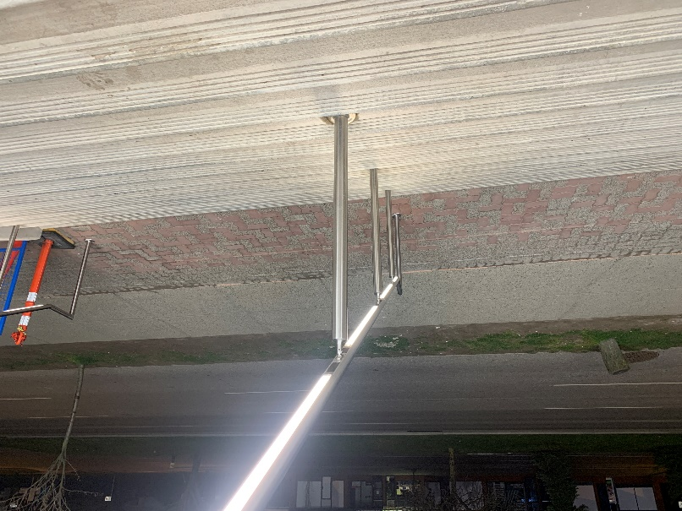
Figure 4: Handrails with lighting fixtures under (Photo Courtesy of Arnold Cheng)

    - Tactile attention indicators (truncated domes) (Maximum Points: 5)
May be required by regulation or standards on both top and bottom
Minimum/Maximum Points:
- Ensures tactile attention indicators are placed at the top of the stairs to notify people who are blind or have low vision
Note: Tactile attention indicators are generally not used on intermediate landings, as this can give a false impression that the end of the flight of stairs has been reached. However, tactile attention indicators may be used on an intermediate landing that meets with another path of travel or circulation route.
- Ensures material is contrasting in colour with the surrounding surface material and is of a different texture
- Ensures tactile attention indicators extend the full width of the stairs and are of sufficient length in the direction of travel to provide adequate warning to people who are blind or have low vision
    - Colour-contrasted and slip-resistant strip on nosing (Maximum Points: 4)
Minimum Points:
- Ensures each step edge has strip that colour contrasts with the tread to visually highlight the step edge and improve depth perception
Note: Light-coloured strips on dark treads are preferred to light-coloured treads on dark strips as dark strips on nosings are harder to notice by people with low vision.
- Ensures strip extends the full width of the step and is of adequate width
Maximum Points:
- Ensures strip is slip resistant
- Ensures each contrasting strip wraps around nosing and continues down the riser so that it is visible when both ascending and descending the stairs (e.g., no more than 10 mm)
- Ensures a single colour is used for contrasting strips
    - Riser height and tread depth (Maximum Points: 4)
Minimum/Maximum Points:
- Ensures steps are consistent throughout with uniform riser heights and tread depths; inconsistencies in rise or in tread depth can create tripping hazards
- Ensures dimensions are adequate to provide safe footing for all users

    - No open riser (Maximum Points: 3)
Minimum/Maximum Points:
- Ensures all step risers are closed and opaque; open risers can be tripping hazards, a source of visual confusion, or disconcerting
Note: People who wear leg braces or prosthetic devices need a solid riser to guide their foot up the riser and over the nosing to the next step; those who use canes or crutches place them against the riser of the next step in order to maintain balance.
    - Nosing design (Maximum Points: 2)
Minimum/Maximum Points:
- Ensures nosings are flush with riser, or are sloped to the riser at an angle greater than 60° to the horizontal, where they project
- Where projecting nosings are used, ensures they do not have sharp or abrupt edges or an underside that prevents a foot from sliding up the riser and may cause tripping; projecting nosings must be rounded or bevelled
    - Drainage (Maximum Points: 2)
Minimum/Maximum Points:
- Ensures steps, treads, and landings have adequate drainage to prevent water pooling
    - Height clearance (Maximum Points: 3)
N/A only if stairs do not have overhead shelter or underside of stairs is enclosed
Minimum/Maximum Points:
- Maintains overhead clearance throughout the full length of the stairway and on any landings (e.g., if sheltered or if items are suspended above stairs)
- Ensures the area beneath an unenclosed staircase has a cane-detectable feature, such as guardrails or planters, to prevent people from colliding with the underside of the stairs
- Provides ample overhead clearance (e.g., if sheltered or if items are suspended above stairs)

    - Well-illuminated (if required for expected usage) (Maximum Points: 3)
N/A only if no power or policy for day use only
Minimum/Maximum Points:
- Ensures the stair is brightly lit to be used safely after dark
- Ensures steps and stairs are lit by low-level fixtures to highlight the tread and riser surface
- Provides even light distribution at ground level and minimizes lights presenting a source of glare or creating pools of light and areas of shadow
Ideas for Innovation:
- Glow-in-the-dark stair nosing strips along emergency exit routes to illuminate steps during a power outage

  - Building Entrances
(Maximum Score: 70 Points)
The main entrance to a Site must be welcoming to all intended users and easy to find. Everyone who is meant to have access to a Site should be able to safely enter or exit the premises conveniently, independently, and with minimal effort.
Depending on the nature of the Site, Site access may be either uncontrolled and open to anyone, or restricted.
Entrances should be highly visible. Hidden entrances are not only difficult to find, but they can present safety challenges. All entrances should support Crime Prevention Through Environmental Design (CPTED), which stipulates that there should be no hiding spots or danger zones exposing vulnerable people to attack.
The entrance door should be easy to operate and wide enough to accommodate all Site users. Doors can be manually operated or power operated, although in most situations, a power operated door is preferred.
Doors that provide clear visibility (e.g., tempered clear or frosted glass, vision panels) allow people to see if someone is approaching from either side and reassure them the area is safe.
Shelter should be provided for weather protection, particularly in areas that experience weather extremes. Availability of seating is important for seniors or for people with mobility or vision disabilities who often need a comfortable place to wait.
    - Entrance(s) required to be accessible (Maximum Points: 5)
Minimum Points:
- Ensures at least 50% of all building entrances are accessible, if more than one; if only one door, it must be accessible
- Ensures at least one door or doorway is accessible, for people using wheelchairs or electric scooters, or for people with strollers or service dogs
Note: Revolving doors and turnstiles are not accessible and cannot be part of accessible routes. An adjacent accessible alternative, such as automated sliding doors or an automated swing door, should always be available.
- Ensures the route to the entrance is accessible, with a direct accessible pathway connecting the building to city sidewalks, parking, passenger drop-off and pick-up zones, and/or public transit
- Ensures a secondary or alternative accessible entrance is acceptable for existing Sites only
Note: It should be clearly identified and available for everyone to use. Using a service entrance as the only point of access for people with disabilities is unacceptable.

Maximum Points:
- Ensures the main entrance is accessible
- Ensures all building entrances are accessible
Ideas for Innovation:
- The original inaccessible entrance to a heritage building had stair access only with minimal shelter from the weather. A new accessible main entrance was built at street level to provide access and has automated door and shelter.
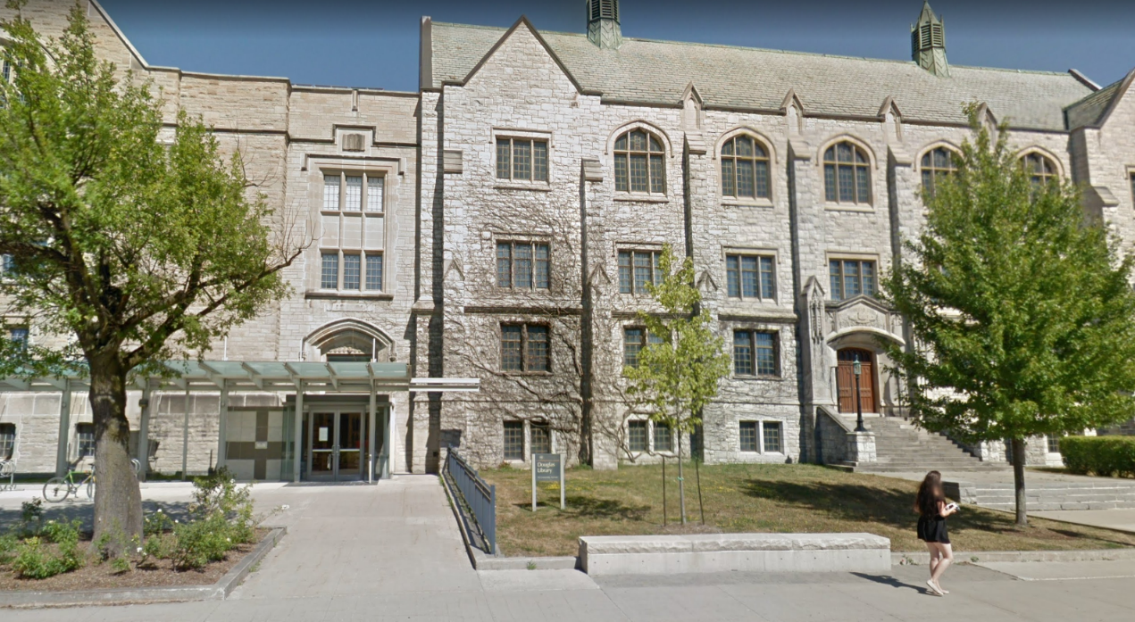
Figure 5: Innovative accessible entrance at Queen’s University, Kingston (Source: 2018 Google)
    - Entrance is easily identified (Maximum Points: 5)
N/A only if purpose of Site dictates privacy
Minimum/Maximum Points:
- Ensures entrance is easy to locate from site arrival points (e.g., city sidewalks, parking, passenger drop-off and pick-up zones, and/or public transit) and decision points
- Ensures entrance is identified from rest of site via colour, architectural element, flags, or change in surface texture
- Incorporates tactile direction indicators that lead to the entrance, where exterior approach consists of large open areas
- Ensures entrance doors visually contrast with adjacent surfaces
- Ensures the address of Site is clearly visible
- Provides clear signage
- Ensures the location of route(s) to the building entrance(s) are clearly obvious
- Uses artificial lighting to highlight the entrance at night
- If main entrance is not accessible, provides appropriate directional signs indicating the location of the nearest accessible entrance
- Adds distinct audio or olfactory wayfinding clues, such as a small fountain or aromatic plants, to assist people who are blind or have low vision
    - Power-operated door or easy-to-open door (Maximum Points: 5)
Minimum Points:
- Provides power-operated doors with manually-activated controls, or controlled with a motion-detector actuator, or other hands-free device
- If no power-operated door, ensures any manual doors are easy to open with minimal force and have accessible hardware at an accessible height and location
Note: Large D-pull or hardware that can be operated with one-hand, without grasping, pinching, or twisting are recommended. If sliding doors are used, ensures operational devices are exposed and usable from both sides when in a fully open position.
Maximum Points:
- Provides an automatic sliding door activated by a motion sensor that are responsive to all users at different height
- Ensures door edges are marked in high-contrast colour
- Provides open entry, where possible
    - Sufficient opening, hold-open, and closing time for power-operated doors (Maximum Points: 4)
N/A only if not a power-operated door
Minimum/Maximum Points:
- Ensures sufficient time for people who are slow moving
- Takes at least three seconds to move from a closed to a fully open position
- Ensures door remains fully open for a sufficient length of time to allow all Site users to safely enter or exit the building—at least five seconds
    - Controls for manually activated power-operated doors (Maximum Points: 4)
N/A only if motion sensor present or not power operated
Minimum Points:
- Ensures controls for power-operated doors are located at accessible height and location
- Ensures controls are located on latch side of door and outside of door swing
- Ensures people do not have to manoeuvre backwards and are clear of the door swing after activation of the door control device
- Ensures controls are easy to use and operable with one hand and without tight grasping, pinching, or twisting
- Provides clear space for approach in front of controls
- Ensures controls are clearly identified and contrast visually with surrounding surfaces
Maximum Points:
- Ensures controls are operable at multiple heights; an elongated or second control that can be foot-activated allows people with restricted hand functions to open doors
- Uses International Symbol of Access to identify control
Ideas for Innovation:
- Use of universal “Open Door” text accompanied by recognized symbol and pictogram, instead of International Symbol of Access, does not segregate and label users
    - Emergency power or fail-safe systems for power-operated doors (Maximum Points: 2)
N/A only if not a power-operated door. This feature allows for exit through power-operated door in an emergency when the power is out.
Minimum Points:
- Ensures that power-operated doors can be pushed open with minimal force in the event of a power failure
- Provides a break-out opening on automated sliding doors lacking standby power or that do not stay open when power is off
- Ensures emergency-opening device is clearly visible, can be accessed immediately, and has a fast response time
- Ensures door lock release is at accessible height and is clearly identifiable
- Ensures doors incorporate a safety stop that is activated if doors start to close as a person is passing through
- Ensures safety sensors for power-operated doors are responsive to all users, including young children
Maximum Points:
- Provides emergency power source for power-operated door, so that they can be used in emergency situations

A preventable accident
This young boy broke his arm when a set of automatic sliding glass doors at an assisted living facility closed on his arm. This could have been avoided if the safety sensors for the sliding doors were adjusted to provide sufficient time for safe passage.
Figure 6: Boy broke his arm in automatic sliding door when sensors failed to activate
    - Door security and entry system is accessible and easy to use (Maximum Points: 5)
N/A only if there are no door security or entry systems. Door security and entry systems include but are not limited to keypads, proximity card readers, intercoms, bells, and alarms.
Minimum Points:
- Ensures security and entry system is easy to use and equipped with visual and audible signals to indicate that system has been activated
- Incorporates assistive listening and communication enhancement technologies, where two-way communication is expected
- Ensures sufficient time is provided once activated for slow-moving people
- Ensures a separate telephone-style keypad is raised with a tactile indicator on the number 5, if touch screen security and entry system is used
- Provides clear instructions in visual and tactile format, if instructions are required for use
Maximum Points:
- Ensures text to text communication system is available for people who are deaf, where two-way communication is expected
Note: A sign including a phone number that people can text to communicate with security staff may be an option or intercoms with teletypewriter (TTY) jacks.
- Ensures security and entry system are proximity (non-touch) type
- Ensures security and entry system is synchronized with power-operated door control, if door is power-operated
Ideas for Innovation:
- Complementary Wi-Fi/4G for people to connect to communication systems available
- Video Relay Services / Video Remote Interpreting that allow real-time communications for people who are deaf, hard of hearing, where two-way communication is expected
    - Door security and entry system is easily identified and conveniently located (Maximum Points: 4)
N/A only if there are no door security or entry systems
Minimum/Maximum Points:
- Ensures security and entry system is located at accessible height
- Ensures security and entry system is in a convenient position with clear space for people using wheeled mobility devices
- Ensures security and entry system is located on latch side of door and outside of door swing
- Ensures security and entry system is clearly identified and contrasts visually with surrounding surfaces
    - Clear opening width of entrance doors (Maximum Points: 5)
Minimum Points:
- Provides sufficient clear opening width, free from obstructions, for people using wheelchairs or electric scooters, or for people with strollers, companions, or service dogs
- Allows one or two-way flow of people, depending on the expected number of people and the nature of the facility
Maximum Points:
- Provides swing (hinged) door opening fully to 90° and door handles that do not obstruct the clear width
- If a double door is used, ensures both leafs are operable and unlocked to provide option for additional clearance
    - Level landing at entrance (Maximum Points: 5)
Minimum/Maximum Points:
- Ensures a level clear space at entry
- Provides a slip-resistant landing as a safe space for all Site users to wait, enter, and exit the building; people using wheelchairs or scooters, strollers, or with service dogs need adequate space to manoeuvre and turn

    - Level threshold (Maximum Points: 5)
Minimum Points:
- Ensures a raised threshold is a maximum of 13 mm and is bevelled, ramped, or rounded
Maximum Points:
- Ensures threshold is flush with the external ground surface and internal floor finish
- Ensures entry mat is recessed in a mat well and is high contrast, where provided
    - Clear space on exterior and interior of door (Maximum Points: 4)
Minimum/Maximum Points:
- Provides clear space for access and manoeuvring on both sides of the entrance with extra space on the pull side
- If doors are installed in a series (e.g., aligned or not aligned; vestibules), provides adequate clear space to facilitate traffic flow and ensure people using wheelchairs or electric scooters, or for people with strollers or service dogs can manoeuvre in space and use power-operated door controls if provided
Note: It is recommended that the distance between doors in series is 1500 mm, in addition to the width of any door swinging into the space.
- Provides safe unobstructed clearance from door swing
- Ensures security bollards and screening devices (e.g., metal detectors) do not obstruct accessible routes and pathways or accessible means of egress
- If doors are located near a stairway or a ramp, ensures they are positioned to avoid the risk of anyone falling backwards while opening the door
    - Outward-opening doors (Maximum Points: 3)
N/A only if there are no hinged doors or doors do not open into perpendicular path of travel
Minimum/ Maximum Points:
- Provides cane-detectable feature to ensure people who are blind or with low vision do not walk into opening door
- Provides a door swing path marking to show people how far out the door will open, allowing people to move safely out of the way
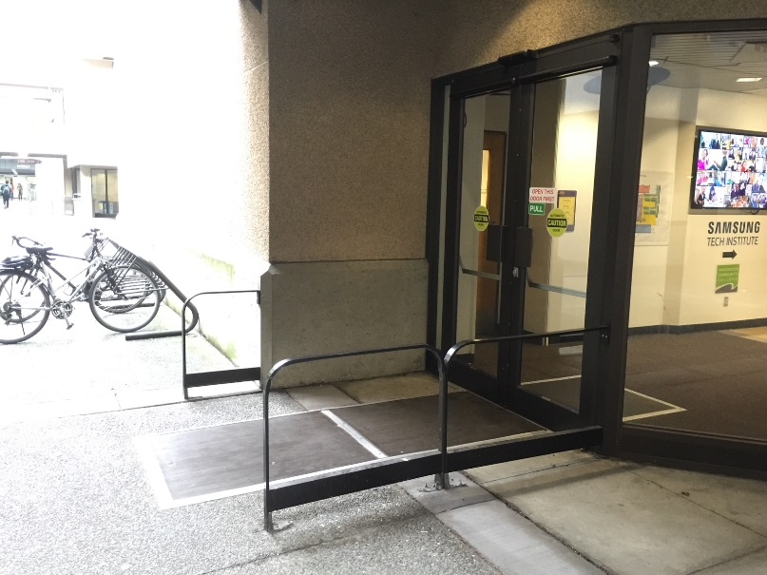
Figure 8: Outward-opening power-operated doors with cane-detectable guards
    - Glazed doors have colour-contrasted strips or markings (Maximum Points: 3)
Applies to frameless glass doors, fully-glazed doors, glazed screens, sidelights, and where approximately 75% of the door is glazed
Minimum Points:
- Incorporates continuous colour-contrasted markings at eye level along the full width of glazed doors for safety and visibility
Note: Etched strips or white frosted decals do not provide suitable colour contrast for people with low vision.
Maximum Points:
- Incorporates continuous colour-contrasted markings at two levels along full width of glazed doors
- Highlights edges of frameless glass doors clearly so they are easily identified when open and closed; visually contrasting strips can be used
    - Vision panels (if provided) (Maximum Points: 2)
- Ensures vision panel is at a height that can be used by people using mobility devices and in a seated position
- Ensure vision panel is wide enough to provide suitable visibility and security

    - Well-illuminated (if site expected to be lit) (Maximum Points: 3)
Minimum Points:
- Ensures the entrance is brightly lit to be used safely after dark
- Positions lighting to adequately illuminate the entrance and any adjacent landing surfaces or stairs
- Ensures there is no sudden contrast between brightly lit areas or bright sunlight and dimly lit or shaded areas
- Provides even light distribution at ground level and minimizes lights presenting a source of glare or creating pools of light and areas of shadow
Maximum Points:
- Has fixtures shielding light sources and casting indirect light
- Has fixtures mounted below eye level used in addition to standard lighting to provide better definition of ground surfaces
Ideas for Innovation:
- Light levels are approximately 25% higher than code minimum
    - Seating (Maximum Points: 3)
N/A only if there is no safe space for seating
Minimum/Maximum Points:
- Ensures seating is on a level, firm, and stable surface
- Ensures seating does not obstruct circulation routes
- Provides seating with back support, armrest, and kick space
- Ensures seating is colour-contrasted with surroundings
- Incorporates clear space for people using wheelchairs, scooters, or strollers so they can sit alongside one another and with their companions
- Provides a clear space at the end of the seating for a service dog to rest
- Ensures seating is sheltered to provide a comfortable place to wait
Ideas for Innovation:
- A dog relief area located adjacent to a main access route. The use of service dogs, including guide dogs, hearing dogs, and seizure dogs, is steadily increasing. Incorporating a relief station into landscape plans considers the dogs’ needs and makes it easier for owners to respond when nature calls.

    - Shelter (Maximum Points: 3)
Minimum/Maximum Points:
- Ensures shelter is provided for weather protection (e.g., a recessed entrance door, awning, or architectural element)
- Ensures shelter provides suitable overhead clearance

- Interior Circulation
The table below displays the Site elements used to measure accessibility for this category, the corresponding maximum score available for each, and the category total.
Site Element | Maximum Score
3.1 Interior Doors and Doorways (not including Washrooms) | 63
3.2 Path of Travel | 22
3.3 Corridors and Hallways | 31
3.4 Interior Ramps | 35
3.5 Elevators | 71
3.6 Interior Stairs | 41
3.7 Escalators and Moving Walkways | 19
3.8 Platform Lifts | 30
Innovation | 31
Total Maximum Score | 343
Description
The interior circulation refers to all the elements allowing people to move throughout a Site and access its key facilities. Circulation routes are designed to optimize the flow of people within and between floors—horizontally and vertically. Interior circulation consists of the walkways, hallways, and doors connecting the facilities on each level as well as the various structures and devices people use to move between levels such as ramps, stairways, elevators, escalators, and platform lifts.
In terms of accessibility, the layout of these elements should be logical, clear, and as direct as possible. Travel distances should be minimized and level changes within a storey should be avoided where possible. Access routes should be well-maintained and free of any obstructions.
In some situations, incorporating handrails and regular seating may be helpful. Seating may be provided in adjacent spaces along the path of travel, if it is visible and near the path of travel. Seating should be located within areas where users are likely to be standing for longer periods of time.

  - Interior Doors and Doorways (not including Washrooms)
(Maximum Score: 63 Points)
Doors, by their very nature, act as barriers and can have a significant influence on accessibility. In some situations, conventional doors may not be necessary at all. Instead, privacy may be achieved through the careful placement of walls and screens.
Doors come in various shapes, sizes, types, modes of operation, and configurations. The main types of doors are sliding, swinging, revolving, and folding. There are two modes of operation: manual and power assisted. Power-assisted doors can be automatically activated or manually activated. The most suitable type of door arrangement will depend on the nature of the Site, the frequency of use, the available space, and security requirements.
The easiest way to access a facility is through power-assisted doors. These types of doors are typically used at an entrance or in high-traffic areas within a Site. Power-assisted doors should ideally slide aside rather than swing in or out, as door swing creates a barrier and requires the need for additional manoeuvring space on either side of the door.
Doors may be single and stand-alone or, depending on the nature and size of the Site, they may be configured in series.
Revolving doors should be avoided, as they are not accessible for many and can be hazardous. Wherever revolving doors exist, there should always be a fully accessible alternative available.
    - Power-operated door or open entry (Maximum Points: 5)
N/A only if there is no expected requirement for a power-operated door
Minimum Points:
- Provides power-operated door where there is limited clearance on the latch side of the door on the pull side
- Provides power-operated door at main circulation doors, high-traffic areas and rooms, if required for easy circulation
- Provides power-operated doors with manually-activated controls, or are controlled with a motion-detector actuator, or other hands-free device, where applicable
Maximum Points:
- Provides open entry, where possible
- Ensures door edges are marked in high-contrast colour
- Ensures sensors are responsive to all users at different height, where door sensors are used

    - Sufficient opening, hold-open, and closing time for power-operated doors (Maximum Points: 4)
N/A only if there is no power-operated door or open entry
Minimum/Maximum Points:
- Ensures sufficient time for people who are slow moving
- Takes at least three seconds to move from a closed to a fully open position
- Ensures door remains fully open for a sufficient length of time to allow all Site users to manoeuvre in and out of door safely—at least five seconds
    - Controls for manually activated power-operated doors (Maximum Points: 4)
N/A only if motion sensor present or not power operated or open entry
Minimum Points:
- Ensures controls for power-operated doors are located at accessible height and location
- Ensures controls are located on latch side of door and outside of door swing
- Ensures people do not have to manoeuvre backwards or clear of the door swing after activation of the door control device
- Ensures controls are easy to use and operable with one hand and without tight grasping, pinching, or twisting
- Provides clear space for approach in front of controls
- Ensures controls are clearly identified and contrast visually with surrounding surfaces
Maximum Points:
- Ensures controls are operable at multiple heights; an elongated or second control that can be foot-activated allows people with restricted hand functions to open doors
- Uses International Symbol of Access to identify control
Ideas for Innovation:
- Use of universal “Open Door” text accompanied by recognized symbol and pictogram, instead of International Symbol of Access, does not segregate and label users

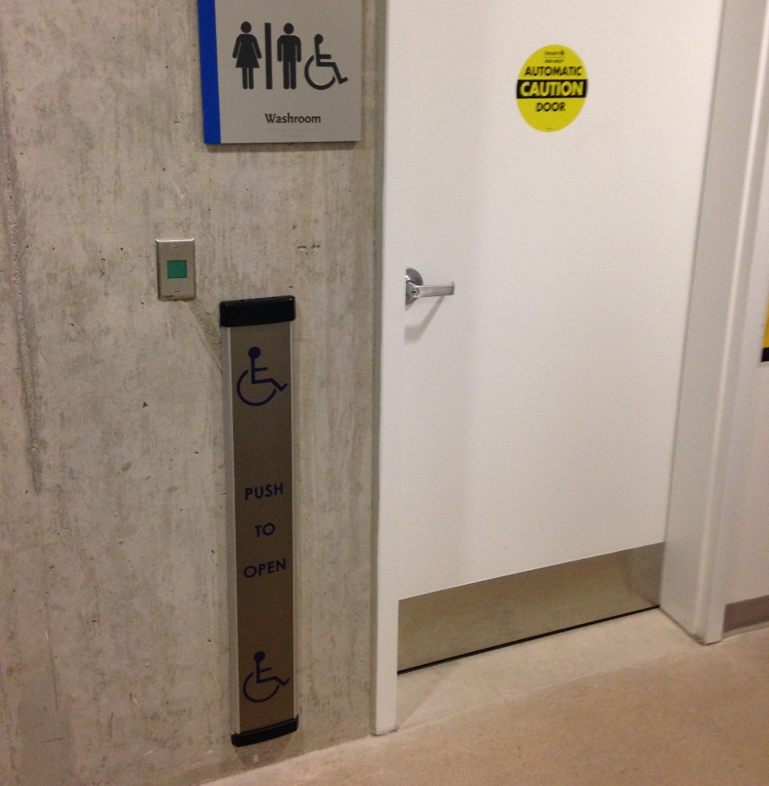
Figure 9: Elongated power-operated door control usable at multiple heights
    - Emergency power or fail-safe systems for power-operated doors (if on an emergency exit route) (Maximum Points: 2)
Applies only to interior power-operated doors along emergency exit routes that are expected to be used in emergency situations
Minimum Points:
- Ensures that power-operated doors can be pushed open with minimal force and release latch can be easily identified and operated
Maximum Points:
- Provides emergency power source for power-operated door, so that they can be used in emergency situations

    - Door security and entry system is accessible and easy to use (Maximum Points: 5)
N/A only if there are no door security or entry systems. Door security and entry systems include but are not limited to keypads, proximity card readers, intercoms, bells, and alarms.
Minimum Points:
- Ensures security and entry system is easy to use and equipped with visual and audible signals to indicate that system has been activated
- Incorporates assistive listening and communication enhancement technologies, where two-way communication is expected
- Ensures sufficient time is provided once activated for slow-moving people
- Ensures a separate telephone-style keypad is raised with a tactile indicator on the number 5, if touch screen security and entry system is used
- Provides clear instructions in visual and tactile format, if instructions are required for use
Maximum points:
- Ensures text to text communication system is available for people who are deaf, where two-way communication is expected
Note: A sign including a phone number that people can text to communicate with security staff may be an option or intercoms with teletypewriter (TTY) jacks.
- Ensures security and entry system are proximity (non-touch) type
- Ensures security and entry system is synchronized with power-operated door control, if door is power-operated
- Ensures keypad entry systems have raised buttons easily located by touch; buttons contrast visually with adjacent surface and have raised symbols, numbers, or letters arranged in a logical order
    - Door security and entry system is easily identified and conveniently located (Maximum Points: 4)
N/A only if there are no door security or entry systems
Minimum/Maximum Points:
- Ensures security and entry system is located at accessible height
- Ensures security and entry system is in a convenient position with clear space for people using wheeled mobility devices
- Ensures security and entry system is located on latch side of door and outside of door swing
- Ensures security and entry system is clearly identified and contrasts visually with surrounding surfaces
Figure 10: Proximity card reader door security system and hands-free power-operated door control
    - Minimum force required to open doors with sufficient opening time (Maximum Points: 5)
N/A only if there are doorways, but no doors
Minimum/Maximum Points:
- If manual door, ensures it is easy to open with minimal force (e.g., low friction hinges or light weight door)
- Ensures the force applied at the handle, push plate, or latch-releasing device does not exceed 22 N (5 lbf.) for interior doors
- Unless otherwise mandated by specific fire code requirements, ensures self-closing doors are equipped with automated delayed-action closers
Note: While delayed-action closers are required for many types of rooms in public buildings, they are not recommended for offices, lunchrooms, and storage rooms.
- Ensures the effort needed to overcome the resistance of the door closer is low enough to allow people with disabilities to pass through with reasonable ease
- Ensures delayed-action door closers allow the door to remain open long enough so that all users can pass through; the closing period is not less than three seconds
Note: This is measured when the door is in an open position of 90° to a semi-closed position of 12°.

    - Clear opening width of doors and doorways (Maximum Points: 5)
Minimum Points:
- Provides sufficient clear opening width, free from obstructions, for people using wheelchairs or electric scooters, or for people with strollers, companions, or service dogs
- Allows one or two-way flow of people, depending on the expected number of people and the nature of the facility
Maximum Points:
- Provides swing (hinged) door opening fully to 90° and door handles that do not obstruct the clear width
- If a double door is used, ensures both leafs are operable and unlocked to provide option for additional clearance
    - Level threshold (Maximum Points: 5)
Minimum Points:
- Ensures a raised threshold is a maximum of 13 mm and is bevelled, ramped, or rounded
Maximum Points:
- Ensures threshold is flush with floor surface
    - Clear space on outside and inside of door (Maximum Points: 4)
Minimum/Maximum Points:
- Provides clear and level space for access and manoeuvring on both sides of the doorway, with extra space on the pull side
- For a manually-operated swing door, ensures a person in a wheelchair or with a service dog can approach the door, activate the door handle, swing the door open, and pass through the door with ease
Note: More space is required for manoeuvring on the pull side of the door (door swings into this space) than on the push side.
- Provides adequate clear space between doors installed in a series (e.g., aligned or not aligned; vestibules) to facilitate traffic flow and ensure people using wheelchairs or electric scooters, or for people with strollers or service dogs can manoeuvre in space
Note: It is recommended that the distance between doors in series is 1500 mm, in addition to the width of any door swinging into the space.

    - Outward-opening doors (Maximum Points: 3)
N/A only if there are no hinged doors or doors do not open into perpendicular path of travel
Minimum/Maximum Points:
- Provides cane-detectable feature to ensure people who are blind or with low vision do not walk into opening door
- Provides a door swing path marking to show people how far out the door will open, allowing people to move safely out of the way
Ideas for Innovation:
- All interior doors are recessed and do not open into path of travel
    - Door handles are U-shaped lever style or equivalent (Maximum Points: 4)
N/A only if there is no door
Minimum Points:
- Uses lever handles or equivalent, as they are more convenient for everyone
- Ensures door handles, pulls, latches, locks, and other operational devices are operable with one hand, using minimal force, and not requiring fine finger control, tight grasping, pinching, or twisting of the wrist; conventional round doorknobs should not be used
- If sliding doors are used, ensures operational devices are exposed and usable from both sides when in a fully open position
Maximum Points:
- Ensures levers return to the door surface or are otherwise designed so they do not catch clothing or other objects
- Ensures handles contrast visually with the door
    - Doors are colour contrasted with adjacent surfaces (Maximum Points: 3)
N/A only if there is no door
Minimum/Maximum Points:
- Ensures doors are easy to identify relative to the adjacent surfaces by using contrasting colour, a different texture, or a distinctive decorative feature

    - Glazed doors have colour-contrasted strips or markings (Maximum Points: 3)
Applies to frameless glass doors, fully-glazed doors, glazed screens, sidelights, and where approximately 75% of the door is glazed
Minimum Points:
- Incorporates continuous colour-contrasted markings at eye level along the full width of glazed doors for safety and visibility
Note: Etched strips or white frosted decals do not provide suitable colour contrast for people with low vision.
Maximum Points:
- Incorporates continuous colour-contrasted markings at two levels along full width of glazed doors
- Highlights edges of frameless glass doors clearly so they are easily identified when open and closed; visually contrasting strips can be used
    - Vision panels (if provided) (Maximum Points: 2)
Minimum/Maximum Points:
- Ensures vision panels are at a height that can be used by people using mobility devices and in a seated position
Note: This allows people to see if someone is approaching from either side and reassuring them the area is safe.
- Ensure vision panels are wide enough to provide suitable visibility and security
    - Kick plates on doors (Maximum Points: 2)
N/A only if there is no door or if it is not in the expected style, such as a glass door
Minimum/Maximum Points:
- Ensures kick plates are installed on lower part of push side of manual doors to protect the door from possible damage from wheelchair footplates
- Ensures plates extend the full width of the door and are of appropriate height

    - Accessible gate (if any turnstile) (Maximum Points: 3)
N/A only if there is no turnstile
Minimum/Maximum Points:
- If the turnstiles are not accessible, ensures they are accompanied by an accessible gate immediately adjacent to the turnstiles
- Ensures the accessible gate provides clear opening width that allows easy movement of all users, including people using wheelchairs or electric scooters, or for people with strollers, companions, or service dogs
- Ensures the accessible gate contrasts visually with surrounding surfaces
- Ensures the accessible gate is easy to identify and marked with the International Symbol of Access
- Provides accessible hardware if required for operating of gate
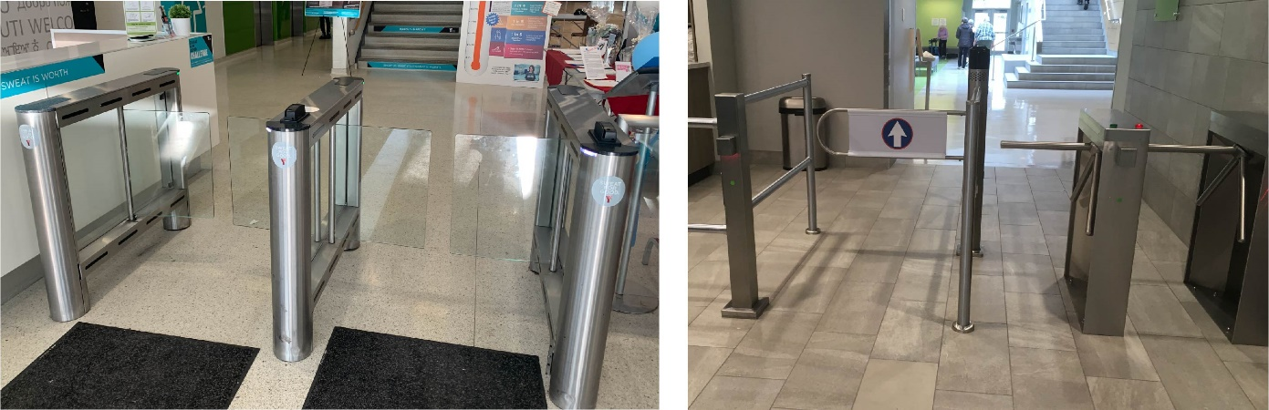
Figure 11: Accessible gates with suitable clear opening width

  - Path of Travel
(Maximum Score: 22)
A Site should have a logical and direct path of travel, ensuring all users are able to easily locate and access key facilities. The path should be free of obstructions, with minimal floor level changes. Where a change in floor level exists, a ramp should be provided to ease the transition.
    - No level changes within a storey or single floor (Maximum Points: 5)
Minimum Points:
- Ensures changes in level are not abrupt and are mitigated using a ramp, passenger lift, etc.
Maximum Points:
- Ensures there are no changes in level on a single floor
    - Access to all facilities expected to be used (Maximum Points: 5)
Access should include public and staff if typically expected to be used by both or either
Minimum Point:
- Ensures an accessible path of travel to all commonly used facilities on all levels
Maximum Points:
- Ensures an accessible path of travel is available to all facilities on all levels
    - Layout is logical and direct (Maximum Points: 3)
Minimum/Maximum Points:
- Ensures arrangement of circulation routes to key facilities is logical, understandable, usable and direct
- Ensures circulation routes are clear and easy to follow
- Ensures circulation routes are as straight and predictable as possible, as people who are blind or with low vision rely on straight paths and consistency for wayfinding
    - Open-plan areas are well defined and include tactile direction indicators (Maximum Points: 5)
N/A only if there is no significantly sized open-plan areas
Minimum/Maximum Points:
- Provides floor surfaces that are colour-contrasted with surrounding surfaces
- Uses a change in texture or different types of floor surfaces to define different areas
- Ensures furniture is appropriately placed and aid in defining open-plan areas
- Incorporates colour and textural contrasted markings or tactile direction indicators to guide people who are blind or with low vision to key facilities and path of travel
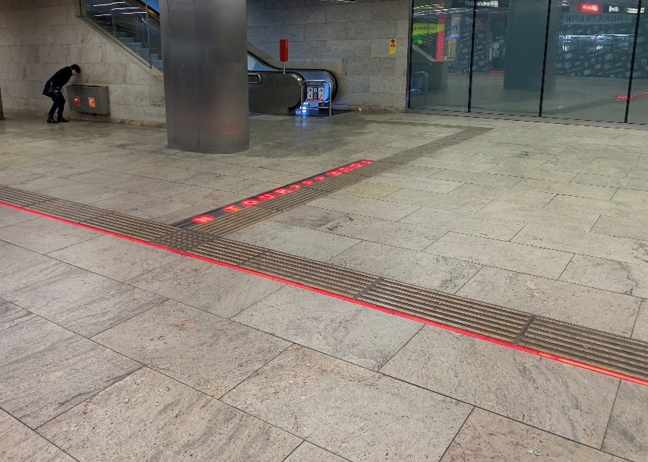
Figure 12: Tactile direction indicators installed in large open-plan areas to guide users to different key areas and features
    - Line-up/queuing guides (if provided) (Maximum Points: 4)
Minimum Points:
- Provides sufficient clear width free of obstructions between line-up/queuing guides for people using wheelchairs or electric scooters, or for people with companions or service dogs
- Ensures clear space is provided at entry and exit points, and when there is a change in direction along path of travel with line-up guides
- Ensures line-up/queuing guides are laid out in parallel and logical order
- Ensures lower edge or base of guides are cane-detectable and colour contrasted with surroundings
- Ensures non-fixed queuing systems are cane detectable and colour contrasted
Note: If retractable banding is used, a second lower banding at cane-detectable height is required.
Maximum Points:
- Ensures supports for line-up guides are firmly mounted to assist users with balance and stability issues
- Provides detectable path using colour and textural contrast with floor surfaces through queuing area for people who are blind or with low vision
- Provides rest areas with accessible seating, where queuing system is long

  - Corridors and Hallways
(Maximum Score: 31)
Corridors and hallways need to be wide enough to easily accommodate people moving in both directions. They should be well illuminated with colour-contrasted, non-glare surfaces, and be free of obstacles. If a hallway is long, recessed seating and handrails should be incorporated. Carpeting, if used, needs to be low pile and high density, in a light colour and no busy patterns.
    - Clear width (Maximum Points: 5)
Minimum Points:
- Provides sufficient clear width, free from obstructions, for people using wheelchairs or scooters, and for people with companions or service dogs
- Allows one or two-way flow of people, depending on the nature of the facility and expected number of people
- Provides passing areas within sight of one another or at reasonable intervals if hallway is not wide enough
Note: Passing places are also useful at hallway junctions, and at the end of passageways.
Maximum Points:
- Allows at least two people using wheelchairs or people with strollers to walk alongside or easily pass one another
- Provide adequate turning space for people using wheelchairs or scooters; people need to be able to turn around within a corridor, particularly when the corridor is long
- Ensures minimal sharp corners when there is a change in corridor or hallway direction
Note: Rounded corners or provision of convex mirrors allow people to see others approaching and are helpful for people who are deaf or hard of hearing.
- Has established maintenance policies (e.g., storage) in place to ensure that pathways are kept clear
    - Surface is stable, firm, and slip resistant (Maximum Points: 5)
Minimum/Maximum Points:
- Has a stable, firm surface that resists movement
- Has appropriate type of surface material for designated use and location
- Has a slip-resistant finish for both wet and dry conditions
- Ensures an even, continuous surface with minimal irregularities
- Ensures there are minimal gaps, joints, or breaks in the surface, which present tripping hazards
Note: Any gaps should run perpendicular to the direction of movement.
    - No obstacles on path and overhead, or obstructions are cane detectable and high contrast (Maximum Points: 5)
Applies to all paths of travel, including open-plan areas, corridors, hallways, and anywhere interior circulation is expected
Minimum/Maximum Points:
- Ensures path of travel is well maintained and free of obstacles
- Provides suitable overhead clearance across the entire width and length of the pathway, meaning it is free of any signs or obstacles
Note: A cane-detectable feature is required, where overhead objects present a hazard, in order to prevent collision hazards for people who are blind or have low vision.
- Ensures any projections, such as columns or wall-mounted items (e.g., drinking fountains, display cases), are adequately guarded, visually highlighted, and colour contrasted with the surrounding surfaces, as well as cane detectable for people who are blind or have low vision
- Ensures items such as fire extinguishers, drinking fountains are recessed, if possible
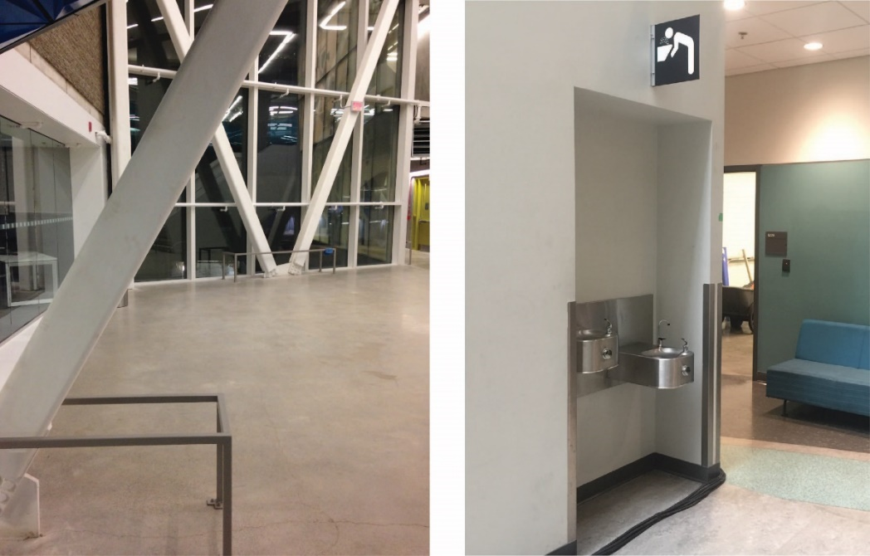
Figure 13: Examples of obstacles that are cane-detectable and recessed
    - Flooring and/or carpet with no busy patterns (Maximum Points: 2)
Minimum/Maximum Points:
- Has plain, light-coloured flooring or simple-patterned flooring, including carpeting, tiles, or other types of flooring
Note: Busy patterns, such as stripes and checks, can create confusion for people with low vision, while solid dark colours can create a “bottomless pit” effect.
    - Colour contrast between wall and floor, with no glare (Maximum Points: 3)
Minimum/Maximum Points:
- Uses visual or colour contrast between wall, floor, or other large fields of tile or colour to help with depth perception, assist in wayfinding for people, and minimize vertigo for people who are blind or have low vision
- Ensures all surfaces are non-glare and have non-slip textured finishes, as polished surfaces cause glare and can be slippery
    - Glazed walls have colour-contrasted strips or markings (Maximum Points: 2)
Minimum Points:
- Incorporates continuous colour-contrasted markings at eye level along the full width of glazed walls for safety and visibility
Note: Etched strips or white frosted decals do not provide suitable colour contrast for people with low vision.
Maximum Points:
- Incorporates continuous colour-contrasted markings at two levels, along full width of glazed walls
    - Handrails (if long hallway) (Maximum Points: 3)
Applies only to connecting corridors or long hallways connecting to commonly-used amenities; N/A only if not required for expected Site users
Minimum/Maximum Points:
- Offers accessible handrails to provide support, balance, and directional guidance
- Ensures the handrail size (diameter) facilitates grip, with a smooth and round design
- Ensures sufficient clearance exists between handrail and wall, free of any sharp and abrasive elements
- Ensures the ends of handrails turn down or sideways and return to post, floor, or wall to prevent handbags, pockets, etc. from getting caught, with a consistent method used throughout the building
- Has fixed support brackets on underside that do not interfere with a person running their hand along the length
- Is securely attached and supports enough weight for its intended use
- Contrasts visually with surrounding surfaces

    - Seating (if long hallway) (Maximum Points: 3)
Minimum Points:
- Provides seating at regular intervals along/close to a hallway to allow people to rest
- Ensures seating is located on a level, firm, and stable area and does not obstruct circulation routes
- Provides direct, unobstructed access to seating
- Provides back support and at least one armrest
- Incorporates clear space for people using wheelchairs, scooters, or strollers so they can sit alongside one another and with their companions
- Provides a clear space at the end of the seating for a service dog to rest
- Contrasts visually with surrounding surfaces
Maximum Points:
- Offers a variety of seating options to suit different people, such as seats with and without armrests, and fixed and movable seats
- Provides adequate heel space to allow people to stand up easily
- Ensures resting area is clearly visible and identified with a change in surface materials (i.e., texture and colour)
- Ensures seats positioned in a row are of the same style (e.g., all with armrests or all without)
Note: Mixture of seat styles in a single row can cause confusion for people who are blind or with low vision.
    - Well-illuminated (Maximum Points: 3)
Minimum/Maximum Points:
- Provides adequate lighting for the nature and use of the space
- Ensures light is evenly distributed throughout circulation areas
- Ensures surfaces minimize any glare or reflection
- Ensures lighting minimizes the creation of shadows on walls and floors
Ideas for Innovation:
- Provision of a higher light levels (e.g., 25% higher than standard)

  - Interior Ramps
(Maximum Score: 35)
Ramps are often used as an effective means of overcoming changes in elevation in a Site—within a storey, or in larger facilities, such as airport terminals or shopping centres, from one storey to another. Where a ramp is provided, there should always be a stepped alternative. In many situations, there will also be an elevator, escalator, or passenger lift.
Ramps are generally safer than stairs, as people are less likely to trip on a ramp. They also benefit people using wheelchairs or scooters and people pushing strollers or luggage.
Long ramps with a significant change in elevation should be avoided, as some people find them difficult to use. Alternatives, such as an elevator or escalator, may be suitable for some locations.
Ramps can have one of the following configurations:
- Straight run
- 90° turn
- Switchback or 180° turn
Circular or curved ramps are not recommended. As well, ramps within stairs (S-ramps) can be hazardous to people who are blind or have low vision, people with mobility disabilities, and people using walking aids.
    - Slope (Maximum Points: 5)
Minimum Points:
- Has a running slope of 8.3% (1:12) or less (as per building code and CSA B651)
- Ensures the cross slope on ramps is 2% (1:50) to allow for proper drainage
Maximum Points:
- Has a running slope of 5% (1:20) or less
Note: As the recommended slope is gentler than the minimum required by code (8.3% (1:12) or less), the length of the ramp will be greater.
- Ensures gradient is constant and consistent
- Ensures ramps with two or more consecutive slopes are of the same gradient; between landings, the gradient of ramps should be the same

    - Clear width (Maximum Points: 3)
Minimum/Maximum Points:
- Provides sufficient clear width, free from obstructions, for people using wheelchairs or electric scooters, or for people with companions or service dogs
- Allows one or two-way flow of people, depending on expected number of people and the nature of the facility
- Allows people to easily pass one another at the same time when approaching from different directions
    - Surface is stable, firm, and slip resistant (Maximum Points: 5)
Minimum/Maximum Points:
- Has a stable, firm surface that resists movement
- Has appropriate type of surface material for designated use and location
- Ensures an even, continuous surface with minimal irregularities
- Ensures there are minimal gaps, joints, or breaks in the surface, which present tripping hazards
Note: Any gaps should run perpendicular to the direction of movement.
- Ensures all surfaces are non-glare and have non-slip textured finishes
Note: Polished surfaces cause glare and can be slippery.
    - Level landings with clear space (Maximum Points: 4)
Minimum/Maximum Points:
- Provides landings at top and bottom of each run
- Provides intermediate landings between runs and where ramps change direction, for resting, manoeuvring, and avoiding excessive speed
Note: A ramp should be no longer than 9,000 mm and have level landing at the top and bottom.
- Provides adequate turning space for people using wheelchairs or mobility aids, people with strollers, or people with service dogs
- Ensures landings are unobstructed by door swings
    - Colour-contrasted and slip-resistant strip (Maximum Points: 4)
Minimum/Maximum Points:
- Ensures colour-contrasted and slip-resistant strips at landing before each run
- Ensures strips extend the full width of the ramp

    - Handrails (Maximum Points: 5)
Minimum Points:
- Provides handrails on both sides of a ramp at a consistent, accessible height along its run
- Ensures handrails are continuous through the length of ramps
Note: People who are blind or have low vision rely on handrails to guide them in negotiating ramps, while people with mobility disabilities rely on them for stability.
- Ensures the handrail size (diameter) facilitates grip, with a smooth and round design
- Ensures sufficient clearance exists between handrail and wall, free of any sharp and abrasive elements
- Provides horizontal handrail extensions at the top and bottom of all ramps to provide support and orientation for people as they move between the ramp and a level surface and vice versa
- Ensures extensions are turned down or sideways and returned to post, floor, or wall to prevent handbags, pockets, etc. from getting caught, with a consistent method used throughout the building
Note: Extensions are not required where they would project into another path of travel.
- Has fixed support brackets on underside that do not interfere with a person running their hand along the length
- Is securely attached and supports enough weight for its intended use
- Contrasts visually with surrounding surfaces
Maximum Points:
- Provides intermediate handrails, if ramp is wide
Note: If ramp is wider than 2,200 mm, provide an intermediate handrail ensuring sufficient clear width for people using wheelchairs or electric scooters, or for people with companions or service dogs.
- Prevents people and service dogs from walking underneath
- Allows people with lower eye level, such as people using wheelchairs or people of short stature, to see through the railings
Ideas for Innovation:
- Photo luminescent (glow-in-the-dark) guidance strips on handrails to help guide users in case of no power
- A parallel lower handrail for people of different heights, including children or people of short stature

    - Edge protection (Maximum Points: 3)
Minimum Points:
- Provides curbs or protective barriers (e.g., raised barrier or rail) on both sides of the ramp and on landings, where there is a drop-off, to prevent wheelchair casters or crutch tips from slipping off edge
Maximum Points:
- Contrasts visually with ramp surface
    - Well-illuminated (Maximum Points: 3)
Minimum/Maximum Requirement:
- Illuminates ramp and landing surfaces so they can be used safely at any time
- Provides adequate lighting for the nature and use of the space
- Ensures light is evenly distributed throughout circulation areas
- Ensures surfaces minimize any glare or reflection
- Ensures lighting minimizes the creation of shadows on walls and floors
Ideas for Innovation:
- Provision of a higher light levels (e.g., 25% higher than standard)
    - Convenient location (Maximum Points: 3)
Minimum Points:
- Ensures ramp is in obvious location along the path of travel
- Provides directional signage to ramp if location is not obvious
Maximum Points:
- Ensures ramps are well integrated with existing route
- Ensures route offers choice of both ramp and stair, where practical
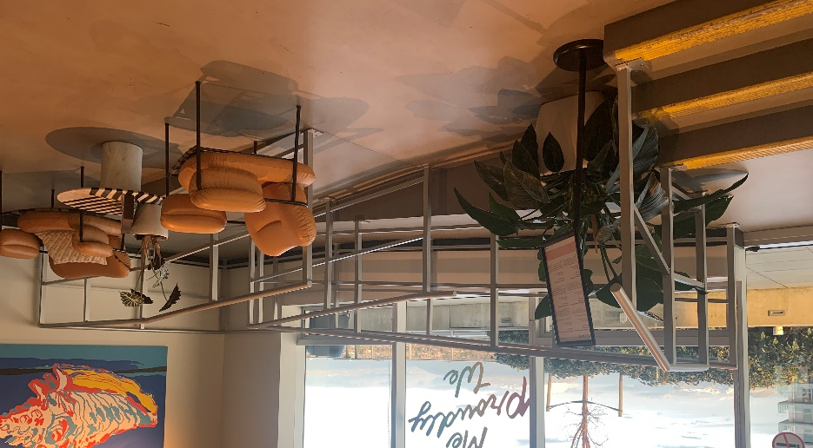
Figure 14: Choice of ramp and stairs to access patio

  - Elevators
(Maximum Score: 71)
A passenger elevator is often the preferred method of travel between floors in a multi-storey building. Elevators should be located adjacent to an accessible stairway to offer an alternative means of access and should serve all levels of a building available to the public. Furthermore, all facilities on the floors served by the elevator should be accessible (e.g., kitchen, offices, and washrooms). When more than one elevator is provided in a building, each should be accessible.
If a passenger elevator is not possible due to structural or other constraints, then a vertical platform lift, or another type of suitable elevating device, such as a limited use/limited application elevator (LULA), may be used. Using a freight or service elevator to transport people with disabilities is unacceptable from both a human rights and a Universal Design perspective, as it segregates people with disabilities.
As standard elevators are not designed for use in fire conditions, suitable alternatives for evacuation of people with disabilities should be available (e.g., evacuation chairs). In new buildings, installing a specialized elevator that can be used in an evacuation in the case of fire or other emergency should be considered.
    - Easy to find (Maximum Points: 3)
Minimum Points:
- Ensures elevator locations are easy to find and clearly indicated by directional signage located throughout the building—from the entrance(s) or other key areas within the building on each floor level
- Provides a sign at the elevator location using the appropriate international symbols
Maximum Points:
- Ensures elevator is at an obvious location from the entrance(s) and along a main circulation route
- Provides a tactile sign mounted at accessible height on the left side of the elevator door
- Uses blade-type signage to assist in wayfinding, where required
- Uses an audible location indicator (e.g., locating tones)
Ideas for Innovation:
- Installation of tactile direction indicators (TDI) from building entrances to elevators

    - Easy to use (Maximum Points: 5)
Minimum/Maximum Points:
- Ensures elevator system is easy to use and intuitive regardless of user’s experience and knowledge
- Provides different alternative operating features to ensure users with vision and hearing disabilities can use elevators
Note: New elevator technologies can be challenging to use by everyone. The use of touchscreen panel only is not accessible to people who are blind or with low vision as they would not be able to identify the buttons. A telephone-style keypad would also be required. Elevators that are voice activated only may not be accessible to everyone and people who are deaf or hard of hearing. Destination dispatch elevators can also be hard to use especially for users who are blind or with low vision if suitable wayfinding cues and operating mechanism features are not in place. People who are blind or with low vision may have difficulty locating and using the control panel to enter their destination; and then finding and getting to the elevator identified on the control panel. These should be carefully reviewed when rating elevators with such technologies.
    - Clear space in front of hall call buttons in elevator lobbies (Maximum Points: 3)
Minimum/Maximum Points:
- Allows all users to approach and reach hall call buttons with ease
- Ensures suitable clear space is provided in front of call buttons in the elevator lobbies to accommodate people using wheeled mobility devices
    - Hall call buttons are accessible and at accessible height (Maximum Points: 5)
Minimum/Maximum Points:
- Ensures call buttons are at an accessible height and position for all users
Note: The highest controls should be mounted no higher than accessible as many people in wheelchairs do not have full use of their arms.
- Ensures call buttons are raised so they can be operated with minimal force; flush or recessed buttons are not recommended because they are generally not usable for people with little or no use of their fingers
- Supplements control buttons with tactile characters and/or symbols that can be read by touch with an ideal combination of large, embossed, raised characters and Braille text
Note: Many people who are blind or have low vision cannot read Braille but can readily identify raised markings.
- Ensures tactile characters and call buttons visually contrast with the adjacent surfaces

Ideas for Innovation:
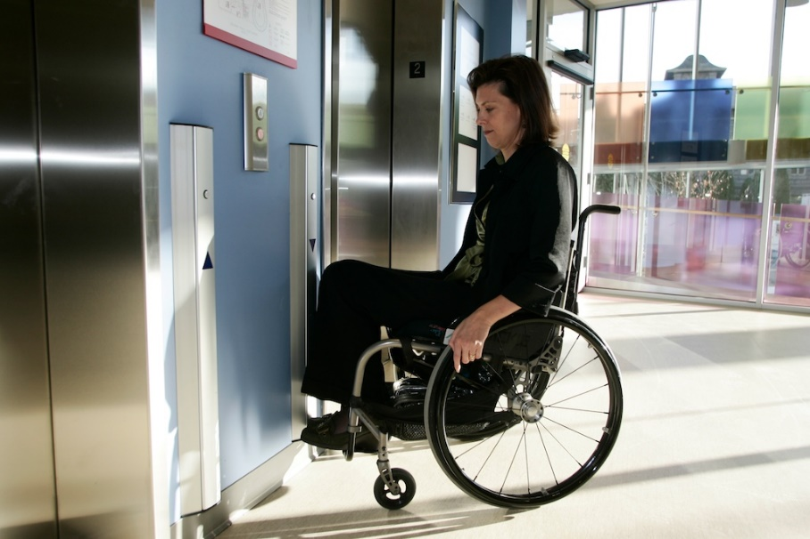
Figure 15: Elongated hall call control allowing operation at multiple height (Photo courtesy of ICORD)
- Elongated hall call controls that allows people to operate at multiple height
    - Clear opening width of door (Maximum Points: 5)
Minimum/Maximum Points:
- Provides sufficient clear width to access elevator for people using wheelchairs or electric scooters, and/or people with strollers, accompanied by companions or service dogs
    - Sufficient opening, hold-open, and closing time (Maximum Points: 4)
Minimum/Maximum Points:
- Ensures doors remain fully open for a sufficient length of time (at least five or six seconds), allowing users to enter and exit the elevator without interruption; door-opening or door closing buttons can be used to alter the time for each
- Ensures sufficient length of time is provided to allow users to travel to elevator that answered the call
Note: Length of time should be adjusted according to the size of elevator lobbies, number of elevators, the distance from the call button control panel to furthest elevator.

    - Door reopening device (Maximum Points: 2)
Minimum/Maximum Points:
- Provides an automatic, non-contact door reopener preventing the door from closing on a person or object
Note: There should be no physical contact between the door and the person or object.
- Ensures the device causes the door to stay open or to reopen automatically
- Ensures safety sensors are responsive to all users, including young children
    - Self-levelling and level threshold (Maximum Points: 3)
Minimum/Maximum Points:
- Ensures the elevator has a two-way automatic floor levelling device, which brings the elevator to a stop so the elevator floor is flush with the finished floor level of each landing
    - Interior dimensions and floor surfaces (Maximum Points: 5)
Minimum Points:
- Ensures size and capacity is appropriate for site type and occupancy
Note: There should be as much available floor space in the elevator as possible, as elevator use is expected to steadily increase as the population ages.
- Provides adequate manoeuvring and turning space for people using wheelchairs or scooters, people with strollers or luggage, or those with service dogs; people should not have to reverse out of the elevator
- Ensures floor surfaces are firm and slip resistant, permitting wheelchairs and scooters to move easily
Note: A soft under-cushion in combination with a thick or long-pile carpet makes manoeuvring difficult for people using wheelchairs or scooters. If carpeting is used, it should be low pile and high density.
Maximum Points:
- Provides flow-through design with doors on opposite sides of the elevator car allowing one-way travel (i.e., no need to turn around or reverse in the elevator)
Note: Elevators designed with front and back doors (flow-through design) are helpful, as they eliminate the need for users to turn around to exit. This is particularly useful during crowded conditions for people with mobility and vision disabilities.
Ideas for Innovation:
- A fire-resistant elevator.

    - Controls inside elevator cab at accessible height and location (Maximum Points: 4)
N/A only if controls are not in elevator cab
Minimum Points:
- Ensures all floor designation and emergency communication controls are accessible
- Ensures all controls are at an accessible height and position for all users
Note: Many people in wheelchairs do not have full use of their arms therefore it is recommended that every effort is made to keep all the controls at accessible height.
- Ensures control panel is placed as far as possible from the side wall, or it will be difficult to reach, if mounted on the front wall (return panel)
Maximum Points:
- Provides a convenient side-wall-mounted control panel, allowing people using wheelchairs or walking aids to access the controls without turning around, leaning forward, or twisting around backwards, risking a fall
- Arranges buttons vertically (preferred) to give a direct functional correlation to the direction of travel
- Where two control panels are installed, the most appropriate configuration is to have one placed on the front return panel and the other on the wall located on the opposite side of the elevator
Ideas for Innovation:
- Elongated cab controls mounted on the walls allowing use of all controls at consistent and accessible height, depending on size and use of elevator
    - Cab controls include Braille and tactile characters, and are easy to use (Maximum Points: 4)
Minimum/Maximum Points:
- Ensures cab control buttons are raised so they can be operated with minimal force; flush or recessed buttons are not recommended because they are generally not usable for people with little or no use of their fingers
- Supplements cab control buttons with tactile characters (numbers or symbols) that can be read by touch, with an ideal combination of large, embossed, raised characters and Braille text; many people who are blind or have low vision cannot read Braille but can readily identify raised markings
- Positions tactile characters adjacent to and on the left of the controls
- Ensures tactile characters and cab control buttons contrast visually with the adjacent surfaces
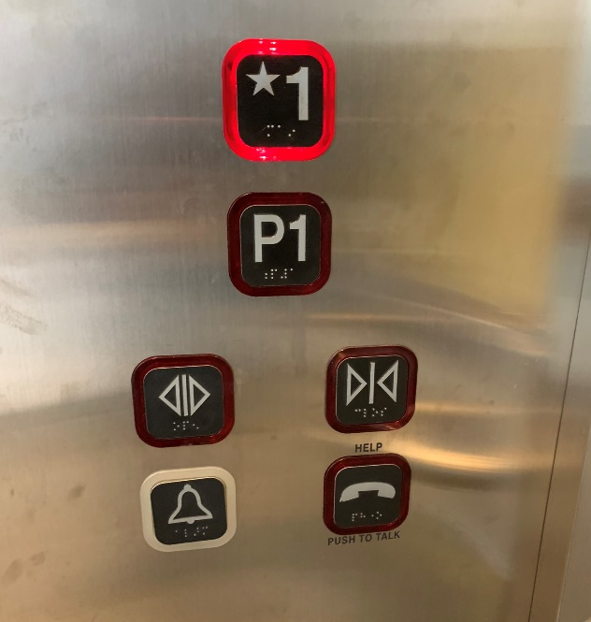
Figure 16: Large cab controls with tactile characters and braille, including visual indicators when control is operated
    - Emergency communication systems (Maximum Points: 5)
Minimum/Maximum Points:
- Ensures communication system can be operated with one hand and not require tight pinching, grasping, or twisting of the wrist
- Provides accessible communication systems compatible with assistive listening and communication enhancement technologies (e.g., hearing loop, telephone interface jacks compatible with both digital and analog signal use)
- Ensures text to text communication system is available for people who are deaf to communicate in case of emergency
Note: This can include a jack to support teletypewriter (TTY) for the communication systems.
    - Audible elevator components (Maximum Points: 4)
Minimum/Maximum Points:
- Ensures an audible verbal announcement inside the elevator that announces the direction the elevator is going and the floor level when the elevator stops at a landing
Note: Synthesized voice floor callers announcing the direction and destination of the elevator are extremely useful to all users, particularly seniors and people who are blind or have low vision.
- Provides audible indicators when the elevator is answering a call, has arrived or has stopped, the doors are opening or closing and any other important information for elevator use
- Ensures buttons emit an audible signal when pressed to confirm button was activated
    - Visual elevator components (Maximum Points: 4)
Minimum/Maximum Points:
- Provides visual indicators when the elevator is answering a call, has arrived or has stopped, the current floor position, and the direction of travel
- Ensures hall call and cab controls illuminate when pressed
- Ensures high-contrast colours are used for the visual floor indicator inside the elevator
    - Handrails (Maximum Points: 4)
Minimum/Maximum Points:
- Ensures handrails are installed at an accessible height on all interior walls, except on the door side, to provide support to people who are unsteady on their feet or who are anxious about riding an elevator
- Ensures handrails stop where they meet the control panel
- Ensures the handrail size (diameter) facilitates grip, with a smooth and round design
- Ensures sufficient clearance exists between handrail and wall, free of any sharp and abrasive elements
- Is securely attached and supports enough weight for its intended use
Ideas for Innovation:
- A flip-down seat is provided inside elevator for people who are unsteady on their feet or who have limited stamina
    - Colour contrast between interior cab floor and wall, with no glare (Maximum Points: 3)
Minimum Points:
- Ensures the interior cab floor and walls are colour contrasted to help people with low vision assess the size and shape of the elevator’s interior
- Ensures the elevator sill at each door entrance is colour-contrasted with the opposite floor finish
- Ensures wall and floor surfaces have a matte finish to minimize potential glare and reflection
Maximum Points:
- Ensures interior cab floor is a light colour and walls are dark
Note: Dark floors in an elevator can be confusing for people with low vision, as they may think they are stepping into an open shaft.

    - Doors are colour contrasted with surroundings (Maximum Points: 2)
Minimum/Maximum Points:
- Ensures doors contrast visually with adjacent wall surfaces
- Ensures any areas of glass incorporate permanent markings at two levels that visually contrast to the background surfaces
Note: Markings should be apparent to people from a range of different eye levels.
    - Mirror in rear of elevator cab (if not flow-through type) (Maximum Points: 3)
Minimum/Maximum Points:
- Provides mirror on the rear wall
Note: This allows people to see what is behind them if they need to reverse out of the elevator, like a rear-view mirror in a car, and protects their personal safety. It should extend from 900 mm above the finished floor to ceiling level. Full height mirrors should be avoided, as they can make the wall appear as a corridor, causing people to walk into it.
- Ensures mirror is constructed of safety glass
    - Well-illuminated cab interior and elevator lobbies (Maximum Points: 3)
Minimum/Maximum Requirement:
- Maintains lighting levels inside the cab at ambient hallway light levels and provides even, flicker-free light
- Illuminates elevator lobbies and inside the cab so they can be used safely at any time
- Provides adequate lighting for the nature and use of the space
- Ensures surfaces minimize any glare or reflection
- Ensures lighting minimizes the creation of shadows on walls and floors
Ideas for Innovation:
- Provision of a higher light levels (e.g., 25% higher than standard)

  - Interior Stairs
(Maximum Score: 41)
Stairs are inherently hazardous. They need to be well dimensioned to provide a stable footing and to ensure the safety and comfort of all users. They should be equipped with accessible handrails and tactile attention indicators (TAIs) and kept clear of all obstacles.
Interior stairs should be provided in conjunction with an elevator to offer choice. Where possible, elevators should be located adjacent to an associated set of stairs.
Stair dimensions should be uniform and consistent throughout a flight of stairs. Circular stairs and stairs with tapered treads should be avoided, as anyone can find them difficult to navigate.
    - Clear width (Maximum Points: 2)
Minimum/Maximum Points:
- Provides sufficient clear width, free from obstructions, for people with service dogs
- Allows one or two-way flow of people, depending on the expected number of people and nature of the building
- Allows people to easily pass one another at the same time when approaching from different directions
    - Surface is firm, stable, and slip resistant (Maximum Points: 5)
Minimum/Maximum Points:
- Ensures treads and landings have a stable and firm surface
- Has appropriate type of surface material for designated use and location
- Ensures stairs are in good condition with no damage or settlement
- Ensures there are minimal gaps, joints, or breaks in the surface, which present tripping hazards
Note: Any gaps should run perpendicular to the direction of movement.
- Ensures all surfaces are non-glare
- Ensures treads and landings have a slip-resistant finish or have slip-resistant strips for both wet and dry conditions
- If carpeting is used, ensures it is used only on the tread (top of step) but not continuously over the nosing and throughout the flight of stairs

    - Level landings with clear space and at regular intervals (Maximum Points: 3)
Minimum Points:
- Ensures landings are provided at the top and bottom of each flight, with the length equivalent to the step width
- Provides landings at reasonable intervals throughout the stairway to break up significant difference in level
- Ensures landings extend along full width of stairs
- Ensures there are no stepped landings
- Ensures landings are unobstructed by door swings
- Provides guardrails, where there is drop-off at the edge of the landings
Maximum Points:
- Ensures the total rise for a flight of stairs is appropriate; if more than one flight is required, the number of steps in each flight is the same
Note: The maximum number of steps each flight should have is 12.
- Provides convex mirrors at landings to increase visibility for people who are deaf or hard of hearing, where needed
    - Handrails (Maximum Points: 5)
Minimum Points:
- Provides handrails on both sides of stairs at a consistent and accessible height
Note: If stair is wide, an intermediate handrail is recommended to ensure people can reach handrails on both sides if required.
- Ensures handrails are continuous through the stairs and landings; people who are blind or have low vision rely on handrails to guide them in negotiating stairs, while people with mobility disabilities rely on them for stability
- Ensures the handrail size (diameter) facilitates grip, with a smooth and round design
- Ensures sufficient clearance exists between handrail and wall, free of any sharp and abrasive elements
- Provides horizontal handrail extensions at the top and bottom of all stairs to provide support and orientation for people as they move between the stair and a level surface
- Ensures extensions are turned down or sideways and returned to post, floor, or wall to prevent handbags, pockets, etc. from getting caught, with a consistent method used throughout the building
Note: Extensions are not required where they would project into another path of travel.
- Has fixed support brackets on underside that do not interfere with a person running their hand along the length
- Is securely attached and supports enough weight for its intended use
- Contrasts visually with surrounding surfaces
Maximum Points:
- Ensures handrails are continuous on both sides and along landings
- Prevents people and service dogs from walking underneath
- Allows people with lower eye level, such as children or people of short stature, to see through the railings
Ideas for Innovation:
- Glow-in-the-dark handrails to illuminate route during a power outage
- A parallel lower handrail for people of different heights, including children or people of short stature
    - Tactile attention indicators (truncated domes) (Maximum Points: 5)
Minimum/Maximum Points:
- Has tactile attention indicators placed at the top of the stairs
Note: Tactile attention indicators are generally not used on intermediate landings, as this can give a false impression that the end of the flight of stairs has been reached. However, tactile attention indicators may be used on an intermediate landing that meets with another path of travel or circulation route.
- Ensures tactile attention indicators extend the full width of the stairs and are of sufficient length in the direction of travel to provide adequate warning to people who are blind or have low vision
- Ensures material is contrasting in colour with the surrounding surface material and of a different texture
- Uses floor finishes that contrast both visually and audibly (surface sounds different from adjacent surface when walked on)
    - Colour-contrasted and slip-resistant strip on nosing (Maximum Points: 4)
Minimum Points:
- Ensures each step edge has strip that colour contrasts with the tread to visually highlight the step edge and improve depth perception
Note: Light-coloured strips on dark treads are preferred to light-coloured treads on dark strips as dark strips on nosings are harder to notice by people with low vision.
- Ensures strip extends the full width of the step and is of adequate width
Maximum Points:
- Ensures strip is slip resistant
- Ensures each contrasting strip wraps around nosing and continues down the riser so that it is visible when both ascending and descending the stairs (e.g., no more than 10 mm)
- Ensures a single colour is used for contrasting strips
Ideas for Innovation:
- Glow-in-the-dark stair nosings to illuminate route during a power outage
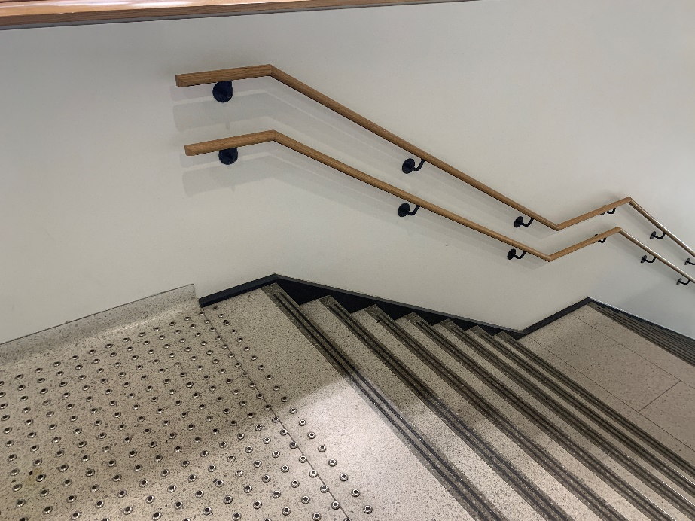
Figure 17: Interior stairs with handrails installed at two levels, tactile attention indicators and nosing strips
    - Riser height and tread depth (Maximum Points: 4)
Minimum/Maximum Points:
- Ensures steps are consistent throughout with uniform riser heights and tread depths; inconsistencies in rise or in tread depth can create tripping hazards
- Ensures dimensions are adequate to provide safe footing for all users
    - No open riser (Maximum Points: 3)
Minimum/Maximum Points:
- Ensures all step risers are closed and opaque; open risers can be tripping hazards, a source of visual confusion, or disconcerting
Note: People who wear leg braces or prosthetic devices need a solid riser to guide their foot up the riser and over the nosing to the next step; those who use canes or crutches place them against the riser of the next step in order to maintain balance.

    - Nosing design (Maximum Points: 2)
Minimum/Maximum Points:
- Ensures nosings are flush with riser, or are sloped to the riser at an angle greater than 60° to the horizontal, where they project
- Ensures any projecting nosings do not have sharp or abrupt edges or an underside that prevents a foot from sliding up the riser as that may cause tripping; projecting nosings must be rounded or bevelled
    - Flooring with no busy patterns (Maximum Points: 2)
Minimum/Maximum Points:
- Has plain, light-coloured flooring or simple-patterned flooring, including carpeting, tiles, or other types of flooring
Note: Busy patterns, such as stripes and checks, can create confusion for people with low vision, while solid dark colours can create a “bottomless pit” effect.
    - Height clearance (Maximum Points: 3)
Minimum/Maximum Points:
- Maintains overhead clearance throughout the full length of the stairway and on any landings (e.g., if sheltered or if items are suspended above stairs)
- Ensures the area beneath an unenclosed staircase has a cane-detectable feature, such as guardrails or planters, to prevent people from colliding with the underside of the stairs
- Provides ample overhead clearance (e.g., if sheltered or if items are suspended above stairs)
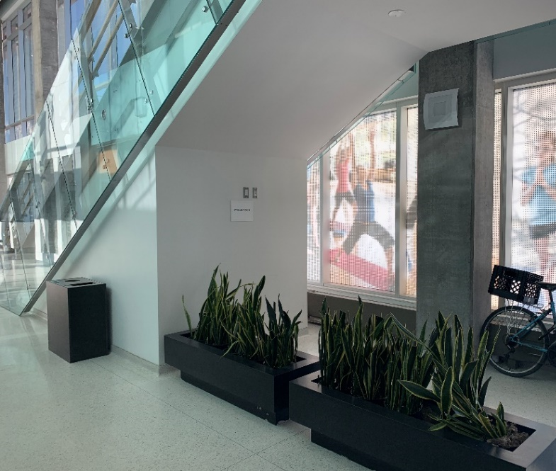
Figure 18: Cane-detectable feature at the underside of stairs
    - Well-illuminated (Maximum Points: 3)
Minimum/Maximum Points:
- Illuminates stair and landing surfaces so they can be used safely at any time
- Provides adequate lighting for the nature and use of the space
- Ensures light is evenly distributed throughout circulation areas
- Ensures surfaces minimize any glare or reflection
- Ensures lighting minimizes the creation of shadows on walls and floors
Ideas for Innovation:
- Provision of a higher light levels (e.g., 25% higher than standard)

  - Escalators and Moving Walkways
(Maximum Score: 19)
While escalators are common to many large Sites, they are not considered part of an accessible route of travel. They are quick and easy for many Site users but are unsuitable for people in wheelchairs, people with strollers, and people with service dogs, and they are often difficult to navigate for people with mobility challenges. Many people prefer to use stairs, ramps, or elevators. Accordingly, an alternative means of access should always be provided in association with escalators.
Moving walkways are frequently used to move people over long horizontal distances in a large Site or vertically to another floor, such as in airports. They are convenient for people pulling suitcases or pushing strollers or shopping carts. Moving walkways should always have an accessible route adjacent to it. Where moving walkways are inclined, the angle of inclination should not be steeper than 1:20 (5%).
    - Alternative is available (Maximum Points: 3)
Minimum/Maximum Points:
- Ensures stairs, elevators, or accessible passenger lifts are available as alternatives to an escalator or inclined moving walkway
- Provides golf carts or similar vehicles, as well as an accessible path of travel, as alternatives to a moving walkways, where possible
- Ensures alternatives are in an adjacent location and clearly identified
    - Colour-contrasted detectable feature at the top (Maximum Points: 3)
Minimum/Maximum Points:
- Ensures detectable feature is placed at the top of the escalator or start of moving walkway to notify people who are blind or with low vision
- Ensures detectable feature extends the full width of the escalator or walkway and are of sufficient length in the direction of travel to provide adequate warning to people with low vision
- Ensures material is contrasting in colour with the surrounding surface material and is of a different texture
    - Colour-contrasted nosings and side edges (Maximum Points: 4)
Minimum/Maximum Points:
- Provides high-contrast markings (preferably signal yellow) on all nosings and side edges

    - Visual and audible notifications at start and end (Maximum Points: 3)
Minimum/Maximum Points:
- Provides audible signals to notify users that they are entering and exiting escalators or moving walkways
- Ensures direction of travel of escalators and moving walkways is clearly identified
    - Accessible stop button (Maximum Points: 3)
Minimum/Maximum Points:
- Ensures controls are clearly identified, at an accessible height, and within reach of all users
- Ensures clear space is provided in front of controls for easy access
    - Well-illuminated (Maximum Points: 3)
Minimum/Maximum Points:
- Illuminates escalators and/or moving walkways so they can be used safely at any time
- Provides adequate lighting for the nature and use of the space
- Ensures light is evenly distributed throughout circulation areas
- Ensures surfaces minimize any glare or reflection
- Ensures lighting minimizes the creation of shadows on walls and floors
Ideas for Innovation:
- Provision of a higher light levels (e.g., 25% higher than standard)

  - Platform Lifts
(Maximum Score: 30)
Platform lifts are sometimes used as a means of improving access in existing Sites where it is not possible to install an elevator due to structural or space constraints. They are slower moving than conventional passenger elevators and have limited capacity, as they are typically designed to carry only two passengers. Wherever a platform lift is located, an associated flight of stairs or steps should be provided as an alternative means of access.
Platform lifts are suitable for historic Sites where preservation of the existing structure is key, but they should not be installed in new Sites. People should be able to use them independently, without assistance, and without having to seek permission. As standard platform lifts are not designed for use in evacuations, an evacuation chair or suitable alternatives should be available for people with disabilities in emergency situations.
Short-rise platform lifts travelling up to 2,000 mm do not need to be fully enclosed unless it is required for fire-resistance. Non-enclosed lifts require a safety guard and gate or a barrier on both the entry and exit side. A permanent, solid barrier is required on any non-access side of the lift.
All platform lifts travelling more than 2,000 mm need to be fully enclosed and to incorporate power-assisted, outward-opening doors for access.
    - Installed in existing site where elevator is not feasible (Maximum Points: 5)
Minimum/Maximum Points:
- Ensures platform lift is installed in an existing building due to structural or space constraints preventing installation of a conventional elevator
Note: Platform lifts should not be installed in new Sites.
    - Independently operated (Maximum Points: 5)
Minimum Points:
- Ensures assistance is readily available for people who have difficulty using the controls, if lifts cannot be operated independently
Maximum Points
- Ensures operation of platform lift does not require a key or assistance; it can be operated independently or as needed without requiring support

    - Door/gate clear opening width and threshold (Maximum Points: 5)
Minimum/Maximum Points:
- Provides sufficient, clear width for people using wheelchairs or scooters, and for people with companions or service dogs, to access lift
- Ensures threshold at door/gate is flushed with floor surface or is bevelled, ramped, or rounded, if threshold is raised to a maximum of 13 mm
- Ensures clearance from door swing is provided adjacent to manually activated power door controls
    - Barriers and guards (Maximum Points: 3)
Minimum/Maximum Points:
- Provides a safety guard and barrier on both the entry and exit side for short-rise non-enclosed lifts
- Ensures platform lifts travelling more than 2,000 mm are fully enclosed with power-assisted outward-opening doors for access
- Provides a permanent, solid barrier on any non-access side of the lift
- Provides handrails to provide support to people who are unsteady on their feet or who are anxious about riding a platform lift
    - Size and capacity appropriate for expected usage (Maximum Points: 3)
Minimum Points:
- Ensures size and capacity is appropriate for site type and occupancy
- Ensures lift can carry with ease a person in a wheelchair with an assistant, a person with a stroller, or a person with a service dog
- Provides a clear space on landing area enabling people to approach and manoeuvre around the door or gate and turn through 180°
Maximum Points:
- Provides doors on opposite sides allowing one-way travel such that people do not need to turn around or reverse in the lift (preferred arrangement); if one-way travel is not possible, entry and exit doors are positioned on adjacent sides of the lift
Ideas for Innovation
- A fold-down seat for passengers who have difficulty standing or who have vertigo

    - Light pressure control buttons (Maximum Points: 3)
Minimum/Maximum Points:
- Provides easy-to-use control buttons; for safety purposes, controls on platform lifts require continuous pressure in order to operate
    - Emergency communication button (Maximum Points: 3)
Minimum/Maximum Points:
- Ensures emergency communication button is clearly identified, at an accessible height, and within reach of all users
- Ensures emergency assistance button is incorporated into the control panel and is linked to a trained source of assistance
- Ensures emergency communication provides both visual and audible feedback
    - Well-illuminated (Maximum Points: 3)
Minimum/Maximum Points:
- Illuminates platform lifts so they can be used safely at any time
- Provides adequate lighting for the nature and use of the space
- Ensures light is evenly distributed throughout circulation areas
- Ensures surfaces minimize any glare or reflection

- Interior Services and Environment
The table below displays the Site elements used to measure accessibility for this category, the corresponding maximum score available for each, and the category total.
Site Element | Maximum Score
4.1 Lobby and Reception Areas | 18
4.2 Reception Desks, Service Counters, and Self-Service Transaction Kiosks | 37
4.3 Waiting Areas, General Seating, Meeting Rooms, and Lounges | 31
4.4 Kitchens | 43
4.5 Acoustic Considerations | 10
4.6 Illumination and Building Systems | 28
Innovation | 17
Total Maximum Score | 184
Description
Interior services and environment refers to the key internal facilities themselves—that is, the facilities that people use within a Site.
Although the types of internal facilities available will vary with each Site’s occupancy and use, many of the elements and features found in this category are general to all. These include location, space and clearance, appropriate furnishings, availability of appropriate equipment, acoustics, illumination, and building systems.
Considering these requirements during the design phase of a Site—well before the shovels break ground—will help ensure a Site’s facilities can accommodate everyone.
  - Lobby and Reception Areas
(Maximum Score: 18)
Lobby and reception areas of a Site must be welcoming and accessible for all intended users. They should orient people and provide clear information about the Site and its services. Access to circulation routes and facilities as well as routes to the entrance and exit from the lobby and reception areas should be obvious, clear, and unobstructed. There should be sufficient clear space for people using mobility devices to manoeuvre without blocking access for others.
To ensure the comfort and convenience of everyone, comfortable seating should be available in lobby and reception areas with washrooms located nearby. Lighting levels should help people adjust to daylight or exterior lighting as they move from the interior to the exterior environments, and vice versa.

    - Logical arrangement of circulation routes and facilities (Maximum Points: 3)
Minimum/Maximum Points:
- Ensures overall arrangement of circulation routes is logical and usable, and provides direct access to key facilities
- Connects accessible circulation routes on entrance-level floor to other floors (e.g., horizontal and vertical circulation)
    - Location of key facilities easily identified (Maximum Points: 3)
Minimum/Maximum Points:
- Provides clear signage or other wayfinding (e.g., colour and texture contrast flooring surfaces) within lobby and reception area highlighting key facilities, such as elevators, stairs, washrooms, and main building spaces
Ideas for innovation
- Use of tactile direction indicators (TDI) to identify key facilities and amenities from building entrance(s)
    - Washroom facilities adjacent to lobby and reception area (Maximum Points: 3)
Minimum/Maximum Points:
- Ensures washroom facilities are near the lobby and reception areas, if there is a waiting area where people are expected to wait
    - Floor finishes are firm and slip resistant, with no glare or busy patterns (Maximum Points: 3)
Minimum/Maximum Points:
- Has a stable, firm, surface that resists movement
- Ensures all surfaces are non-glare and have non-slip textured finishes, as polished surfaces cause glare and can be slippery
- Has plain, light-coloured flooring or simple-patterned flooring, including carpeting, tiles, or other types of flooring
Note: Busy patterns, such as stripes and checks, can create confusion for people with low vision, while solid dark colours can create a “bottomless pit” effect.
- If a mat is provided on the inside of the entrance, ensures it has a firm, level surface and is placed in a recessed well that is flush with the surrounding floor surface

    - Seating where expected to wait (Maximum Points: 3)
Minimum Points:
- Ensures access to seating is direct and unobstructed
- Ensures seating is located on a level, firm and stable area, and does not obstruct circulation routes
- Contrasts visually with surrounding surfaces
- Incorporates clear space for people using wheelchairs, scooters, or strollers so they can sit alongside one another and with their companions
- Provides a clear space at the end of the seating for a service dog to rest
- Provides back support and at least one armrest
- Ensures location of seating area is clearly identified, if not obvious
Maximum Points:
- Ensures seating is located close to reception/information desks, if present
- Offers a variety of seating options to suit different people (e.g., seats with and without armrests, different seat height and width, fixed and movable seats)
- Provides adequate heel space to allow people to stand up easily
- Ensures seating area is clearly visible and identified with a change in surface materials (i.e., texture and colour)
- Provides tables for placing objects so people are not required to bend to the floor
    - Well-illuminated (Maximum Points: 3)
Minimum/Maximum Points:
- Provides adequate lighting for the nature and use of the space
- Ensures lighting in entrance lobbies eases the transition between the exterior and interior environment to enable people’s eyes to adjust; a sudden change in lighting levels can be difficult for many people
- Ensures lighting optimizes visual communication and lip-reading or speech-reading
- Ensures lighting minimizes reflection on glazed components
- Ensures lighting minimizes the creation of shadows on walls and floors

  - Reception Desks, Service Counters, and Self-Service Transaction Kiosks
(Maximum Score: 37)
Ensuring all Site users have meaningful access to reception desks, service counters, and self-service transaction kiosks is a fundamental part of an access plan. This element applies to reception desks, information/security desks, any service counters, and self-service transaction kiosks where services are obtained. Reception desks should be highly visible, easily located, and situated on a direct, unobstructed route from the entrance. Counters should be usable from both sides by both people who are standing and those who are seated.
Some Sites have a concierge and reception desk at the entrance to control access to a Site. Both people who are standing and people using wheelchairs must be able to access and use these desks.
    - Desks/counters at accessible height or variety of heights (Maximum Points: 5)
Minimum/Maximum Points:
- Ensures desk or counter height is accessible by all, including people using wheelchairs or scooters, those who access the desk or service counter from a seated position, and people who are standing
- Ensures the main service area of the desk/counter is at universally accessible height or provide desk/counter at variety of height for people in both seated and standing position
Note: Small segregated cut-outs or service areas added onto counter designs for people using wheelchairs or scooters are not acceptable, since they isolate, rather than integrate, people with disabilities. Furthermore, separate lowered sections often become storage and/or product display areas. All counters must provide equal and integrated access for people with mobility disabilities.
Ideas for Innovation:
- Height adjustable desk/counter allows for use at variety of height and accommodates everyone
    - Space for knee clearance at transaction points for public and staff (Maximum Points: 5)
Minimum/Maximum Points:
- Ensures adequate knee clearance is provided underneath desks/counters at transaction points to allow front approach for both public and staff using mobility devices
Note: This is important where a physical action or exchange takes place between people, such as processing a payment, completing forms, etc.
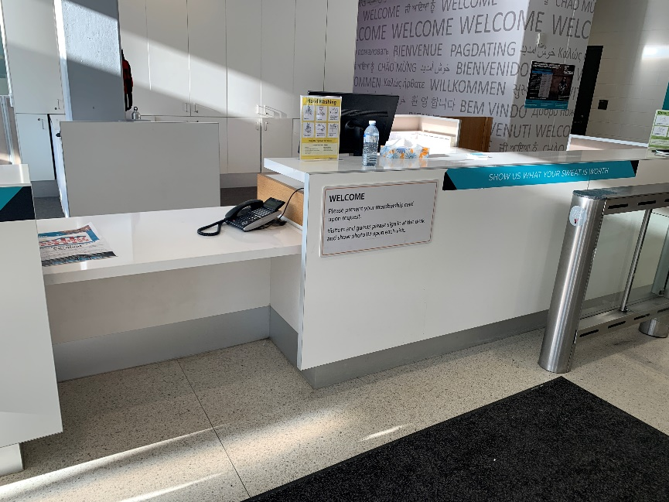
Figure 19: Multiple height reception counters
    - Clear space for approach for public and staff (Maximum Points: 3)
Minimum/Maximum Points:
- Provides an accessible route to allow people using wheeled mobility devices to access both the public and staff sides of the desk/counter and/or self-service transaction kiosk with ease
- Provides clear space in front of desk/counter or kiosk
- Ensures space allows for adequate reach over the desk/counter for all users
    - Clearly visible from entrance doors with direct route (Maximum Points: 3)
Minimum/Maximum Points:
- Ensures reception desks and/or service counters are highly visible and can be easily located by all Site users, and are situated on a direct, unobstructed route from the entrance
- Provides directional signage to identify locations of reception/service counters, if not obvious
    - Clear signage (Maximum Points: 3)
Minimum/Maximum Points:
- Provides clear, understandable identification signage indicating the purpose or function of the desk or counter
- Ensures signs use a large font and contrasting colours
- Ensures signs are easy to locate and well positioned
- Provides tactile signage with raised characters/symbols and Braille that are within easy reach for people who are blind or have low vision
    - Desk/counter is colour contrasted with surroundings (Maximum Points: 2)
Minimum/Maximum Points:
- Ensures desk/counter contrasts visually with adjacent surfaces (e.g., floor, walls)
    - Assistive listening and communication enhancement technologies (Maximum Points: 5)
Minimum/Maximum Points:
- Provides assistive listening and communication enhancement technologies (e.g., hearing loop) to amplify sound for people who are hard or hearing, where information is exchanged
- Ensures text to text communication system is available for people who are deaf
Ideas for Innovation:
- Video remote services or video remote interpreting is available at reception desks or service counters
    - Accessible interactive self-service transaction kiosks (Maximum Points: 5)
Minimum Points:
- Ensures display panels/screens of self-service transaction kiosks can be viewed from a seated position
- Ensures all operating controls are operable without tight grasping or twisting of the wrist
- Ensures all operating controls are mounted at an accessible heights and location
Maximum Points:
- Ensures display panels/screens of self-service transaction kiosks are positioned to minimize glare and reflections
- Ensures alternate ways of completing a transaction are provided (e.g. tactile keyboard and audio instructions, if touch-screen technology is used
Ideas for Innovation:
- Display panels or screens that automatically adjust to the height of its users
    - Audio information and instructions (if self-service transaction kiosks) (Maximum Points: 3)
Minimum/Maximum Points:
- Ensures any information displayed on screen is conveyed in spoken form
- Ensures kiosks are equipped with headset jacks with adjustable volume controls or other assistive listening and communication enhancement technologies

    - Well-illuminated (Maximum Points: 3)
Minimum/Maximum Points:
- Illuminates reception desks, service counters, and self-service transaction kiosks so they can be identified and used easily
- Ensures lighting optimizes visual communication and lip-reading or speech-reading
- Provides adequate lighting for the nature and use of the space
- Ensures surfaces minimize any glare or reflection
- Ensures lighting minimizes the creation of shadows
Ideas for Innovation:
- Provision of higher light levels (e.g., 25% higher than standard)

  - Waiting Areas, General Seating, Meeting Rooms, and Lounges
(Maximum Score: 31)
This element applies to all areas where people need to wait, rest, or meet. These areas include but are not limited to waiting areas, general seating areas, meeting rooms, and lounges. They should be comfortable and offer a variety of seating types to accommodate all users.
Important: Spaces such as multi-purpose rooms and small classrooms can also be rated as part of this element if they do not provide multi-tiered seating. Large lecture halls should be rated in Element 6.2: Public Assembly Areas.
    - Variety of seating types (Maximum Points: 5)
Minimum Points:
- Provides seating with back support and at least one armrest
- Ensures seats are comfortable, with firm padding and rounded edges
- Ensures seating is located on a level, firm and stable area, and does not obstruct circulation routes
Maximum Points:
- Offers a variety of seating options to suit different people (e.g., seats with and without armrests, different seat height and width, fixed and movable seats)
- Provides adequate heel space to allow people to stand up easily
- Provides tables for placing objects so people are not required to bend to the floor
- Ensures seats positioned in a row are of the same style (e.g., all with armrests or all without)
Note: A mixture of seat styles in a single row can cause confusion for persons with low vision.
    - Arrangement of seating with clear space (Maximum Points: 3)
Minimum Points:
- Ensures access to seating is direct and unobstructed from main circulation route
- Incorporates clear space for people using wheelchairs, scooters, or strollers so they can sit alongside one another and with their companions
- Provides a clear space at the end of the seating for a service dog to rest
Maximum Points:
- Provides flexible seating that allows seating arrangements to be easily altered to accommodate individual situations

    - Upholstery is matte, non-slip without bold pattern, and contrasts with environment (Maximum Points: 2)
Minimum/Maximum Points:
- Ensures upholstery is plain coloured or has a simple pattern
Note: Strong patterns, such as stripes and checks, can create confusion for people with low vision.
- Contrasts visually with surrounding surfaces
- Ensures upholstery is matte and non-slip
    - Tables are stable with rounded corners (Maximum Points: 2)
Minimum/Maximum Points:
- Ensures tables are stable
- Ensures tables have no sharp corners or edges
    - Tables at accessible height with knee clearance (Maximum Points: 5)
Minimum/Maximum Points:
- Ensures tables or work surfaces are at an accessible height for all users
- Ensures any tables or work surfaces provide suitable knee clearance
- Provides clear space in front of tables or work surfaces for people using wheeled mobility devices
    - Assistive listening and communication enhancement technologies (Maximum Points: 5)
Applies to rooms where information is exchanged
Minimum/Maximum Points:
- Provides assistive listening and communication enhancement technologies designed for the type of room, room size, and occupancy load
    - Other communication systems (both visual and audible) (Maximum Points: 3)
Minimum/Maximum Points:
- Provides audible and visual announcements, especially if numbers/names are being called out in waiting areas
- Ensures captions are turned on, where TV screens are provided
Ideas for Innovation:
- Video monitors for public information dissemination
- “Pick-a-number” ticketing devices that include verbal announcement of the number that is being pulled out so that people who are blind or with low vision know which number they picked
    - Floor finishes are firm and slip resistant, with no glare or busy patterns (Maximum Points: 3)
Minimum/Maximum Points:
- Has a stable, firm surface that resists movement
- Ensures all surfaces are non-glare and have non-slip textured finishes, as polished surfaces cause glare and can be slippery
- Uses colour/texture contrast to delineate path of travel from waiting areas, seating areas, and lounges
- Has plain, light-coloured flooring or simple-patterned flooring, including carpeting, tiles, or other types of flooring
Note: Busy patterns, such as stripes and checks, can create confusion for people with low vision, while solid dark colours can create a “bottomless pit” effect.
    - Well-illuminated (Maximum Points: 3)
Minimum/Maximum Points:
- Illuminates waiting areas, seating areas, meeting rooms, lounges and other spaces so they can be used easily
- Ensures lighting optimizes visual communication and lip-reading or speech-reading
- Provides adequate lighting for the nature and use of the space
- Ensures surfaces minimize any glare or reflection
- Ensures lighting minimizes the creation of shadows
Ideas for Innovation:
- Provision of higher light levels (e.g., 25% higher than standard)

  - Kitchens
(Maximum Score: 43)
Kitchens should be located on an accessible route, adjacent to any dining or seating areas. Several features can help ensure ease of use for everyone: open layouts, pull-down or reachable cupboards or storage areas, work surfaces adjacent to or under appliances, seating areas that colour contrast with adjacent wall and floor surfaces, and counters with rounded corners.
Refer to the latest version of CSA B651 for additional details on kitchens.
    - Approach to kitchen is accessible (Maximum Points: 5)
Minimum Points:
- Ensures there is an accessible path leading to the kitchen
- Where entryway is provided to kitchen, ensures it provides suitable clear opening width
- Ensures doors have a manual swing door with low resistance closer and accessible hardware (e.g., levered handle), if swing doors are present
- Ensures door is identified from adjacent surfaces via colour or a change in surface texture
Maximum Points:
- Provides a power-operated door, if door is present
- Ensures door provides clear visibility (e.g., tempered clear or frosted glass, vision panels), allowing people to identify any hazards
    - Clear space for manoeuvring (Maximum Points: 5)
Minimum/Maximum Points:
- Provides adequate turning space for people using wheelchairs or scooters; people need to be able to turn around within a kitchen
- Provides suitable clear space in front of accessible counters, sink, kitchen amenities and appliances, and to the one side where drawers or doors open
    - Sink at accessible height (Maximum Points: 4)
Minimum/Maximum Points:
- Ensures sink is at an accessible height for wheelchair users or users in a seated position to easily use the sink and faucet
Idea for Innovation:
- Power-operated height adjustable sinks

    - Knee clearance under sink (Maximum Points: 4)
Minimum/Maximum Points:
- Provides knee clearance underneath sink to allow front approach for users of mobility devices
- Ensures pipes are insulated, with no exposed sharp edges or projecting components
- Ensures the lower shelf typically provided under a sink can be removed to enable a wheelchair user to easily roll under it
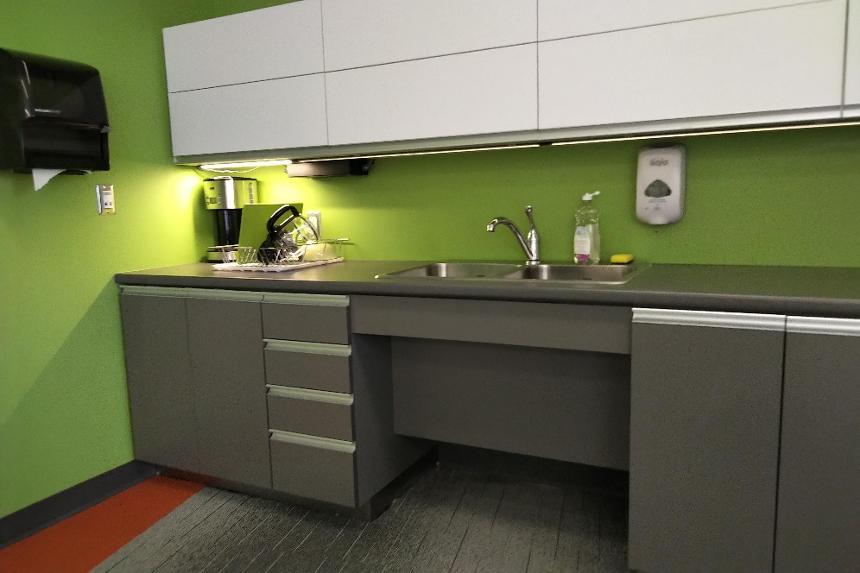
Figure 20: Kitchen sink with knee clearance (Photo courtesy of Julie Sawchuk)
    - Sink faucet is easy to use or automatic (Maximum Points: 3)
Minimum Points:
- Provides easy-to-use faucet or an automated faucet on sink
- Ensures the faucet can be reached from a seated position
Maximum Points:
- Provides colour coding on faucet to clearly identify cold/hot (e.g., blue/red or C/H)
- Provides single lever handles, if lever type handles are used
- Note: Separate controls for hot and cold water are not recommended. Single easy-to-use lever handle is preferred, if a manual faucet is provided.
Ideas for Innovation:
- Tactile labels or braille to identify cold/hot temperature
- Visual temperature indicator on faucet identifying the exact temperature of the water
    - Counter surfaces at accessible height (Maximum Points: 5)
Minimum Points:
- Provides an accessible height counter surfaces for users in seated position
- Provides knee clearance underneath accessible counter to allow front approach and improved reach ranges for wheelchair users
- Ensures no sharp or abrasive surfaces under it
- Ensures counters have rounded corners and edges
Maximum Points:
- Provides height options that allow people to work from either a standing or a seated position
- Ensures adjacent level work surface is provided beside all appliances
Ideas for Innovation:
- Power-operated height adjustable counters and islands
    - Microwave mounting height accessible and safe (Maximum Points: 4)
Minimum Points:
- Ensures the microwave is located on an accessible height counter with adjacent clear space on latch side of unit
Note: This allows users to transfer hot items on a counter safely.
- Ensure microwaves are mounted at an accessible height
Note: Microwaves placed overhead or below counter height are not accessible and can create potential significant burn/scald hazard.
Maximum Points:
- Has pull-out counter (cutting-board style) underneath unit/counter
Ideas for innovation:
- Kitchen appliances include signage with braille to help identify appliances
    - Vertical side-by-side refrigerator (Maximum Points: 2)
Minimum/Maximum Points:
- Ensures fridge and freezer can be accessed without having to bend down or reach
- Ensures refrigerator has two doors — one freezer compartment and one fridge (side-by-side)

    - Accessible storage options (Maximum Points: 3)
Minimum Points:
- Ensures storage units are at accessible height and location for people using wheeled mobility devices
- Ensures cupboards and drawers have accessible hardware so that they can be easily opened
- Ensures items may be accessed with minimal bending or reaching
Maximum Points:
- Provides flexible storage options (e.g., fold-down shelves, pull-out drawers, circular shelving)
    - Variety of seating and table options (Maximum Points: 5)
Minimum Points:
- Ensures tables are at an accessible height for all users
Note: Where elevated tables are desirable (e.g., bar style), they are provided in addition to accessible tables.
- Provides seating with back support and at least one armrest
- Ensures a variety of seating options are available to suit different people, including seats with and without arm rests, seats with backrests, and fixed and movable seats
Maximum Points:
- Offers a variety of seating options to suit different people (e.g., seats with and without armrests, different seat height and width, fixed and movable seats)
- Provides flexible seating that allows seating arrangements to be easily altered to accommodate individual situations
- Provides adequate heel space to allow people to stand up easily
    - Well-illuminated (Maximum Points: 3)
Minimum/Maximum Points:
- Provides adequate lighting for the nature and use of the space
- Provides task lighting at work surfaces

  - Acoustic Considerations
(Maximum Score: 10)
Acoustics should be appropriate for the type of Site and enable all users to hear clearly without interference from background noise or excessive reverberation. Acoustics are influenced by several factors, including layout, room shape and size, fabrics, and furnishings. In general, soft surfaces, such as carpeting, curtains, ceiling tiles and upholstery, will absorb sound; hard surfaces, such as concrete, brick, tile, and wood, tend to reflect sounds, which can create a noisy and echoing environment.
The location of a Site or room is important when it comes to acoustics. If it is located on a busy thoroughfare, sound damping materials such as double-glazed windows will help to reduce the effects of outside noise. Heating, ventilation, and air conditioning (HVAC) systems, can sometimes be noisy. Most building systems are electro-mechanical. The acoustic properties of boilers used for heating, or chillers used for air conditioning are determined at the design stage.
    - Sound damping and background noise (Maximum Points: 5)
Minimum/Maximum Points:
- Ensures all users, including those wearing assistive hearing technology and cochlear implants, can hear clearly with minimal interference from background noise
- Provides carpets, foam boards, ceiling tiles, soundproof curtains, corkboard, or other wall padding to reduce noise by absorbing sound
- Ensures ceiling design does not create echo
Note: Curved ceiling can amplify sound but also cause terrible echoes.
Ideas for Innovation:
- Sound design to reduce echo within a building can include the use solid-core doors
    - Volume of speakers and voice paging systems adjustable per area (Maximum Points: 3)
Minimum/Maximum Points:
- Provides individual controls to allow systems to be operated independently for different areas of a Site
Ideas for Innovation:
- Multiple speakers within the space, with a PA system that adjusts its volume based on ambient conditions (e.g., occupancy and noise level)

    - Double-glazed windows are installed (Maximum Points: 2)
Minimum/Maximum Points:
- Has double-glazed windows installed in areas susceptible to outside noise

  - Illumination and Building Systems
(Maximum Score: 28)
Illumination is an important measure of accessibility for a range of interior facilities — from building entrances, hallways, elevators, ramps, and interior stairs.
While proper lighting helps everyone, it is particularly important for people with low vision or for anyone who has difficulty making out surroundings when they are too bright or too dark. Good illumination enables people to move safely and independently around the built environment and aids them with perception of space, colour, and texture. It also helps people identify features and signage. Lighting also optimizes visual communication and lip-reading or speech-reading for people who are deaf or hard of hearing.
Appropriate lighting depends on the nature and use of a space. Lighting should be positioned such that it minimizes glare, reflection, or shadows. Glare can cause confusion or disorientation, and shadows reduce visibility or create false impressions, which can create potential tripping hazards.
Interior lighting includes all sources of natural and artificial light, including windows, skylights, glazed doors, glazed walls, and light fixtures. Flexibility within lighting design, such as provision of local lighting and task lighting, enables people to control their own lighting levels. Passive infrared sensors can also be used to increase light levels automatically. It is important to note that some fluorescent lights cause interference with hearing enhancement equipment.
    - Flooring, walkway, ramp, and stairway surfaces are well illuminated (Maximum Points: 4)
Minimum Points:
- Ensures flooring, walkway, ramp and stairway surfaces are illuminated and can be used safely at any time of day or night
- Ensures shadows and reflective glare are minimized
Maximum Points:
- Provides additional lighting at circulation routes such as walkways, ramps and stairs
Ideas for Innovation:
- Photoluminescence (glow-in-the-dark) treatments on fixtures (e.g., obstacles, features, stairs)

    - Lighting levels are consistent throughout site (Maximum Points: 4)
Minimum Points:
- Ensures light is evenly distributed throughout rooms and circulation areas
- Ensures light levels in hallways and corridors are similar to feature areas, rooms, and spaces
Maximum Points:
- Ensures generally higher light levels (e.g., 25% higher than standard)
Ideas for Innovation:
- Lighting that reduces eye fatigue, including flicker and glare-minimizing light bulbs and full-spectrum fluorescent tubes
    - Lighting individually controlled in task areas (if required for expected usage) (Maximum Points: 4)
Minimum Points:
- Provides flexibility within lighting design, such as localized lighting and task lighting, enabling people to control their own lighting levels
Maximum Points:
- Uses passive infrared sensors to increase light levels automatically
- Uses dimmer switches and high wattage light bulbs whenever possible and appropriate so that lighting levels may be adjusted to suit the needs of different users of the space
    - Interaction between lighting and surfaces minimizes glare (Maximum Points: 3)
Minimum/Maximum Points:
- Ensures lighting is positioned to minimize glare, reflection or shadows
Note: Glare can cause confusion or disorientation, and shadows reduce visibility or create false impressions, which can create potential tripping hazards.
- Ensures surfaces minimize any glare or reflection
Note: Glare is reduced by using matte finishes, low-gloss varnish, and non-reflective glass and by avoiding mirrored surfaces.
    - No abrupt changes in lighting levels between outdoor and indoor spaces (Maximum Points: 3)
Minimum/Maximum Points:
- Ensures people can transition easily between outdoor and indoor areas, with no sudden contrast in light levels
    - Building controls are at accessible heights (Maximum Points: 4)
Applies to building controls that Site users is expected to operate
Minimum/Maximum Points:
- Ensures electrical outlets and light switches are mounted at accessible height and reach
- Ensures clear space is provided in front of outlet and switches
    - Windows are glazed or fitted with material to reduce glare (Maximum Points: 3)
Minimum/Maximum Points:
- Ensures windows have anti-glare, non-reflective properties or coatings
Note: Tinted glass, exterior awnings and canopies, and translucent wall panels can help minimize glare and shadows.
- Provides window blinds or shades to control glare from the sun
    - Drinking fountains are accessible (Maximum Points: 3)
Applies to drinking fountains and bottle filling stations
Minimum Points:
- Ensures they are mounted at an accessible height or mounted at variety of heights
- Ensures clear space is provided in front of drinking fountain/bottle filling station
- Ensures operating controls are within accessible reach ranges and can be operated with one hand and not require tight pinching, grasping, or twisting of the wrist
- Ensure they are recessed or cane detectable if they are installed along a path of travel
Maximum Points:
- Ensures they are colour contrasted with adjacent surfaces
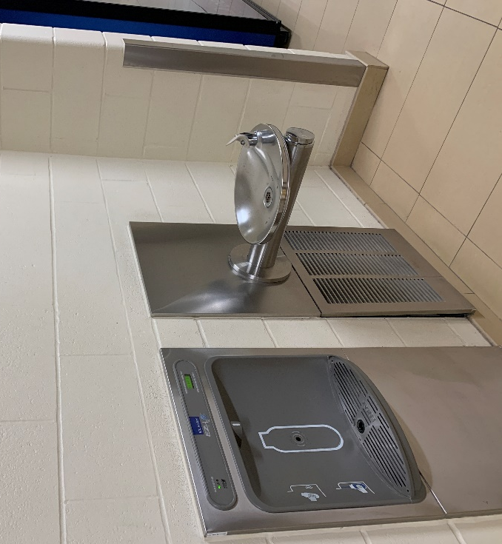
Figure 21: Drinking fountain and bottle filling station recessed and at accessible height

- Sanitary Facilities
The table below displays the Site elements used to measure accessibility for this category, the corresponding maximum score available for each, and the category total.
Site Element | Maximum Score
5.1 Washrooms | 93
5.2 Showers | 42
Innovation | 14
Total Maximum Score | 149
Description
Creating accessible sanitary facilities goes well beyond ensuring barrier-free entrances or installing grab bars. They must ensure the protection of an individual’s privacy, dignity, and security while accommodating a much wider user group than in years past. Demand for real accessibility in public or commercial sanitary facilities is increasing due to our aging population combined with a more active community of people with disabilities.
To accommodate a range of users, no-touch features are recommended. Because they are more accessible and more sanitary for everyone, the more no-touch features, the better. These include screen walls or motion-controlled power-operated doors, automated toilets, faucets, hand dryers, dispensers, and other accessories.
Single-user washrooms at trailheads, including prefabricated washroom units, should be located on an accessible route. They must meet technical requirements for signage, have clear floor space inside the washroom and around the toilet, and have sinks, urinals, switches and controls, electrical outlets, grab bars, and doors.
Refer to the latest version of CSA B651 for additional details on washroom and shower facilities.
  - Washrooms
(Maximum Score: 93)
In commercial and public buildings, washrooms that provide accessible features for people using mobility devices are typically designated as follows:
- Multiple occupancy washrooms that are either Male or Female, with multiple stalls, which may include accessible stalls and limited mobility stalls for independent use; and/or
- Universal washrooms are enclosed individual washrooms that typically include a single toilet and sink. They are gender neutral and provide the greatest flexibility and extra space for people who may need assistance, such as people with disabilities, older adults or small children, many of whom may have an attendant of a different gender. They allow people to attend to their personal needs in privacy and with dignity. In most cases, users should be able to access these facilities without a key or without having to ask for assistance.
Conventional, multiple occupancy washrooms that are either Male or Female must be accessible and user-friendly. Stalls, urinals, and hand-washing facilities should be arranged logically, based on typical user behaviour, with at least one accessible toilet stall to accommodate people with wheeled mobility devices. At least one limited mobility stall—a standard-sized stall equipped with rear and sidewall grab bars—should be considered in addition to the accessible stall(s).
Note: In existing Sites, if it is difficult to provide accessible stalls in multiple occupancy washrooms, universal washrooms can be provided instead.
Universal washrooms are required to be placed adjacent to all newly constructed projects and should have a separate entrance.
    - Number of accessible washrooms adequate for expected use (Maximum Points: 5)
Minimum/Maximum Points:
- Ensures number of accessible washrooms, including universal washrooms and/or multiple occupancy gender washrooms with accessible stalls, are available for expected use
Ideas for Innovation:
- Child and ambulatory stall are available for people who use cane or crutches, where multiple occupancy washrooms are provided
    - Universal washrooms (Maximum Points: 5)
Minimum Points:
- Provides at least one universal washroom inside the building
- Provides suitable clearance and manoeuvring spaces inside universal washroom for wheeled mobility devices
- Includes accessible fixtures (e.g., grab bars, sink with knee clearance, etc.)
Maximum Points:
- Provides universal washroom at each washroom cluster
- Where more than one universal washroom is provided, ensures the layouts provide transfer space on either side of the toilet and installation of wall-mounted/fold-down grab bars, including a toilet paper dispenser, on both sides

    - Washroom identification signage (Maximum Points: 3)
Minimum/Maximum Points:
- Provides signage using standardized international symbols consistently for all washrooms throughout the building
- Ensures signage incorporates raised lettering and/or symbols
- Ensures Braille lettering is in a consistent location, near the bottom of the sign
- Ensures signage is mounted at recommended height
- If there is no door, ensures signage is mounted on the outside walls on both sides of the entrance
- If washroom has a door, ensures signage is mounted on the wall on the latch side of the entrance to ensure people who are blind or have low vision can read tactile signage safely
- Note: Tactile signage should not be mounted on the door itself as people who are blind or have low vision would be on the direct path of travel of others when reading the signage.
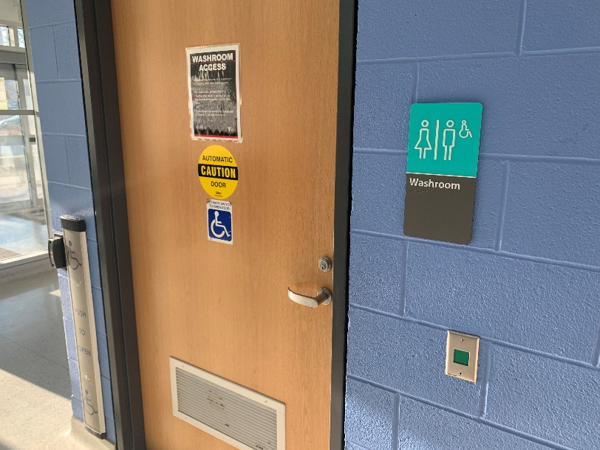
Figure 22: Washroom identification signage with tactile marking and braille
    - Power-operated door or screen wall entry (Maximum Points: 5)
Minimum/Maximum Points:
If power-operated door:
- Takes at least three seconds to move from a closed to fully open position
- Remains fully open for a sufficient length of time to allow all Site users to safely enter or exit, including people who are slow moving—at least five seconds
- Has easy to identify control(s) mounted at accessible height and location, clear of door swing, if manual power-operated door controls are provided

If screen wall entry:
- Has suitable clear width and manoeuvering space for wheeled mobility devices
    - Minimum force required to open entry door (Maximum Points: 3)
Apply to free-swing door and door that has a closer
Minimum/Maximum Points:
- If manual door, ensures it is easy to open with minimal force (e.g., low friction hinges or light weight door)
- Ensures the force applied at the handle, push plate, or latch-releasing device does not exceed 22 N (5 lbf.)
- Ensures self-closing doors are equipped with automated delayed-action closers
- Ensures the effort needed to overcome the resistance of the door closer is low enough to allow people with disabilities to pass through with reasonable ease
- Ensures delayed-action door closers allow the door to remain open long enough so that all users can pass through; the closing period is not less than three seconds
Note: This is measured when the door is in an open position of 90° to a semi-closed position of 12°.
    - Clear opening width of entry and toilet stall doors (Maximum Points: 3)
Includes entry doors to the washroom facilities and stall door of the accessible toilet stall
Minimum/Maximum Points:
For entry/stall door:
- Provides adequate clear width to accommodate power wheelchairs and scooters and other wheeled mobility devices
- Provides clear space for manoeuvring on both sides of door
- Ensures stall doors open outward to provide ample room for manoeuvring inside the stall for a wheeled mobility device
Note: If doors are inward opening, they should be equipped with lift-off hinges to allow removal of the door if a person becomes trapped.
For screen wall entry:
- Ensures screen wall is easy to navigate, with no 90° outside edges or obstructions
- Provides adequate clear width to accommodate all users and for two people to pass easily

    - Entry door and toilet stall door have accessible hardware (Maximum Points: 3)
Minimum/Maximum Points:
- Ensures the opening hardware on entry or toilet stall doors, including handles, pulls, latches, locks, and other operational devices, is easy to use (i.e., operable with one hand, using minimal force, and not requiring fine finger control, tight grasping, pinching, or twisting of the wrist)
- Provides a graspable pull on the inside face of the door (near the hinge side) as well as on the outside of the door (near the latch side)
- Ensures locking hardware on entry or toilet stall doors is operable with one hand, using a closed fist position
Note: A sliding-style lock is accessible to all users, if they are operable with a closed fist. Rotary locks are not appropriate, as they require good dexterity to operate unless modified to include flanged handles.
- Ensures entry or toilet stall doors can be unlocked/released from the outside in case of emergency
Note: Doors to washrooms and other enclosed spaces with no other exit should not be equipped with deadbolts or other means of security which can only be manipulated from the inside.
- Provides D-handle mounted on the pull side of the door, where no automatic closers are present
    - Entry door and toilet stall door are colour contrasted with adjacent surfaces (Maximum Points: 3)
Minimum/Maximum Points:
- Ensures door contrasts visually with adjacent walls, if there is an entry door
- Ensures wall surfaces contrast visually with the floor, if screen wall entry is used
    - Clear space for manoeuvring and transfer (Maximum Points: 5)
Minimum/Maximum Points:
- Dimensions ensure that a wheelchair user has suitable clearance and floor space to manoeuvre inside the washroom and position themselves in front of accessible stall, sink, urinal, and all washroom accessories
- Dimensions ensure that a wheelchair user has clear space to turn and position themselves adjacent to the toilet

Maximum Points:
- Ensures toilet stall door aligns with the transfer space adjacent to the toilet to enable wheeled mobility devices to head directly to the transfer space without having to manoeuvre around the toilet
- Dimensions ensure that a wheelchair user has the choice of preferred transfer arrangements (i.e., lateral, angled, frontal, or rear)
Note: Overall required dimensions depend on the door position and whether the door swings inwards or outwards, and whether the toilet is wall hung or floor mounted.
    - Grab bars at appropriate height and locations at toilets (Maximum Points: 5)
Minimum Points:
- Ensures diameter of grab bars is appropriate for holding
- Ensures grab bars are mounted on the side wall beside the toilet, with adequate clearance from the wall and other fixtures
- Ensures grab bars are mounted securely
Note: Grab bars should not be mounted on stall dividers unless they are rated to carry a minimum load of 133 kg.
Maximum Points:
- Ensures side grab bars are L-shaped or at an angle of 120° (elbow style), and installed based on current best practice for height and positioning to allow for easier use by people with reduced arm strength
- Provides grab bar on the rear wall centred over the toilet and with suitable clearance if tank-style toilet is provided
- Ensures a rear-wall-mounted, fold-down grab bar located on the transfer side of the toilet is available to assist people who are ambulatory but still require support
Note: Force required to pull down grab bar should not exceed 22 N (5 lbf.).
    - Toilets at appropriate height and have back supports (Maximum Points: 5)
Minimum Points:
- Ensures toilet seat is at a suitable height and secured (e.g., not spring activated)
- Provides a back rest or toilet seat lid so someone with limited balance can lean against it; the toilet seat is not the spring-up type
Maximum Points:
- Ensures the tank is secured (bolted down) so someone can lean on it during a transfer, where a tank-type toilet is used
- Provides a toilet seat cover that rests against a rear grab bar at an angle of between 95° and 110° for back support, where a tank-type toilet is not used
Ideas for Innovation:
- Adaptive devices such as toilets seats that wash and dry users automatically and/or lift toilet seats
    - Toilet flushing mechanisms are within easy reach (Maximum Points: 4)
Minimum Points:
- Ensures hand-operated flushing controls are accessible and easy to use
- Ensures toilet flush controls are positioned on the transfer side of the toilet (the side opposite the wall), or within easy reach for a person who has transferred back onto their wheeled mobility device, eliminating the need to reach over the toilet to flush
Note: For many people using wheelchairs or with mobility disabilities or poor balance and for people who are blind or have low vision, this reach creates an unnecessary falling hazard.
Maximum Points:
- Ensures flush controls are automatically activated and have a manual flush override control within easy reach from the transfer side of the toilet
    - Toilet paper dispensers at appropriate height and locations (Maximum Points: 5)
Minimum Points:
- Ensures toilet paper dispenser is mounted on the side wall, typically below the grab bar and within comfortable reach from a sitting position (typically in line with the front edge of the toilet)
Note: If users are required to reach up or in front of the toilet, this creates a significant falling hazard for most people with mobility and vision disabilities.
Maximum Points:
- Provides an open-roll toilet paper dispenser design as they can easily be mounted under grab bars therefore allowing people with limited mobility or dexterity to grasp and pull
    - Power outlet near toilet (Maximum Points: 2)
Minimum/Maximum Points:
- Ensures an AC outlet or at least has a spot roughed in for the outlet adjacent to each accessible toilet to accommodate adaptive devices and technology, such as personal hygiene devices, heated seats, automatic seats, in anticipation of electrically operated assistive devices
Note: This should be required in all new construction.

    - Accessible urinals with clear space (Maximum Points: 5)
Minimum/Maximum Points:
- Provides clear space, centred in front of the urinal(s), with sufficient space for approach by people using mobility devices
- Ensures clear space is adjacent to an accessible route and unobstructed by floor level changes or privacy screens
- Ensures urinals are stall-type or wall-hung bowls
Note: Urinal troughs should never be used as they are inappropriate for people who are blind or have low vision.
- Ensures at least one urinal is mounted at a lower height to accommodate people of short stature and children
- Ensures at least one urinal is equipped with two vertically mounted grab bars (one on either side), to provide support for people with walking aids
- Provides flush controls that are automatic or easily operated manually with a closed fist
- Provides privacy screens between each urinal and between the urinals and adjacent sink or cubicle area
    - Urinals are colour contrasted with adjacent surface (Maximum Points: 2)
Minimum/Maximum Points:
- Ensures urinals are colour contrasted with the surrounding surfaces
- Provides tactile centreline indicator for people who are blind or have low vision
Note: This can be achieved by installing a raised piece of tile in a contrasting colour above the urinal.
    - Sink and counter at accessible height with knee clearance (Maximum Points: 5)
Minimum Points:
- Ensures sink and counter are at accessible height
- Provides adequate knee clearance underneath the sink and counter
- Ensures hot water and drain pipes are offset to the rear, to help protect people using wheelchairs from burns and abrasions
- Ensures the accessible sink is clearly identified using the international symbol where only one sink is equipped with an offset drain
- Ensures hot water pipes are insulated or covered
- Ensures faucet is easy to reach
- Ensures there are no sharp corners and edges on counters, shelves, and vanities

Maximum Points:
- Ensures washroom sinks intended for use by people with disabilities include a counter or adjacent shelf
- Provides a step at one sink without blocking wheelchair access, where possible
- Provides a corner sink, if larger accessible stalls are available
Note: If space is available, a corner sink should be incorporated into the stall design. Space can often be created by realigning the stall entry door.
Ideas for Innovation:
- Power-operated adjustable height sinks and counters to allow a variety of heights for use by various users
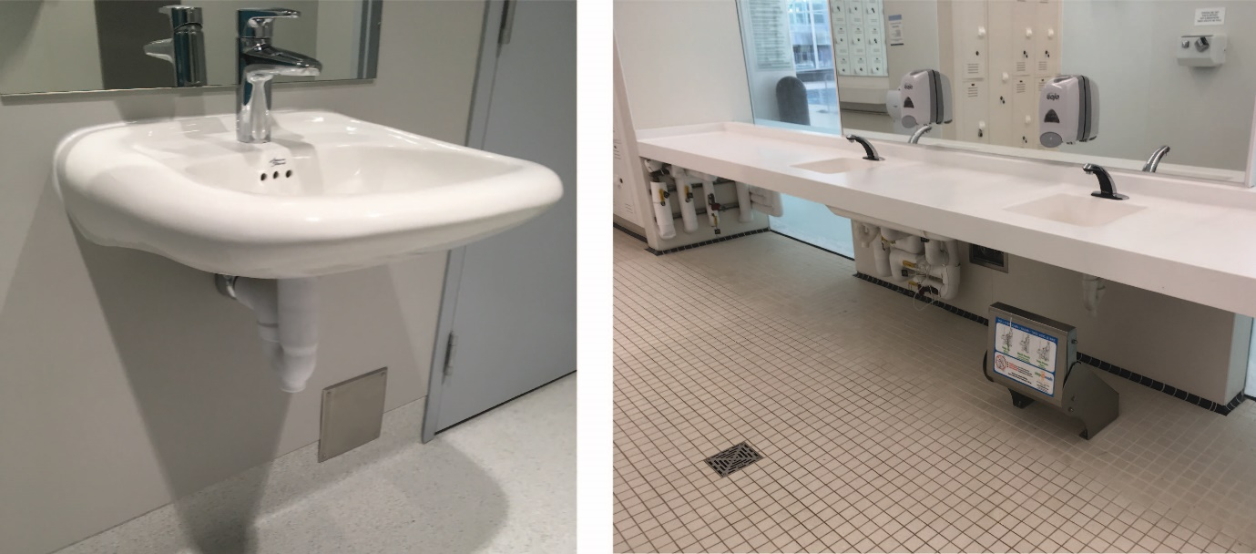
Figure 23: Sinks with knee clearance and insulated water pipe (left). A fold-down step is available at one of the sinks (right)
    - All washroom accessories at accessible heights and locations (Maximum Points: 4)
Applies to any washroom accessories which includes but is not limited hand dryers, paper towel dispensers, soap dispensers, mirrors, coat hooks, dispensing machines, and sanitary disposal receptacles
Minimum Points:
- Ensures all washroom accessories have their operating controls and dispensing areas at accessible height above the finished floor
- Ensures soap dispensers are easy to use and within reach from sinks
- Ensures at least one hand dryer or paper towel dispenser is positioned adjacent to the sink and soap dispenser and within easy reach from a seated position
Note: Pushing a wheelchair with wet hands to access a paper towel dispenser is hazardous—not only do hands become dirty again, but wet hands can also slip off the wheel, which can cause the wheelchair user to fall. Wet hands are also hazardous for people using walking aids, as people can lose their grip.
- Ensures mirror is usable from a seated position
Note: Fixed mirrors with their base at 900‑1,000 mm AFF are preferred.
- Provides a coat hook on the side wall at an accessible height; not on the door
- Has sanitary disposal receptacles mounted on the side wall and within easy reach of toilet
- Ensures garbage cans or other obstacles do not block access to the paper towel dispensers or the required pull space beside the exit door
Maximum Points:
- Provides both automated hand dryers and paper towel dispensers
- Provides shelves for personal appliances that do not project into path of travel
- Has a complete range of washroom accessories available that are all accessible
Ideas for Innovation:
- Clear space for left and right hand use of fixtures/accessories
    - Automated or easy-to-operate plumbing fixtures and accessories (Maximum Points: 4)
Minimum Points:
- Ensures all washroom accessories are operable with one hand, using minimal force, and not requiring fine finger control, tight grasping, pinching, or twisting of the wrist
- Provides accessible faucets with a single, thermostatically controlled, lever-operated faucet
Note: Hands-free is preferred but if manual faucets are used, separate controls for hot water and cold water are not permitted.
- Ensures hand dryers or paper towel dispensers are easy to operate by people with reduced dexterity
Note: Many designs require users to reach up, often with both hands, grasp firmly, and pull down, which is not accessible for people with disabilities.
Maximum Points:
- Ensures all plumbing fixtures and accessories are accessible and automated (automatic hands-free design)
- Provides visual and tactile temperature indicators on faucets

    - Floor surface is stable, firm, and non-slip (Maximum Points: 4)
Minimum/Maximum Points:
- Ensures surfaces are stable and firm
- Ensures surfaces have non-slip finish for both wet and dry conditions
- Ensures all surfaces are non-glare and have non-slip textured finishes
    - Colour contrast between floor and wall, and fixtures (Maximum Points: 2)
Minimum/Maximum Points:
- Uses visual or colour contrast between wall and floor to enhance depth perception, assist in wayfinding, and minimize vertigo in users
- Ensures all accessories are colour contrasted with their mounting surfaces
    - Emergency call button (Maximum Points: 3)
Minimum Points:
- Provides an emergency call button in all accessible washroom stalls and universal washrooms to allow people that may have fallen to call for assistance
Note: An emergency call system with both audible and visual signals that includes a cancellation feature to override call in case button was activated by accident should be provided.
- Ensures call button is operable with one hand using a closed fist and minimal force, without requiring fine finger control, tight grasping, pinching, or twisting of the wrist
- Ensures call button is mounted on an open clear wall at a height where a person who is unable to get up from the floor can use it
Note: Call button located at a centreline mounting height of 450 mm above the finished floor and mounted on a clear wall within 600 mm of the toilet allow easy access.
Maximum Points:
- Ensures emergency call button is operable from a supine position
Ideas for Innovation:
- Emergency call buttons mounted at two heights, with one accessible from a supine position and other from a seated position

    - Child change table at accessible height (Maximum Points: 2)
Minimum/Maximum Points:
- Provides change table for parents and caregivers of either gender
- Ensures change table is mounted at an accessible height with knee clearance (preferably adjustable)
- Ensures change table is located within safe reach of sink and hand dryer
    - Adult change table (if universal washroom) (Maximum Points: 3)
Minimum Points:
- Provides a manually-operated variable-height adult change table in universal washrooms to assist people who are unable to stand while getting dressed
Note: A variable-height gurney could be used instead of the bench if placed beside a wall.
Maximum Points:
- Provides a power-operated variable-height adult change table with easy to use controls
Ideas for Innovation
- A tracking hoist system to eliminate the need to lift a person manually if self-transfer is not possible
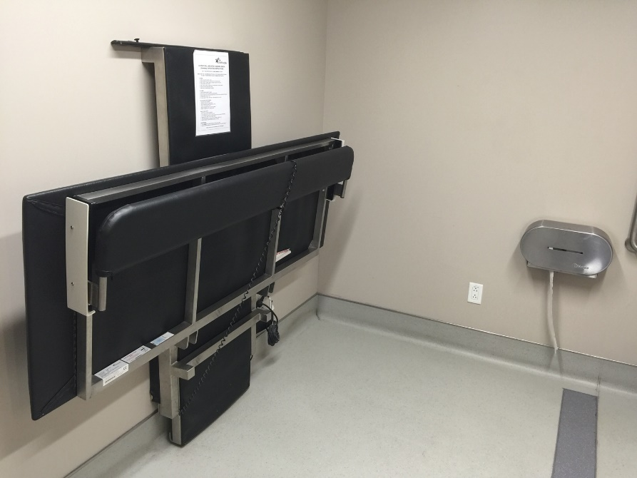
Figure 24: Adjustable height adult change table available in universal washroom

    - Well illuminated (Maximum Points: 3)
Minimum/Maximum Points:
- Illuminates all areas of washrooms so people can navigate and use the washrooms
- Provides adequate lighting for the nature and use of the space
- Ensures surfaces minimize any glare or reflection
- Provides flat, even light to minimize shadows

  - Showers
(Maximum Score: 42)
In areas where showers are required, at least one shower must be accessible. Accessible shower facilities should be provided in single-gender communal shower and changing areas. If possible, separate universal shower facilities, containing a shower, toilet, sink, and accessories, should also be provided. Universal shower facilities enable a caregiver of a different gender to assist. They should be located adjacent to single-gender changing facilities and near the areas they serve.
    - Number of accessible showers adequate for expected use (Maximum Points: 5)
Minimum/Maximum Points:
- Ensures number of accessible showers are available for expected use
Ideas for Innovation:
- A universal shower facility with an adult change table is available to allow people to attend to their personal needs in privacy and with dignity
    - Roll-in shower (Maximum Points: 5)
Minimum Points:
- Provides adequate clear floor area in front of shower entrance
- Ensures entrance to shower area has an adequate clear width
- Has easy-to-access roll-in shower for people using wheelchairs, with adequate clear space for manoeuvring
- Ensures no fixtures that project into clear area impede required clear space
- Ensures threshold does not exceed 13 mm in height and is beveled at a maximum slope of 1:2
Maximum Points:
- Ensures threshold is flush with floor and incorporates an integral floor drain or a collapsible water barrier
- Provides curtains for privacy and to keep the surrounding area dry
- Ensures any enclosures, such as doors or curtains do not obstruct transfer or controls
Ideas for Innovation:
- Emergency call button in all accessible roll-in shower

    - Grab bars at appropriate heights and locations (Maximum Points: 5)
Minimum/Maximum Points:
- Provides grab bars at suitable mounting height and locations as follows:
- Vertically on the side wall on the same side as the shower seat
- Horizontally on the side wall opposite from the shower seat
- Horizontally and vertically on the back wall, reachable from the shower seat
- Ensures grab bars are graspable and colour contrasted with the surrounding surfaces
- Ensures grab bars are mounted securely
    - Floor surface is stable, firm, and non-slip (Maximum Points: 4)
Minimum/Maximum Points:
- Ensures surfaces are stable and firm
- Ensures all surfaces are non-glare and matte finish and have non-slip textured finishes, as polished surfaces cause glare and can be slippery
- Ensures floor is level with minimal slope for drainage and includes integral floor drain
Note: Trench or channel drains are recommended.
- Ensures there are no sharp edges or trims
    - Colour contrast between shower tile floor and wall (Maximum Points: 2)
Minimum/Maximum Points:
- Ensures colour contrast is provided between the shower tile flooring or base and the front wall
    - Water control mounted on wall at accessible height (Maximum Points: 4)
Minimum/Maximum Points:
- Ensures controls are within easy reach from a seated position
- Ensures faucet is operable with one hand using a closed fist and requires minimal force
- Identifies temperature (e.g., hot and cold) and volume controls clearly and unambiguously to protect users from scalding water
    - Hand-held adjustable showerhead within easy reach (Maximum Points: 3)
Minimum/Maximum Points:
- Ensures hose length is adequate
- Provides a detachable showerhead with adjustable height, enabling alternative showering positions (both sitting and standing)
    - Shower accessories at accessible height and within reach (Maximum Points: 3)
Minimum Points:
- Ensures soap holders or shelves for toiletries are easy to reach from a seated position
- Ensures soap holders or shelves do not impede required clear space and are of adequate size to hold toiletries
- Provides easy-to-reach towel bar and clothes hook at accessible height
- Ensures mirrors are at accessible height, if provided
Maximum Points:
- Ensures soap holders or shelves are recessed
Ideas for Innovation:
- Warm-air body dryer in showers and changing areas
    - Fold-down shower seat (Maximum Points: 3)
Minimum/Maximum Points:
- Provides fold-down shower seat for showering or changing; a seat that folds to a horizontal position allows persons to use the shower in a seated or standing position
- Provides a smooth, non-slip surface without rough edges
- Provides easy-to-clean seat of adequate size and strength
- Ensures seat does not impede clear space of shower
- Provides seat that is colour contrasted with surrounding surfaces
    - Adult change table (Maximum Points: 5)
N/A only if shower is located in a change room that includes adult change table
Minimum Points:
- Provides a manually operated variable-height adult change table to assist people who are unable to stand while getting dressed
Note: A variable-height gurney could be used instead of the bench if placed beside a wall.
Maximum Points:
- Provides a power-operated variable-height adult change table with easy to use controls
Ideas for Innovation
- A tracking hoist system to eliminate the need to lift a person manually if self-transfer is not possible

    - Well-illuminated (Maximum Points: 3)
Minimum/Maximum Points:
- Illuminates all areas of showers so people can navigate and use the shower
- Provides adequate lighting for the nature and use of the space
- Ensures surfaces minimize any glare or reflection

- Wayfinding and Signage
The table below displays the Site elements used to measure accessibility for this category, the corresponding maximum score available for each, and the category total.
Site Element | Maximum Score
6.1 General Wayfinding and Signage | 42
6.2 Room Identification Signage | 18
6.3 Directory Boards and Interactive Information Kiosks | 24
Innovations | 8
Total Maximum Score | 92
Description
Wayfinding is how people navigate the built environment to get from one place to another. Good wayfinding ensures people can move independently within a Site by providing multiple cues and engaging the senses.
It allows people to (1) determine their location within a setting; (2) determine their destination; (3) develop a plan to take them from their location to their destination; and (4) execute the plan and negotiate any required changes.
Wayfinding is particularly important in complex environments. Without it, people can become disoriented and frustrated. All strategies for wayfinding should communicate effectively to the broadest group possible, including people with a wide range of sensory abilities, intellectual abilities, literacy levels, languages, and physical statures.
Wayfinding relies on both architectural and information cues that help people to construct a mental map of the area. Architectural wayfinding helps people to establish a pattern in the environment and includes spatial planning, architectural forms, and circulation systems.
Examples of architectural wayfinding include:
- Clearly defined paths and hallways and well-defined edges, such as walls, screens or columns
- Elevators, ramps, and stairs in obvious and consistent locations
- Recurring elements, such as washrooms, elevators, and emergency exits, are in the same place on each floor of a multi-storey Site
- Markers or unique features that people associate with different parts of a Site; they can be multi-sensory and may include a special lighting fixture, art piece, window, or water feature—something that people can use to easily identify a particular area or location
- Interior design features, such as distinctive wall and floor treatments or colours, that define different zones in a Site
Note: This is an inexpensive, low-tech way of guiding people through a venue, and it is helpful for people with low vision and for those who are unable to read the language on conventional signage.
“Information wayfinding” delivers information directly with visual, tactile, and audible formats.
Examples of information wayfinding include:
- Visual and tactile signs (e.g., raised characters/symbols or pictograms and braille)
- Audible information, such as public address systems that provides both visual and audible information
- Mobile apps that Site users can access from their mobile devices; some facilities, such as hospitals, provide custom apps that guide users as they navigate a building
  - General Wayfinding and Signage
(Maximum Score: 42)
Both wayfinding and general signage refer to elements related to “architectural wayfinding” and “information wayfinding”. At its simplest, architectural wayfinding may be provided via interior design features, such as distinctive floor and wall treatments, as well as colour and sound elements used to delineate a space. A carpeted area adjacent to linoleum may be used to differentiate different uses of space in a Site. At Vancouver International Airport, for example, all boarding areas are identified using carpeting, while exits are identified with tile flooring, and all retail areas with other floor surface treatments.
Similarly, information wayfinding may be provided via signage and other modes of direct communication. Using a combination of both is the most effective means of identifying a space.
Signage should be simple, clear, consistent, and unambiguous. There are four basic types of signs used in wayfinding:
- Information or descriptive signs: These provide overall orientation to a Site and include maps, plans, diagrams, and directory signs; tactile maps and models which include Braille, raised characters, or symbols, provide orientation for people with a vision disability
- Directional signs: These include arrows providing directional guidance within any size of Site, and they are located where most visible, generally overhead and perpendicular to the path of travel; exterior route information should include approximate distance and gradient information where appropriate
- Identification signs: These identify specific locations, such as a particular Site or facility, or an individual room, and they include Site name signs and facility/room name or number signs
- Mandatory safety signs: These are required by regulation for the safety of all Site users and include fire safety signs and notices and emergency exit signs
Signs incorporating pictorial symbols along with text are helpful for people with learning disabilities or for those who are unfamiliar with the language used on the signage.
Signs need to be mounted so that people using wheelchairs as well as people with low vision can see them easily. Consistent placement of all signs throughout a building is a significant help for all visitors, including persons new to a building or those with a vision disability. Overhead signage is ineffective for most people who have low vision.
    - Directional signage is comprehensive and clearly visible (Maximum Points: 5)
N/A only if there is not a need for directional signage
Minimum Points:
- Ensures signage is located where it is clearly visible, which is generally overhead and perpendicular to the path of travel
- Ensures size of characters and/or symbols allows sign to be read from a reasonable viewing distance
Maximum Points:
- Ensures signs are mounted at consistent location throughout the building
- Ensures signage is uncluttered
Ideas for Innovation:
- Directional signs are in tactile formats (e.g., raised characters/pictograms or symbols and braille)
- “Talking signs” or a similar beacon or signal-based system for audio navigation
- Maps and route descriptions that are compatible with a text-to speech application, are available on the organization’s website
- Mobile apps that Site users can access from their mobile devices; some facilities, such as hospitals, provide custom apps that guide users as they navigate a building
- Free and strong wireless internet is available to Site users so that they can use mobile applications such as “Be My Eyes” and “AIRA”, which provide them with verbal instructions to navigate throughout the Site

    - Blade signage is used to supplement overhead signage where useful (Maximum Points: 4)
N/A only if not useful and depending on the layout of the Site
Minimum/Maximum Points:
- Provides projecting blade signage to ensure people can easily identify key rooms and amenities
- Ensures blade signage is visible and clear of obstruction
- Ensures size of characters and/or symbols allows sign to be read from a reasonable viewing distance
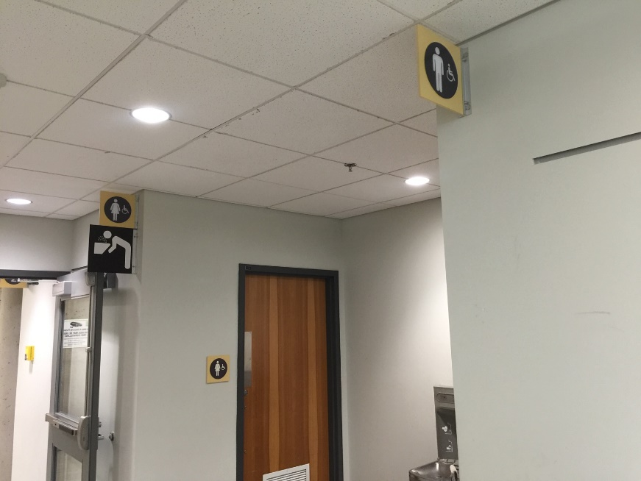
Figure 25: Use of blade signage to ensure facilities and amenities can be clearly identified
    - Wayfinding includes a variety of techniques (Maximum Points: 5)
N/A only if the building is a very small space or similar circumstance
Minimum Points:
- Ensures design features, such as distinctive wall and surface treatments or colours, are used to define different zones either inside or outside a Site
- Ensures elevators, ramps, and stairs are in obvious and consistent locations
Maximum Points:
- Ensures different areas at the Site are identified using unique multi-sensory features, such as a fountain, scented plants, a piece of art, etc.
- Ensures recurring elements, such as washrooms, elevators, and emergency exits, are in the same place on each floor of a multi-storey building
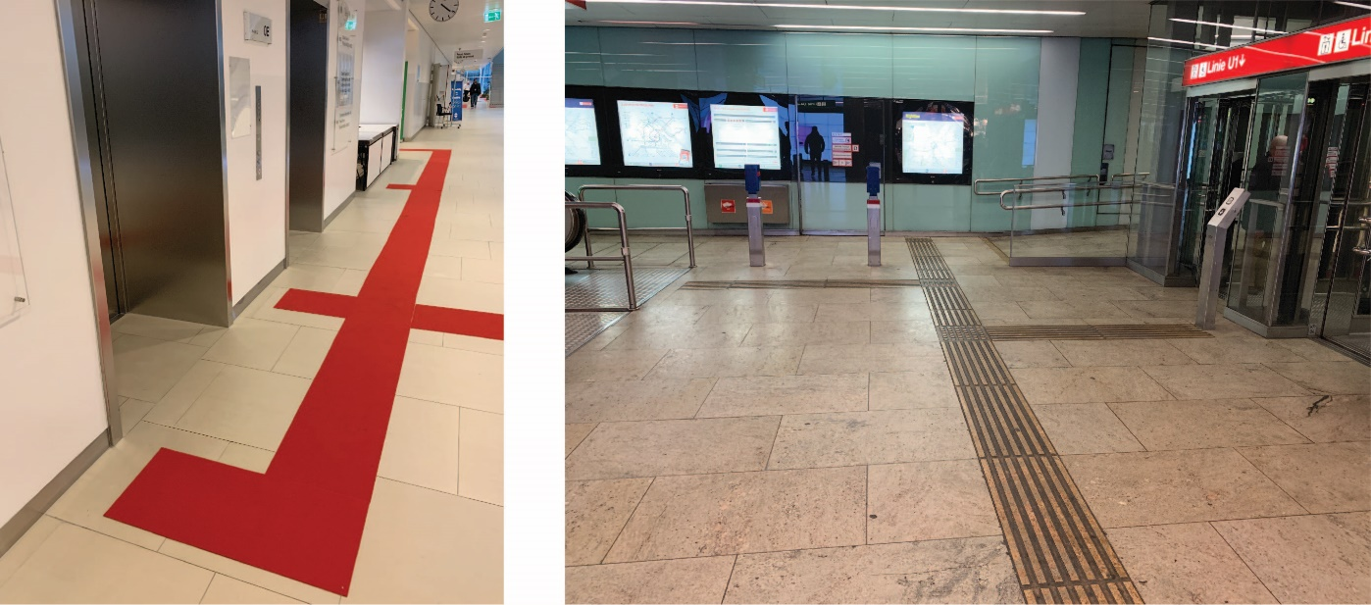
Figure 26: Use of colour-contrasted and tactile direction indicators on flooring
    - Signage uses Arabic numerals and/or sans-serif lettering (Maximum Points: 4)
N/A only if there are not any numbers or letters
Minimum Points:
- Uses easy-to-read sans-serif fonts, which are clear, uncomplicated, and which incorporate adequate spacing, and avoids decorative or italicized fonts, which people with low vision have difficulty reading
- Uses only Arabic numerals (1, 2, 3, etc.) and avoids Roman numerals, which are not universally recognized
Maximum Points:
- Uses a consistent font for all signage throughout the building
    - Lettering, numerals and symbols are clearly visible (Maximum Points: 5)
Minimum/Maximum Points:
- Ensures lettering, numerals, and symbols on all signage are suitable size and clearly visible from a distance
Maximum Points:
- Uses raised characters (e.g., lettering and numerals) and Braille directly below the text, which can be easily read by touch, and not engraved characters, if tactile signage is useful
Note: Characters and/or symbols are raised up 1 mm from the background.
- Avoids vertical wording and electronic scrolling signage
    - Signs have glare-free surface (Maximum Points: 4)
Minimum/Maximum Points:
- Ensures surface finish of signs is matte or satin, as shiny or reflective surfaces are a potential source of glare or reflections and may be difficult to read
Note: Signs mounted on reflective backgrounds or Plexiglas are ineffective for people with low vision.
    - High-contrast characters/symbols on single-coloured backgrounds (Maximum Points: 4)
Minimum Points:
- Ensures high colour contrast is provided between letters/symbols and the background surface of sign
Maximum Points:
- Ensures background surface of sign is single-coloured
- Ensures sign contrasts visually with the mounting surface (e.g., wall or other mounting surfaces, etc.)
    - Signs with text are efficiently worded (Maximum Points: 4)
N/A only if no text on sign
Minimum Points:
- Provides simple and brief wording
- Ensures words and short sentences begin with a capital letter and continue in lower case; using wholly capitalized words should be avoided
Maximum Points:
- Displays information logically
- Aligns wording to the left
- Avoids abbreviations

    - Use of international symbols/pictograms on signage where useful (Maximum Points: 4)
N/A only if clear that is not useful
Minimum Points:
- Uses standard, internationally recognized symbols in place of, or to supplement, text, which is helpful to people with learning disabilities, to children, or to people who do not understand the language used on the sign
Maximum Points:
- Ensures symbols that are not universally recognized are accompanied by text
    - Signs are well illuminated (Maximum Points: 3)
Minimum/Maximum Points:
- Ensures signs, including maps and directories, are evenly illuminated with an appropriate level of lighting for the room conditions and use
- Ensures any additional lighting does not create glare

  - Room Identification Signage
(Maximum Score: 18)
Room identification signage helps users identify specific individual room. They typically include room name and/or number.
Where electronic signs are used for room identification signage, it is important to provide information in alternative format such as audio or tactile information.
    - Room identification signage is used to identify spaces where useful (Maximum Points: 4)
N/A only if not useful for this type of building
Minimum/Maximum Points:
- Provides room identification signage to ensure people can easily identify principal rooms and doors
Note: Smaller rooms contained within main areas may not require room identification signage, unless these rooms are considered feature areas.
    - Sign includes Braille and characters/symbols that are raised (Maximum Points: 4)
Minimum/Maximum Points:
- Uses raised lettering, which can be easily read by touch, and not engraved lettering; lettering and/or symbols are raised up 1 mm from the background
- Ensures Braille is located directly below the text
- Ensures edges of characters are gently rounded
- Ensures room signage has the minimum number of characters possible, to assist people reading by touch
Note: Where signs are read by touch only, use all uppercase tactile characters as they are easier to read by touch than combination of uppercase and lowercase.
Ideas for Innovation:
- Braille signs are easier to read by touch if they are mounted on an inclined surface that is between 45° and 60° above the horizontal in the direction of the user
Note: Braille mounted vertically can be challenging to read.
- Having a marker or notch on the left edge to indicate the presence of braille on signs
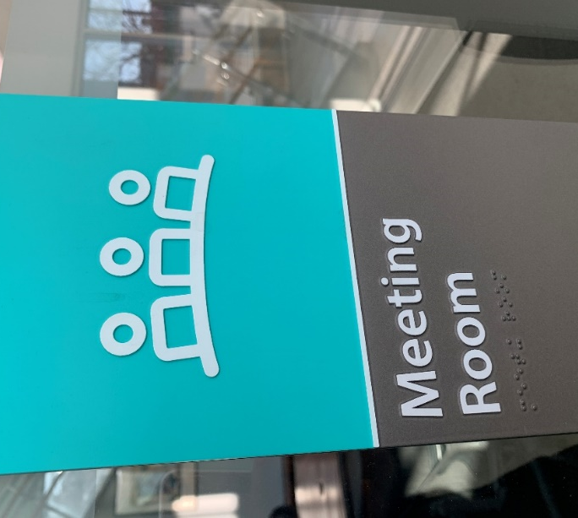
Figure 27: Room identification signage with tactile markings and braille
    - Sign at recommended height (Maximum Points: 4)
Minimum/Maximum Points:
- Ensures signs can be viewed from a comfortable viewing distance
- Ensure Braille and tactile features are within easy reach
    - Tactile sign at recommended location (Maximum Points: 3)
Minimum/Maximum Points:
- Ensures tactile signage is located on the wall on the latch side of doors or openings to ensure people who are blind or have low vision can read tactile signage safely
Note: It is recommended that tactile signs are within 150 mm of door jamb.
- Ensures tactile signage is not mounted on the door itself to ensure people reduce collision hazard by being out of the direct path of travel
- If no door, ensures tactile signage is installed at consistent location on both sides of the entrance
- Ensures signs are mounted at consistent location throughout the building
    - Logical numbering (Maximum Points: 3)
N/A only if not numbered
Minimum/Maximum Points:
- Ensures rooms are easy to locate and in numerical or other logical order
  - Directory Boards and Interactive Information Kiosks
(Maximum Score: 24)
This element applies to directory boards and interactive information kiosks that are found at commercial and residential buildings as well as at outdoor parks and recreational facilities. Most Sites have a directory board, while many retail outlets, such as shopping malls, will supplement a directory board with an information kiosk to enhance communication and the user’s experience.
IMPORTANT: This element does not include self-service transaction kiosks where tasks are completed (e.g., completing forms, paying, etc.). It only applies to kiosks that provide wayfinding information. Self-service transaction kiosks should be rated in Element 4.2 Reception Desks, Service Counters, and Self-Service Transaction Kiosks.
    - Comprehensive relevant information (Maximum Points: 5)
Minimum/Maximum Points:
- Provides information enabling people to clearly understand the layout and function of a space or environment and to navigate independently
- Includes a floor plan layout on each level for easy navigation and identification of amenities, where appropriate
Ideas for Innovation:
- Descriptions and directions of a Site are provided online for orientation and navigation
- Route information on a directory or kiosk including approximate distance or travel time, audio and video, for larger Sites
    - Location of amenities where provided (Maximum Points: 3)
N/A only if no amenities and/or key spaces
Minimum/Maximum Points:
- Ensures directory and/or info kiosk clearly displays locations of washrooms and key spaces (e.g., fitness rooms, cafeterias/restaurants, pool etc.), if useful depending on Site
    - Raised characters and symbols, and Braille where appropriate (Maximum Points: 4)
Minimum/Maximum Points:
- Uses raised characters (e.g., lettering and numerals), which can be easily read by touch, and not engraved lettering
- Provides Braille directly below the text
Ideas for Innovation:
- Tactile map, including 3D maps, readable by sight and touch illustrating the layout of the floor and the path of travel to key features
- “Talking signs” or a similar beacon or signal-based system for audio navigation
- Mobile apps that Site users can access from their mobile devices; some facilities, such as hospitals, provide custom apps that guide users as they navigate a building
    - Accessible height and approach (Maximum Points: 4)
Minimum/Maximum Points:
- Ensures height of directory boards and display screens of interactive information kiosks can be viewed from a seated position
- Provides adequate clear space for approach in front of directory boards and/or interactive information kiosks
- Provides knee clearance depending on design of directory boards/information kiosks
Ideas for Innovation:
- Display panels or screens of interactive information kiosks automatically adjust to the height of its users
- Tactile directional indicators leading to tactile directory board or interactive information kiosks from building entrance
    - Accessible interactive information kiosks (Maximum Points: 5)
Minimum Points:
- Ensures operating controls are mounted at an accessible heights and location
- Ensures operating controls are operable without tight grasping or twisting of the wrist
Maximum Points:
- Ensures display panels/screens of interactive information kiosks are positioned to minimize glare and reflections
- Ensures alternate ways of obtaining information are provided (e.g. tactile keyboard and audio instructions, if touch-screen technology is used)
Ideas for Innovation:
- An accompanying video using signed language or equivalent offering an orientation of a Site’s features

    - Audio information and instructions (if interactive information kiosks) (Maximum Points: 3)
Minimum/Maximum Points:
- Ensures any information displayed on screen is also conveyed in spoken form
- Ensures kiosks are equipped with headset jacks with adjustable volume controls or other assistive listening & communication enhancement technologies

- Emergency Systems
The table below displays the Site elements used to measure accessibility for this category, the corresponding maximum score available for each, and the category total.
Site Element | Maximum Score
7.1 Emergency Exits and Areas of Refuges | 28
7.2 Fire Alarm Systems and Equipment | 22
7.3 Evacuation Instructions | 20
Innovation | 7
Total Maximum Score | 77
Description
The needs of people who are deaf or hard of hearing are most often overlooked when designing emergency and alarm systems. Conventional emergency warning systems rely on an audible signal to alert occupants to a problem. For those who cannot hear, this system is of little use, as they rely on visual cues.
While it is common to think someone who is able to hear would notify people who are deaf or hard of hearing of an alarm, this makes two erroneous assumptions: that people who are Deaf or hard of hearing are never alone, and that an employee with hearing difficulties would never be working in isolation. The lack of effective emergency alarm notification could be perceived as a barrier to employment in some sectors. Exit signs and building evacuation instructions should be easy to spot. They should also identify locations of accessible exit routes and refuge areas.
Refer to the latest version of CSA B651 for additional details on emergency systems.
  - Emergency Exits and Areas of Refuge
(Maximum Score: 28)
    - Designated area of refuge in multi-level building (Maximum Points: 5)
N/A if single storey building or accessible at grade exit is available on all levels of a multi-storey building
Minimum Points:
- Ensures clearly designated areas of refuge are available on every level that does not provide access at grade to the exterior of the building
- Ensures entry door to area of refuge is easy to open with minimal force (e.g., no more than 22N (5lbf.))
- Ensures area of refuge is smoke protected and separated from the remainder of the building by a fire separation
Maximum Points:
- Provides separate emergency lighting and ventilation systems supported by backup generators
- Provides accessible communication systems compatible with assistive listening and communication enhancement technologies (e.g., hearing loop, telephone interface jacks compatible with both digital and analog signal use) connected to an emergency response system
- Ensures text to text communication system is available for people who are deaf to communicate in case of emergency
Ideas for Innovation:
- An AC power outlet in the area of refuge
- A fire-resistant enclosure (in area of refuge) with an independent electrical supply
- Fold-down seat is available at area of refuge
- A reserved stairway with clear signage for use by emergency responders, such as the fire service
    - Area of refuge has adequate clear space for expected usage (Maximum Points: 5)
Minimum Points:
- Ensures area is large enough to accommodate at least two wheeled mobility device
- Ensures space is clear of any adjacent door swing and located out of exit route(s) of other users
Maximum Points:
- Ensures area is kept clear of obstructions and not used for storage
    - Clear signage for emergency exit and area of refuge (Maximum Points: 5)
Minimum Points:
- Ensures blade signage accompanies regular flush signage so that exits and areas of refuge are visible from all directions
- Provides clear directional signage to indicate the location of closest accessible emergency exit and/or area of refuge, if not all exits are accessible
Maximum Points:
- Uses international symbols (i.e., green running man) at exits
- Ensures area of refuge identification signage includes tactile features (e.g., raised characters/symbols) and braille
- Where exit stair numbers are available, ensure the information is provided in tactile and braille format at consistent location
Ideas for Innovation:
- Low-mounted exit signage that is mounted 460 mm above the finished floor (AFF) to assist all users along exit routes
- Glow-in-the-dark signs that are visible in dark and smoke-filled situations
- Lighting to assist people to way find out of an alarm zone
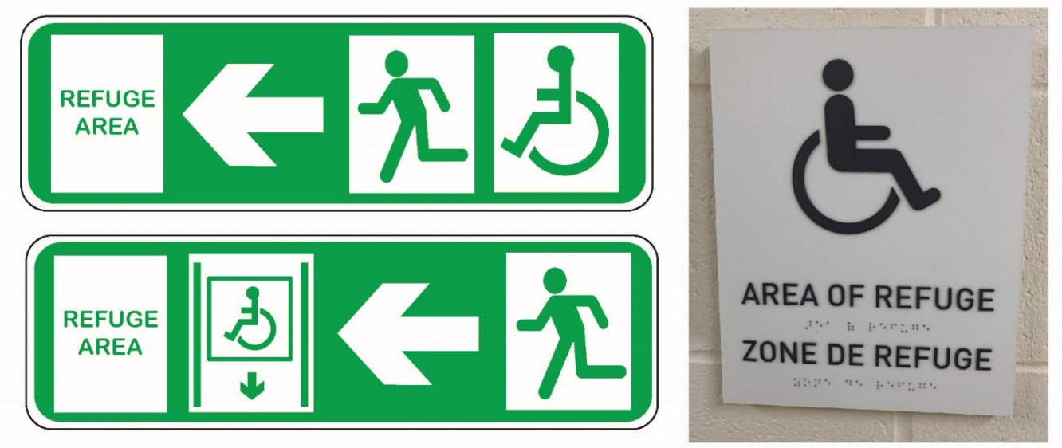
Figure 28: Directional and identification signage for emergency exits and areas of refuge
    - Emergency exit and door to area of refuge are colour contrasted with surrounding (Maximum Points: 3)
Minimum/Maximum Points:
- Ensures doors to emergency exits and/or areas of refuge contrasts with adjacent surfaces such that they are clearly identified
    - Evacuation chair or similar equipment available and easily understood (Maximum Points: 5)
Applies only where exit routes are not accessible, typically in multi-storey buildings
Minimum Points:
- Provides evacuation equipment for people with mobility disabilities unable to use the stairs independently (e.g., evacuation chair or other similar device designed to get people with mobility disabilities)
Note: Manually taking wheelchair users down steps without a mechanical advantage is difficult and even dangerous for all parties, even those with training.

Maximum Points:
- Ensures evacuation equipment is located close to emergency exits but out of exit paths
- Ensures Site operations staff has been trained on the proper use of equipment as part of an overall evacuation strategy that has included feedback from people with disabilities
Ideas for Innovation:
- An evacuation chair that is easy to identify and is stored in a fire-resistant enclosure or in a recessed area
    - Ground-level emergency exit is accessible (Maximum Points: 5)
Applies to all exits leading to exterior
Minimum Points:
- Ensures exit to exterior and/or muster area of the Site is level (no steps)
- Ensures path of travel leading to accessible exits are kept clear at all times and has sufficient space on both sides of the door,
- Ensures door pushes open to the outside with minimal force (e.g., does not exceed 22 N (5lbf.))
Maximum Points:
- Provides no step at all emergency exits
Ideas for Innovation:
- All accessible entrances are also designed to serve as emergency exit routes.

  - Fire Alarm Systems and Equipment
(Maximum Score: 22)
    - Visual fire alarms throughout facility and where people might expect to be alone (Maximum Points: 5)
Minimum/Maximum Points:
- Ensures visual fire alarms operate in conjunction with audible fire alarms and are visible in all public and staff areas
- Provides visual fire alarms in all washrooms throughout the building and in front of all elevators, as well as in storage rooms, parking garages, and any places where people may be alone
Ideas for Innovation:
- Portable vibrating pager systems for users with vision and hearing disabilities
    - Audible fire alarms throughout facility (Maximum Points: 2)
Minimum/Maximum Points:
- Ensures audible fire alarms can be heard throughout the building
Ideas for Innovation:
- Directional sound that help guide people to location of exits using broadband noise. The audible signals provide easy-to-discern cues for finding the way out
    - Fire alarm pulls at accessible height and location (Maximum Points: 5)
Minimum Points:
- Ensures fire and emergency alarm controls are mounted at accessible height so that users in a seated position can operate them
- Ensures clear space in front of fire and emergency alarm controls for users of wheeled mobility devices to approach them
Maximum Points:
- Ensures they are tamper-proof to prevent accidental activation
- Ensures space in front of fire and emergency alarm controls is kept clear and free of obstructions

    - Fire-fighting and first-aid equipment at accessible height and location (Maximum Points: 5)
Includes but not limited to fire extinguishers, fire hose, first-aid equipment, automated external defibrillator, eye wash station, and other related equipment
Minimum Points:
- Ensures equipment is mounted at accessible height so that users in a seated position can reach them
- Ensures clear space in front of equipment for users of wheeled mobility devices to approach them
Maximum Points:
- Ensures space in front of equipment is kept clear and free of obstructions
    - Emergency notification systems (Maximum Points: 5)
Minimum Points:
- Provides a combination of methods to ensure people with vision and hearing disabilities have access to emergency information
Maximum Points:
- Provides different types alert systems to differentiate between emergency situations
Note: Visual warnings for people who are deaf or hard of hearing should be different for emergency situations where users are expected to exit the building as opposed to ones where they should remain inside (e.g., lockdown situations).
- Ensures captioning is provided on any screens that displays emergency messages, where provided
Ideas for Innovation:
- Wireless in-house emergency paging systems that notifies users of emergency situations using a vibrating pager or by being displayed on LCD displays that are placed throughout the building
- Mobile app that allows for real-time mass texting to communicate emergency information to Site users
- Scrolling reader boards that flash to attract attention and provide information about the type of emergency

  - Evacuation Instructions
(Maximum Score: 20)
Easily readable emergency procedures and exit route maps are critical to everyone’s safety.
    - Evacuation instructions on non-reflective surface (Maximum Points: 5)
Minimum/Maximum Points:
- Ensures instructions are positioned to avoid glare and reflections
- Ensures instructions are mounted on a matte surface
    - Evacuation instructions in large print and high contrast (Maximum Points: 5)
Minimum Points:
- Ensures all instructions are in high colour/brightness contrast with background surface
- Uses easy-to-read sans-serif fonts, which are clear, uncomplicated, and which incorporate adequate spacing, and avoids decorative or italicized fonts, which people with low vision have difficulty reading
- Uses only Arabic numerals (1, 2, 3, etc.) and avoids Roman numerals, which are not universally recognized
Maximum Points:
- Ensures evacuation instructions are in large print (minimum of 14 point)
- Ensures evacuation instruction signs are high contrast with mounting surfaces
    - Evacuation instructions include a floor plan diagram and alternate formats (Maximum Points: 5)
Minimum Points:
- Provides clear map or graphic showing clearly marked evacuation routes, exit points and areas of refuge
- Ensures accessible exit routes and exit points are clearly identified on all instructions, if not all exits are accessible
Maximum Points:
- Provides emergency evacuation instructions on evacuation routes and exit points in alternative formats (e.g., raised characters/symbols and Braille)
- Provides tactile map readable by sight and touch, illustrating the layout of the floor and the path of travel to exits points and areas of refuge

Ideas for Innovation:
- Emergency planning that specifically includes people with disabilities and features disability awareness training for staff so they understand how to safely evacuate or move people with disabilities to emergency refuges.
- Audio and electronic text format of evacuation instructions are available
- Emergency procedures and information are available online
    - Evacuation instructions at accessible height and location (Maximum Points: 5)
Minimum Points:
- Ensures evacuation instructions are mounted at accessible height allowing users in a seated position to read them
- Ensures clear space in front of evacuation instructions for users of wheeled mobility devices to approach them
Maximum Points:
- Ensures space in front of evacuation instructions is kept clear and free of obstructions

- Additional Use of Space
The table below displays the Site elements used to measure accessibility for this category, the corresponding maximum score available for each, and the category total.
Site Element | Maximum Score
8.1 Workstations | 21
8.2 Public Assembly Areas | 47
8.3 Exhibit Spaces | 29
8.4 Lodging and Temporary Accommodation | 62
8.5 Outdoor Recreation Areas | 16
8.6 Cafeterias, Restaurants and Bars | 45
8.7 Retail Outlets | 36
8.8 Playgrounds | 20
8.9 Fitness Centre | 29
8.10 Pools | 50
8.11 Change Rooms | 25
8.12 Mail Service | 19
8.13 Shared Laundry Rooms | 24
8.14 Storage Facilities and Lockers | 21
8.15 Garbage Rooms | 13
8.16 Viewpoints | 34
8.17 Visitor Centre and Kiosk | 29
8.18 Picnic Areas | 26
Innovation | 55
Total Maximum Score | 601
Description
This category includes additional areas that are specific or unique to a Site. These areas include swimming pools, cafeterias, play areas, retail outlets and fitness centres, to name a few. They must be included in the overall RHFAC rating if they are present.
  - Workstations
(Maximum Score: 21)
    - Accessible path of travel and manoeuvring space (Maximum Points: 5)
Minimum Points:
- Ensures path of travel and aisles provide sufficient clear width throughout work areas
- Provides suitable clear space for users of wheeled mobility devices to manoeuvre and position themselves in front of workstations and other office equipment (e.g., printer, photocopier, etc.)
- Ensures adequate overhead clearance along all path of travel and aisles
Maximum Points:
- Provides turning space for users of wheeled mobility devices
- Ensures storage, boxes or other obstacles are not stored in aisles
- Ensures sharp edges and corners, or immovable obstructions, are blunted or otherwise mitigated
    - Chairs are adjustable (Maximum Points: 3)
Minimum Points:
- Ensures workstation chairs move up and down and recline with ease
Maximum Points:
- Ensures workstation chairs have adjustable armrests, lumbar support, and others, to meet individual need
- Ensures variety of seating (e.g., with or without arms) is available, if required for guests
    - Desk height is adjustable (Maximum Points: 3)
Minimum Points:
- Provides desks that are height adjustable so that users can work in either seated or standing positions
Maximum Points:
- Provides easy-to-use or automated controls to adjust desk height
    - All workstations are appropriate size for expected usage (Maximum Points: 3)
Minimum/Maximum Points:
- Ensures the size of workstations accommodates expected users
- Provides workstations with adequate space to perform expected tasks comfortably
    - Outlets and switches are at accessible heights (Maximum Points: 4)
Minimum/Maximum Points:
- Ensures workstation controls (e.g., electrical outlets, data ports, and light switches, if applicable) are mounted at accessible height and within easy reach
- Ensures clear space is provided in front of all workstation controls

    - Well-illuminated and task lighting is available (Maximum Points: 3)
Minimum/Maximum Points:
- Provides adequate lighting for the nature and use of the space
- Provides desk lamps and/or individually controlled lighting, enabling people to control their own lighting levels

  - Public Assembly Areas
(Maximum Score: 47)
    - Accessible path of travel to accessible seating spaces (Maximum Points: 5)
Minimum/Maximum Points:
- Ensures path of travel and aisles leading to accessible seating spaces provides sufficient clear width for users of wheeled mobility devices
- Ensures adequate overhead clearance along all path of travel and aisles
- Ensures any sharp edges and corners, or immovable obstructions, are blunted or otherwise mitigated
    - Number and location of accessible seating spaces (Maximum Points: 5)
Minimum Points:
- Ensures number of accessible seating spaces are provided based on the expected use and size of the assembly area
- Ensures accessible seating spaces are dispersed throughout the assembly area (e.g., at the front, back, centre, and all levels to provide choice for users)
Maximum Points:
- Provides at least two accessible seating spaces side by side
- Provides adaptable seating equipped with movable or removable armrest on the side of the seat adjoining the path of travel
- Provides directional signage to identify location of accessible seating space(s), if required
Ideas for Innovation:
- Braille and raised characters/symbols are provided to identify seat numbers
- Storage space for mobility devices is provided on the same level and in close proximity to the accessible seating spaces and adaptable seating
    - Accessible seating space has adequate clear space (Maximum Points: 3)
Minimum Points:
- Provides clear space to accommodate at least one wheeled mobility device
Note: A minimum clear space of 900 mm by 1220 mm for a front or rear approach or 900 mm by 1525 mm for a side approach is required.
- Ensures accessible seating spaces are located on a level surface
Maximum Points:
- Provides clear space to accommodate two wheeled mobility devices side by side
    - Accessible seating space with line of sight (Maximum Points: 3)
Minimum/Maximum Points:
- Ensures sightlines are comparable at different viewing angles
- Ensures sightlines from accessible seating spaces are not blocked if people stand up in front of them
    - Adjacent seating for companions and clear space for service dogs (Maximum Points: 4)
Minimum Points:
- Provides companion seating directly beside the accessible seating space and not behind or separate in any way
- Provides clear space to accommodate service dogs adjacent to seating and close to the path of travel
Maximum Points:
- Ensures companion seat is not fixed
- Provides companion seating that is wheelchair accessible (e.g., two accessible seating spaces side by side)
Ideas for Innovation:
- Companion seat is higher than a standard seat to make conversation with people using wheelchairs easier and more natural
    - Stairs and steps (Maximum Points: 4)
Minimum Points:
- Ensures treads and landings have a slip-resistant finish
- Ensures steps are consistent throughout with uniform riser height and tread depth, where possible
- Provides adequate dimensions to ensure safe footing for all users
Maximum Points:
- Ensures each step edge has strip that colour contrasts with the tread to visually highlight the step edge and improve depth perception
- Provides handrails at accessible height for support, where possible
Ideas for Innovation:
- Gently sloped circulation aisles throughout theatre
    - Assistive listening and communication enhancement technologies (Maximum Points: 5)
Minimum/Maximum Points:
- Provides assistive listening and communication enhancement technologies (e.g., hearing loop, infrared system, captioning/CART capabilities, FM systems) designed for the type of room, room size, occupancy load, and expected use
    - Access to stage by performers/speakers and audience (Maximum Points: 5)
Minimum Points:
- Ensures stage is accessible from the wings and backstage
- Ensures the perimeter of the stage is clearly identified with colour contrasted and/or tactile material
- Ensures any podiums are at accessible height or adjustable height, with knee clearance
Maximum Points:
- Ensures stage is accessible from the front of the house and for audience
- Ensures any podiums are colour contrasted with surrounding surfaces
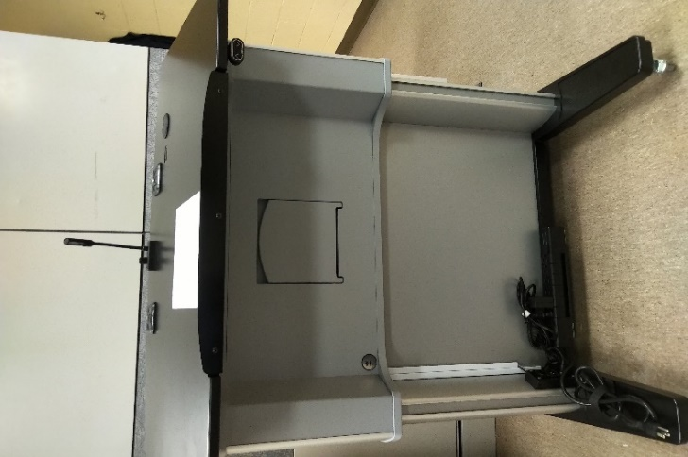
Figure 29: Height adjustable podium
    - Access to all backstage facilities (Maximum Points: 5)
Minimum/Maximum Points:
- Ensures all areas, including dressing rooms, washrooms, green room, audio visual equipment area, staff areas, etc., are accessible to people with disabilities
    - Ticket counters/concessions are accessible (Maximum Points: 5)
Minimum Points:
- Ensures ticket counters/concessions are at accessible height
- Ensures knee space under counters/concessions is provided, allowing people using wheelchairs to face the staff directly when carrying out transactions
Maximum Points:
- Ensures ticket counter surfaces are high contrast with adjacent surfaces
- Provides assistive listening and communication enhancement technologies (e.g., hearing loop) to amplify sound for people who are hard of hearing
- Ensures text to text communication system is available for people who are Deaf to communicate
Ideas for Innovation:
- Video remote services or video remote interpreting is available at ticket counters/concessions
    - Well-illuminated (Maximum Points: 3)
Minimum/Maximum Points:
- Provides adequate lighting for the nature and use of the space
- Provides flexibility within lighting design through localized and task lighting allowing increased visibility of presenters and sign language interpreters on stage, if required
Ideas for Innovation:
- Lighting strips on steps and accessible routes to assist with identification

  - Exhibit Spaces
(Maximum Score: 29)
    - Accessible path of travel (Maximum Points: 5)
Minimum Points:
- Ensures path of travel and aisles provide sufficient clear width throughout exhibit space
- Provides suitable clear space for users of wheeled mobility devices to manoeuvre and position themselves in front of all displays in exhibit space
- Ensures adequate overhead clearance along all path of travel and aisles
Maximum Points:
- Ensures layout of exhibit space is logical, intuitive, and easy-to-follow where exhibits follow a specific order
- Provides turning space for users of wheeled mobility devices
- Ensures path of travel is clearly delineated using colour/textural contrast surfaces
- Ensures sharp edges and corners, or immovable obstructions, are blunted or otherwise mitigated
Ideas for Innovation:
- Audio tours of exhibit areas
- Tactile maps of exhibits or floor area
    - Seating (Maximum Points: 3)
Minimum Points:
- Provides seating dispersed throughout the space and anywhere people might be expected to wait (e.g., lineups for popular exhibits)
- Incorporates clear space for people using wheelchairs or scooters, or pushing strollers, so they can sit alongside one another and with their companions
- Provides a clear space at the end of the seating for a service dog to rest
Maximum Points:
- Provides a variety of seating options, including seats with and without armrests, seats with backrests, and fixed and movable seats
- Ensures seats are comfortable, with firm padding and rounded edges
- Ensures seating visually contrasts with surrounding surfaces

    - Accessible sight lines for all displays (Maximum Points: 4)
Minimum/Maximum Points:
- Ensures clear sightlines for people in the seated position
- Ensures items in displays are visible to guests from different heights and angles
- Ensures display surfaces and lighting minimize glare
    - Accessible interactive devices (Maximum Points: 3)
Minimum Points:
- Ensures display panels/screens can be viewed from a seated position
- Ensures controls are operable without tight grasping or twisting of the wrist
- Ensures display panels/screens and controls are mounted at an accessible height and location
Maximum Points:
- Ensures display panels/screens of interactive devices are positioned to minimize glare and reflections
- Ensures alternate (non-visual) ways of operating interactive devices, such as tactile keyboard and audio instructions are provided, if touch-screen technology is used
Ideas for Innovation:
- Display panels and screens with automatically adjustable height for use at different heights
    - Accessible operable controls (Maximum Points: 3)
Applies to operable controls part of exhibits
Minimum/Maximum Points:
- Ensures controls are operable without tight grasping or twisting of the wrist
- Ensures controls are mounted at an accessible height and location
    - Alternative media for all audio/video presentations (Maximum Points: 3)
Minimum/Maximum Points:
- Provides alternative formats (e.g., descriptive video services, sign language coverage (live or video) of presentations, and captioning of all video presentations) for audio/video presentations to ensure people with vision and hearing loss can enjoy displays in exhibits
Ideas for Innovation:
- A sign language video that welcomes visitors to features in exhibit spaces

    - Alternative media for all descriptive information (Maximum Points: 3)
Minimum/Maximum Points:
- Ensures alternative formats such as large print, audio and Braille versions, of the information
Ideas for Innovation:
- Line drawings and photographs that complement any labels and text provided
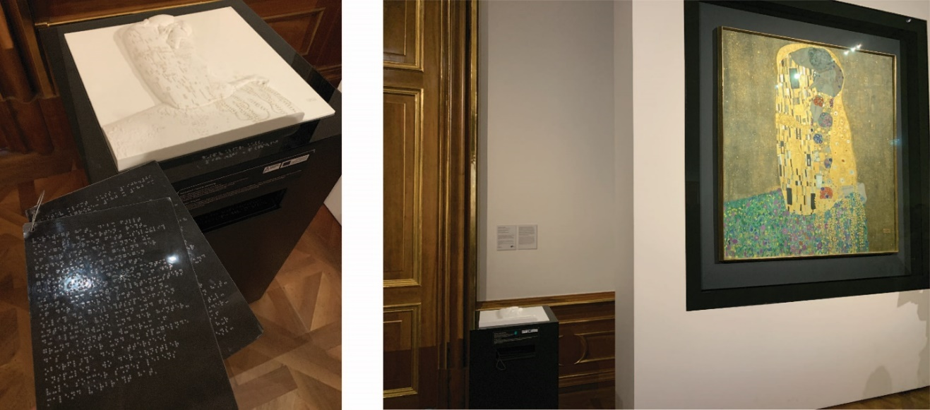
Figure 30: Tactile representation of a painting with descriptive information available in braille
    - Information in alternative languages for major exhibits (Maximum Points: 2)
Minimum/Maximum Points:
- Ensures information provided about major exhibits is multilingual
    - Well-illuminated (Maximum Points: 3)
Minimum/Maximum Points:
- Provides adequate lighting for the nature and use of the space

  - Lodging and Temporary Accommodation
(Maximum Score: 62)
    - Adequate number of rooms accessible (Maximum Points: 4)
Minimum/Maximum Points:
- Ensures an adequate number of accessible rooms are available for expected use, dispersed throughout the building and not concentrated in a single area
- Ensures accessible rooms are dispersed among the different classes of available rooms
- Ensures at least one accessible room is available in each class
    - Additional rooms adaptable (Maximum Points: 3)
Minimum/Maximum Points:
- Ensures rooms not designated as accessible provide basic access, such as an accessible entry door and bathroom door
    - Clear signage (Maximum Points: 3)
Minimum Points:
- Ensures room signage is clearly visible
- Ensures any characters (e.g., lettering and numbering) on room signage contrast with background
- Uses only Arabic numerals (1, 2, 3, etc.) and avoids Roman numerals, which are not universally recognized
Maximum Points:
- Ensures room signage is mounted at accessible height and on the latch side of the door
- Uses raised characters, which can be easily read by touch
- Ensures braille is located directly below the text
- Uses lighting to highlight the room signage, if required
    - Entrance door is easy to open or power operated (Maximum Points: 5)
Minimum/Maximum Points:
- Ensures any manual doors are easy to open with minimal force or have power-operated door located at accessible height and location

    - Accessible door hardware (Maximum Points: 3)
Minimum Points:
- Ensures door hardware is operable with a closed fist without requiring grasping, pinching, or twisting required
Note: Lever handles or equivalent are more convenient for everyone.
- Ensures it is mounted at an accessible height and location
Maximum Points:
- Ensures lever handles return to the door surface or are otherwise designed so they do not catch clothing or other objects
- Ensures door hardware contrast visually with the door
- Ensures locking mechanisms are accessible to people with reduced dexterity and reduced hand and arm strength
- Ensures security and entry system are proximity (non-touch) type and equipped with visual and audible signals to indicate that the system has been activated, if card access type
    - Door viewer at accessible height (if available) (Maximum Points: 2)
Minimum Points:
- Provides a door viewer at accessible height for users in a seated position
Maximum Points:
- Provides two door viewers, one at standard height and the other one at accessible height
    - Accessible options for bed heights and no platform (Maximum Points: 4)
Minimum Points:
- Ensures the height of bed allows for transfer to and from a wheelchair, or for people with knee or back problems to get in and out of bed
Note: Platform beds are generally too low to the ground. Bed height at 508 – 584 mm above the finished floor for easy transfer to bed, according to recent research.
- Ensures clear space is provided on at least two sides of the bed, positioned for parallel approach
Maximum Points:
- Ensures space under the bed accommodates portable lift; platform beds generally have insufficient space
- Ensures clear space is provided on both sides of the bed to allow for left- or right-hand transfer

Ideas for Innovation:
- Accessible room is equipped with a ceiling transfer lift
- Adjustable legs or various height bed risers to allow flexibility of bed heights
    - All controls and outlets are within reach (Maximum Points: 4)
Minimum/Maximum Points:
- Ensures all room controls (e.g., light switches, electrical outlets and thermostats) are mounted at accessible height
- Ensures clear space is provided in front of all room controls
    - Adequate ratio of mix of rooms with roll-in showers and bathtubs (Maximum Points: 3)
Minimum/Maximum Points:
- Provides roughly 50/50 split of accessible roll-in showers and bathtubs
    - Design of toilets, showers and bathrooms (Maximum Points: 5)
Minimum/Maximum Points:
- Ensures bathroom entry has suitable clear opening width and clear space for manoeuvring at door
- Ensure clear manoeuvring and transfer space is available inside bathroom
- Ensures bathroom provides basic accessibility requirements for knee clearances at sinks and mounting height of accessories to meet the needs of all potential guests
- Provides grab bars at toilets, showers and/or bathtubs to provide support for guests
    - Furniture and amenities are accessible (Maximum Points: 4)
Minimum/Maximum Points:
- Provides furniture and other amenities, such as desks, mini bar or other built-in furniture, at accessible height
- Ensures desks provide suitable knee clearance

    - Emergency alarm systems have both audible and visual signals (Maximum Points: 5)
Minimum/Maximum Points:
- Ensures room includes both audible and visual fire and smoke alarms
- Ensures visual fire alarms operate in conjunction with audible fire alarms and are visible throughout the room
Note: People who are deaf or hard of hearing may not be aware of emergency situations when they are sleeping. A vibrating device is required so that they can be alerted.
Ideas for Innovation:
- Vibrating alarm-signalling devices which are configured with a bed vibrator that activates if the building alarm system or a smoke alarm system within a dwelling unit is triggered
    - Visual notification system (Maximum Points: 3)
Minimum/Maximum Points:
- Provides visual notification system (e.g., a coloured flashing light) to alert room occupants of a door knock or bell, and incoming telephone calls
Note: Notification should not be connected to visual fire alarm signals.
    - Assistive listening and communication enhancement technologies (Maximum Points: 3)
Applies where two-way communication is expected
Minimum/Maximum Points:
- Provides accessible communication systems compatible with assistive listening and communication enhancement technologies (e.g., telephone interface jacks compatible with both digital and analog signal use)
- Ensures text to text communication system is available for people who are deaf
Ideas for Innovation:
- Video Relay Services/Video Remote Interpreting that allow real-time communications for people who are deaf, hard of hearing, where two-way communication is expected
    - Storage space with clear floor space, closets with shelves at variety of heights (Maximum Points: 3)
Minimum Points:
- Provides a clear space in front of closet door, shelves, and other storage spaces
- Ensures some shelving and hangers are at accessible height for easy reach for users in a seated position
Maximum Points:
- Ensures storage areas have flexible, easy‑to‑adjust shelves that accommodate all users
    - Windows with accessible hardware (Maximum Points: 2)
Applies to windows that can be operated and/or used for viewing
Minimum/Maximum Points:
- Ensures window operating control is at accessible height
- Ensures window operating control is operable with a closed fist without requiring grasping, pinching or twisting required
- If viewing windows are available, ensures the sills are at a viewing height for people in a seated position
    - Well-illuminated (Maximum Points: 3)
Minimum/Maximum Points:
- Provides adequate lighting for the nature and use of the space
    - External spaces and patios are accessible (Maximum Points: 3)
Minimum Points:
- Ensures entrance has low threshold (i.e., maximum of 13 mm and is bevelled, ramped or rounded)
- Ensures a level clear space at on both sides of entrance
- Provides sufficient clear opening width, free from obstructions, for people using wheeled mobility devices
- Ensures entrance door hardware is operable with one hand, using minimal force, and not requiring fine finger control, tight grasping, pinching, or twisting of the wrist
Maximum Points:
- Provides flush transition across threshold

  - Outdoor Recreation Areas
(Maximum Score: 16)
    - Accessible pathways to all facilities and amenities (Maximum Points: 5)
Minimum Points:
- Ensures accessible routes connect with other accessible elements in the outdoor recreation areas, such as playgrounds, sporting fields, picnic areas, washrooms and parking, etc.
- Ensures pathways provide sufficient clear width throughout recreation area
- Ensures adequate overhead clearance across the entire width and length of the pathway
Maximum Points:
- Ensures obstacles or protruding objects along path of travel are colour contrasted and cane detectable
- Ensures pathways includes high-contrast markings, tapping rail, scented gardens and/or tactile directional indicators (TDI), where required
    - Seating (Maximum Points: 4)
Minimum Points:
- Provides seating dispersed throughout the outdoor recreation area and along routes at 30 m intervals
- Ensures seating is located on a level, firm, and stable area and does not obstruct circulation routes
- Incorporates clear space for people using wheelchairs or scooters, or pushing strollers, so they can sit alongside one another and with their companions
- Provides a clear space at the end of the seating for a service dog to rest
Maximum Points:
- Provides a variety of seating options, including seats with and without armrests, seats with backrests
- Provides adequate heel space to allow people to easily stand up
- Ensures seating area is clearly visible and identified with a change in surface materials (i.e., texture and colour)
- Ensures seating visually contrasts with surrounding surfaces
    - Shelter (Maximum Points: 4)
Minimum/Maximum Points:
- Ensures shelter is provided for weather protection
- Ensures shelter provides adequate overhead clearance
    - Well-illuminated (if site expected to be lit) (Maximum Points: 3)
N/A only if no power to site or policy is for day use only
Minimum/Maximum Points:
- Provides adequate lighting for the nature and use of the space

  - Cafeterias, Restaurants and Bars
(Maximum Score: 45)
Cafeterias, restaurants, and bars are where people gather and intermingle. Thus, everyone who uses these public spaces must have equal access to and within them.
    - Access to all facilities and amenities (Maximum Points: 5)
Minimum Points:
- Ensures accessible path of travel is provided to some dining areas and all amenities (e.g., washrooms)
Maximum Points:
- Ensures accessible path of travel is provided to all dining areas and amenities, including any raised or sunken areas, and outdoor dining areas
- Ensures table and chairs are arranged in regular and logical pattern
Ideas for Innovation:
- Sound damping materials are used throughout dining area or quieter areas are available
    - Accessible path of travel (Maximum Points: 5)
Minimum Points:
- Ensures path of travel and aisles provide sufficient clear width
- Ensures adequate overhead clearance along all path of travel and aisles
Maximum Points:
- Includes turnaround points at the end of the aisles
- Ensures obstacles or protruding objects along path of travel are colour contrasted and cane-detectable
- Ensures storage, boxes, or other obstacles are not stored in aisles
    - Counter, table, and bar at accessible height, or variety of options (Maximum Points: 5)
Minimum Points:
- Ensures tables are at an accessible height for all users; where elevated tables are desirable (e.g., at a bar), they are provided in addition to accessible tables
- Ensures suitable knee clearance is provided at tables, bars and counters
Note: Stanchion underneath tables limits approach for wheeled mobility devices to properly roll under table.
Maximum Points:
- Ensures users have variety of options, whether at the tables, at the bar, or during counter service
- Provides a lowered section to accommodate two people using wheelchairs and/or people unable to use high stools, where there is bar seating
- Ensures they are colour contrasted with surroundings
- Ensures corners of tables, counters, and bars are rounded
    - Variety of seating available (Maximum Points: 3)
Minimum Points:
- Provides a variety of seating options, including seats with and without armrests, seats with backrests, fixed and movable seats
Note: Booth seating is not considered accessible seating.
Maximum Points:
- Ensures seats are comfortable, with firm padding and rounded edges
- Provides adequate kick space to allow people to stand up with ease
- Provides flexible seating that allows for different seating arrangements
- Provides chairs with different heights and widths
    - Continuous tray rail in cafeterias, and condiments and cutlery within reach (Maximum Points: 3)
Minimum/Maximum Points:
- Ensures all products are within easy reach from a seated position
- Ensures condiment counters have a clear work surface for food preparation
Note: Packaged condiments are difficult for people with limited dexterity because of the small packets and the finger strength required to open them. Tamper-proof, easy-to-operate bulk supplies on accessible condiment tables are preferred.
Ideas for Innovation:
- Colour-contrasted stops at the end of the tray counter so that tray cannot be pushed off

    - Menu display boards are easy to read (Maximum Points: 3)
Minimum Points:
- Ensures menu display boards provide large text
- Ensures any characters (e.g., lettering and numbering) contrast with background
Maximum Points:
- Ensures prices are visually communicated
- Ensure they are positioned to avoid shadow and glare
    - Goods are within reach, vertically stacked where possible (Maximum Points: 4)
Minimum Points:
- Ensures products are within easy reach for people in a seated position
Maximum Points:
- Ensures products are stacked vertically such that some of each product is available for people with different ranges of motion
- Ensures doors on coolers and/or shelves are sliding, rather than swing type
    - Front-opening doors on refrigerators and freezers (Maximum Points: 4)
Minimum Points:
- Ensures clear space in front of refrigerators and/or freezers is provided
- Ensures items in refrigerators and/or freezers are within reach for people in a seated position
Maximum Points:
- Ensures refrigerators/freezers have front-opening sliding doors, not swing-open doors
    - Vending and dispensing machines are accessible (Maximum Points: 5)
Minimum Points:
- Ensures display panels/screens of vending machines can be viewed from a seated position
- Ensures controls are easy to operate without tight grasping or twisting of the wrist
- Ensures controls are mounted at an accessible height and location
- Ensures coin slots or the payment system is accessible from a seated position
- Ensures product retrieval is accessible to people with reduced dexterity and/or range of motion

Maximum Points:
- Provides signage and instructions in a high‑contrast sans-serif font
- Ensures alternate (non-visual) ways of completing a transaction are provided (e.g. tactile keyboard and audio instructions, if touch-screen technology is used)
    - Check-out counters or point of sale (POS) location is accessible (Maximum Points: 5)
Minimum Points:
- Ensures check-out counter in cash area is configured with an accessible counter height and knee clearance
- Ensures clear space in front of check-out counter in cash area or point of sale is provided
- Ensures point-of-sale system is easy-to-use and within accessible reach
Maximum Points:
- Ensures check-out counter surfaces are high contrast with adjacent surfaces
- Ensures prices on cash register displays or point-of-sale systems are easily viewed by all patrons
- Provides assistive listening and communication enhancement technologies (e.g., hearing loop) to amplify sound for people who are hard of hearing, if required for larger venues
- Ensures text to text communication system is available for people who are Deaf to communicate
Ideas for Innovation:
- Video remote services or video remote interpreting is available at check-out counter/point-of-sale
    - Well-illuminated (Maximum Points: 3)
Minimum/Maximum Points:
- Provides adequate lighting for the nature and use of the space

  - Retail Outlets
(Maximum Score: 36)
    - Access to all facilities and display areas (Maximum Points: 5)
Minimum/Maximum Points:
- Ensures accessible path of travel is provided in all areas of the retail space, including any raised or sunken areas
- Ensures furniture (e.g., display cases, shelves, racks, etc.) is arranged in regular and logical pattern
    - Accessible path of travel (Maximum Points: 5)
Minimum Points:
- Ensures path of travel and aisles provide sufficient clear width
- Ensures adequate overhead clearance along all path of travel and aisles
Maximum Points:
- Includes turnaround points at the end of the aisles
- Ensures obstacles or protruding objects along path of travel are colour contrasted and cane detectable
- Ensures storage, boxes or other obstacles are not stored in aisles
    - Display units are solid, stable, and have rounded edges (Maximum Points: 3)
Minimum Points:
- Ensures display units are well-anchored, solid, and stable
- Provides clear space in front of display units for approach
- Ensures display units are within easy reach for people using wheelchairs or those in a seated position
Maximum Points
- Ensures sharp edges and corners, or immovable obstructions are blunted or otherwise mitigated

    - Clothes racks within accessible reach (Maximum Points: 4)
Minimum Points:
- Ensures clear space around clothing racks is provided
- Ensures racks are within easy reach for people using wheelchairs or those in a seated position
Maximum Points
- Ensures sharp edges and corners, or immovable obstructions are blunted or otherwise mitigated
    - Goods are clearly visible and within reach (Maximum Points: 4)
Minimum Points:
- Ensures goods are within easy reach for people in a seated position
Maximum Points:
- Ensures goods are stacked vertically such that some of each product is available for people with different ranges of motion
    - Front-opening doors on refrigerators and freezers (Maximum Points: 4)
Minimum Points:
- Ensures clear space in front of refrigerators and/or freezers is provided
- Ensures items in refrigerators and/or freezers are within reach for people in a seated position
Maximum Points:
- Ensures refrigerators/freezers have front-opening sliding doors, not swing-open doors
    - Prices are clearly displayed (Maximum Points: 3)
Minimum Points:
- Ensures prices and cost of sale are clearly visible on the shelves or products
Maximum Points:
- Ensure they are positioned to avoid shadow and glare
- Ensures prices and cost of sale are provided in large text

    - Check-out counters or point of sale (POS) location is accessible (Maximum Points: 5)
Minimum Points:
- Ensures check-out counter in cash area is configured with an accessible counter height and knee clearance
- Ensures clear space in front of check-out counter in cash area or point of sale is provided
- Ensures point-of-sale system is easy-to-use and within accessible reach
Maximum Points:
- Ensures check-out counter surfaces are high contrast with adjacent surfaces
- Ensures prices on cash register displays or point-of-sale systems are easily viewed by all patrons
- Provides assistive listening and communication enhancement technologies (e.g., hearing loop) to amplify sound for people who are hard of hearing, if required for larger venues
- Ensures text to text communication system is available for people who are Deaf to communicate
Ideas for Innovation:
- Video remote services or video remote interpreting is available at check-out counter/point of sale
    - Well-illuminated (Maximum Points: 3)
Minimum/Maximum Points:
- Provides adequate lighting for the nature and use of the space
- Ensures display units are well-lit

  - Playgrounds
(Maximum Score: 20)
    - Adequate space for all children and their caregivers (Maximum Points: 5)
Minimum/Maximum Points:
- Ensures accessible path of travel is provided to the play space, including any raised or sunken areas
- Ensures an accessible pathway to move through, in, and around the play space
- Ensures entry and exit points to the play space are accessible with transitions that are flush or less than 13 mm
    - Surfaces along routes leading to and in play space (Maximum Points: 5)
Minimum/Maximum Points:
- Ensures surface is firm, stable, and able to absorb the shock of a fall to help prevent injuries
- Ensures safety surface (e.g., rubber tiles, poured-in-place rubber) is continuous throughout the play space
Note: Sand and pea gravel are not considered accessible surfacing materials.
- Ensures an even surface with minimal irregularities to reduce potential for water accumulation, which can create a slippery surface
- Ensures all surfaces are non-glare
    - Accessible play space components (Maximum Points: 5)
Minimum Points:
- Provides variety of play components including sensory components that promote active play experiences
- Provides accessible play components that are connected to ramps or transfer systems, if elevated
Maximum Points:
- Provides scented gardens or plantings
- Provides quiet areas to support children with autism, Asperger syndrome, or attention-deficit/hyperactivity disorder, allowing autonomous play
- Provides stand-alone play features, such as spring rockers or teeter-totters
Note: Stand-alone features provide good universal access because they can be accessed from the ground surface.

    - Seating and shelter (Maximum Points: 5)
Minimum Points:
- Ensures access to seating is direct and unobstructed
- Ensures seating is located on a level, firm, and stable area and does not obstruct circulation route
- Incorporates clear spaces for people using wheelchairs or scooters, or pushing strollers, so they can sit alongside one another and with their companions
- Provides a clear space at the end of the seating for a service dog to rest
- Ensures seating provides direct view of the play space for parents/caregivers
Maximum Points:
- Provides a variety of seating options, including seats with and without armrests, seats with backrests
- Ensures seats are comfortable and have rounded edges
- Ensures seating visually contrasts with surrounding surfaces
- Ensures seating area is clearly visible and identified with a change in surface materials (i.e., texture and colour)
- Provides sheltered seating with adequate overhead clearance

  - Fitness Centre
(Maximum Score: 29)
    - Accessible path of travel (Maximum Points: 5)
Minimum Points:
- Ensures path of travel and aisles provides sufficient clear width
- Ensures aisles throughout the fitness centre are clear of any obstructions and easy to access
- Ensures adequate overhead clearance along all path of travel and aisles
- If the turnstiles are provided and not accessible, ensures they are accompanied by an adjacent accessible gate
Maximum Points:
- Includes turnaround points at the end of the aisles
- Ensures furniture and equipment are arranged in regular and logical pattern
- Ensures any obstacles or protruding objects along the path of travel are colour contrasted and cane detectable
    - Number/variety of accessible fitness equipment (Maximum Points: 5)
Minimum Points:
- Ensures equipment is available to accommodate people using wheeled mobility devices, (e.g., equipment with swing away or removable seats)
- Provides clear space adjacent to fitness equipment
Maximum Points:
- Provides equipment expressly designed for people with disabilities (e.g., arm cycles, resistance band, cuff weights, functional electrical stimulation (FES) bike, or other FES equipment)
- Provides clear space on both sides of the equipment to allow for left- or right-hand transfer
    - Raised stretching mat (Maximum Points: 5)
Minimum Points:
- Provides a raised platform with a padded surface at accessible height to allow for easy transfer from a wheeled mobility device
- Provides clear space adjacent to raised stretching mat for easy transfer from wheeled mobility devices
Maximum Points:
- Provides a grab bar on an adjacent wall
Ideas for Innovation:
- Power-operated height adjustable stretching mat
    - Accessible lockers (Maximum Points: 4)
Minimum Points:
- Ensures any shelving and hangers are at accessible height for easy reach for users in a seated position
- Ensures clear space is provided in front of lockers
Maximum Points:
- Ensures lockers are provided at a variety of heights
- Provides identification signage with high contrast large print, raised characters, and braille
- Provides accessible hardware that is easy-to-use, operable with one hand, using minimal force, and not requiring fine finger control, tight grasping, pinching, or twisting of the wrist
    - Service counter is accessible (Maximum Points: 4)
Minimum Points:
- Ensures service counter at accessible height with knee clearance
- Provides clear space in front of service counter
Maximum Points:
- Ensures service counters are high contrast with adjacent surfaces
- Provides assistive listening and communication enhancement technologies (e.g., hearing loop) to amplify sound for people who are hard of hearing
- Ensures text to text communication system is available for people who are Deaf to communicate
Ideas for Innovation:
- Video remote services or video remote interpreting is available at service counter
    - Drinking fountain is accessible (Maximum Points: 3)
Applies to drinking fountains and bottle filling stations
Minimum Points:
- Ensures it is mounted at an accessible height
- Ensures clear space is provided in front of drinking fountain/bottle filling station

Maximum Points:
- Ensures it is mounted at variety of heights
- Ensures it is colour contrasted with adjacent surfaces, recessed and/or cane-detectable if along a path of travel
    - Well-illuminated (Maximum Points: 3)
Minimum/Maximum Points:
- Provides adequate lighting for the nature and use of the space
- Provides task lighting at service counter, if required

  - Pools
(Maximum Score: 50)
    - Access to pool and all facilities (Maximum Points: 5)
Minimum/Maximum Points:
- Ensures accessible path of travel is provided around the pool and to all facilities (e.g., change rooms, whirlpool, sauna, etc.), including any raised or sunken areas
- Provides seating with direct and unobstructed access
    - Accessible path of travel (Maximum Points: 5)
Minimum Points:
- Ensures path of travel around pool deck provides sufficient clear width
- Ensures adequate overhead clearance across the entire width and length of path of travel (e.g., where diving boards or platforms are provided)
Maximum Points:
- Includes turnaround points at the end of the path of travel on deck
- Ensures any obstacles or protruding objects along the path of travel are colour contrasted and cane detectable
- Ensures path of travel around pool deck is clear of any obstructions
    - Deck surface is firm, stable, and slip resistant (Maximum Points: 5)
Minimum/Maximum Points:
- Ensures pool deck surfaces are firm, stable and non-slip
- Provides drainage grates that are recessed with openings perpendicular to the path of travel
    - Colour-contrasted edges around pool (Maximum Points: 5)
Minimum/Maximum Points:
- Has high colour/texture contrast markings at the edge of pools to clearly define pool boundaries
- Ensures high colour/texture contrast markings are provided around hazards along the path of travel on pool deck
Ideas for Innovation:
- Tactile attention indicators installed around the edge of the pool to indicate the perimeter of pool deck

    - Marked pathway from change room to pool (Maximum Points: 4)
Minimum Points:
- Has a colour contrasted marked accessible route provided from the change rooms to pool facilities (e.g., pool, hot tub)
    - Ramp/sloped entrance or pool lift to access pool (Maximum Points: 5)
Minimum Points:
- Provides accessible means of entry and exit into the pool (e.g., ramp/sloped entrance, pool lifts, or other transfer systems)
- Ensures accessible path of travel is provided to all entry and exit systems into pool
- Provides clear space adjacent to mechanical pool lift for easy transfer
Maximum Points:
- Provides ramp or zero-depth entry ramp to access pool
- If a mechanical pool lift is the only means of entry and exit, provides two pool lifts in case one breaks down
    - Stairs into pool (Maximum Points: 4)
Minimum Points:
- Ensures each step edge has non-slip and colour-contrasted strip on nosing to visually highlight the step edge and improve depth perception
- Ensures strips extend the full width of the step and are of adequate width
Maximum Points:
- Uses a single colour for contrasting strips
    - Handrails (Maximum Points: 4)
Applies to handrails used at ramp/sloped entrance, stairs, or ladders into pool
Minimum Points:
- Provides handrails at consistent and accessible height
- Ensures sufficient clearance exists between handrail and wall
- Ensures the handrail size (diameter) facilitates grip, with a smooth, round design free of any sharp, abrasive elements
- Is securely attached and supports enough weight for its intended use

Maximum Points:
- Provides horizontal handrail extensions at the top and bottom of ramp, stairs, or ladders to provide support and orientation for people as they move in and out of pool
- Ensures extensions are turned down or sideways and returned to post, floor, or wall
Note: Extensions are not required where they would project into another path of travel
- Contrasts visually with surrounding surfaces.
    - General safety equipment at accessible height and location (Maximum Points: 3)
Minimum Points:
- Ensures safety equipment is mounted at accessible height and location
- Provides a clear space in front of the equipment for access
Maximum Points:
- Indicates the location of safety equipment clearly using symbols or icons in high contrast
    - Pool wheelchair (Maximum Points: 3)
Minimum Points:
- Provides at least one pool wheelchair
Maximum Points:
- Ensures armrests are located on both sides of the pool wheelchair seat, with at least one armrest capable of being moved away from the side of the chair
- Provides a pool wheelchair with push rims whenever a wet ramp is used as an accessible means of water entry and exit
    - Accessible lockers (Maximum Points: 4)
Minimum Points:
- Ensures any shelving and hangers are at accessible height for easy reach for users in a seated position
- Ensures clear space is provided in front of lockers
Maximum Points:
- Ensures lockers are provided at a variety of heights
- Provides identification signage with high contrast large print, raised characters, and braille
- Provides accessible hardware that is easy to use, operable with one hand, requires minimal force, and does not require fine finger control, tight grasping, pinching, or twisting

    - Well-illuminated (Maximum Points: 3)
Minimum/Maximum Points:
- Provides adequate lighting for the nature and use of the space

  - Change Rooms
(Maximum Score: 25)
Accessible change or locker rooms allow everyone to participate in recreational activities, including swimming, playing sports and using fitness equipment. If available, the change room must be accessible.
    - Accessible path of travel (Maximum Points: 5)
Minimum Points:
- Ensures path of travel with sufficient clear width to all amenities, including the entrance, showers, and pool
- Ensures path of travel is clear of any obstructions and is easy to access
- Ensures adequate overhead clearance across the entire width and length of path of travel
Maximum Points:
- Includes turnaround points at the end of the path of travel
- Ensures any obstacles or protruding objects along the path of travel are colour contrasted and cane detectable
    - Surface is firm, stable, and slip resistant (Maximum Points: 5)
Minimum Points:
- Ensures floor surfaces are matte finish and non-slip (even when wet), with good drainage
- Ensures all surfaces are non-glare and have non-slip textured finishes, as polished surfaces cause glare and can be slippery
Maximum Points:
- Has plain, light-coloured flooring, tiles, or other types of flooring
    - Adult change table with privacy (Maximum Points: 5)
Minimum Points:
- Provides clear floor transfer space parallel to the long side of the change table
- Provides a manually operated variable-height adult change table to assist people who are unable to stand while getting dressed
Note: A variable-height gurney could be used instead of the bench if placed beside a wall.
- Ensures change table is designed for a minimum load of 1.33 kN (300 lbf.)
Maximum Points:
- Provides a power-operated variable-height adult change table with easy-to-use controls
- Ensures change table is in a location that ensures privacy
Ideas for Innovation
- A tracking hoist system to eliminate the need to lift a person manually if self-transfer is not possible
- A universal change room to provide the greatest flexibility and extra space for people who may need assistance
    - Accessible lockers (Maximum Points: 4)
Minimum Points:
- Ensures any shelving and hangers are at accessible height for easy reach for users in a seated position
- Ensures clear space is provided in front of lockers
Maximum Points:
- Ensures lockers are provided at a variety of heights
- Provides identification signage with high contrast large print, raised characters, and braille
- Provides accessible hardware that is easy to use, operable with one hand, using minimal force, and not requiring fine finger control, tight grasping, pinching, or twisting of the wrist
    - Seating (Maximum Points: 3)
Minimum Points:
- Ensures seating is available adjacent to lockers
- Ensures access to seating is direct and unobstructed
Maximum Points:
- Provides a variety of seating options, including seats with and without armrests, seats with backrests
- Ensures seating has a non-slip surface when wet
- Ensures seats are comfortable and rounded edges
- Ensures seating visually contrasts with surrounding surfaces
    - Well-illuminated (Maximum Points: 3)
Minimum/Maximum Points:
- Provides adequate lighting for the nature and use of the space

  - Mail Service
(Maximum Score: 19)
    - Clear space for approach (Maximum Points: 5)
Minimum Points:
- Ensures suitable clear space is provided in front of all mailboxes and counters to accommodate people using wheeled mobility devices
- Ensures adequate overhead clearance
Maximum Points:
- Provides turning space for users of wheeled mobility devices inside mail room
    - Mailboxes at accessible heights (Maximum Points: 5)
Minimum Points:
- Provides mailboxes mounted at accessible height or variety of heights for easy reach for users in a seated position or users who are taller
Maximum Points:
- Provides accessible hardware that is easy-to-use, operable with one hand using minimal force
- Ensures mailboxes are colour contrasted with surrounding surfaces
Ideas for Innovation:
- Fob system to open mailboxes
    - Clear signage for mailboxes (Maximum Points: 3)
Minimum Points:
- Provides identification signage with characters that are high contrast with the background
Maximum Points:
- Uses only Arabic numerals (1, 2, 3, etc.) and avoids Roman numerals, which are not universally recognized
- Provides identification signage with large print, raised characters, and braille

    - Service counters and work surfaces are accessible (if provided) (Maximum Points: 3)
Minimum Points:
- Ensures service counters/work surfaces are at accessible height with knee clearance
- Provides clear space in front of service counters/work surfaces
Maximum Points:
- Ensures counter surfaces are high contrast with adjacent surfaces
- Provides assistive listening and communication enhancement technologies (e.g., hearing loop) to amplify sound for people who are hard of hearing, if required
- Ensures text to text communication system is available for people who are Deaf to communicate
Ideas for Innovation:
- Video remote services or video remote interpreting is available at service counter
    - Well-illuminated (Maximum Points: 3)
Minimum/Maximum Points:
- Provides adequate lighting for the nature and use of the space
- Provides task lighting if service desk and sorting table are present

  - Shared Laundry Rooms
(Maximum Score: 24)
    - Clear space for approach (Maximum Points: 5)
Minimum Points:
- Ensures suitable clear space is provided in front of washer and dryer to accommodate people using wheeled mobility devices
- Ensures adequate overhead clearance
Maximum Points:
- Allows for parallel approach such that someone using a wheeled mobility device can manoeuvre, open the door, and add/remove laundry
- Provides turning space for users of wheeled mobility devices inside the laundry room
    - Accessible controls and payment options (Maximum Points: 5)
Applies to all operable parts (e.g., doors, lint traps) and controls (e.g., time or temperature settings, on/off button)
Minimum Points:
- Ensures operating mechanisms are easy to use with minimum effort; it must be operated with one hand and not require tight pinching, grasping, or twisting of the wrist
- Ensures front controls at an accessible height and within easy reach
- Ensures payment options are accessible and reachable
Maximum Points:
- Ensures audible tones indicate cycle operation (e.g., cycle selection, on, off)
- Ensures electronic functions (menu and cycle display) are easy to read; information is communicated using visual and tactile controls
Ideas for Innovation:
- Washers and dryers are raised on platforms to reduce need to bend, stoop, or lean over
    - Front-loading machines (Maximum Points: 5)
Minimum/Maximum Points:
- Ensures 50% of washing machines and dryers are front loading
Note: Front-loading machines are generally preferable to top-loading machines.
- Ensures the washing machines and dryers are not stacked
Note: Dual-use equipment or stacked units could be acceptable if they show equivalent or greater levels of accessibility than front-loading machines. However, most of the stacking washer/dryers on the market do not meet the upper reach range limit requirement.
    - Clear signage for washers and dryers (Maximum Points: 3)
Minimum Points:
- Provides identification signage with characters that are high contrast with the background
Maximum Points:
- Uses only Arabic numerals (1, 2, 3, etc.) and avoids Roman numerals, which are not universally recognized
- Provides identification signage with large print, raised characters, and braille
    - Counters, laundry sinks, and seating (Maximum Points: 3)
Minimum Points:
- Ensures work surfaces and laundry sinks are at accessible height with knee clearance
- Provides clear space in front of work surfaces for folding clothes and laundry sinks
Maximum Points:
- Ensures counter surfaces are high contrast with adjacent surfaces
- Ensures work surfaces are height adjustable
- Provides seating
    - Well-illuminated (Maximum Points: 3)
Minimum/Maximum Points:
- Provides adequate lighting for the nature and use of the space

  - Storage Facilities and Lockers
(Maximum Score: 21)
This element applies to storage facilities and lockers that are typically provided in multi-unit residential buildings for residents, or in office environments for staff.
    - Clear space for approach (Maximum Points: 5)
Minimum Points:
- Ensures suitable clear space is provided in front of storage facilities and lockers to accommodate people using wheeled mobility devices
- Provides manoeuvring space on both sides of storage facility entrance with extra space on the pull side
- Ensures adequate overhead clearance
Maximum Points:
- Provides safe, unobstructed clearance from door swing
- Provides turning space for users of wheeled mobility devices inside storage facilities
    - Clear signage for lockers (Maximum Points: 3)
Minimum Points:
- Provides identification signage with characters that are high contrast with the background
Maximum Points:
- Uses only Arabic numerals (1, 2, 3, etc.) and avoids Roman numerals, which are not universally recognized
- Provides identification signage with large print, raised characters, and braille
- Ensures signage is mounted at accessible height on the latch side of the door
- Provides directional signage to locate the storage facility or locker, if useful
    - Low threshold entry to storage unit (Maximum Points: 5)
Minimum Points:
- Ensures a raised threshold is a maximum of 13 mm and is bevelled, ramped, or rounded
Maximum Points:
- Ensures threshold is flush with adjacent floor surface

    - Accessible controls (Maximum Points: 5)
Minimum/Maximum Points:
- Ensures operating mechanism is easy to use with minimum effort; it must be operated with one hand and not require tight pinching, grasping, or twisting of the wrist
- Ensures controls are at an accessible height
- Ensures the force applied at the handle, push plate, or latch-releasing device does not exceed 22 N (5 lbf.)
    - Well-illuminated (Maximum Points: 3)
Minimum/Maximum Points:
- Provides adequate lighting for the nature and use of the space

  - Garbage Rooms
(Maximum Score: 13)
This element applies to garbage rooms in multi-unit residential buildings.
    - Clear space for approach (Maximum Points: 5)
Minimum Points:
- Ensures suitable clear space is provided in front of garbage disposal area to accommodate people using wheeled mobility devices
- Provides manoeuvring space on both sides of garbage room entrance with extra space on the pull side
- Ensures adequate overhead clearance
Maximum Points:
- Provides safe unobstructed clearance from door swing
- Provides turning space for users of wheeled mobility devices inside garbage rooms
    - Accessible controls (Maximum Points: 5)
Minimum Points:
- Ensures operating mechanism is easy to use with minimum effort; it must be operated with one hand and not require tight pinching, grasping, or twisting of the wrist
- Ensures controls and garbage disposal system (e.g., garbage chute) are at an accessible height
- Ensures the force applied at the handle, push plate, or latch-releasing device does not exceed 22 N (5 lbf.) for garbage chute door, if applicable
Maximum Points:
- Ensures electronic functions are easy to read; information is communicated using visual and tactile controls, if applicable
    - Well-illuminated (Maximum Points: 3)
Minimum/Maximum Points:
- Provides adequate lighting for the nature and use of the space

  - Viewpoints
(Maximum Score: 34)
Viewpoints at scenic locations should be safe and accessible for everyone. It is essential that shelter and seating are provided to allow people to safely rest and take in the surroundings. Often, information is provided to explain the history or significance of the area. This information should be easily read and interpreted by all users.
    - Accessible path of travel to viewpoints (Maximum Points: 5)
Minimum/Maximum Points:
- Ensures pathways to viewpoints provide sufficient clear width for people using wheeled mobility devices, people with strollers, accompanied by companions or service dogs
- Ensures adequate overhead clearance across the entire width and length of the pathway
- Ensures obstacles or protruding objects along path of travel are colour contrasted and cane detectable
    - Handrails/guardrails (Maximum Points: 5)
Minimum/Maximum Points:
- Provides adequate barrier for protection where adjacent to steep slope or dangerous terrain
- Ensures handrails do not block view of people who are of short stature or who are using a wheeled mobility device
Maximum Points:
- Ensure handrails/guardrails are colour contrasted with surroundings
    - Surface is firm, stable, and slip resistant (Maximum Points: 5)
Minimum/Maximum Points:
- Has a stable and firm surface that resists movement
- Has appropriate type of surface material (climate/weather conditions):
- Uses suitable types of exterior surface materials, including asphalt, concrete, stone, timber, brick/paving
- Avoids using loose materials, such as sand, gravel, or woodchips, or rough/irregular materials, such as cobble stones
- Ensures an even surface with minimal irregularities to reduce potential for water accumulation, which can create a slippery surface
- Ensures there are minimal gaps, joints, or breaks in the surface, which present tripping hazards; any gaps should run perpendicular to the direction of movement
- Ensures all surfaces are non-glare and have non-slip textured finishes for both wet and dry conditions
    - Level landings and clear space (Maximum Points: 5)
Minimum Points:
- Provides level landings when a change in grade exists within the viewpoint; ideally, the viewpoint will be at a single elevation
- Provides landings before and after an incline
Maximum points:
- Ensures entire viewpoint is on single level or elevation
- Provides adequate turning space for people using wheelchairs or mobility aids, and for people with strollers or service dogs
    - Drainage (Maximum Points: 2)
Minimum Points:
- Ensures cross slope is minimal but sufficient enough to allow adequate drainage (2%); does not permit water accumulation or pooling that would create slippery surfaces or cause glare
- Ensures openings for drainage grates are perpendicular to the path of travel
    - Viewing amenities are accessible (Maximum Points: 3)
Minimum/Maximum Points:
- Ensures information signs and maps are available to indicate locations and provide descriptions of points of interest
- Ensures other amenities, as appropriate, such as drinking fountains, binoculars, waste receptacles, etc., are accessible, when provided
    - Interpretive signage is accessible (Maximum Points: 3)
Minimum Points:
- Ensures all information is at an accessible height
- Uses Arabic numerals and sans-serif lettering
- Ensures the size of the characters/symbols allows the signage to be read
- Provides high-contrast text and single-coloured backgrounds
Maximum Points:
- Uses raised characters and braille, which can be easily read by touch
- Ensures signs are efficiently worded
- Provides information in audio format
- Uses international symbols or pictograms on signage, where useful
Ideas for Innovation:
- Graphic representation of feature in tactile format
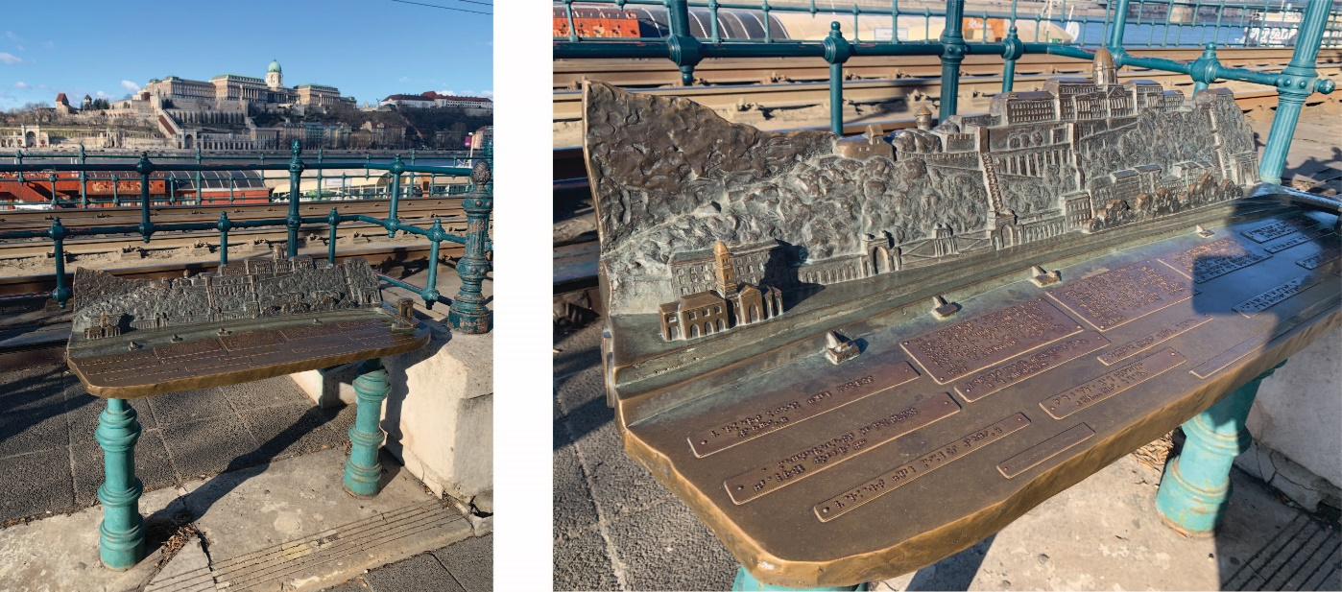
Figure 31: Tactile representation of scenic view with braille description
    - Seating (Maximum Points: 3)
Minimum Points:
- Ensures access to seating is direct and unobstructed; for people using walking aids, rest areas are critical
- Ensures seating is located on a level, firm, and stable area and does not obstruct circulation routes
- Incorporates clear spaces for people using wheelchairs or scooters, or pushing strollers, so they can sit alongside one another and with their companions
- Provides a clear space at the end of the seating for a service dog to rest
Maximum Points:
- Provides a variety of seating options, including seats with and without armrests, seats with backrests
- Provides adequate heel space to allow people to easily stand up
- Ensures seating area is clearly visible and identified with a change in surface materials (i.e., texture and colour)
- Ensures seating visually contrasts with surrounding surfaces

    - Shelter (Maximum Points: 3)
Minimum Points:
- Provides some protection from weather
- Ensures shelter provides suitable overhead clearance
Maximum Points:
- Provides full coverage from weather

  - Visitor Centre and Kiosk
(Maximum Score: 29)
This element refers to visitor centres and kiosks that are often provided at recreation and tourist facilities to welcome and orient visitors. They are typically located in a central location — near trailheads or adjacent to parking areas. A visitor centre and kiosk must be accessible to everyone. Access includes routes to the facility as well as the facility itself.
    - Accessible path of travel (Maximum Points: 5)
Minimum Points:
- Ensures pathways to visitor centre and kiosk provides sufficient clear width for people using wheeled mobility devices, people with strollers, accompanied by companions or service dogs
- Ensures adequate overhead clearance across the entire width and length of the pathway
Maximum Points:
- Ensures accessible routes connect with other accessible elements in the outdoor environment, such as accessible trail entrance, picnic areas, washrooms, and parking
- Ensures obstacles or protruding objects along path of travel are colour contrasted and cane detectable
    - Accessible entrance to facility (Maximum Points: 5)
Minimum Points:
- Ensures entrance is clearly identified, with clear space on both sides of door and no level change or ramp
- Provides sufficient clear opening width for people using wheelchairs or scooters, and for people with companions or service dogs
- Ensures a raised threshold is a maximum of 13 mm and is bevelled, ramped, or rounded
Maximum Points:
- Ensures any manual doors are easy to open with minimal force or have power-operated door located at accessible height and location
- Ensures threshold is flush with adjacent floor surface

    - Clear signage (Maximum Points: 3)
Minimum/Maximum Points:
- Provides clear directional signage from parking and other accessible elements to accessible entrance
- Provides clear informational signage, including available information and services, such as beach or trail wheelchair rental and guided tours
    - Service counter is accessible (Maximum Points: 4)
Minimum Points:
- Ensures service counter at accessible height with knee clearance
- Provides clear space in front of service counter
Maximum Points:
- Ensures service counters are high contrast with adjacent surfaces
- Provides assistive listening and communication enhancement technologies (e.g., hearing loop) to amplify sound for people who are hard of hearing
- Ensures text to text communication system is available for people who are Deaf to communicate
- Provides task lighting at service counter, if required
Ideas for Innovation:
- Video remote services or video remote interpreting is available at service counter
    - Printed information and sale items within accessible reach (Maximum Points: 4)
Minimum/Maximum Points:
- Ensures any printed information or products for sale are within easy reach for people in a seated position
- Ensures clear space for approach in front of shelves and displays
Maximum Points:
- Ensures printed information and products are stacked vertically such that some of each is available for people with different ranges of motion

    - Information available in a variety of formats (Maximum Points: 3)
Minimum/Maximum Points:
- Provides information in a variety of accessible formats, such as large-text printed brochures and posters, audio programs, subtitled video, and accessible websites
- Provides alternative formats (e.g., descriptive video services, sign language coverage (live or video) of presentations, and captioning of all video presentations) for any audio/video presentations to ensure people with vision and hearing loss
    - Seating and shelter (Maximum Points: 5)
Minimum Points:
- Provides seating outside or inside
- Provides shelter with adequate overhead clearance for weather protection
Maximum Points:
- Provides seating both outside and inside
- Provides a variety of seating options, including seats with and without armrests, seats with backrests

  - Picnic Areas
(Maximum Score: 26)
Visitor amenities, such as picnic areas, are provided to enhance the public’s experience in using trails and pathways, and outdoor recreational areas.
    - Accessible path of travel (Maximum Points: 5)
Minimum Points:
- Ensures pathways to picnic areas provides sufficient clear width for people using wheeled mobility devices, people with strollers, accompanied by companions or service dogs
- Ensures adequate overhead clearance across the entire width and length of the pathway
Maximum Points:
- Ensures accessible routes connect picnic areas to other accessible elements in the outdoor environment, such as accessible trails, washrooms, drinking fountains, and parking
- Ensures obstacles or protruding objects along path of travel are colour contrasted and cane detectable
    - Appropriate number of accessible picnic tables with seating (Maximum Points: 5)
Minimum Points:
- If two or fewer picnic tables, ensures all tables are accessible with knee clearance
- If greater than two, ensures most are accessible and dispersed within the area to provide for a variety of picnic experiences
Maximum Points:
- Ensures all picnic tables are accessible and provides space for more than one wheelchair as well as a choice of where to sit
- Ensures picnic tables are fixed to prevent movement away from accessible routes
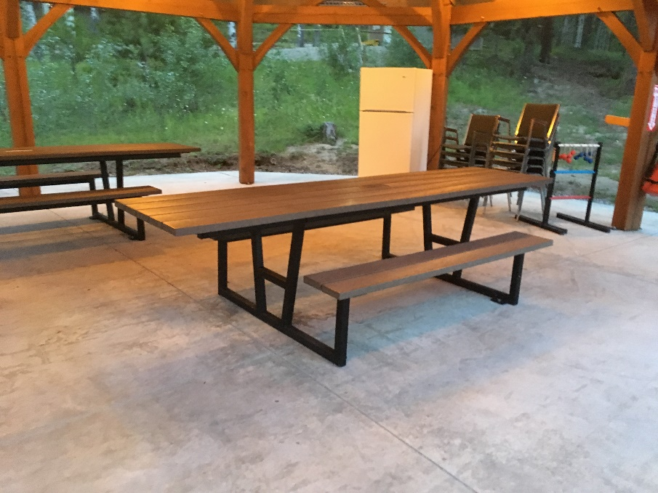
Figure 32: Picnic table extension with knee clearance
    - Surface is firm, stable, and slip resistant (Maximum Points: 5)
Minimum/Maximum Points:
- Has a stable and firm surface that resists movement
- Has appropriate type of surface material (climate/weather conditions):
- Uses suitable types of exterior surface materials, including asphalt, concrete, stone, timber, brick/paving
- Avoids using loose materials, such as sand, gravel, or woodchips, or rough/irregular materials, such as cobble stones
- Ensures an even surface with minimal irregularities to reduce potential for water accumulation, which can create a slippery surface
- Ensures there are minimal gaps, joints, or breaks in the surface, which present tripping hazards; any gaps should run perpendicular to the direction of movement
- Ensures all surfaces are non-glare and have non-slip textured finishes for both wet and dry conditions.

    - Clear space around picnic table, fire pit, and in front of barbecue grill (Maximum Points: 4)
Minimum Points:
- Ensures adequate space around picnic table and fire pit, and in front of barbecue
Maximum Points:
- Provides colour/texture contrasted markings around fire pit and barbecue grill area so that they can be easily identified by people with low vision
    - Shelter option available (Maximum Points: 4)
Minimum Points:
- Provides protection from weather at some picnic areas
- Ensures shelter provides suitable overhead clearance
Maximum Points:
- Provides protection from weather at all picnic areas
    - Well-illuminated (if site expected to be lit) (Maximum Points: 3)
N/A only if no power to site or policy is for day use only
Minimum/Maximum Points:
- Provides adequate lighting for the nature and use of the space

- Residential Units
The table below displays the Site elements used to measure accessibility for this category, the corresponding maximum score available for each, and the category total.
Site Element | Maximum Score
9.1 Unit Security and Entry Systems | 12
9.2 Unit Entrance and Entrance to Outdoor Spaces | 51
9.3 Unit Interior Doors | 18
9.4 Unit Kitchen | 52
9.5 Unit Hallways | 14
9.6 Unit Interior Stairs | 36
9.7 Unit Bedrooms and Closets | 16
9.8 Unit Toilet Rooms | 56
9.9 Unit Showers and Bathtubs | 33
9.10 Unit Laundry | 18
9.11 Unit General Requirements | 24
Innovation | 33
Total Maximum Score | 363
Description
This category describes the rating requirements for a single unit in a multi-unit residential building. For the purpose of the rating system, multi-unit residential buildings include condominiums, apartments (low-rise and high-rise), and townhouses.
Important: If different types of units (e.g., bachelor, 1 bedroom, etc.) are available, at least one of each unit type must be included in the scope of rating. This is to ensure that accessible and adaptable units are available for all unit types available, therefore allowing for choice for a variety of family sizes.
Adaptable units that can be easily modified to provide access to people with disabilities and allow residents to age in place, should be provided to address the growing need of accessible units. Having adaptable units also minimizes the cost of any retrofit required in the future in order to make the unit accessible or adapt to the needs of residents.
  - Unit Security and Entry Systems
(Maximum Score: 12)
In multi-residential buildings, controlled-access security at both the entrance and throughout the building is important. Electronic entry systems (e.g., keypads, proximity readers, card swipes, push locks, doorbells and intercoms) should be accessible for all Site users.
Important: Only door security and entry systems inside and directly outside of the residential unit entrance door are rated in 9.1 Unit Security and Entry Systems. All other door security and entry systems should be rated in Elements 2.4 Building Entrances of 3.1 Interior Doors and Doorways.
    - Convenient location and easy identification (Maximum Points: 4)
Minimum Points:
- Ensures clear space is provided in front of door security and entry system
- Positions entry system to suit both people who are standing and people who are using the system in a wheelchair or from a seated position
- Ensures security or entry system is well out of the swing path of the entry door and alongside the power door opener (if provided)
Maximum Points:
- Ensures entry system is within reach of all users, and close to door frame
- Ensures entry system is located on latch side of door
- Ensures the device contrasts visually with the adjacent surface
    - Accessible and easy-to-use controls (Maximum Points: 4)
Minimum Points:
- Ensures devices are accessible to people with reduced dexterity or hand and arm strength
- Ensures sufficient time is provided once activated for slow-moving people
Maximum Points:
- Ensures security and entry system are proximity (non-touch) type, if card access type
- Ensures security and entry system is synchronized with power-operated door control, if door is power-operated
- Ensures a telephone-style keypad is raised with a tactile indicator on the number 5
Note: A separate keypad is especially important if intercom touch screen security and entry system is used, touch screen panels are hard to use by people with vision disabilities.
- Ensure security and entry system is easy to use and equipped with visual and audible signals to indicate that system has been activated
- Provides clear instructions in visual and tactile format, if instructions are required for use
Ideas for Innovation:
- Ring video doorbell with video and audio compatible with smartphone or tablet
- Doorbells and call buttons that give visual and audible indication (e.g., flashing doorbell) for both visitor and resident
    - Communication system (Maximum Points: 4)
Applies where two-way communication is expected
Minimum Points:
- Provides accessible communication systems compatible with assistive listening & communication enhancement technologies (e.g., hearing loop, telephone interface jacks compatible with both digital and analog signal use)
Maximum Points:
- Ensures text to text communication system is available for people who are deaf to communicate
Note: For example, a sign including a phone number that people can text to communicate with security staff may be an option.
- Provides controls for adjusting speaker volume
Ideas for Innovation:
- Video Relay Services / Video Remote Interpreting that allow real-time communications for people who are deaf, where two-way communication is expected

  - Unit Entrance and Entrance to Outdoor Spaces
(Maximum Score: 51)
The main entrance to a residential unit should allow occupants and visitors alike to safely enter or exit the premises conveniently, independently and with minimal effort.
    - Unit entrance is accessible (Maximum Points: 5)
Minimum Points:
- Ensures at least one door or doorway to the residential unit is accessible, for people using wheeled mobility devices
- Ensures the interior circulation route to the entrance is accessible, with a direct accessible route to parking, elevators, the main building entrance, etc.
Maximum Points:
- Ensures primary entrance to the residential unit is accessible and does not require alternative entrance
    - Unit entrance is easy to identify (Maximum Points: 3)
Minimum Points:
- Ensures entrance is easy to locate
- Ensures entrance door visually contrasts with adjacent surfaces
- Ensures the address of unit is clearly visible
Maximum Points:
- Ensures clear directional signage is provided to identify unit location, as appropriate (e.g., elevator lobbies)
- Ensures the location of route(s) to the unit is clearly obvious
- Ensures units are easy to locate and are in numerical and logical order
    - Clear signage (Maximum Points: 3)
Minimum Points:
- Ensures unit signage is clearly visible
- Ensures any characters and/or numbering on residential unit signage contrast with background
Maximum Points:
- Ensures signage is mounted at accessible height on the latch side of the door
- Provides identification signage with large print, raised characters/symbols and braille
- Uses lighting to highlight the residential unit signage, if required
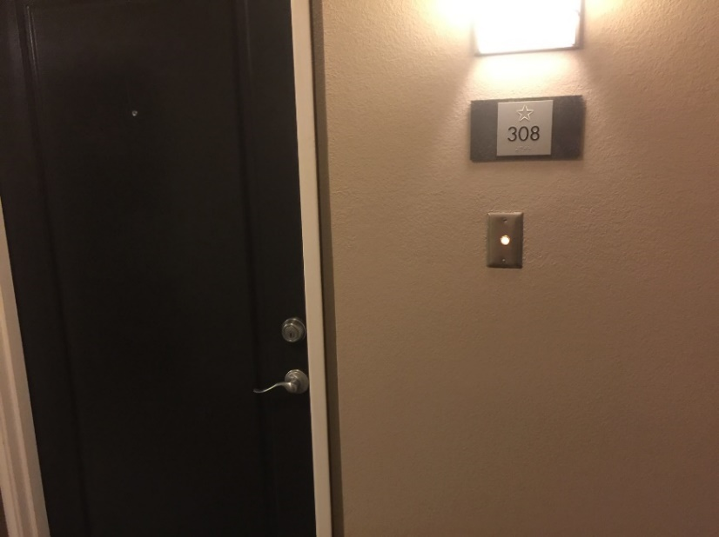
Figure 33: Unit identification signage with tactile markings and braille, and a door bell with visual indicator
    - Clear opening width of entrance (Maximum Points: 5)
Minimum Points:
- Provides sufficient clear width, free from obstructions, for people using wheelchairs or scooters, and for people with companions or service dogs
Maximum Points:
- Provides swing (hinged) door opening fully to 90° and door handles that do not obstruct the clear width
    - Level landing at entrance (Maximum Points: 5)
Minimum Points:
- Ensures a level clear space at entry
Maximum Points:
- Provides a slip-resistant landing as a safe space for all Site users to wait, enter and exit
    - Unit door is easy to open or power operated (Maximum Points: 5)
Minimum/Maximum Points:
- Ensures any manual doors are easy to open with minimal force or have power-operated door located at accessible height and location
- Ensures the force applied at the handle, push plate, or latch-releasing device does not exceed 38 N (8.5 lbf.) for exterior doors or 22 N (5 lbf.) for interior doors
    - Level threshold (Maximum Points: 5)
Minimum Points:
- Ensures a raised threshold is a maximum of 13 mm and is bevelled, ramped, or rounded
Maximum Points:
- Ensures threshold is flush with adjacent floor surface
    - Clear space on interior and exterior of door (Maximum Points: 4)
Minimum/Maximum Points:
- Provides clear space for access and manoeuvring on both sides of the entrance with extra space on the pull side
- For a manually operated swing door, ensures a person in a wheelchair or with a service dog can approach the door, activate the door handle, swing the door open, and pass through
- Provides adequate clear space between doors installed in a series (e.g., aligned or not aligned; vestibules) to facilitate traffic flow and ensure people using wheelchairs or electric scooters, or for people with strollers or service dogs can manoeuvre in space
Note: It is recommended that the distance between doors in series is 1500 mm, in addition to the width of any door swinging into the space.
- If doors are located near a stairway or a ramp, ensures they are positioned to avoid the risk of anyone falling backwards while opening the door
- Ensures doors do not project into any adjacent access route (e.g., recessed), if outward-opening doors
Ideas for Innovation:
- A place to put bags and/or parcels down next to the door while opening the door
    - Accessible door hardware (Maximum Points: 4)
Minimum Points:
- Ensures door hardware is operable with a closed fist without requiring grasping, pinching, or twisting required
Note: Lever handles or equivalent, as they are more convenient for everyone.
- Ensures it is mounted at an accessible height and location
Maximum Points:
- Ensures lever handles return to the door surface or are otherwise designed so they do not catch clothing or other objects
- Ensures handles contrast visually with the door
- Provides kick plates to prevent possible damage from wheelchair foot plates
    - Door viewer at accessible height (if available) (Maximum Points: 2)
Minimum Points:
- Provides a door viewer at accessible height for users in a seated position
Maximum Points:
- Provides two door viewers, one at standard height and the other one at accessible height
    - Well-illuminated (Maximum Points: 3)
Minimum Points:
- Provides adequate lighting for the nature and use of the space
- Positions lighting to adequately illuminate the unit entry and any adjacent landing surfaces
Maximum Points:
- Has fixtures shielding light sources and casting indirect light
Ideas for Innovation:
- A task light focused on an entry door lockset
- Overall light levels approximately 25% higher than code minimum
- Brighter doorway and entry hall lighting to support people who use sign language
    - Shelter (if outdoor entry) (Maximum Points: 2)
Minimum/Maximum Points:
- Provides shelter for weather protection (e.g., recessed door, canopy, overhang, porch)
- Ensures shelter provides suitable overhead clearance
    - Entrance to outdoor balcony, patio, and other outdoor spaces is accessible (Maximum Points: 5)
Minimum/Maximum Points:
- Ensures entrance has low threshold (i.e., maximum of 13 mm and is bevelled, ramped, or rounded)
- Ensures a level clear space at on both sides of entrance
- Provides sufficient clear opening width, free from obstructions, for people using wheeled mobility devices
- Ensures entrance door hardware is operable with one hand, using minimal force, and not requiring fine finger control, tight grasping, pinching, or twisting of the wrist

  - Unit Interior Doors
(Maximum Score: 18)
Doors, by their very nature, act as barriers and can have a significant influence on accessibility. In some situations, conventional doors may not be necessary at all. Instead, privacy may be achieved through the careful placement of walls and screens.
Manual swing doors are generally found in residential buildings. For a manual swing door, more space is required for manoeuvring on the pull side of the door than on the push side — it is easier to push a door open than to pull it. Generally, doors leading into rooms should open into the room, as doors that open outward into the main circulation route present a hazard. Inward-opening doors should be installed to open against a side wall. The direction in which doors open into rooms should be consistent.
    - Clear opening width (Maximum Points: 5)
Minimum Points:
- Provides sufficient clear width, free from obstructions, for people using wheelchairs or scooters, and for people with companions or service dogs
Maximum Points:
- Provides swing (hinged) door opening fully to 90° and door handles that do not obstruct the clear width
    - Level threshold (Maximum Points: 5)
Minimum Points:
- Ensures a raised threshold is a maximum of 13 mm and is bevelled, ramped, or rounded
Maximum Points:
- Ensures threshold is flush with floor surface
    - Clear space on outside and inside of door or doorway (Maximum Points: 4)
N/A if residential unit is a studio or similar single room with no door or doorway
Minimum Points:
- Provides clear and level space for access and manoeuvring on both sides of the doorway
- For a manually operated swing door, ensures a person in a wheelchair or with a service dog can approach the door, activate the door handle, swing the door open, and pass through the door with ease
Note: More space is required for manoeuvring on the pull side of the door (door swings into this space) than on the push side.
- Provides adequate clear space between doors installed in a series (e.g., aligned or not aligned; vestibules) to facilitate traffic flow and ensure people using wheelchairs or electric scooters, or for people with strollers or service dogs can manoeuvre in space
Note: It is recommended that the distance between doors in series is 1500 mm, in addition to the width of any door swinging into the space.
Maximum Points:
- Ensures doors do not project into any adjacent access route (e.g., recessed), if outward-opening doors
    - Accessible door hardware (if standard for all units) (Maximum Points: 4)
Applies only if door hardware type is standard for all units
Minimum Points:
- Ensures door hardware is operable with a closed fist without requiring grasping, pinching, or twisting required
Note: Lever handles or equivalent, as they are more convenient for everyone.
- Ensures it is mounted at an accessible height and location
Maximum Points:
- Ensures lever handles return to the door surface or are otherwise designed so they do not catch clothing or other objects
- Ensures handles contrast visually with the door

  - Unit Kitchen
(Maximum Score: 52)
Kitchens are an integral part of how a home functions and are part of the social fabric of a family. Accessible and adaptable kitchens support intergenerational living, older adults and seniors, and a generally more active community of people with disabilities.
Refer to the latest version of CSA B651 for additional details on kitchens.
    - Clear space for manoeuvring (Maximum Points: 5)
Minimum Points:
- Provides adequate turning radius for people using wheelchairs or scooters; people need to be able to turn around within a kitchen
Maximum Points:
- Provides suitable clear space in front of accessible counters, sinks, kitchen amenities and appliances, and to the one side where drawers or cabinet doors open
    - Accessible height sink (Maximum Points: 4)
Minimum/Maximum Points:
- Ensures sink is at an accessible height for wheelchair users or users in a seated position to easily use the sink and faucet
Ideas for Innovation:
- Power-operated height adjustable sinks
    - Knee clearance underneath sink or easily modified (Maximum Points: 4)
Minimum Points:
- Provides knee clearance underneath sink to allow front approach for wheelchair users
- Ensures pipes are insulated, with no exposed sharp edges or projecting components
Maximum Points:
- Ensures the lower shelf typically provided under a sink can be removed to enable a wheelchair user to easily roll under it
Ideas for Innovation:
- Shallow sink bowl which allows room for more knee space underneath sink

    - Sink faucet is easy to use or automatic (Maximum Points: 3)
Minimum Points:
- Ensures easy-to-operate or automated faucet that are operable with one hand, using minimal force, and not requiring fine finger control, tight grasping, pinching, or twisting of the wrist
Note: Separate controls for hot and cold water are not recommended. Single easy-to-use lever handle is preferred, if a manual faucet is provided.
- Ensures the faucet can be reached from a seated position
Maximum Points:
- Provides colour coding on faucet to clearly identify cold/hot (e.g., blue/red or C/H)
- Provides single lever handles, if lever type handles are used
Ideas for Innovation:
- Tactile labels or braille to identify cold/hot temperature
- Visual temperature indicator on faucet identifying the exact temperature of the water
    - Counter at accessible height or variety of heights (Maximum Points: 3)
Minimum Points:
- Provides an accessible height counter surfaces for users in seated position
- Provides knee clearance underneath accessible counter to allow front approach and improved reach ranges for wheelchair users
Maximum Points:
- Provides height options that allow people to work from either a standing or a seated position
- Ensures no sharp or abrasive surfaces under it
Ideas for Innovation:
- Power-operated height adjustable counters and islands
    - Clear counter space adjacent to sink and appliances (Maximum Points: 3)
Minimum/Maximum Points:
- Ensures adjacent accessible level work surface is provided beside all appliances to allow people to move items into fridge, to place pots and dishes beside cooktop or range, to prepare food, etc.

    - Rounded corners on counters and cabinetry (Maximum Points: 3)
Minimum/Maximum Points:
- Ensures no sharp 90° corners
- Ensures corners are rounded
    - Counter has electrical outlets within accessible reach (Maximum Points: 2)
Minimum/Maximum Points:
- Ensures an electrical receptacle is located at either the side or front of a kitchen counter, rather than at the back, eliminating the need to reach across a counter
- Ensures the outlets are colour contrasted with the mounting surface
    - Accessible storage options (Maximum Points: 3)
Minimum Points:
- Ensures storage space is at accessible height and location for people using wheeled mobility devices
- Ensures items may be accessed with minimal bending or reaching
Maximum Points:
- Provides flexible storage options (e.g., fold-down shelves, pull-out drawers, circular shelving)
Ideas for Innovation:
- Power-operated height adjustable lifting system for wall cabinets making items easier to reach
    - Cabinet hardware is accessible (if standard for all units) (Maximum Points: 3)
Applies only if cabinet hardware type is standard for all units
Minimum/Maximum Points:
- Ensures cupboards, drawers and cabinets have accessible hardware that is easy to use, operable with one hand, using minimal force, and not requiring fine finger control, tight grasping, pinching, or twisting of the wrist

    - Accessible cooktop or range (Maximum Points: 5)
Minimum Points:
- Ensures cooktop or range is at accessible height
Maximum Points:
- Ensures cooktop controls are safely and easily accessed without reaching over elements, typically on the front of cooktop and range
Ideas for Innovation:
- Induction cooktop replacing electric or gas cook top, eliminating fire hazards and reducing the frequency of burns and scalding
- Cooktop or range that includes tactile controls and/or provide audible feedback
    - Knee clearance underneath cooktop, or easily modified (Maximum Points: 3)
Minimum/Maximum Points:
- Provides knee clearance underneath cooktop or have lower shelf/cabinets that can be removed to allow front approach for wheelchair users
- Ensures insulation or other protection on the underside is provided where knee clearance is provided
    - Microwave mounting height accessible and safe (Maximum Points: 4)
Minimum Points:
- Ensures the microwave is located on an accessible height counter with adjacent clear space on latch side of unit
Note: This allows hot items to be transferred on a counter safely.
- Ensure microwaves are mounted at an accessible height
Note: Microwaves placed overhead or below counter height are not accessible and can create potential significant burn/scald hazard.
Maximum Points:
- Has pull-out counter (cutting-board style) underneath unit/counter
    - Vertical side-by-side style refrigerator (Maximum Points: 2)
Minimum/Maximum Points:
- Ensures fridge and freezer may be accessed without having to bend down or reach
- Ensures refrigerator has two doors — one freezer compartment and one fridge (side-by-side)
    - Raised dishwasher (Maximum Points: 2)
Minimum/Maximum Points:
- Ensures dishwasher is raised to make loading/unloading easier
Note: This will also create a raised counter for use by taller people using the kitchen.
    - Well-illuminated and task lighting available (Maximum Points: 3)
Minimum Points:
- Illuminates kitchen so it can be used easily
- Provides adequate lighting for the nature and use of the space
Maximum Points:
- Provides task lighting at work areas in the kitchen
- Ensures lighting minimizes any glare or reflection on surfaces
Note: Glossy or glass surfaces that cause significant glare should be avoided.
- Provides flat, even light to minimize shadows
Ideas for Innovation:
- Automatic internal lighting for cupboards and drawers

  - Unit Hallways
(Maximum Score: 14)
    - Clear width (Maximum Points: 5)
Minimum Points:
- Provides sufficient clear width, free from obstructions, for people using wheelchairs or scooters, and for people with companions or service dogs
- Provides adequate overhead clearance across the entire width and length of the hallway
Maximum Points:
- Provides adequate turning radius for people using wheelchairs or scooters; people need to be able to turn around within a corridor, particularly when the corridor is long
- Ensures minimal sharp corners when there is a change in corridor or hallway direction
- Note: Rounded corners or provision of convex mirrors allow people to see others approaching are helpful for people who are deaf or hard of hearing.
    - Colour contrast between wall and floor, with no glare (if colours are standard for all units) (Maximum Points: 3)
Applies only if colour palette is standard for all units, typical for rental apartments
Minimum/Maximum Points:
- Uses visual or colour contrast between wall, floor, or other large fields of tile or colour to help with depth perception, assist in wayfinding for people, and minimize vertigo for people who are blind or have low vision
- Ensures all surfaces are non-glare and have non-slip textured finishes, as polished surfaces cause glare and can be slippery
    - No level changes requiring steps (Maximum Points: 3)
Minimum Points:
- Ensures changes in level are not abrupt and are mitigated using a ramp, passenger lift, etc.
- Ensures changes in level do not require steps
Maximum Points:
- Ensures there are no changes in level on a single floor

    - Well-illuminated (Maximum Points: 3)
Minimum/Maximum Points:
- Provides adequate lighting for the nature and use of the space
- Ensures light is evenly distributed throughout circulation areas
- Ensures surfaces minimize any glare or reflection

  - Unit Interior Stairs
(Maximum Score: 36)
    - Clear width (Maximum Points: 2)
Minimum/Maximum Points:
- Provides sufficient clear width, free from obstructions, to allow people in both directions to easily pass one another
- Provides sufficient clear width that could accommodate installation of potential platform lift
    - Surface is firm, stable, and slip resistant (Maximum Points: 5)
Minimum/Maximum Points:
- Ensures treads and landings have a stable and firm surface
- Ensures stairs are in good condition with no damage or settlement
- Ensures all surfaces are non-glare
- Ensures treads and landings have a slip-resistant finish or have slip-resistant strips for both wet and dry conditions
- If carpeting is used, ensures it is used only on the tread (top of step) but not continuously over the nosing and throughout the flight of stairs
    - Level landings with clear space (Maximum Points: 3)
Minimum Points:
- Ensures landings are provided at the top and bottom of each flight
- Ensures landings extend along full width of stairs
- Ensures there are no stepped landings
- Ensures landings are unobstructed by door swings
- Provides guardrails where there is drop-off at the edge of the landings
Maximum Points:
- Ensures the total rise for a flight of stairs is appropriate; if more than one flight is required, the number of steps in each flight is the same
Note: The maximum number of steps should be 12 at each flight.
- Provides a colour/textural change at the top of the stairs to identify the staircase

    - Handrails (Maximum Points: 5)
Minimum Points:
- Provides handrails on both sides of stairs at a consistent and accessible height
Note: If stair is wide, an intermediate handrail is recommended to ensure people can reach handrails on both sides if required.
- Ensures handrails are continuous through the stairs and landings; people who are blind or have low vision rely on handrails to guide them in negotiating stairs, while people with mobility disabilities rely on them for stability
- Ensures sufficient clearance exists between handrail and wall
- Ensures the handrail size (diameter) facilitates grip, with a smooth, round design free of any sharp, abrasive elements
- Provides horizontal handrail extensions at the top and bottom of all stairs to provide support and orientation for people as they move between the stair and a level surface and vice versa
- Ensures extensions are turned down or sideways and returned to post, floor or wall to prevent handbags, pockets, etc. from getting caught, with a consistent method used throughout the unit
Note: Extensions are not required where they would project into another path of travel.
- Is securely attached and supports enough weight for its intended use
- Contrasts visually with surrounding surfaces
Maximum Points:
- Has fixed support brackets on underside that do not interfere with a person running their hand along the length
- Allows people with lower eye level, such as children or people of short stature, to see through the railings
- Prevents people and dogs from walking underneath
Ideas for Innovation:
- A parallel lower handrail for people of different heights, including children or people of short stature
    - Colour-contrasted and slip-resistant strip on nosing (if standard in all units) (Maximum Points: 4)
Applies only if this is standard for all units
Minimum Points:
- Ensures each step edge has strip that colour contrasts with the tread to visually highlight the step edge and improve depth perception
Note: Light-coloured strips on dark treads are preferred to light-coloured treads on dark strips as dark strips on nosings are harder to notice by people with low vision.
- Ensures strip extends the full width of the step and is of adequate width
Maximum Points:
- Ensures strip is slip resistant
- Ensures each contrasting strip wraps around nosing and continues down the riser so that it is visible when both ascending and descending the stairs (e.g., no more than 10 mm)
- Ensures a single colour is used for contrasting strips
    - Riser height and tread depth (Maximum Points: 4)
Minimum/Maximum Points:
- Ensures steps are consistent throughout with uniform riser heights and tread depths; inconsistencies in rise or in tread depth can create tripping hazards
- Ensures dimensions are adequate to provide safe footing for all users
    - No open riser (Maximum Points: 3)
Minimum/Maximum Points:
- Ensures all step risers are closed and opaque; open risers can be tripping hazards, a source of visual confusion, or disconcerting
Note: People who wear leg braces or prosthetic devices need a solid riser to guide the foot up the riser and over the nosing to the next step; those who use canes or crutches place them against the riser of the next step in order to maintain balance.
    - Nosing design (Maximum Points: 2)
Minimum/Maximum Points:
- Ensures nosings are flush with riser, or are sloped to the riser at an angle greater than 60° to the horizontal, where they project
- Ensures, where projecting nosings are used, they do not have sharp or abrupt edges or an underside that prevents a foot from sliding up the riser and that may cause tripping; projecting nosings must be rounded or bevelled
    - Flooring with no busy patterns (if standard in all units) (Maximum Points: 2)
Minimum/Maximum Points:
- Has plain, light-coloured flooring or simple-patterned flooring, including carpeting, tiles or other types of flooring
Note: Busy patterns, such as stripes and checks, can create confusion for people with low vision, while solid, dark colours can create a “bottomless pit” effect.
    - Height clearance (Maximum Points: 3)
Minimum/Maximum Points:
- Maintains adequate overhead clearance throughout the full length of the stairway and on any landings (e.g., if sheltered or if items are suspended above stairs)
- Ensures the area beneath an unenclosed has a protective guardrail or barrier to prevent people from colliding with the underside of the stairs
    - Well-illuminated (Maximum Points: 3)
Minimum/Maximum Points:
- Illuminates stair and landing surfaces so they can be used safely at any time
- Provides adequate lighting for the nature and use of the space
- Ensures light is evenly distributed throughout circulation areas
- Ensures surfaces minimize any glare or reflection
- Ensures lighting minimizes the creation of shadows on walls and floors

  - Unit Bedrooms and Closets
(Maximum Score: 16)
    - Clear space in front of closet door or clear width in walk-in closet (Maximum Points: 3)
Minimum Points:
- Provides a clear space in front of closet door
- Provides sufficient clear width in walk-in closet for people using wheeled mobility devices
Maximum Points:
- Provides adequate turning radius for people using wheelchairs or scooters to be able to turn around within a walk-in closet
    - Low mounted or adjustable hanger rods, and accessible shelving (Maximum Points: 2)
Minimum Points:
- Ensures some shelving and hangers are at accessible height for easy reach for users in a seated position
Maximum Points:
- Ensures approximately half or more of the available storage is below the maximum accessible height
    - Clear space on at least two sides of bed (Maximum Points: 4)
Minimum/Maximum Points:
- Ensures clear space can be provided on at least two sides of the bed
Ideas for Innovation:
- A bathroom is located adjacent to the bedroom for easy access by user
    - Power outlet within accessible reach (Maximum Points: 2)
Minimum/Maximum Points:
- Provides at least one electrical outlet at a convenient and accessible location
Note: Ideally outlet should be close to where the bed is most likely be placed so that people can charge their powered wheelchairs, scooters, communication aids and other devices.

    - Reinforced ceiling for lift (Maximum Points: 5)
Minimum/Maximum Points:
- Provides broad structural support between ceiling joists with adequate load-bearing capacity to permit new ceiling lift installations without removing ceiling panels
Note: The most common use for ceiling lifts are bedrooms and bathrooms however where possible, broad structural support between ceiling joists throughout the home is desirable.
Ideas for Innovation:
- Broad blocking between ceiling joists throughout the home

  - Unit Toilet Rooms
(Maximum Score: 56)
Accessible toilet rooms should be designed to accommodate wheelchair users, persons with mobility challenges, and those who need extra space.
    - Accessible toilet room on the entry level (Maximum Points: 5)
Minimum/Maximum Points:
- Ensures the toilet room is accessible to all residents and visitors, including people using wheelchairs
    - Floor surface is stable, firm, and non-slip (Maximum Points: 4)
Minimum/Maximum Points:
- Ensures surfaces are stable and, firm that resists movement
- Ensures surfaces have non-slip finish for both wet and dry conditions
- Ensures all surfaces are non-glare and have non-slip textured finishes, as polished surfaces cause glare and can be slippery
    - Clear opening width of entry door (Maximum Points: 5)
Minimum/Maximum Points:
- Provides sufficient clear width, free from obstructions, for people using wheelchairs or scooters, and for people with companions or service dogs
- Provides clear and level space for access and manoeuvring on both sides of the doorway; a person using a wheelchair or with a service dog must be able to approach the door, swing the door open, and pass through the door with ease
Note: More space is required for manoeuvring on the pull side of the door (door swings into this space) than on the push side.
    - Entry door swings out or slides (Maximum Points: 3)
Minimum/Maximum Points:
- Ensures the entry door swings out or slides and does not encroach on the toilet room’s interior space and clearance

    - Accessible entry door hardware (if door hardware is standard for all units) (Maximum Points: 4)
Minimum/Maximum Points:
- Ensures opening hardware on entry doors is easy to use; door handles, pulls, latches, locks, and other operational devices should be operable with one hand and minimal force and not require fine finger control, tight grasping, pinching, or twisting of the wrist
- Ensures locking hardware on entry or toilet stall doors is operable with one hand, using a closed fist position, and allows door to be unlocked from the outside in case of emergency
Note: Doors to washrooms and other enclosed spaces which have no other exit should not be equipped with deadbolts or other means of security that can only be manipulated from the inside. Instead, they are to be equipped with an easily manipulated push-lock doorknob that can be released from the outside with a special tool, key or similar hardware.
    - Clear space to manoeuvre and transfer (Maximum Points: 5)
Minimum/Maximum Points:
- Dimensions ensure that a wheelchair user has clear space to turn and position themselves adjacent to the toilet
- Dimensions ensure that a wheelchair user has the choice of preferred transfer arrangements (i.e., lateral, angled, frontal, or rear)
Note: Overall required dimensions depend on the door position and whether the door swings inwards or outwards as well as whether the toilet is wall hung or floor mounted.
    - Clear width of route to toilet (Maximum Points: 5)
Minimum/Maximum Points:
- Provides sufficient clear width allowing people using wheelchairs or scooters to easily get to the toilet
    - Reinforced walls for installation of grab bars (Maximum Points: 5)
Minimum Points:
- Ensures walls are reinforced with structural support between studs to support grab bars beside toilet
Maximum Points:
- Ensures broad structural support between studs on walls around toilet with adequate load-bearing capacity to allow for new installation or relocation of existing grab bars
Note: Having structural support for the full height of the corner walls around the toilet gives Site user the flexibility to install grab bars and other equipment at most appropriate locations based on their needs. This also eliminates the need to remove walls and install blocking later.
    - Toilet at appropriate height and has back support (Maximum Points: 5)
Minimum Points:
- Ensures toilet seat is at a suitable height and secured (e.g., not spring activated)
- Provides a back rest or toilet seat lid so someone with limited balance can lean against it; the toilet seat is not the spring-up type
Maximum Points
- Ensures, where a tank-type toilet is used, the tank is secured (bolted down) so someone can lean on it during a transfer
Ideas for Innovation:
- Adaptive devices such as toilets seats that wash and dry users automatically and/or lift toilet seats
    - Toilet flushing mechanism within easy reach (Maximum Points: 4)
Minimum Points:
- Ensures hand-operated flushing controls are accessible and easy to use
- Ensures toilet flush handles are positioned on the transfer side of the toilet (the side opposite the wall), or within easy reach for a person who has transferred back onto their wheeled mobility device, eliminating the need to reach over the toilet to flush
Note: For many people using wheelchairs or with mobility disabilities or poor balance and for people who are blind or have low vision, this reach creates an unnecessary falling hazard.
Maximum Points:
- Ensures flush controls are automatically activated
    - Power outlet near toilet (Maximum Points: 2)
Minimum/Maximum Points:
- Ensures an AC outlet or at least has a spot roughed in for the outlet adjacent to each accessible toilet to accommodate adaptive devices and technology, such as personal hygiene devices, heated seats, automatic seats, in anticipation of electrically operated assistive devices
Note: This should be required in all new construction.

    - Sink and counter are accessible (Maximum Points: 5)
Minimum Points:
- Ensures sink and counter are at accessible height
- Provides adequate knee clearance underneath the sink and counter
- Ensures hot water and drainpipes are offset to the rear, to help protect people using wheelchairs from burns and abrasions.
- Ensures hot water pipes are insulated or covered if they abut required clearances
- Ensures faucet is easy to reach and operate
- Ensures there are no sharp corners and edges on counters, shelves, and vanities
Maximum Points:
- Includes a counter or shelf adjacent to the sink
- Ensures mirror is positioned at a height that can be used by people in either a seated or standing position
Ideas for Innovation:
- Power-operated height adjustable sink allowing use at variety of height and additional knee clearance if required
    - Accessible storage (Maximum Points: 4)
Applies built-in storage space/vanity
Minimum/Maximum Points:
- Ensures storage space is at accessible height and location for people using wheeled mobility devices
- Ensures items may be accessed with minimal bending or reaching
- Ensures cabinet hardware has accessible hardware that is easy to use, operable with one hand, using minimal force, and not requiring fine finger control, tight grasping, pinching, or twisting of the wrist
Ideas for Innovation:
- Power-operated height adjustable lifting system for wall cabinets making items easier to reach

  - Unit Showers and Bathtubs
(Maximum Score: 33)
    - Floor surfaces are stable, firm, and non-slip (Maximum Points: 4)
Minimum/Maximum Points:
- Ensures surfaces are stable firm, and resist movement
- Ensures surfaces have matte and non-slip finish for both wet and dry conditions
- Ensures all surfaces are non-glare and have non-slip textured finishes, as polished surfaces cause glare and can be slippery
    - Reinforced walls for installation of grab bars (Maximum Points: 5)
Minimum/Maximum Points:
- Ensures broad structural support between studs on walls around tub and/or shower with adequate load-bearing capacity to allow for installation of grab bars and/or shower seat
Note: Having structural support for the full height of the corner walls around the tub and/or shower gives Site user the flexibility to install grab bars and other equipment at most appropriate locations based on their needs. This also eliminates the need to remove walls and install blocking later.
    - Roll-in shower (Maximum Points: 5)
Minimum Points:
- Provides adequate level clear floor area in front of shower entrance
- Provides entrance to shower area has an adequate clear width
- Has easy-to-access roll-in shower for people using wheelchairs, with adequate clear space for manoeuvring;
- Ensures no fixtures that project into clear area impede required clear space
- Ensures threshold does not exceed 13 mm in height and is beveled at a maximum slope of 1:2
Maximum Points:
- Ensures shower threshold is flush with floor and incorporates a trench drain or a collapsible water barrier
- Ensures any enclosures, such as doors or curtains do not obstruct transfer or controls
- Ensures there are no sharp edges or trims
Ideas for Innovation:
- Fold-down shower seat is installed in roll-in shower at suitable height and location
    - Accessible bathtub (if tub available) (Maximum Points: 5)
Minimum/Maximum Points:
- Ensures unobstructed clear space is provided parallel to the bathtub for transfer by users of wheeled mobility devices
- Ensures bathtub enclosures do not obstruct controls or interfere with transfer from a mobility device
    - Accessible water faucet and shower wand (if standard for all units) (Maximum Points: 5)
Minimum Points:
- Ensures water controls and shower wand are located within easy reach from a seated position
- Ensures shower head is detachable and height is adjustable to enable alternative showering positions, both sitting and standing
- Ensures faucet is operable with a closed fist and requires minimal force
Maximum Points:
- Provides clearly identifiable and unambiguous temperature and volume controls to protect users from scalding water
- Ensures shower hose length is adequate to allow for flexible use
Ideas for Innovation:
- Faucets are offset halfway between the typical location and the outside edge of the shower or tub, making it easier and safer to reach
- Faucets are located between the centre of the end wall and the open side of the bath tub so that users can adjust controls before transferring to bath tub
    - Recessed soap holders or shelves within easy reach (Maximum Points: 4)
Minimum Points:
- Ensures soap holders or shelves for toiletries are easy to reach from a seated position
- Ensures soap holders or shelves do not impede required clear space and are of adequate size to hold toiletries
Maximum Points:
- Ensures soap holders or shelves are recessed
- Provides easy-to-reach towel bar and clothes hook at accessible height, if these are standard for all units
    - Colour contrast between shower/tub tile floor or base and front wall (if standard in all units) (Maximum Points: 2)
Minimum/Maximum Points:
- Ensures colour contrast is provided between the shower tile flooring or base/bathtub base and the front wall
    - Drainage (Maximum Points: 3)
Minimum Points:
- Ensures floor is level with minimal slope provided for drainage
Maximum Points:
- Includes an integral floor drain
Note: Trench or channel drains are recommended.

  - Unit Laundry
(Maximum Score: 18)
    - Clear space for approach (Maximum Points: 5)
Minimum/Maximum Points:
- Ensures clear space across full width and in front of washer and dryer
- Allows for parallel approach such that someone using a wheeled mobility device can manoeuvre, open the door and add/remove laundry
    - Front-loading machines (if appliances are provided for all units) (Maximum Points: 5)
Minimum/Maximum Points:
- Ensures washing machines and dryers are front loading
- Ensures washing machines and dryers are not stacked
Note: Front-loading machines are generally preferable to top-loading machines. Dual-use equipment or stacked units could be acceptable if they show equivalent or greater levels of accessibility than front-loading machines. However, most of the stacking washer/dryers on the market do not meet the upper reach range limit requirement.
    - Accessible controls (Maximum Points: 5)
Minimum Points:
- Ensures operating mechanism is easy to use with minimum effort and operable with one hand and not require tight pinching, grasping, or twisting of the wrist
- Ensures front controls are at an accessible height and reach
Maximum Points:
- Ensures electronic functions (menu and cycle display) are easy to read; information is communicated using visual and tactile controls
- Ensures audible tones indicate cycle operation (e.g., cycle selection, on, off)
    - Well-illuminated (Maximum Points: 3)
Minimum/Maximum Points:
- Provides adequate lighting for the nature and use of the space

  - Unit General Requirements
(Maximum Score: 24)
    - Adequate number of accessible and adaptable units (Maximum Points: 5)
Minimum Points:
- Ensures at least 15% of the total number of units is accessible or adaptable
Maximum Points:
- Includes accessible or adaptable residential unit(s) for each type of units (e.g., bachelor, 1 bedroom, etc.) available
- At least 20% or more of the total units are accessible or adaptable
- Ensures units not designated as accessible provide basic access to be visitable
    - Unit has both audible and visual fire/smoke alarm (Maximum Points: 5)
Minimum/Maximum Points:
- Ensures unit includes both audible and visual fire and smoke alarms
- Ensures visual fire alarms operate in conjunction with audible fire alarms and are visible throughout the unit
Ideas for Innovation:
- Vibrating alarm-signalling devices which are configured with a bed vibrator that activates if the building alarm system or a smoke alarm system within a dwelling unit is triggered
    - All controls and outlets are within accessible reach (Maximum Points: 5)
Minimum/Maximum Points:
- Ensures all unit controls (e.g., light switches, electrical outlets and thermostats) are mounted at accessible height
- Ensures clear space is provided in front of all unit controls and outlets
    - Space/framing is provided for future residential lift (if multiple level) (Maximum Points: 5)
Applies only to unit that are multiple level
Minimum Points:
- Provides broad structural support between studs in walls at staircase, allowing for new installations of platform lift or other devices for vertical circulation, while providing adequate load-bearing capacity, eliminating the need to remove walls and install blocking later
Maximum Points:
- Ensures an elevator shaft is framed in for future use
    - Windows with accessible hardware (Maximum Points: 4)
Applies to windows that can be operated and/or used for viewing
Minimum/Maximum Points:
- Ensures window operating control is at accessible height
- Ensures window operating control is operable with a closed fist without requiring grasping, pinching or twisting required
- If viewing windows are available, ensures the sills are at a viewing height for people in a seated position

- Trails and Pathways
The table below displays the Site elements used to measure accessibility for this category, the corresponding maximum score available for each, and the category total.
Site Element | Maximum Score
10.1 Trail and Pathway Features | 45
10.2 Trail and Pathway Ramps | 32
10.3 Trail and Pathway Stairs | 38
10.4 Trail and Pathway Wayfinding and Signage | 35
Innovation | 15
Total Maximum Score | 165
Description
Accessible pedestrian trails are typically front country, including greenway trails, short-distance hiking trails and interpretive trails. Some trails are only accessible a portion of the length due to topography and other constraints.
Fully accessible trails must meet guidelines related to surfaces, width, grade, resting intervals, edge protection and obstacles. In order to make a trail accessible, surfaces must be firm and stable.
  - Trail and Pathway Features
(Maximum Score: 45)
Trails and pathways should be safe for all users, free of obstacles, well illuminated, easy to find, and well-integrated with any stairs or ramps along the route.
    - Designated trailheads (Maximum Points: 5)
Minimum/Maximum Points:
- Integrates designated trailhead as part of the trail design at key entrance and exit points along the trail, intermediate areas on lengthy trails, and decision points
    - Trail/pathway entrances are accessible (Maximum Points: 5)
Minimum/Maximum Points:
- Provides sufficient clear width, free from obstructions, for people using wheelchairs or scooters, and for people with companions or service dogs, especially if bollards are used
- Ensures any gates are simple and easy to open, with no level change or ramp

    - Clear width and passing spaces at regular intervals (Maximum Points: 5)
Minimum Points:
- Provides sufficient clear width, free from obstructions, for people using wheelchairs or scooters, and for people with companions or service dogs
- Allows one or two-way flow of people, depending on the expected number of people
Maximum Points:
- Allows at least two people using wheelchairs or people with strollers to walk alongside or easily pass one another when approaching from different directions
- Provides level passing areas at reasonable intervals if pathway is not wide enough and at decision points
- Has established maintenance policies (e.g., snow clearing, storage) in place to ensure that pathways are kept clear
    - Surface is firm, stable, and slip resistant (Maximum Points: 5)
Minimum/Maximum Points:
- Has a stable and firm surface that resists movement
- Has appropriate type of surface material (climate/weather conditions):
- Uses suitable types of exterior surface materials, including asphalt, concrete, stone, timber, brick/paving
- Avoids using loose materials, such as sand, gravel, or woodchips, or rough/irregular materials, such as cobble stones
- Ensures an even surface with minimal irregularities to reduce potential for water accumulation, which can create a slippery surface
- Ensures there are minimal gaps, joints, or breaks in the surface, which present tripping hazards
Note: Any gaps should run perpendicular to the direction of movement.
- Ensures all surfaces are non-glare and have non-slip textured finishes for both wet and dry conditions
    - Path is level or low-gradient slope (when not accommodated by ramp) (Maximum Points: 5)
Minimum Points:
- Ensures minimal running slope of less than 5% (1:20)
Note: If running slope is more than 5% (1:20), a ramp is typically required but this may not be possible due to the trail’s topography.
- Ensures handrails are installed if sloped pathways have a running slope over 5%, where ramp cannot be installed due to topography of the trail
- Ensures cross slope is 2% (1:50) maximum
- Ensures gradient is constant and consistent
Note: Variations in slope, such as grade breaks within runs, can disrupt wheelchair travel.
Maximum Points:
- Has a level surface
    - No obstacles on path and overhead, or obstacles are cane detectable and high contrast (Maximum Points: 5)
Minimum/Maximum Points:
- Provides suitable overhead clearance across the entire width and length of the pathway, meaning it is free of any signs or obstacles (e.g., tree branches)
Note: A cane-detectable feature is required where overhead objects present a hazard to prevent collision hazards for people who are blind or have low vision.
- Ensures obstacles or protruding objects in the path of travel are cane-detectable
- Ensures path is clear of bins, bicycles, leaves, and litter
- Ensures the base of trees is protected by a tree grate or cane-detectable tree guard, where trees are in the path of travel
- Ensures any fixed items along the route, such as furniture (e.g., bollards, seating, disposal bins, drinking fountains), are located off the path of travel, if possible
- Ensures any fixed items located on the path of travel are cane-detectable and clearly indicated using a contrasting colour
- Has established maintenance policies (e.g., leaves and litter) in place to ensure that pathways are kept clear
    - Edge protection (Maximum Points: 4)
Only applies if there is a drop-off at edge of trail/pathway
Minimum/Maximum Points:
- Has clearly defined pathway edges with a change in texture and tonal contrast to help people who are blind or have low vision
- Provides suitable protection if the path is adjacent to a vehicular route or if it is a shared-use route (e.g., shared with other users such as cyclists)
- Provides suitable edge protection, such as curb, barriers or guardrails, on either side of a path to prevent accidents where a change in level exists
- Uses guardrails or barriers that visually contrast with surrounding surfaces where there is a significant change in level
- Ensures guardrails or barriers are designed to allow people using wheelchairs and children, to see and be seen through railings, and to be detectable for people who are blind or have low vision
    - Clearly marked pedestrian crossings (if in path of traffic) (Maximum Points: 3)
N/A only if the trail/pathway does not cross traffic
Minimum Points:
- Provides logical and understandable directional signage at crossings
- Ensures crosswalks are clearly marked on the pavement
- Ensures crosswalks are located where they are clearly visible, safe, and convenient
Maximum Points:
- Provides a variety of clear wayfinding cues with curb ramps aligned with the crossing area
- Uses appropriate crosswalk markings to indicate uncontrolled crossing
- Ensures crosswalks have additional alerts (e.g., flashing lights, audible signal, or embedded LED lighting)
- Ensures raised crossing is in place
    - Seating (Maximum Points: 3)
N/A only if pathway is short distance and there are no level changes or decision points
Minimum Points:
- Provides seating off path of travel at rest areas, if long route and/or steep grade
- Ensures surface on which seating is located is level, firm, and stable
- Contrasts visually with surrounding surfaces
- Incorporates clear space for people using wheelchairs, scooters, or strollers so they can sit alongside one another and with their companions
- Provides a clear space at the end of the seating for a service dog to rest
- Offers a variety of seating options to suit different people: seats with and without armrests, seats with backrests, and fixed and movable seats
- Ensures seats positioned in a row are of the same style (e.g., all with armrests or all without)
Note: A mixture of seat styles in a single row can cause confusion for people who are blind or have low vision.
Maximum Points:
- Provides back support and at least one armrest
- Provides adequate heel space to allow people to stand up easily
- Ensures resting area is clearly visible and identified with a change in surface materials (i.e., texture and colour)
- Provides regular, frequent, and predictable intervals for intended use and before level changes; seating intervals are 10m, if possible
- Ensures seating areas are level and within sight of one another
- Provides shelter
    - Drainage (Maximum Points: 2)
Minimum Points:
- Ensures cross slope is minimal but sufficient enough to allow adequate drainage (2%); does not permit water accumulation or pooling that would create slippery surfaces or cause glare
- Ensures drainage channels do not obstruct path of travel
- Has drainage grates offset from main pathway
- Ensures openings for drainage grates are perpendicular to the path of travel
Maximum Points:
- Ensures grate is high contrast relative to surrounding surfaces, and drain slots are aligned to the typical path of travel
    - Well-illuminated (if required for expected usage) (Maximum Points: 3)
N/A only if no power along trail/pathway or policy is for day use only
Minimum/Maximum Points:
- Ensures the complete trail/pathway is brightly lit
- Provides adequate lighting for the nature and use
- Provides even light distribution at ground level and minimizes lights presenting a source of glare or creating pools of light and areas of shadow
- Has fixtures shielding light sources and casting indirect light
- Has fixtures mounted below eye level used in addition to standard lighting to provide better definition of ground surfaces

  - Trail and Pathway Ramps
(Maximum Score: 32)
Exterior ramps should be provided in areas along trails and pathways where the slope (grade, gradient, incline) exceeds 5% (1:20).
Important: This element applies to structures that were built as exterior ramps to overcome a level change along the trails and pathways. In some cases, sloped pathways exceed 5% (1:20) due to the trail’s topography and should be rated in Element 10.1 Trails and Pathways Features.
Ramps should provide adequate width to accommodate the expected number of people, including people using power wheelchairs and scooters. Ramps can have one of the following configurations:
- Straight run
- 90° turn
- Switchback or 180° turn
Circular or curved ramps are not recommended, nor are ramps within stairs (S-ramps) since they are extremely hazardous to people who are blind or have low vision, people with mobility disabilities, and people using wheeled mobility devices or walking aids.
    - Slope (Maximum Points: 5)
Minimum Points:
- Has a running slope of 8.3% (1:12) or less (as per building code and CSA B651)
- Ensures the cross slope on ramps is 2% (1:50) maximum to allow for proper drainage
Maximum Points:
- Has a running slope of 5% (1:20) or less
- Ensures gradient is constant and consistent
- Ensures ramps with two or more consecutive slopes are of the same gradient; between landings, the gradient of ramps should be the same
    - Clear width (Maximum Points: 3)
Minimum/Maximum Points:
- Provides sufficient clear width, free from obstructions, for people using wheelchairs or electric scooters or for people with companions or service dogs
- Allows one or two-way flow of people, depending on expected number of people and the nature of the facility
- Allows people to easily pass one another at the same time when approaching from different directions
    - Surface is firm, stable, and slip resistant (Maximum Points: 5)
Minimum/Maximum Points:
- Has a stable and firm surface that resists movement
- Uses suitable types of exterior ramp surface materials, including asphalt, concrete and timber
- Ensures an even surface with minimal irregularities to reduce potential for water accumulation, which can create a slippery surface
- Ensures there are minimal gaps, joints, or breaks in the surface, which present tripping hazards
Note: Any gaps should run perpendicular to the direction of movement.
- Ensures all surfaces are non-glare and have non-slip textured finishes for both wet and dry conditions
    - Level landings with clear space (Maximum Points: 4)
Minimum/Maximum Points:
- Ensures landings are located at the top and bottom of each run
- Provides intermediate landings between runs and where ramps change direction, for resting, manoeuvring, and avoiding excessive speed
Note: A ramp should be no longer than 9,000 mm and have level landing at the top and bottom.
- Provides adequate turning space for people using wheelchairs or mobility aids, and for people with strollers or service dogs
    - Colour-contrasted and slip-resistant strip (Maximum Points: 4)
Minimum/Maximum Points:
- Ensures colour-contrasted and slip-resistant strips at landing before each run
- Ensures strips extend the full width of the ramp
    - Handrails (Maximum Points: 5)
Minimum Points:
- Provides handrails on both sides of a ramp at a consistent, accessible height along its run
- Ensures handrails are continuous through the length of ramps
Note: People who are blind or have low vision rely on handrails to guide them in negotiating ramps, while people with mobility disabilities rely on them for stability
- Ensures the handrail size (diameter) facilitates grip, with a smooth and round design
- Ensures sufficient clearance exists between handrail and wall, free of any sharp and abrasive elements
- Provides horizontal handrail extensions at the top and bottom of all ramps to provide support and orientation for people as they move between the ramp and a level surface and vice versa
- Ensures extensions are turned down or sideways and returned to post, floor, or wall to prevent handbags, pockets, etc. from getting caught
Note: Extensions are not required where they would project into another path of travel
- Has fixed support brackets on underside that do not interfere with a person running their hand along the length
- Is securely attached and supports enough weight for its intended use
- Contrasts visually with surrounding surfaces
Maximum Points:
- Provides intermediate handrails if ramp is wide
Note: If ramp is wider than 2,200 mm, provide an intermediate handrail ensuring sufficient clear width for people using wheelchairs or electric scooters, or for people with companions or service dogs
- Is constructed of materials of low thermal conductivity that do not become too cold or hot to the touch, with preferred materials including wood or plastic-coated steel or stainless steel
- Prevents people and service dogs from walking underneath
- Allows people with lower eye level, such as people using wheelchairs or people of short stature, to see through the railings
Ideas for Innovation:
- A parallel lower handrail for people of different heights, including children or people of short stature

    - Edge protection (Maximum Points: 3)
Minimum/Maximum Points:
- Provides curbs or protective barriers (e.g., raised barrier or rail) on both sides of the ramp and on landings, where there is a drop-off, to prevent wheelchair casters or crutch tips from slipping off edge
Maximum points:
- Contrasts visually with ramp surface
    - Well-illuminated (if required for expected usage) (Maximum Points: 3)
N/A only if no power or policy is day use only
Minimum/Maximum Points:
- Ensures the ramp is brightly lit to be used safely after dark
- Positions lighting to adequately illuminate any ramp and landing surfaces and to highlight changes in slope
- Provides even light distribution at ground level and minimizes lights presenting a source of glare or creating pools of light and areas of shadow
- Has fixtures shielding light sources and casting indirect light
- Has fixtures mounted below eye level used in addition to standard lighting to provide better definition of ground surfaces

  - Trail and Pathway Stairs
(Maximum Score: 38)
Stairs are inherently hazardous. They need to be well dimensioned to provide a stable footing and to ensure the safety and comfort of all users. They should not be steep, and surfaces should be firm, stable, and slip resistant. Stairs should be equipped with accessible handrails and tactile attention indicators (TAIs), and be kept clear of all obstacles, including litter and leaves.
Stairs should be provided in conjunction with a ramp to offer choice and to meet all users’ needs. Where possible, the top and bottom of a ramp should be adjacent to the top and bottom of an associated set of stairs.
Single steps should be avoided in an access route, as they are not as obvious as a longer flight of stairs and may present a tripping hazard. If a change in level is equivalent to the rise of a single step, the surface should be gently graded. Stair dimensions should be consistent throughout a flight of stairs.
Circular stairs and stairs with tapered treads should be avoided, as they can be difficult for people with low vision to navigate, and they may create falling hazards.
    - Clear width (Maximum Points: 2)
Minimum/Maximum Points:
- Provides sufficient clear width, free from obstructions, for people with service dogs
- Allows one or two-way flow of people, depending on the expected number of people
- Allows people to easily pass one another at the same time when approaching from different directions
    - Surface is firm, stable, and slip resistant (Maximum Points: 5)
Minimum/Maximum Points:
- Ensures treads and landings have a stable and firm surface
- Ensures stairs are in good condition with no damage or settlement
- Has appropriate type of surface material (climate/weather conditions)
- Ensures an even surface with minimal irregularities to reduce potential for water accumulation, which can create a slippery surface
- Ensures there are minimal gaps, joints, or breaks in the surface, which present tripping hazards
Note: Any gaps should run perpendicular to the direction of movement.
- Ensures all surfaces are non-glare and have non-slip textured finishes for both wet and dry conditions.

    - Level landings with clear space and at regular intervals (Maximum Points: 3)
Minimum Points:
- Ensures landings are provided at the top and bottom of each flight, with the length equivalent to the step width
- Provides landings at reasonable intervals throughout the stairway to break up significant difference in level
- Ensures landings extend along full width of stairs
- Ensures there are no stepped landings
- Ensures landings are unobstructed by door swings
- Provides guardrails where there is drop-off at the edge of the landings
Maximum Points:
- Ensures the total rise for a flight of stairs is appropriate; if more than one flight is required, the number of steps in each flight is the same
Note: The maximum number of steps each flight should have is 12
    - Handrails (Maximum Points: 5)
Minimum Points:
- Provides handrails on both sides of stairs at a consistent and accessible height
Note: If stair is wide, provide an intermediate handrail
- Ensures handrails are continuous through the stairs
Note: People who are blind or have low vision rely on handrails to guide them in negotiating stairs, while people with mobility disabilities rely on them for stability
- Ensures the handrail size (diameter) facilitates grip, with a smooth and round design
- Ensures sufficient clearance exists between handrail and wall, free of any sharp and abrasive elements
- Provides horizontal handrail extensions at the top and bottom of all stairs to provide support and orientation for people as they move between the stair and a level surface and vice versa
- Ensures extensions are turned down or sideways and returned to post, floor or wall to prevent handbags, pockets, etc. from getting caught
Note: Extensions are not required where they would project into another path of travel
- Has fixed support brackets on underside that do not interfere with a person running their hand along the length
- Is securely attached and supports enough weight for its intended use
- Contrasts visually with surrounding surfaces
Maximum Points:
- Ensures handrails are continuous on both sides and along landings
- Is constructed of materials of low thermal conductivity that do not become too cold or hot to the touch, with preferred materials including wood or plastic-coated steel, or stainless steel
- Prevents people and service dogs from walking underneath
- Allows people with lower eye level, such as children or people of short stature, to see through the railings
Ideas for Innovation:
- A parallel lower handrail for people of different heights, including children or people of short stature
    - Tactile attention indicators (truncated domes) (Maximum Points: 5)
Minimum/Maximum Points:
- Ensures tactile attention indicators are placed at the top of the stairs to notify people who are blind or have low vision
Note: Tactile attention indicators are generally not used on intermediate landings, as this can give a false impression that the end of the flight of stairs has been reached. However, attention indicators are used on an intermediate landing that meets with another path of travel or circulation route.
- Ensures material is contrasting in colour with the surrounding surface material and is of a different texture
- Ensures tactile attention indicators extend the full width of the stairs and are of sufficient length in the direction of travel to provide adequate warning to people who are blind or have low vision
    - Colour-contrasted and slip-resistant strip on nosing (Maximum Points: 4)
Minimum Points:
- Ensures each step edge has a strip that colour contrasts with the tread to visually highlight the step edge and to improve depth perception
Note: Light-coloured strips on dark treads are preferred to light-coloured treads on dark strips as dark strips on nosings are harder to notice by people with low vision
- Ensures strip extends the full width of the step and is of adequate width
Maximum Points:
- Ensures strip is slip-resistant
- Ensures each contrasting strip wraps around nosing and continues down the riser so that it is visible when both ascending and descending the stairs (e.g., no more than 10 mm)
- Ensures a single colour is used for contrasting strips

    - Riser height, and tread depth (Maximum Points: 4)
Minimum/Maximum Points:
- Ensures steps are consistent throughout with uniform riser heights and tread depths; inconsistencies in rise or in tread depth can create tripping hazards
- Ensures dimensions are adequate to provide safe footing for all users
    - No open riser (Maximum Points: 3)
Minimum/Maximum Points:
- Ensures all step risers are closed and opaque; open risers can be tripping hazards, a source of visual confusion, or disconcerting
Note: People who wear leg braces or prosthetic devices need a solid riser to guide the foot up the riser and over the nosing to the next step; those who use canes or crutches place them against the riser of the next step in order to maintain balance.
    - Nosing design (Maximum Points: 2)
Minimum/Maximum Points:
- Ensures nosings are flush with riser, or are sloped to the riser at an angle greater than 60° to the horizontal, where they project
- Ensures, where projecting nosings are used, they do not have sharp or abrupt edges or an underside that prevents a foot from sliding up the riser and may cause tripping; projecting nosings must be rounded or bevelled
    - Drainage (Maximum Points: 2)
Minimum/Maximum Points:
- Ensures steps, treads, and landings have adequate drainage to prevent water pooling
    - Well-illuminated (if required for expected usage) (Maximum Points: 3)
N/A only if no power or policy for day use only
Minimum/Maximum Points:
- Ensures the stair is brightly lit to be used safely after dark
- Ensures steps and stairs are lit by low-level fixtures to highlight the tread and riser surface
- Has fixtures mounted below eye level used in addition to standard lighting to provide better definition of ground surfaces

  - Trail and Pathway Wayfinding and Signage
(Maximum Score: 35)
This element pertains to wayfinding and signage located on trails and pathways. Good wayfinding ensures everyone knows where they are in an environment, where their desired location is, and how to get there from their present location.
Wayfinding is important for navigating access on and around nature trails and pathways due to the possible unfamiliarity and often changing outdoor elements. People need visual cues such as maps, directions, and symbols to help guide them to their destinations. Effective wayfinding systems contribute to a sense of well-being, safety, and security.
Access to information about trails and pathways is very important to everyone, both to enhance the experience and for safety. Adequate signage increases the comfort and confidence of users in navigating the trail system and promotes trail use. A variety of information formats may be used to convey trail information.
Trailhead Signs or Directories
A trailhead sign and/or directory is a map of the trail or system located at the start of a trail. A trailhead directory should include information that helps users select an appropriate and safe trail. These are:
- name of trail
- trail-specific trail symbol
- length of trail
- running slope (average and maximum grade)
- cross-slope (average and maximum)
- surface type
- firmness and stability
- difficulty rating
- known trail hazards
- cumulative elevation change (gain and loss)
- profile of the trail grade showing changes in surface type and accessibility
- clear tread width (minimum and average)
- tread obstacles (magnitude and frequency)
- any major height obstacle, such as boulders, in the trail tread
- uses of trail
Trailhead signs may be posted on an informational kiosk if it is at the trailhead of a single trail. In locations without a trail-specific kiosk, the single-sided trailhead sign should be posted conspicuously so that it is readily visible to users entering the trail. At secondary trail junctions and road crossings, marker posts may be used to provide trail-specific information instead of using trailhead signs.
On-trail directional and information signs
On-trail directional and information signage is essential in ensuring users do not become disoriented. It allows them to accurately estimate their ability to meet the challenges required with their choice of route, and to ensure they can find their way back to parking or the trailhead.
    - Trail/pathway information signage at trailhead (Maximum Points: 5)
Minimum/Maximum Points:
- Ensures distances of trails are clearly displayed on directory, including accessible trail segments
- Ensures the directory clearly specifies the type(s) of surfaces that are used on trails
- Ensures directory clearly specifies average width for each trail, minimum trail width, and the width of the narrowest points in the trail
- Ensures directory clearly specifies average running slope and cross slope for each trail
- Ensures directory indicates where the steepest grade and the maximum cross-slope occur
- Provides directional signs for accessible routes at trailheads, trail junctions and road crossings
- Where an accessible trail meets a non-accessible trail, clear route signage
Ideas for Innovation:
- A navigation and informational mobile app that provides a variety of information about accessible trails and pathways, such as their location and level of difficulty
- Written information in alternative formats such as Braille, large print, multiple languages, or an audible format (e.g., the text of a trailhead sign could be made available on pre-recorded audio)
    - Distance markers along route (Maximum Points: 3)
Minimum Points:
- Displays the distance from either end of the trail or from a designated trailhead
- Marks distance at regular intervals (minimum of 400 m)
Maximum Points:
- Ensures design of distance markers consistent along the entire length of the trail
- Ensures markers are placed at 160 m intervals
- Ensures distance markers are provide in both metric and imperial units

    - Amenities and/or point of interest signage (if available) (Maximum Points: 3)
Minimum Points:
- Provides direction and identification signage to amenities
Maximum Points:
- Includes distance markers to the amenities and/or points of interest (e.g., washrooms, viewpoints, etc.)
    - Accessible interpretive signage (if available) (Maximum Points: 3)
Minimum/Maximum Points:
- Points out features of interest along the trail in a variety of formats
- Educates trail users about those features (i.e., natural, cultural, historical or recreational), using symbols and simple descriptions
- Ensures all information is at an accessible height
Ideas for Innovation:
- Graphic representation of feature in tactile format
    - Signage uses Arabic numerals and/or sans-serif lettering (Maximum Points: 4)
N/A only if there aren't any numbers or letters
Minimum Points:
- Uses easy-to-read sans serif fonts, which are clear, uncomplicated, and which incorporate good letter spacing; and avoids decorative or italicized fonts, which people with low vision have difficulty reading
- Uses only Arabic numerals (1, 2, 3, etc.) and avoids Roman numerals, which are not universally recognized
Maximum Points:
- Uses a consistent font for all signage along trail/pathway
    - Lettering, numerals and symbols are clearly visible (Maximum Points: 5)
Minimum Points:
- Ensures lettering, numerals, and symbols on all signage are suitable size and clearly visible from a distance
Maximum Points:
- Uses raised characters/symbols, which can be easily read by touch, and not engraved lettering; characters and/or symbols are raised up 1 mm from the background
- Ensures Braille is located directly below the text
    - Signs have glare-free surface (Maximum Points: 4)
Minimum/Maximum Points:
- Ensures surface finish of signs is matte or satin, as shiny or reflective surfaces are a potential source of glare or reflections and may be difficult to read
Note: Signs mounted on reflective backgrounds or Plexiglas are ineffective for people with low vision.
    - High-contrast characters/symbols on single-coloured backgrounds (Maximum Points: 4)
Minimum Points:
- Ensures high colour contrast is provided between characters/symbols and the background surface of sign
Maximum Points:
- Ensures background surface is sign is single coloured
    - Use of international symbols/pictograms on signage where useful (Maximum Points: 4)
Minimum Points:
- Uses standard, internationally recognized symbols in place of, or to supplement, text, which is helpful to people with learning disabilities, to children, or to people who do not understand the language used on the sign
Maximum Points:
- Ensures symbols that are not universally recognized are accompanied by text

Appendices
Appendix A. Fundamental Specifications 261
A.1 Space and Clearance 261
A.1.1 Clear Space 261
A.1.2 Turning Space 262
A.1.3 Clear Width (Path of Travel) 262
A.1.4 Clear Opening Width (Doors and Doorways) 264
A.1.5 Overhead Clearance 265
A.1.6 Protruding Objects 266
A.1.7 Outward Opening Doors 267
A.2 Reach Ranges 268
A.2.1 Mounting Operating Heights of Controls 268
A.2.2 Grasp and Touch Reach 269
A.3 Counters, Work Surfaces, and Sinks 270
A.3.1 Accessible Height 270
A.3.2 Knee Clearance 270
A.4 Signage 271
A.4.1 Mounting Height 271
A.4.2 Tactile Signage 271
A.5 Colour Contrast 272
Appendix B. Guidelines on Writing the Scope of Rating 273
Appendix C. Guidelines on Writing a Rating Summary 276
Appendix D. Technical Language Glossary 279
Appendix E. References 287

- Fundamental Specifications
There are some features or key measures of accessibility that are fundamental to accessibility, and as such, they are common across multiple categories in the Rating Survey. The following dimensions should be used as a base when assigning a score to a feature.
Important: The dimensions identified in Appendix A are the base dimensions that should be used when applying the rating survey. If any dimensions differ from CSA B651, the Handbook prevails.
  - Space and Clearance
    - Clear Space
People using wheeled mobility devices rely on suitable clear space in front of features for easy use and reach. The minimum floor space required for a person using a manual wheelchair in a stationary position is:
800 by 1350 mm
Research from the Center for Inclusive Design and Environmental Access (IDeA) suggests that a “universal” clear space of 860 by 1480 mm will accommodate 95% of users of wheeled mobility devices.
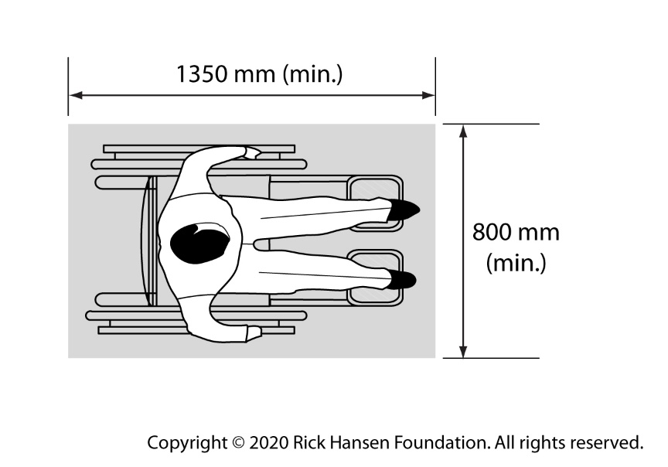
Figure 34: Minimum clear space for wheeled mobility devices
Note: This does not apply to clear floor space required for accessible seating spaces in public assembly areas and areas of refuge. A minimum clear space of 900 mm by 1220 mm for a front or rear approach and 900 mm by 1525 mm for a side approach is required.
    - Turning Space
People using wheeled mobility devices rely on ample turning space to navigate their environment. The minimum turning space required to perform a complete 360-degree turn is:
1700 mm diameter
For increased level of accessibility and to support the increasing number of options and variety of wheeled mobility devices, the Center for Inclusive Design and Environmental Access (IDeA) suggests a turning space of 2500 mm based on a study that analyzed the turning diameter of various types of wheeled mobility devices.
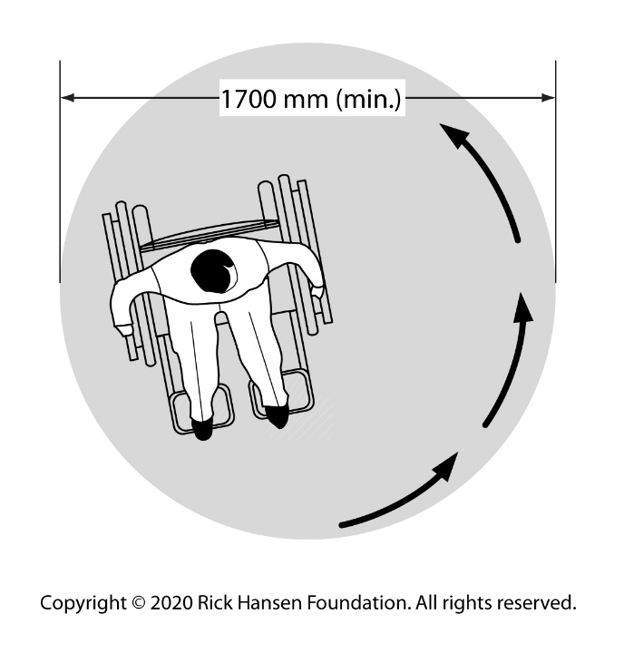
Figure 35: Minimum turning space for wheeled mobility devices

    - Clear Width (Path of Travel)
People using wheeled mobility devices, service dogs, or crutches must be able to easily navigate along paths of travel and require more space to do so. The minimum base clear width along paths of travel is:
1100 mm for one-way traffic along interior circulation routes and aisles
1700 mm for two-way traffic, allowing people to pass each other
According to DeafSpace, corridors that are 2000 mm wide or more provides suitable space for people to clearly view sign language, while walking and signing. This also allows for two wheeled mobility devices to pass each other.
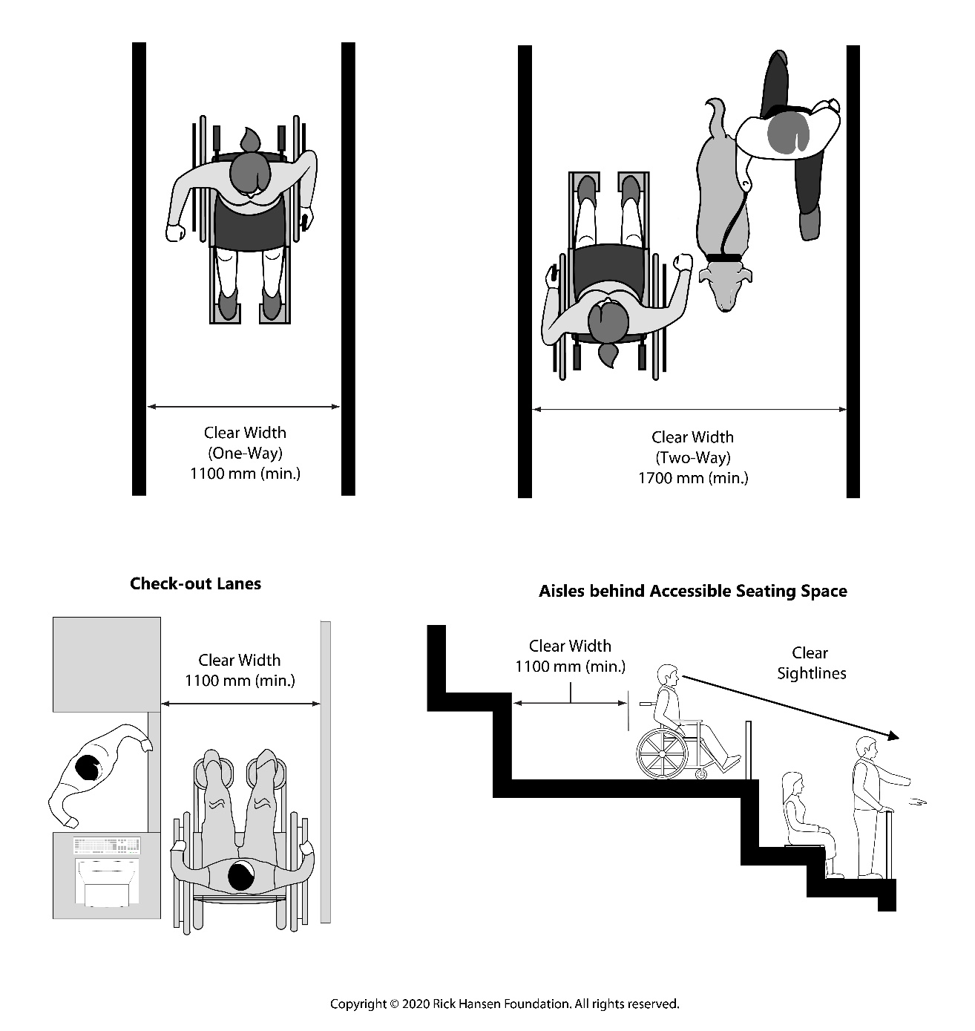
Figure 36: Minimum clear width of circulation routes/aisles

    - Clear Opening Width (Doors and Doorways)
People using wheeled mobility devices, service dogs, or crutches must be able to pass through doors and doorways. The minimum clear opening width of doors and doorways:
850 mm
Clear opening width of doors that are wide enough to accommodate one “universal” clear floor space of 860 by 1480 mm is recommended by the Center for Inclusive Design and Environmental Access (IDeA).
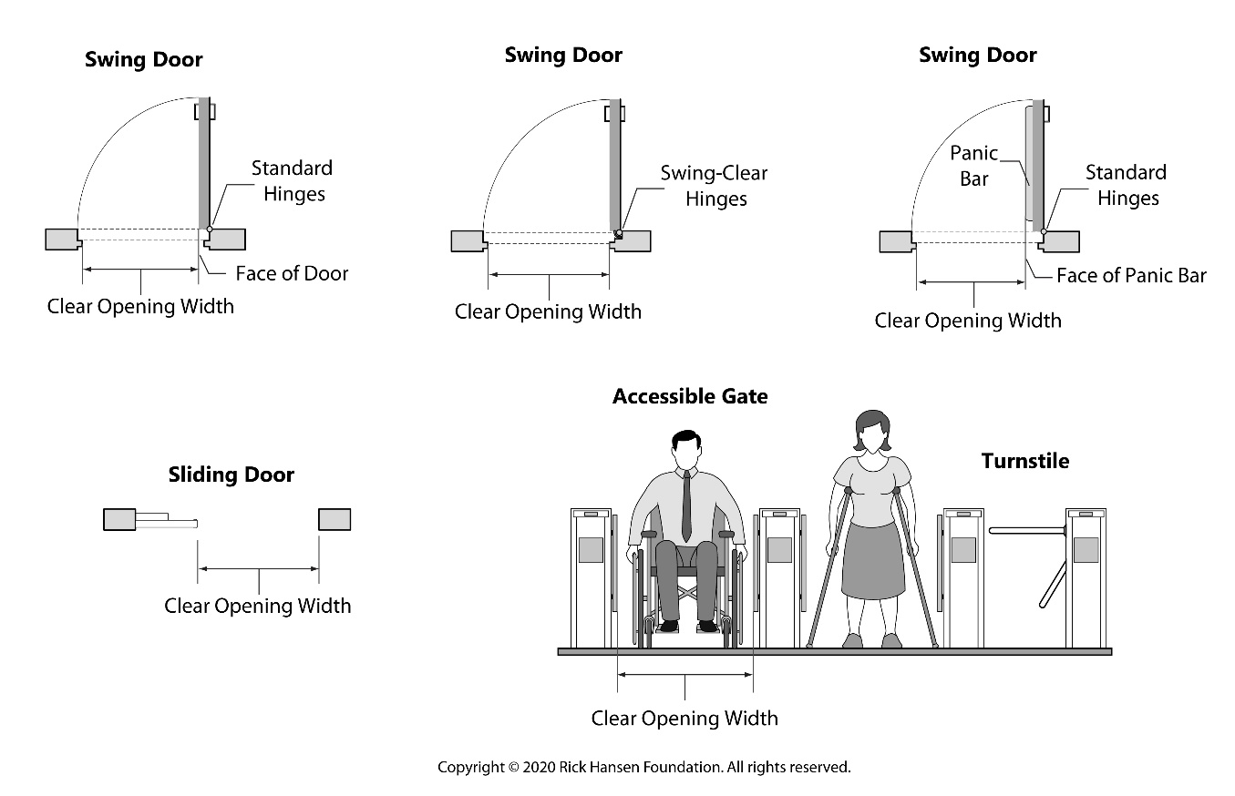
Figure 37: Minimum clear opening width of doors and doorways

    - Overhead Clearance
The minimum overhead clearance along path of travel:
2050 mm high
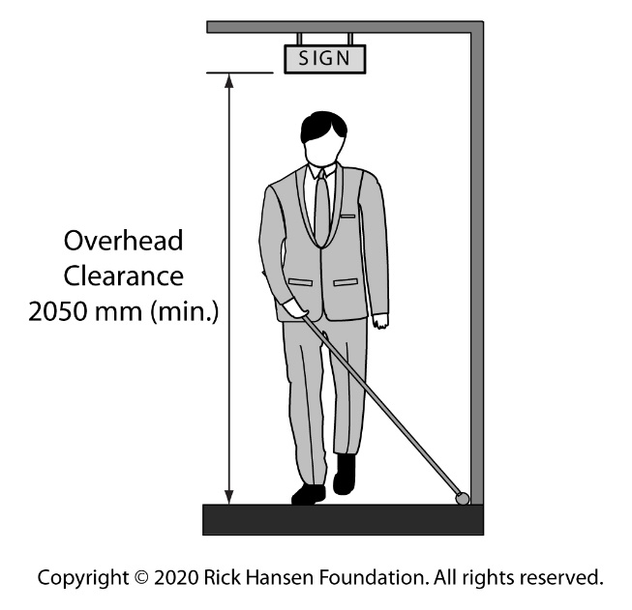
Figure 38: Minimum overhead clearance along path of travel
Where overhead clearance is less than 1980 mm high, a cane-detectable feature is required with its leading edge at no higher than 680 mm.
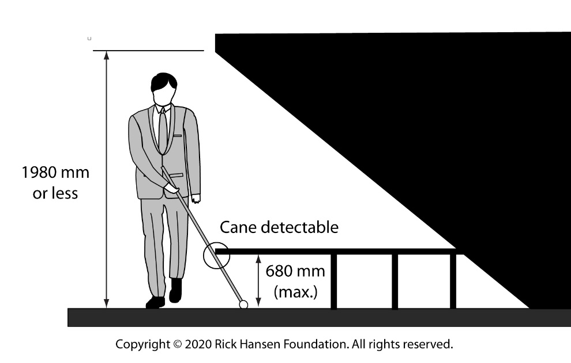
Figure 39: Cane-detectable feature requirement where overhead clearance is reduced

    - Protruding Objects
People who are blind or have low vision often use walls as wayfinding clues, and they rely on consistency when navigating the built environment. Objects mounted on walls, columns, or other features along a path of travel represent potential hazards.
Objects projecting no more than 100 mm from the wall can be mounted at any height. If objects project more than 100 mm from the wall along a path of travel, they must be cane detectable, with their lower edge no higher than 680 mm above the finished floor.
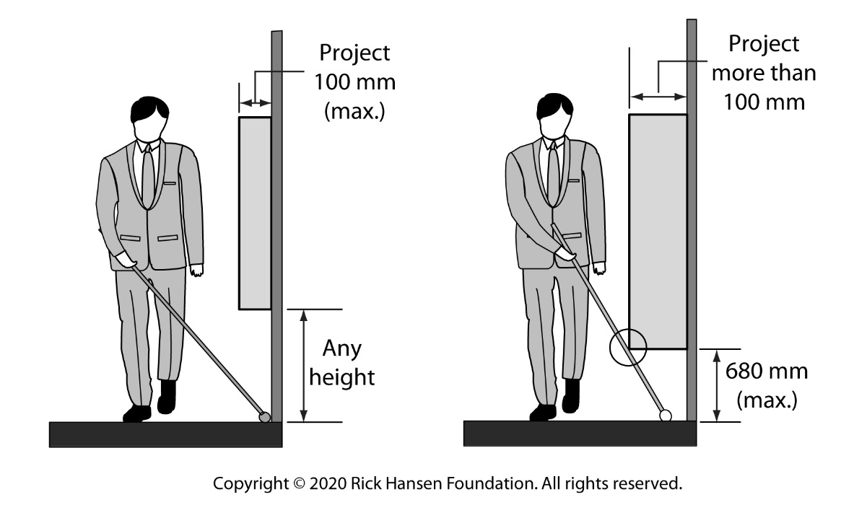
Figure 40: Cane-detectable requirement for objects protruding from wall

    - Outward Opening Doors
Where door opens into a path of travel, cane-detectable feature must be installed to ensure doors do not open on pedestrians. Cane-detectable feature should have its leading edge no higher than 680 mm high above the finish floor. A high contrast marking on the floor also allows pedestrians to identify the path of the door swing.
It is recommended that doors that open into a path of travel be recessed.
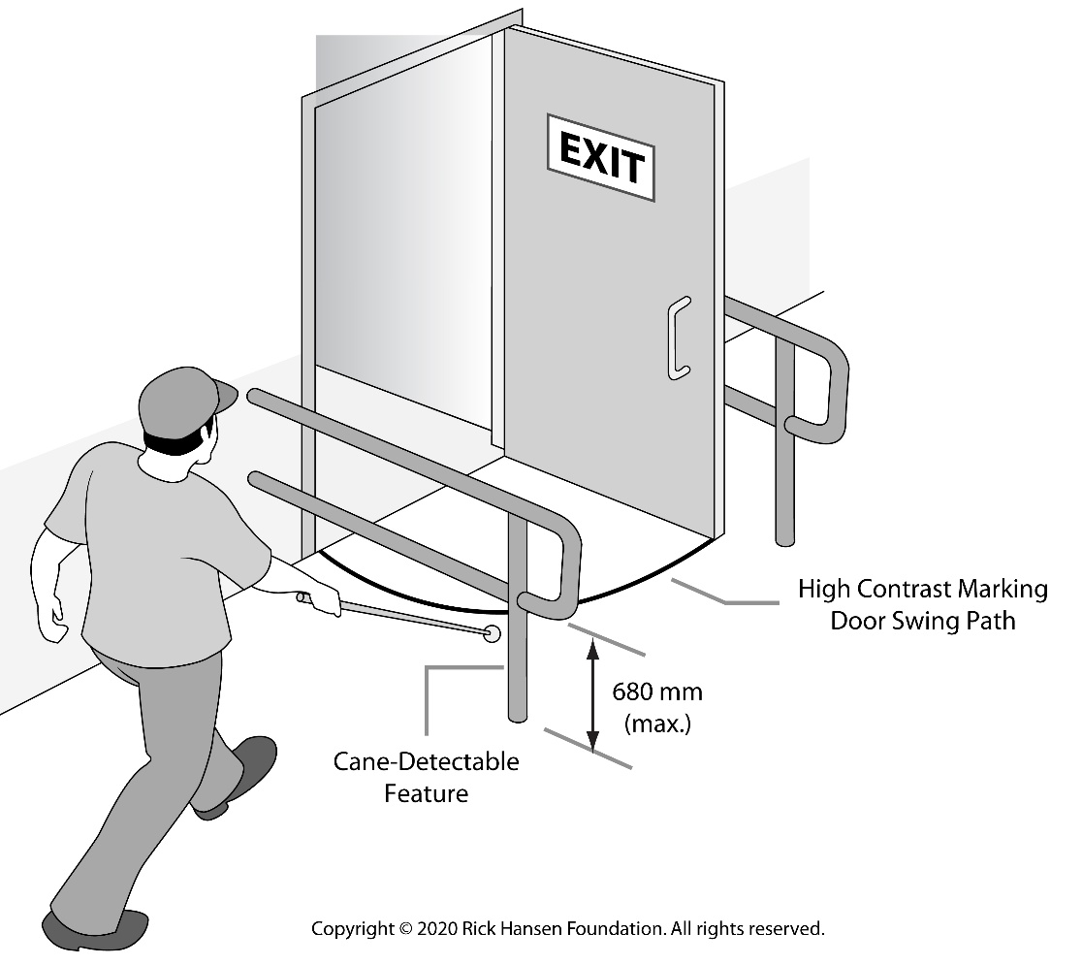
Figure 41: Outward opening door with cane-detectable feature and floor marking

  - Reach Ranges
    - Mounting Operating Heights of Controls
Controls mounted at this height can be reached by people using wheeled mobility devices for both a forward and lateral reach from a seated position:
400 - 1100 mm high
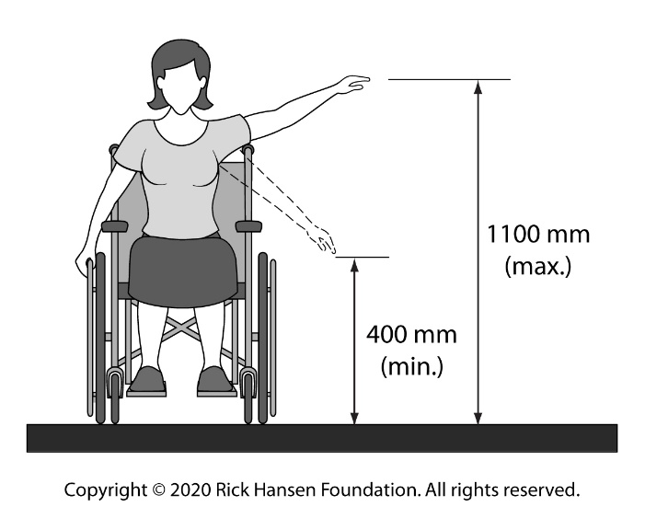
Figure 42: Reach range
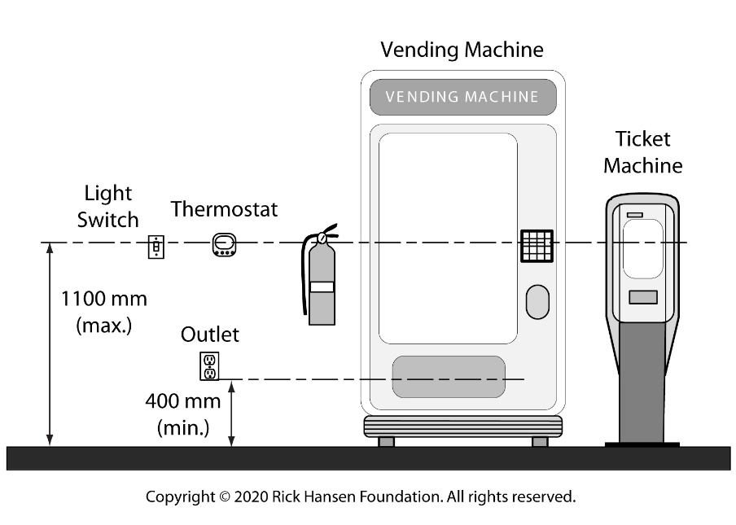
Figure 43: Mounting heights of operating controls
Controls and any dispensing areas (e.g., receipts, coins, ticket, etc.) should be within the recommended mounting height of controls.
    - Grasp and Touch Reach
Controls mounted within this distance can be reached by people using wheeled mobility devices for both a forward and lateral reach from a seated position:
500 mm for a grasp reach
600 mm for a touch reach
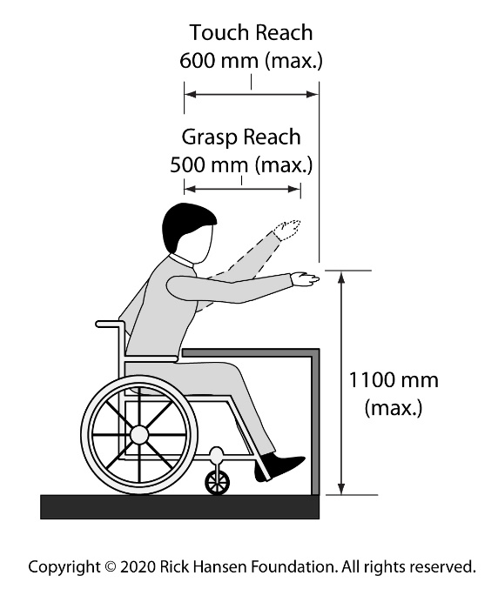
Figure 44: Reach range from a seated position

  - Counters, Work Surfaces, and Sinks
    - Accessible Height
The maximum height for accessible counters, work surfaces, and sinks for use by people using wheeled mobility devices is:
860 mm high
Adjustable height counters, work surfaces, and sinks provide greater flexibility for users in both seated and standing positions.
    - Knee Clearance
The minimum knee clearance for accessible counters, work surfaces, and sinks for people using wheeled mobility devices to easily approach and roll underneath is:
685 mm high by 480 mm deep
Research from the Center for Inclusive Design and Environmental Access (IDeA) suggests that providing a knee clearance height of 720 mm will accommodate 95% of users of wheeled mobility devices.
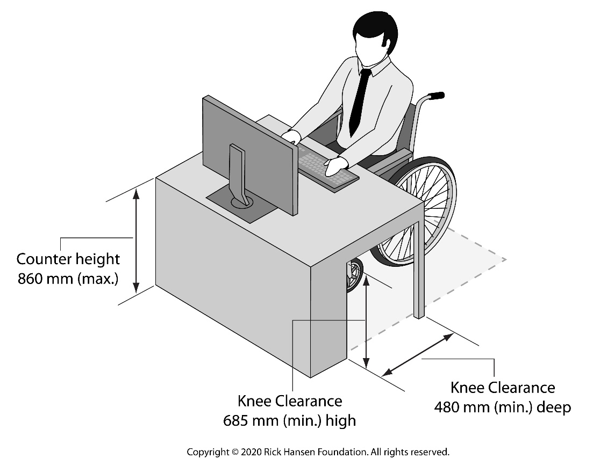
Figure 45: Counter, work surfaces, and sinks dimensions

  - Signage
    - Mounting Height
Wall-mounted signage should be installed with their centreline at:
1500 mm high
    - Tactile Signage
Where tactile markings such as raised characters/symbols and braille are provided, the tactile markings should be located between:
1200 and 1500 mm high above the finished floor
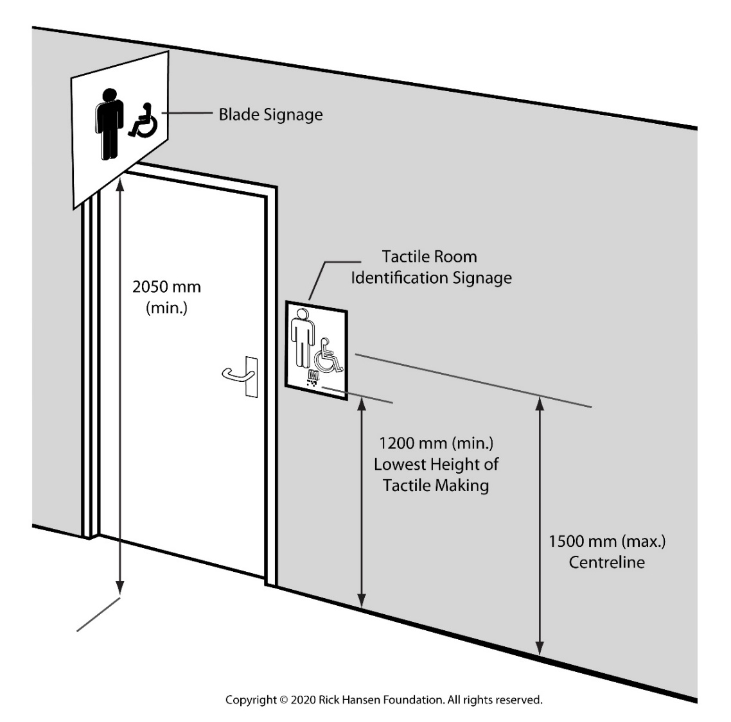
Figure 46: Room identification signage and blade signage

  - Colour Contrast
Using colour contrast between surfaces to highlight objects and features has a significant effect on accessibility. Many people, not just those who are blind or have low vision, have difficulty navigating the built environment when the colour contrast is low. Walls, floors, or other large fields should include high-contrast surfaces and areas to help with depth perception, to assist in wayfinding, to identify potential obstacles, and to minimize vertigo.
Colour contrast refers to the difference in colour between one colour and another. Higher contrast is achieved by using colours that are visually different (e.g., dark versus light). However, colour contrast is dependent on adequate lighting in order to be effective. Without sufficient lighting, users may not be able to perceive the difference in colours. This is also often referred to as luminance contrast.
The minimum colour contrast should be:
50% to be visible to most people with low vision
70% for signage and at hazards
When considering contrasting colours, it is important to recognize that people who are colour-blind have difficulty distinguishing between red/green or blue/green colour combinations. Accordingly, these combinations should be avoided.
Some recommended good colour combinations include black/white, yellow/black or dark red/white. Colour schemes should be kept as simple as possible to avoid confusion.
For additional information about colour contrast, refer to CNIB, Clearing our Path.

- Guidelines on Writing the Scope of Rating
The scope of rating is one of the most important parts of the rating as it helps the adjudicator, client, and public understand which elements are included in the rating. It is critical that RHFAC Professionals accurately define the specific areas of a Site that are included and excluded from a rating. The scope also allows RHFAC Professionals to describe the Site and its users to further enhance understanding of how the Site functions. The scope of rating should tell a story.
General (all rating):
- Identify the number of floor(s) in the building and the square footage of the building.
- Identify the user profile of the Site (e.g., who uses the building? public or staff only, mostly seniors, all ages).
- Identify all the exterior elements available on Site that the typical users will encounter to access the building (e.g., parking, passenger drop-off zones, transit stops, pathways, ramps, stairs, etc.)
- Identify all the facilities and spaces (e.g., meeting rooms, offices, kitchens) present on the Site.
Important: If a space or facility is excluded from the rating, they MUST be identified in scope along with a brief explanation as to why they were not (e.g., renovation underway).
- If the Site does not meet any of the two Mandatory Certification Requirements (e.g., you have answered NO to either of the two Mandatory Certification Requirements), you MUST provide a brief explanation as to why the Site did not meet the mandatory certification requirements.
Note: This allows the adjudicator and client to have a better understanding as to why the Site cannot be certified, especially if it is not obvious. Additionally, this also ensures that the clients understand why their Sites could not be certified RHF Accessibility Certified or RHF Accessibility Certified Gold, even when the Sites achieved 60%+ or 80%+ respectively.
- Check for grammar and spelling. This part of the rating is visible to the client and the public if the client decides to publicly list their Site.
Additional Site-specific details to include:
- If the Site is a tenanted space in a multi-storey building, defining the scope is especially important.
Note: The client may not be responsible for the common areas of the building but it is important that these elements are included in the rating because the rating is looking at the entire user experience at the Site. RHFAC Professionals MUST identify and include:
- the floor level the tenant space is located
- the closest accessible building entrance (may include parking if facilities exist) and the direct route from the entrance to the tenanted space
- the closest sanitary facilities and the most direct route from the tenanted space, if they are located outside of the tenanted space
- all common areas and spaces that are typically used by users of the Site that are outside of the tenanted space
- all facilities and spaces available to the public and employees provided within the tenanted space
- the most direct emergency exit route from the tenanted space
- If the Site is a multi-unit residential building, RHFAC Professionals MUST identify the different residential unit types (e.g., bachelor, one bedroom, two bedrooms, etc.) available in the building, if they are included in the rating.
- If the rating includes a trail or urban pathway, RHFAC Professionals MUST identify its length, and the start and end point of the trail or urban pathway.
Sample of Scope of Rating:
The following are some examples of scope of rating:
Example 1: Community Centre (Owned Space)
Community Centre A is 150,000 sq. ft. 3 storey building. The typical users of the space are people of all ages with programing ranging from children to seniors. This Centre has a large senior population.
The scope of this rating includes: 2 parking lots, a passenger drop-off zone in front of the building entrance, the closest transit stops serving the Centre, and all the exterior circulation elements leading to the building entrances (e.g. multiple pathways, one ramp and a two sets of stairs).
The rating also encompasses the entire building which included: lounges, meeting/boardrooms, a fitness centre, two basketball courts, change rooms with showers, and a cafeteria. The theatre is not included in this rating because it was closed for renovation at the time this rating was conducted.
Example 2: Office Space (Tenant Space)
Office B is a 4,000 sq. ft. tenanted space located on the 6th floor of Building X. The office is mostly used by staff with occasional public interaction.
The scope of this rating includes the parking lot closest to the building entrance, the route leading to the building entrance, the building entrance itself and the most direct interior circulation routes leading to the tenanted space.
The rating encompasses the entire tenanted space which included a reception/waiting area, meetings rooms, communal office spaces, private offices, and a kitchen. The washrooms included in this rating are located in the common areas of the building.
This Site did not meet the certification requirement because the main entrance to the building has two steps and is not accessible for people using wheeled mobility devices. There are no alternative entrances available.
- Guidelines on Writing a Rating Summary
The Rating Summary is an essential part of the rating. This is where RHFAC Professionals can provide more information to the clients on how their Sites have fared and what they can do to improve access. This is the part of the rating that the client is most looking forward to as the report identifies the potential next steps that will guide their roadmap to making their Sites more inclusive.
General:
- Use the scorecard as a guide to develop your Rating Summary. Any comments you enter in this section MUST be supported by the facts identified in the Rating Survey. Identify the elements that have scored highly in the Key Areas of Success and the ones that received the lowest scores in the Key Areas of Improvement.
- Identify the element/feature and give a brief description on how the element/feature works or does not work for people with disabilities. This description helps clients get a better understanding of how the element/feature impacts the different users of their Site.
- Check for grammar and spelling. This part of the rating is visible to the client.
Key Areas of Success:
It is recommended that RHFAC Professionals:
- Identify the elements that have received the highest scores on the scorecard and also consider including key features that made the element more accessible to everyone.
- Note: RHFAC Professionals are not expected to list every feature that has achieved a full score. Instead, they should select the ones that follow universal design principles (e.g., the provision of both audible and visual components inside an elevator to ensure both people with vision and hearing disabilities are able to use the elevator).
- Include any innovative features that were identified in the rating survey, as they are provided to improve access and are typically specific to the Site.
- Provide a brief explanation on how each element/feature is successful in providing access and following universal design principles. This allows the clients to have a better understanding of the elements/features and they can therefore apply them to their future projects.
Key Areas of Improvement:
It is recommended that RHFAC Professionals:
- Identify the reasons why a Site has not met the mandatory certification requirements, if this is the case. Clients must be aware that they should address these issues first (e.g., providing an accessible entrance to the building if none is currently provided) in order to be certified.
Note: Where Sites have achieved a rating score of 80%+ but have not met the Mandatory Gold Certification Requirements, it is recommended that RHFAC Professionals also identify these reasons as well.
- Identify the features that have received zero and/ or present safety issues as they are typically the ones that clients would want to address first (e.g., an overhead obstacle along a path of travel that may be a hazard to someone who are blind who may bump their head).
- Organize your list into short-term and long-term improvements. Safety and high-impact considerations should be at the top of the short-term list. Long term accessibility considerations that could be done as part of the normal building or site maintenance and operations can be placed in the long-term list.
- Provide a brief explanation as to why the lack of or inadequacy of the elements/features impact access for people with disabilities. This helps clients understand the importance of addressing these barriers and the potential safety issues they present.
- Ensure the list of key areas of improvements makes sense when considering meaningful access. For example, if there is no accessible route (e.g., stair access only) to a public assembly area, this MUST be identified at the top of the list. It would not make sense to identify other accessibility issues such as the lack of designated accessible seating spaces as a top priority if users of wheeled mobility devices are unable to get inside the public assembly area in the first place.
Sample of Rating Summary:
Key Areas of Success:
- Elevators provide both visual and audio features, including verbal announcements.
- A variety of types of seating are provided in meeting room and lounges including chairs with and without armrests, which offers choice to staff and visitors.
- Room identification signage has raised lettering and Braille, mounted on the latch side of the door at an accessible height.
- An area of refuge is available to provide a safe place for people with limited mobility to wait during an emergency.
- All workstations have adjustable height desks to provide flexible workspaces for everyone.

Key Areas for Improvement:
Short-term
- Marking pedestrian routes from accessible parking spaces will increase safety and visibility.
- Installing vertical signage at accessible height for accessible spaces to clearly identify a space.
- Installing highly visible signage with large print and colour contrast will help visitors identify the building entrance.
- Providing sheltered seating at the main entrance will allow people to comfortably wait or rest.
- Providing visual fire alarms throughout the office and kitchen area will ensure that people who are deaf can be alerted in an emergency.
- Providing a mirror in elevator to improve visibility will assist in manoeuvring a wheeled mobility device.
- Installing colour contrasting strips on interior stairs on nosing will help people identify each step.
- Installing grab bars at the back of the toilet will allow options for transfer.
- Lowering paper towel dispensers in washroom or offer choice of heights will provide an option within reach for all users.
- Providing an emergency call buttons in accessible stalls allows users to call for assistance.
- Adjusting the resistance on interior doors to make them easier to open.
- Providing seating and tables at a variety of height allows for choice.
- Installing back support on toilets will help to provide stability for people with limited core strength.
- Providing clear blade signage for washrooms, stairways and elevators will help identify their location at decision points.
Long term:
- Providing shelter over accessible parking spaces will protect people from the weather when entering or exiting the vehicle.
- Providing a designated passenger drop-off area with dedicated curb ramp will improve the safe loading and unloading of passengers.
- Providing a universal washroom will offer an option for users that requires extra clear space, privacy and would accommodate a caregiver.
- Installing power-operated door openers on all washrooms.
- Installing assisted listening system in meeting rooms will support users with hearing loss to more easily participate.

Note: The lists of short-term and long-term improvements provided in the example above will be different based depending on the projects.

- Technical Language Glossary
Developing a vocabulary of relevant technical terms to accurately describe the built environment as it relates to accessibility is critical. The terms and definitions provided in the table below were obtained from recognized sources, including the Rick Hansen Foundation, Canadian Standards Association (CSA) B651-18, the Centre for Excellence in Universal Design (CEUD), the Canadian Human Rights Commission (CHRC), Global alliance on Accessible Technologies and Environments (GAATES), CNIB’s Clearing Our Path (CNIB), and BC Housing Design Guidelines and Construction Standards, 2019 (BCH).
Technical Language Glossary
Term | Definition | Source
Access aisle | Clear, level area parallel to a parking space for people with mobility disabilities to get in and out of a car or van. | CHRC
Accessible | With respect to buildings, or parts of buildings, means that people regardless of age, size, ability or disability, are able to both access and use the building and its facilities. | CEUD
Accessible route (path of travel) | A pedestrian path of travel within the interior or exterior environment that is without barriers, as defined in the CSA Standard, and usable by all persons, including those with physical, sensory, or cognitive disabilities. | CSA B651
Adaptable | Easily renovated to create a barrier-free environment.  Adaptable units are designed and constructed to facilitate future modification to provide access for persons with disabilities. | CHRC  BCH
Adaptable seating | A fixed seat or seats designed to facilitate a side transfer from a wheeled mobility device. | CSA B651
Alternative (alternate) format | Information presented in Braille, in large print, electronically (e.g., on removable or portable media), or online in an accessible format. | CSA B651
Amenity | Anything that adds to a person’s comfort or convenience. | CSA B651
Amenity zone | A designated area, adjacent or connected to an accessible route, that provides amenities and services (e.g., street furniture, mailboxes, telephones) and can include utilities such as light posts, hydrants, etc. | CSA B651
Area of Refuge | An area separate from the general floor area by a fire separation having a fire-resistance rating at least equal to that required for an exit, that is smoke protected and served by an exit or a firefighters elevator. | CHRC
Barrier | A condition that prevents someone’s full participation in the activities of daily living. | Rick Hansen Foundation
Barrier: Attitudinal | An assumption or perception about a disability, held by oneself or others, either purposefully or inadvertently, that may limit or prevent someone's full participation in their communities. | Rick Hansen Foundation
Barrier: Awareness | A lack of understanding of the extent of social, health, and economic impacts of disability and of motivation to care and take action. | Rick Hansen Foundation
Barrier: Education | A lack of appropriate access — whether physical or attitudinal — to educational experiences and/or training and skills development. | Rick Hansen Foundation
Barrier: Employment | A lack of access to meaningful, relevant, and economically self-sustaining work. | Rick Hansen Foundation
Barrier: Health | A lack of cures and care that contribute to an individual’s state of well-being in body and/or mind. | Rick Hansen Foundation
Barrier: Physical | A feature of a site, structure, technology, system, space or an environment that may prevent or limit someone’s ability to fully participate in that designed environment. | Rick Hansen Foundation
Blended transition | A connection with a slope of 1:20 (5%) or less between the level of a pedestrian walkway and the level of a vehicular path of travel. | CSA B651
Bollard | Usually a 900 mm high post to mark pedestrian path from vehicular traffic. | CHRC
Braille | A system where raised dots are used to represent letters and words. Unified English Braille (UEB) is the braille standard for Canada. Note: In the CSA Standard, unless stated otherwise, “braille” indicates uncontracted braille.  A system of small raised dots that are read using the fingertips. Braille can represent everything from words to mathematical symbols to music.  There are two main types of braille: uncontracted and contracted. Just as sighted people have shorthand, some people impacted by blindness use a contracted version of braille that is space-saving and allows for rapid reading and writing. Note that not all braille readers know contracted braille, so it is not always appropriate in the built environment. | CSA B651  CNIB
Building | A permanent or temporary structure of any size that accommodates facilities to which people have access. A site accommodating sanitary facilities may include a toilet block in a public park or shower facilities at a campsite.  A temporary building may include portable toilet facilities such as those provided at outdoor events. | CEUD
Building user | A person regardless of age, size, ability, or disability using facilities in a site or associated external environment. | CEUD
Cane-detectable | Any object or a change in surface texture that falls within the detection range of a long white cane. | CSA B651
Colour contrast | A significant contrast in colour between the foreground and the background of an element, e.g., light on dark background or dark on a light background. | CSA B651
Crosswalk | That portion of a pedestrian crossing that is within the vehicular right-of-way. | CSA B651
Curb ramp | A sloped surface built into a curb. | CSA B651
Disability | A broad term that describes a physical condition that may require consideration to ensure their full participation in the activities of daily living and community involvement. | Rick Hansen Foundation
Glare | An excessive reflection of light from a surface. | CSA B651
Guard | Protective barrier to prevent accidental falls at openings in floors and at the open sides of stairs, landings, balconies, mezzanines and ramps. This is also required where there is a significant drop-off along exterior pathways. | CHRC
Gutter | The sloped drainage area directly in front of a curb or curb ramp. | CSA B651
Illumination | The intensity of light, as measured in lux (symbol: lx). | CSA B651
Inclusion | The practice of eliminating the labelling of people by ability and instead ensuring everyone has an equal opportunity to fully participate in all aspects of community life and services. | Rick Hansen Foundation
Passenger pick-up area | An area where pedestrians board and disembark road vehicles. | CSA B651
Pedestrian crossing | The combination of crosswalk segments, curb ramps, or blended transitions, medians, and refuge islands that connect departure and arrival walkways across a vehicular right-of-way. | CSA B651
Pedestrian right-of-way | That portion of the public right-of-way that is dedicated to the unrestricted movement of persons. | CSA B651
Pedestrian route | A continuous and unobstructed path of travel within a pedestrian circulation area that provides accessibility. | CSA B651
Physical disability | A physical condition (mobility, visual, and hearing) that may require consideration to ensure full participation in the activities of daily living and community involvement. | Rick Hansen Foundation
Platform lift | An elevating device that is installed at a permanent location in a building structure and is used to transport persons with disabilities on a platform that moves between permanent levels.  Enclosed stair lift — an inclined lift where the platform runway is separate from the stair circulation space.  Enclosed vertical lift — a vertical lift with an enclosed platform runway.  Unenclosed stair lift — an inclined lift where the platform or chair runway is within the stair circulation space.  Unenclosed vertical lift — a vertical lift with a partially enclosed or unenclosed platform runway. | CSA B651
Public right-of-way | Private property or public land, usually in interconnected corridors, that is acquired for or devoted to pedestrian and vehicular purposes. | CSA B651
Raised crossing | A crossing where the crosswalk is elevated between 80 mm and 150 mm above the adjacent road surface, with ramps on the approaches. It is designed to reduce speeds and draw attention to the crosswalk and the pedestrians, so that pedestrians can traverse the road safely. | CSA B651
Ramp | A sloping walkway leading from one level to another, which has a running slope with a ratio steeper than or equal to 1:20 (5%).  Walkways with a running slope shallower than 1:20 are not considered to be ramps in the context of the CSA Standard. | CSA B651
Roll-in shower | To be used while staying in a wheelchair, standing or sitting (by adding a seat to the shower stall) | CHRC
Shared-use walkway | A path of travel, separate from a vehicular route, where pedestrians on foot and those using various types of mobility aids (e.g., manual or powered wheelchairs, scooters, canes, long white canes, walkers, or crutches) share space with persons who use non-motorized items (e.g., skateboards, inline skates, bicycles). | CSA B651
Signage | Information provided in the form of visual and tactile communication that incorporates one or more of the following elements: (a) alphanumeric symbols; (b) pictograms; (c) illustrations (plans, etc.); or (d) Braille. | CSA B651
Site | A public, commercial, or multi-unit residential building, or trails/pathways. A Site can be either existing or in the pre-construction phase. | Rick Hansen Foundation
Slope | The ratio of rise to run on an inclined surface  Running slope — the slope that is parallel to the direction of travel.  Cross slope — the slope that is perpendicular to the direction of travel.  Gutter slope — the crossfall of the drainage area at the edge of the street directly in front of a curb ramp.  Counter slope — the combined sum of the running slope of a curb ramp and of the gutter slope, in percentages. | CSA B651
Soffit | The underside of any construction element, the underside of a flight of stairs. | CEUD
Spinal cord injury | A spinal cord injury occurs when trauma (such as a fall or a traffic accident) or disease (such as a tumor or spina bifida) damages the spinal cord, resulting in partial or complete paralysis. | Rick Hansen Foundation
Stair nosing | An edge part of the tread that protrudes over the riser beneath. | CEUD
Stair riser | The vertical portion between each tread of the stair. | CEUD
Stair tread | The part of the stairway that is stepped on. | CEUD
Tactile markings | Lettering or graphics that are slightly raised above the surface. | CSA B651
Tactile walking surface indicator (TWSI) | A standardized surface, detectable underfoot or by a long white cane, to assist persons with low vision or blindness by alerting or guiding them.  Tactile Attention Indicator (TAI): a TWSI comprising truncated domes that signals a need for caution at a change in elevation, a vehicular route, train tracks, or other potential hazard.  Tactile Direction Indicator (TDI): a TWSI that uses flat-topped elongated bars to facilitate wayfinding in open areas. They are designed to guide a person on a designated path of travel. | CSA B651  CNIB
Text Telephone or Teletypewriter (TT/TTY) | Incorporates a keyboard that is connected to the telephone to allow communication through typed messages. | CHRC
Transfer space | An unobstructed area allowing the positioning of a wheelchair to enable a person to transfer to another adjacent seated position. | CSA B651
Universal Design | The design of products and environments to be usable by all people, to the greatest extent possible, without the need for adaptation or specialized design.  Universal Design = Usable Design = Understandable Design (understanding the user). For example, an older person may require many resting places due to discomfort when walking for long distances. | Rick Hansen Foundation  CEUD
Wayfinding | A spatial problem-solving process based upon consistent use and organization of definite sensory cues in the environment that individuals use to understand where they are, know where their desired location is, and know how to get to that destination from their present location. | CSA B651
Wheeled-mobility device | A collective term to describe a range of wheeled personal transportation devices, including manual wheelchairs, powered wheelchairs, and scooters. | CSA B651

- References
- Canadian Human Rights Commission. (2020, April). International Best Practices in Universal Design, A Global Review. Retrieved from https://www.chrc-ccdp.gc.ca/eng/content/international-best-practices-universal-design-global-review
- CNIB. (2020, April). Clearing our Path. Retrieved from: http://www.clearingourpath.ca
- CSA Group. (2018). Accessible design for the built environment – Implementation Handbook, B651HB-18, 2018 CSA Group - Reprinted with revisions March 2020. ISBN 978-1-4883-1877-1.
- Levine, D. (2003). NYC Guidebook to Accessibility and Universal Design. Center for Inclusive Design & Environmental Access, University at Buffalo, State University of New York, ISBN 0-9714202-3-8. Retrieved from http://www.nyc.gov/html/ddc/downloads/pdf/udny/udny2.pdf
- National Disability Authority (NDA). (2020, April). In Centre for Excellence in Universal Design (CEUD). Retrieved from http://universaldesign.ie/Built-Environment/Building-for-Everyone/
- University at Buffalo. School of Architecture and Planning. In Center for Inclusive Design and Environmental Access (IDeA Center). Retrieved from: http://idea.ap.buffalo.edu
- United Nations Secretariat. Department of Economic and Social Affairs (DESA). (June 2013). Accessibility and Development: environmental accessibility and its implications for inclusive, sustainable and equitable development for all. Retrieved from: https://www.un.org/disabilities/documents/accessibility_and_development_june2013.pdf
- United Nations. Accessibility for the Disabled: A Design Manual for a Barrier Free Environment. In Enable. Retrieved from: http://www.un.org/esa/socdev/enable/designm/index.html
- United States Access Board. (2020, April). Americans with Disabilities Act Standards (ADA). Retrieved from: https://www.access-board.gov/attachments/article/983/ADA-Standards.pdf

